New Genes, New Proteins Worksheet

Materials Needed
- 1 codon wheel
- 1 laptop or computer
- 1 Vernier LabQuest or compatible interface
- 1 Vernier force probe
- 1 amino acid model set
- green paracord (unmarked) ≈ 15 feet with a diameter of 5/32 in.
- blue paracord (marked) ≈ 15 feet with a diameter of 5/32 in.

Introduction
Scientists across the globe are working to improve a variety of products and systems to solve environmental challenges and to improve the human condition. Synthetic biology is a multidisciplinary field of science that focuses on living systems and organisms. It applies engineering principles to develop new biological components, devices, and systems. Synthetic biologists are able to use the genetic code to redesign existing systems found in nature and use them to address challenges facing society. At its core, synthetic biology involves generating unique strands of DNA that code for novel proteins. The hope is that these new polypeptides will be used to solve a variety of problems. Examples include Dr. Marcus Foston and his colleagues’ (Anthony et. al 2019) work to use synthetic biology to improve the conversion of plant materials to biofuels, or Dr. Fuzhong Zhang and his research team’s work producing new surgical glues using proteins coded for by a mix of spider (silk) DNA and mussel (glue) DNA. In fact, synthetic biology has the potential to produce a variety of bioelectronics, self-healing fabrics, and new optical materials (LeFeuvre and Scrutton 2018).
Overview
Today, you will model the work of a synthetic biologist as you work to improve a surgical glue. Scientists have synthesized a new adhesive using the DNA that codes for spider silk and the glue that mussels use to stick to rocks. It is called a silk-amyloid-mussel foot protein. It is composed of 16 repeating β-sheet-forming blocks with alternating amyloid and silk peptides. The order of amino acids in the protein is lysine, leucine, valine, phenylalanine, phenylalanine, alanine, glutamic acid, glutamine, glycine, threonine, serine, glycine, arginine, glycine, glycine, leucine, glycine, glycine, glutamine, glycine, alanine, glycine.

The glue is relatively strong, but your task today is to reverse-engineer a new glue using the same amino acids that are currently found in the protein. Remember, when you change the order of amino acids, you also change the shape and function of the protein. You will need to know not only the order of amino acids for your new synthetic protein, but also the genetic code that can be inserted into a virus or bacteria so that more of your glue can be produced. Once your new polypeptide chain is created, you will construct a model of the polypeptide and measure how cohesive it is using a force probe.

Phase 1 – Reverse Engineering
As you know, DNA codes for mRNA and mRNA codes for a protein. In this particular case, you know the amino acid sequence. The next step is to determine which RNA nucleotides are involved. In order to accomplish this, use the codon wheel (Appendix) to determine the possible codons for each of the amino acids.

Steps in using a codon wheel:
- Start at the center of the wheel with the first base of the mRNA codon (5' → 3' direction). For example, if your codon is AUG, begin at A in the center.
- Move to the second ring, using the second base of the codon. From A, move outward to U (for AUG).
- Then, move to the third ring, selecting the third base. From AU, go to G.
- The outermost ring shows the amino acid that corresponds to the full codon. In this case, AUG codes for methionine (Met), which also serves as the start codon for translation.

For example, if the strand of mRNA is: 5'-AUG CCU AGA CUU-3':
AUG → Methionine (Met) – also the start codon
CCU → Proline (Pro)
AGA → Arginine (Arg)
CUU → Leucine (Leu)
The polypeptide chain would then be Met–Pro–Arg–Leu.

- Complete the table below with the codon that corresponds with the amino acid.

Amino Acid  Sequence | Methi. |  |  | Lysine |  |  | Leucine |  |  | Valine |  |  | Phenyl. |  |  | Phenyl. |  |  | Alanine |  |  | Glutamic  Acid
mRNA
Strand

Amino Acid  Sequence | Glutamine |  |  | Glycine |  |  | Threonine |  |  | Serine |  |  | Glycine |  |  | Arginine |  |  | Glycine |  |  | Glycine
mRNA
Strand

Amino Acid  Sequence | Leucine |  |  | Glycine |  |  | Glycine |  |  | Glutamine |  |  | Glycine |  |  | Alanine |  |  | Glycine
mRNA
Strand

- Write the strand of mRNA that codes for the protein in the space below.

mRNA strand

A U G,__ __ __,__ __ __, __ __ __, __ __ __, __ __ __, __ __ __, __ __ __, __ __ __, __ __ __,
__ __ __,__ __ __,__ __ __,__ __ __,__ __ __,__ __ __ __ __ __, __ __ __, __ __ __, __ __ __,
__ __ __, __ __ __, __ __ __,

- Visit with at least two neighboring lab groups. Do your groups have identical strands of
mRNA? Explain how the strands may be different.

- Explain how two different strands of mRNA could code for the same polypeptide chain.

- What is the process of making a polypeptide chain using mRNA, a ribosome, and tRNA called?

- Now, using your known sequence of the mRNA from above, convert it to the template strand of DNA using the base pair rules.

Amino Acid  Sequence | Methi. |  |  | Lysine |  |  | Leucine |  |  | Valine |  |  | Phenyl. |  |  | Phenyl. |  |  | Alanine |  |  | Glutamic  Acid
mRNA
Strand
DNA
Strand
Amino Acid  Sequence | Glutamine |  |  | Glycine |  |  | Threonine |  |  | Serine |  |  | Glycine |  |  | Arginine |  |  | Glycine |  |  | Glycine
mRNA
Strand
DNA
Strand

Amino Acid  Sequence | Leucine |  |  | Glycine |  |  | Glycine |  |  | Glutamine |  |  | Glycine |  |  | Alanine |  |  | Glycine
mRNA
Strand
DNA
Strand

You may also use the DNA nucleotides provided in the lab and create an actual chain of DNA.

- What is the process of making a strand of mRNA from a template of DNA called?

- What are two ways that you can determine whether a nucleotide is from a molecule of DNA or RNA?

Phase 2 – Protein Construction
Now that we know the amino acid sequence and the DNA sequence, use the supplied amino acid model set to construct the amino acid chain for the silk-amyloid-mussel foot protein. The primary level of protein conformation is the order of amino acids. Place the amino acid on the paracord and then fold the model so that hydrogen bonds can form between the amino acids (the magnets represent the hydrogen bonds). The marks on the blue cord indicate the approximate locations of where to place the amino acid.

The order of amino acids in the protein is methionine (start), lysine, leucine, valine, phenylalanine, phenylalanine, alanine, glutamic acid, glutamine, glycine, threonine, serine, glycine, arginine, glycine, glycine, leucine, glycine, glycine, glutamine, glycine, alanine, glycine.

As you bend the cord to connect the amino acids together, note that you are completing the process of translation. You are effectively playing the role of the ribosome and rRNA as you place the amino acids in the correct order. When your lab partner is handing you an amino acid, they are effectively acting as tRNA. Notice how the primary structure of the polypeptide is determined by the sequence of amino acids.
Amino Acid and Shape Legend
Amino Acid | Corresponding model Shape codons
methionine | green sphere
lysine | gray rounded cube 1
leucine | green rounded cube 2
valine | green multifaceted polygon
phenylalanine | white hexagon
alanine | blue “cylinder”
glutamic acid | gray triangle 1
glutamine | white triangle 2
glycine | gray cube 1
threonine (small magnet) | blue cube 2
serine | white indented (lined) cube
arginine (small and large magnet holes on each side) | blue rectangular prism

The order of amino acids in the protein is methionine (start), lysine, leucine, valine, phenylalanine, phenylalanine, alanine, glutamic acid, glutamine, glycine, threonine, serine, glycine, arginine, glycine, glycine, leucine, glycine, glycine, glutamine, glycine, alanine, glycine.

Once your protein is assembled, let me see it so I can stamp or initial your lab.

Great job modeling translation_______________________

Your model should resemble something like Images 1 and 2.

Image 1.
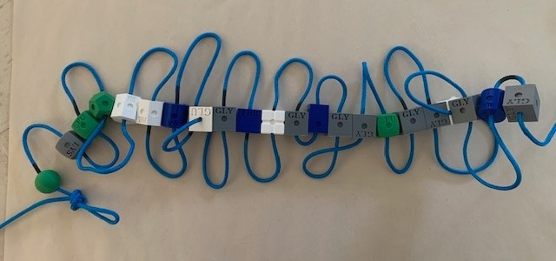

Image 2.
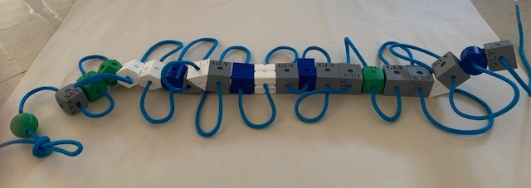
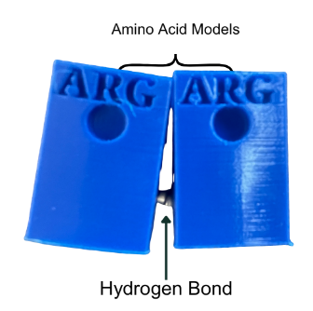

Phase 3 – Strength of Cohesion
Great news!!! You have successfully constructed a protein that forms sheets. This particular protein has adhesive and cohesive properties.

Adhesion is the protein’s ability to stick to other surfaces. Cohesion is the protein’s ability to stick to itself. Cohesion matters in glue because it determines how well the glue holds itself together. High cohesion helps glue resist stretching, pulling, or bending over time.

We will determine the ability for the protein to maintain its structure and overall strength by measuring the cohesive properties of the amino acids. Your next step is to determine the strength of the bonds that give the protein its cohesive properties. The cohesiveness of the protein is due to the number of hydrogen bonds. We are using magnets to symbolize the bonding.

Setting up the Vernier force probe:
- Insert the force probe plug into the LabQuest.
- Turn the LabQuest on.
- Once the LabQuest is on, you may need to change the mode of data collection to “time.”
Set the length of time to 15 seconds. (This will ensure that once you hit “play,” your LabQuest will collect changes in the number of newtons applied to the probe for 15 seconds. This is plenty of time to gradually pull on the protein model.) (See Images 3-7 on how to alter the durations of data collection)

Image 3. Image 4.
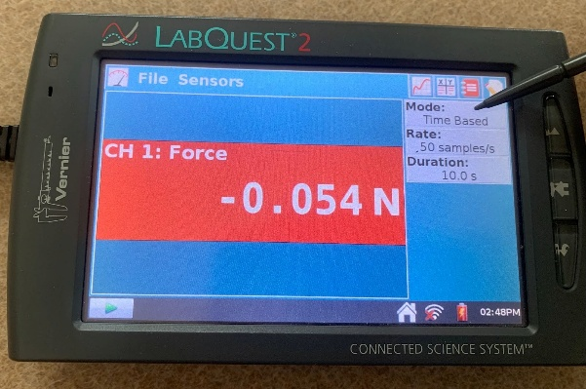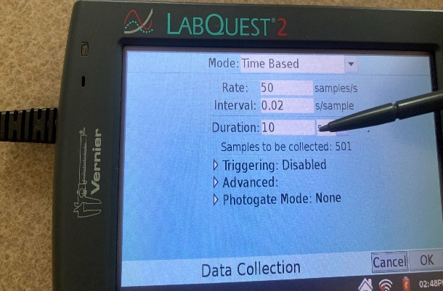
Image 5. Image 6.
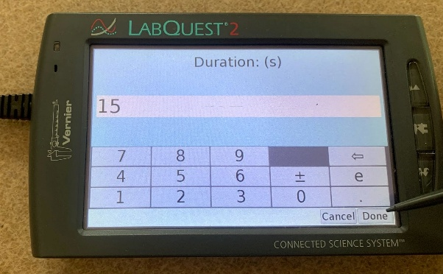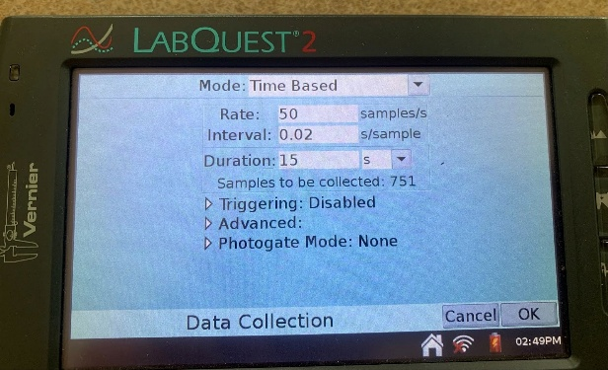

Image 7.
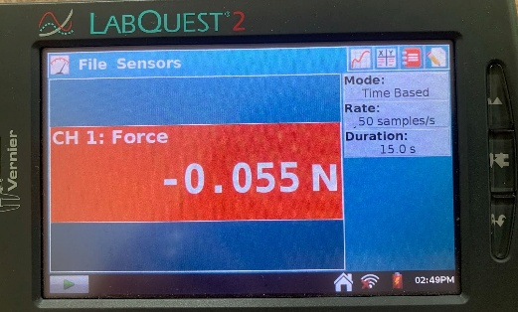

- Your LabQuest is ready to start collecting data. Now, to test the cohesiveness of the protein, form a loop at one end of the cord as depicted in Images 8 and 9. Then, hook the Vernier force probe to one of the loops you formed on the protein model. A lab partner will hold the other looped end of the protein sheet.

Image 8. Image 9.
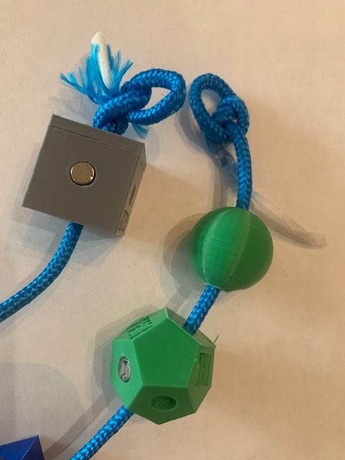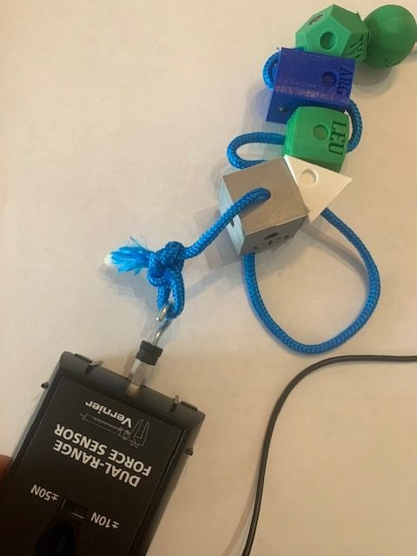

- Press “play” on the LabQuest and then, using the force probe, begin to pull on the protein model until it is apart. Each time a bond breaks between the amino acids, the force probe will collect the change in newtons.

- Record the number of newtons you can apply before the protein loses all structural integrity. This process should be completed in 10-15 seconds. Your LabQuest will automatically stop collecting data after 15 seconds.

Your LabQuest will display data like that of Image 10. Each peak represents the number of newtons needed to break a specific bond.

Image 10.
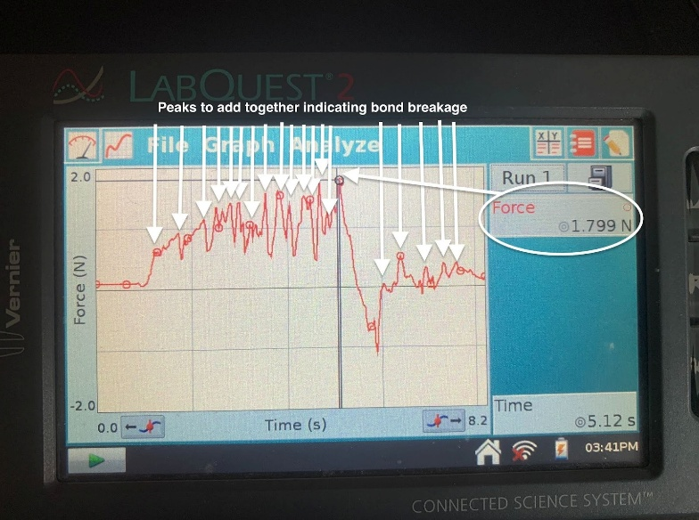

- Using the stylist, select at least 15 of the highest peaks and record the number of newtons.

Peak 1 + Peak 2 + Peak 3 + Peak 4 + Peak 5 + Peak 6 + Peak 7 + Peak 8 + Peak 9 + Peak 10 + Peak 11 + Peak 12 + Peak 13 + Peak 14 + Peak 15
=_________Total Newtons
Add up each of the peaks and enter that number in the data table below.

- Repeat the process three times and record the data in the table below

Original silk amyloid cohesive strength:
Trial | Force in Newtons
1

2

3

Average

Analysis Questions
- Compare your average cohesion to that of two other lab groups. Provide two explanations as to why the numbers are different.

- What statistical test could you do to determine whether the average cohesive properties were significantly different between two different protein models?

- How does the molecular structure of the protein contribute to its cohesive properties?

- What role do intermolecular forces play in the cohesive behavior of proteins?

- How are the forces of attraction between the magnets used in your model like and different from those of hydrogen bonds?

- Provide three limitations of the silk-amyloid model you constructed.

- Compare the protein that you constructed to the originally designed silk-amyloid protein. Explain how the two molecules differ. Include in your explanation how the bacteria used to produce the new proteins would be different from each other.

Phase 4 – Synthetic Biology Meeting the Challenge
The silk amyloid does exhibit some properties of cohesion. However, vascular surgeons would like to use a fast-drying, fluid-resistant glue to aid in the repair of blood vessels. The stronger the glue, the more likely the blood vessel repair will be successful.

Your task as a synthetic biologist is to develop a new protein using the amino acids provided that is more cohesive than the current amyloid.

Your kit contains a green paracord and excess amino acids for you to accomplish this task.
    - Discuss with your research team which amino acids to use, and the sequence that they should be placed on the cord. Make sure your new synthesized protein follows the rules below.

Protein-Building Rules
Just like in the real world, you must work under certain constraints.
- You only have two chances to design a more cohesive protein.
- You cannot increase the number of amino acids in the protein to more than 22. (Long strands of genetic code are more difficult to be successfully inserted and be translated into proteins by bacteria).
- The combination of some amino acids together causes proteins to form helices. In this scenario, assume placing a glutamine and a valine near each other will result in a spiral instead of a sheet.
- Repetitive sequences of some amino acids mimic the genetic code of a virus. Cells have evolved a defense mechanism (RNAi) to stop the translation of viral mRNA. In this model, having multiple glycine amino acids in a row would result in no translation. Avoid placing three glycines or serines in a row.

Last, just because your protein is more cohesive does not necessarily mean that it will be stable. Protein conformation has four layers of folding. Our model is really only investing in the first two levels of protein conformation. In reality, there is a chance the protein you design could be unstable and break apart at room temperature.

- Make your new protein model.

- Once you have constructed your new protein model, test the cohesiveness by repeating the steps used in Phase 3. Place your results in the table below.

Novel Protein cohesive strength
Trial | Force in Newtons
1

2

3

Average

- Once you are happy with your newly designed novel protein, provide the new order of amino acids and the associated strand of mRNA. Also include the correct order of nucleotides in DNA so that they can then be inserted into a bacteria and start producing your new glue.

Amino Acid
Sequence
mRNA
Strand
DNA
Strand

Amino Acid
Sequence
mRNA
Strand
DNA
Strand

Amino Acid
Sequence
mRNA
Strand
DNA
Strand

Analysis Questions

- Was your newly designed synthetic protein more cohesive than the original silk amyloid?

- Explain why your novel protein had different cohesive properties.

- Besides surgical glue, list three other uses for a new cohesive.

- What are some factors that may limit the use of your new protein glue?

- Using your notes, text or internet resources, describe the process of transcription. Be sure to include the main enzymes required for the process to occur.

- Using your notes, text or internet resources, list and describe the process of translation. Be sure to include the main enzymes required for the process to occur.

- Using your notes, text or internet resources, describe how RNAi may impede the process of protein production.

- How can the field of synthetic biology help us understand the process of evolution?

Citations
- Anthony, W.E., Carr, R.R., DeLorenzo, D.M. et al. Development of Rhodococcus opacus as a chassis for lignin valorization and bioproduction of high-value compounds. Biotechnol Biofuels 12, 192 (2019). https://doi.org/10.1186/s13068-019-1535-3

- Eugene Kim, Juya Jeon, Yaguang Zhu, Ethan D. Hoppe, Young-Shin Jun, Guy M. Genin, and Fuzhong Zhang (2021). A Biosynthetic Hybrid Spidroin-Amyloid-Mussel Foot Protein for Underwater Adhesion on Diverse Surfaces. ACS Applied Materials & Interfaces 2021 13 (41), 48457-48468 DOI: 10.1021/acsami.1c14182

- Le Feuvre, Rosalind A. and Nigel S. Scrutton. (2018). A living foundry for Synthetic Biological Materials: A synthetic biology roadmap to new advanced materials. Synthetic and Systems Biotechnology 3:105 - 112.

- Li, Jingyao, Yaguang Zhu, Han Yu, Bin Dai, Young-Shin Jun, and Fuzhong Zhang* (2021). Microbially Synthesized Polymeric Amyloid Fiber Promotes β‐Nanocrystal Formation and Displays Gigapascal Tensile Strength, ACS Nano 15, 11843−11853.

- Qian, Zhi-Gang, Fang Pan, and Xiao-Xia Xia. (2020) Synthetic biology for protein-based materials, Biotechnology, 65:197–204.

Appendix: Codon Wheel
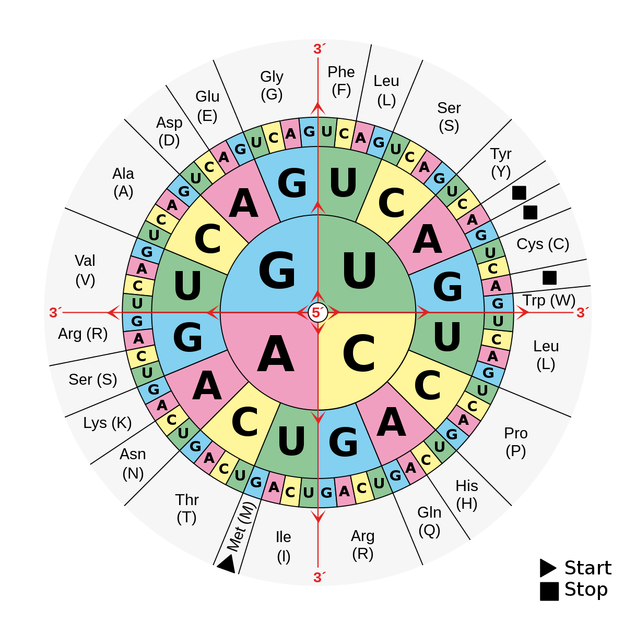
By Mouagip - Codons aminoacids table.png, Public Domain, https://commons.wikimedia.org/w/index.php?curid=5986132

Amino Acid Abbreviations, Names, and Symbols
Ala – Alanine (A) | Glu – Glutamate (E) | Leu – Leucine (L) | Ser – Serine (S)
Arg – Arginine (R) | Gln – Glutamine (Q) | Lys - Lysine (K) | Thr - Threonine (T)
Asn – Asparagine (N) | Gly – Glycine (G) | Met – Methionine (M) | Trp – Tryptophan (W)
Asp – Aspartate (D) | His – Histidine (H) | Phe – Phenylalanine (F) | Tyr – Tyrosine (Y)
Cys – Cysteine (C) | Ile – Isoleucine (I) | Pro – Proline (P) | Val - Valine (V)

