New Genes, New Proteins Worksheet
Teacher Guide / Answer Key

Teacher Resources
In this hands-on interactive investigation, students model the work of a synthetic biologist by designing a strand of DNA, transcribing the DNA into mRNA, and then constructing the resulting amino acid chain. Students then measure the cohesiveness of the resulting polypeptide. The modeled proteins are based on biosynthesized proteins resulting from silk-amyloid-mussel proteins.

 | NGSS Standards
MS-LS3-1 | Develop and use a model to describe why structural changes to genes (mutations) located on chromosomes may affect proteins and may result in harmful, beneficial, or neutral effects to the structure and function of the organism.
HS-LS1-1 | Construct an explanation based on evidence for how the structure of DNA determines the structure of proteins, which carry out the essential functions of life through systems of specialized cells.
HS-ETS1-3 | Evaluate a solution to a complex real-world problem based on prioritized criteria and trade-offs that account for a range of constraints, including cost, safety, reliability, and aesthetics as well as possible social, cultural, and environmental impacts.

 | College Board AP Standards
Big Idea #3 | Information Storage and Transmission (IST): Living systems store, retrieve, transmit, and respond to information essential to life processes
Science Practice 2 | The student can analyze visual representations of biological concepts and processes.
Science Practice 3 | The student can determine scientific questions and methods.
Science Practice 4 | The student can represent and describe data.
Science Practice 5 | The student can perform statistical tests and mathematical calculations to analyze and interpret data (if you choose to run a t-test on comparing cohesive properties of the proteins).

Relevant Background information:
Synthetic Biology and Genetic Engineering
Synthetic biology has its roots in genetic engineering but involves designing and constructing new biological parts, devices, and systems that do not exist in the natural world. A synthetic biologist might use a naturally occurring DNA strand as a base but then alter it by generating a novel genetic code to maximize particular aspects of the new bacterial cell or properties of proteins that the new cellular machine will produce. Genetic engineering modifies specific genes or genetic elements within organisms. A genetic engineer may alter specific traits or functions of organisms for practical applications. Synthetic biology takes a broader, systems-level approach to design and construct entire biological systems or devices. It aims to engineer entirely new biological systems or redesign existing ones to perform desired functions. Genetic engineering and synthetic biology require a firm grasp of the central dogma of molecular biology.

Hydrogels
Hydrogels are complex polymers that are useful biomaterials. They are soft, flexible, and can mimic natural tissue, which makes them useful in a wide range of applications. The silk-amyloid-mussel foot protein is a specific hydrogel developed by synthetic biologists. It contains proteins found in spider silk and proteins mussels use to adhere to surfaces. This specific hydrogel has the potential to be used as a surgical glue. Adhesion refers to its ability to stick to other things. Cohesion is the protein’s ability to stick to itself; cohesion matters in glue because it determines how well the glue holds itself together. High cohesion helps glue resist stretching, pulling, or bending over time.

The Central Dogma of Molecular Biology
The central dogma of molecular biology is a fundamental concept that explains how genes “direct” the production of proteins. The central dogma (DNA → RNA → Protein) explains how genes are transcribed into messenger RNA and then translated into proteins, which perform nearly all of the functions in a cell. First, transcription occurs. Transcription is when a segment of DNA is copied into messenger RNA (mRNA). This mRNA strand carries the genetic instructions from the nucleus to the ribosome, where translation occurs. In translation, the ribosome reads the sequence of the mRNA and assembles a chain of amino acids in the correct order to form a protein.

Transcription
Transcription is the process by which a segment of DNA is copied into mRNA, allowing genetic information to be carried from the nucleus to the cytoplasm for protein synthesis. The process begins when the enzyme RNA polymerase binds to a specific region of DNA called the promoter, located upstream of the gene to be transcribed. In eukaryotic cells, transcription factors are also required to help RNA polymerase recognize and bind to the promoter. Once bound, RNA polymerase unwinds the DNA and begins synthesizing a single-stranded RNA molecule by adding RNA nucleotides that are complementary to the DNA template strand (e.g., A pairs with U instead of T). As the enzyme moves along the DNA, the RNA strand elongates until RNA polymerase reaches a termination sequence, signaling the end of transcription. In eukaryotes, the newly formed pre-mRNA undergoes several modifications: a 5' cap is added, a poly-A tail is attached to the 3' end, and introns (non-coding regions) are removed through RNA splicing by a complex called the spliceosome. The final product is mature mRNA, which exits the nucleus and enters the cytoplasm, where it will be translated into a protein.

Translation
Translation is the process by which the sequence of nucleotides in mRNA is used to build a specific sequence of amino acids, forming a protein. It occurs in the cytoplasm at the ribosome, which is composed of ribosomal RNA (rRNA) and proteins. The process begins when the small ribosomal subunit binds to the mRNA and scans for the start codon (AUG), which codes for the amino acid methionine. Once the start codon is found, the large ribosomal subunit joins to form a complete ribosome. Transfer RNA (tRNA) molecules, each carrying a specific amino acid, recognize codons on the mRNA through their complementary anticodons. As the ribosome moves along the mRNA, tRNAs bring amino acids in the correct order, and the ribosome links them together. Enzymes play a crucial role in forming the peptide bonds between the amino acids. New tRNAs bring in and attach their amino acids to produce a polypeptide chain. Translation continues until a stop codon (UAA, UAG, or UGA) is reached. When the stop codon is reached, the completed protein is released from the ribosome.

Codon and Anticodon
A codon is a sequence of three nucleotides on mRNA that corresponds to a specific amino acid or a stop signal during protein synthesis. For example, the codon AUG codes for the amino acid methionine and also serves as the start codon.

An anticodon is a sequence of three nucleotides on a tRNA molecule that is complementary to an mRNA codon. The anticodon allows the tRNA to recognize and bind to the correct codon on the mRNA, ensuring that the appropriate amino acid is delivered to the ribosome. For example, the anticodon UAC pairs with the codon AUG on the mRNA.

Transcribing DNA into RNA
To transcribe a strand of DNA into RNA, you follow a process where the DNA sequence is used as a template to build a complementary RNA strand.

Steps to Transcribe DNA to RNA
- Identify the template strand of DNA. Transcription reads the 3' to 5' DNA strand, and RNA is built in the 5' to 3' direction. The RNA strand will be complementary to this template.
- Match the RNA nucleotides to the DNA template, using base-pairing rules:
  - DNA A (adenine) pairs with RNA U (uracil)
  - DNA T (thymine) pairs with RNA A
  - DNA C (cytosine) pairs with RNA G
  - DNA G (guanine) pairs with RNA C
- Write the RNA sequence by replacing each DNA base with its RNA complement, moving from the 3' end to the 5' end of the DNA template.

Example:
If the DNA template strand is: 3'-TAC GGA TCT GAA-5'. Then the mRNA strand would be: 5'-AUG CCU AGA CUU-3'. This RNA strand can now be used during translation to make a protein.

Using the Codon Wheel as it relates to Translation and the Central Dogma
A codon wheel (also called a codon chart or genetic code wheel) is a chart that allows you to determine which amino acid is associated with each codon in a strand of mRNA.

Steps in using a Codon Wheel:
- Start at the center of the wheel with the first base of the mRNA codon (5' → 3' direction). For example, if your codon is AUG, begin at A in the center.
- Move to the second ring, using the second base of the codon. From A, move outward to U (for AUG).
- Then, move to the third ring, selecting the third base. From AU, go to G.
- The outermost ring shows the amino acid that corresponds to the full codon. In this case, AUG codes for methionine (Met), which also serves as the start codon for translation.

For example, if the strand of mRNA is: 5'-AUG CCU AGA CUU-3'.
AUG → Methionine (Met) – also the start codon
CCU → Proline (Pro)
AGA → Arginine (Arg)
CUU → Leucine (Leu)

The polypeptide chain would then be Met–Pro–Arg–Leu.

New Genes, New Proteins Worksheet

Materials Needed
- 1 codon wheel
- 1 laptop or computer
- 1 Vernier Labquest or compatible interface
- 1 Vernier force probe
- 1 amino acid model set
- Green paracord (unmarked) ≈ 15 ft with a diameter of 5/32 in.
- Blue paracord (marked) ≈ 15 ft with a diameter of 5/32 in.

Teaching Tip: Comparable force probes can be substituted for the Vernier force probe. If a force probe is unavailable, a spring scale can be used. Alternatively, cups with fishing weights can be used. If this technique is used, the model must be hung and the cups attached to the bottom.

Introduction
Scientists across the globe are working to improve a variety of products and systems to solve environmental challenges and to improve the human condition. Synthetic biology is a multidisciplinary field of science that focuses on living systems and organisms. It applies engineering principles to develop new biological components, devices, and systems. Synthetic biologists are able to use the genetic code to redesign existing systems found in nature and use them to address challenges facing society. At its core, synthetic biologists are generating unique strands of DNA that code for novel proteins. The hope is that these new polypeptides will be used to solve a variety of problems. Examples include Dr. Marcus Foston and his colleagues’ (Anthony et. al 2019) work to use synthetic biology to improve the conversion of plant materials to biofuels, or Dr. Fuzhong Zhang and his research team’s work in producing new surgical glues using proteins coded for by a mix of spider (silk) DNA and mussel (glue) DNA. In fact, synthetic biology has the potential to produce a variety of bioelectronics, self-healing fabrics, and new optical materials (LeFeuvre and Scrutton 2018).
Overview
Today, you will model the work of a synthetic biologist as you work to improve a surgical glue. Scientists have synthesized a new adhesive using the DNA that codes for spider silk and the glue mussels use to stick to rocks. It is called a silk-amyloid-mussel foot protein, and it is composed of 16 repeating β-sheet-forming blocks with alternating amyloid and silk peptides. The order of amino acids in the protein is lysine, leucine, valine, phenylalanine, phenylalanine, alanine, glutamic acid, glutamine, glycine, threonine, serine, glycine, arginine, glycine, glycine, leucine, glycine, glycine, glutamine, glycine, alanine, glycine.

The glue is relatively strong, but your task today is to reverse-engineer a new glue using the same amino acids that are currently found in the protein. Remember, when you change the order of amino acids, you also change the shape and function of the protein. You will need to know not only the order of amino acids for your new synthetic protein, but also the genetic code that can be inserted into a virus or bacterium so that more of your glue can be produced. Once your new polypeptide chain is created, you will construct a model of the polypeptide and measure how cohesive it is using a force probe.

Phase 1 – Reverse Engineering
As you know, DNA codes for mRNA and mRNA codes for a protein. In this particular case, you know the amino acid sequence. The next step is to determine which RNA nucleotides are involved. In order to accomplish this, use the codon wheel (Appendix) to determine the possible codons for each of the amino acids.

Steps in using a codon wheel:
- Start at the center of the wheel with the first base of the mRNA codon (5' → 3' direction). For example, if your codon is AUG, begin at A in the center.
- Move to the second ring, using the second base of the codon. From A, move outward to U (for AUG).
- Then, move to the third ring, selecting the third base. From AU, go to G.
- The outermost ring shows the amino acid that corresponds to the full codon. In this case, AUG codes for methionine (Met), which also serves as the start codon for translation.

For example, if the strand of mRNA is: 5'-AUG CCU AGA CUU-3'.
AUG → Methionine (Met) – also the start codon
CCU → Proline (Pro)
AGA → Arginine (Arg)
CUU → Leucine (Leu)
The polypeptide chain would then be Met–Pro–Arg–Leu.

- Complete the table below with the codon that corresponds with the amino acid.
(Below is a list of all possible mRNA codons. Students should have only 1 codon for each amino acid.)
Amino Acid  Sequence | Methi. |  |  | Lysine |  |  | Leucine |  |  | Valine |  |  | Phenyl. |  |  | Phenyl. |  |  | Alanine |  |  | Glutamic  Acid
mRNA  Strand | A | U | G | A  A | A  A | A  G | C  C  C  C  U  U | U  U  U  U  U  U | UCA  G  A  G | G  G  G  G | U  U  U  U | G  A  C  U | U  U | UU | U  C | U  U | UU | U  C | G  G  G  G | C  C  C  C | U  C  A  G | G  G | A  A | A  G

Amino Acid  Sequence | Glutamine |  |  | Glycine |  |  | Threonine |  |  | Serine |  |  | Glycine |  |  | Arginine |  |  | Glycine |  |  | Glycine
mRNA  Strand | C  C | A  A | A  G | G  G  G  G | G  G  G  G | U  C  A  G | A  A  A  A | C  C  C  C | G  A  C  U | U  U  U  U  A  A | C  C  C  C  G  G | U  C  A  G  C  U | G  G  G  G | G  G  G  G | U  C  A  G | A  A  C  C  C  C | G  G  G  G  G  G | G  A  G  A  C  U | G  G  G  G | G  G  G  G | U  C  A  G | G  G  G  G | G  G  G  G | U  C  A  G

Amino Acid  Sequence | Leucine |  |  | Glycine |  |  | Glycine |  |  | Glutamine |  |  | Glycine |  |  | Alanine |  |  | Glycine
mRNA  Strand | C  C  C  C  U  U | U  U  U  U  U  U | UCA  G  A  G | G  G  G  G | G  G  G  G | U  C  A  G | G  G  G  G | G  G  G  G | U  C  A  G | C  C | A  A | A  G | G  G  G  G | G  G  G  G | U  C  A  G | G  G  G  G | C  C  C  C | U  C  A  G | G  G  G  G | G  G  G  G | U  C  A  G

- Write the strand of mRNA that codes for the protein in the space below

mRNA strand

A U G,__ __ __,__ __ __, __ __ __, __ __ __, __ __ __, __ __ __, __ __ __, __ __ __, __ __ __,
__ __ __,__ __ __,__ __ __,__ __ __,__ __ __,__ __ __ __ __ __, __ __ __, __ __ __, __ __ __,
__ __ __, __ __ __, __ __ __,

- Visit with at least two neighboring lab groups. Do your groups have identical strands of
mRNA? Explain how the strands may be different.
Due to the wobble of the genetic code, students may have different codons for the same amino acids.

- Explain how two different strands of mRNA could code for the same polypeptide chain.
Due to the wobble of the genetic code, students may have different codons for the same amino acids. As a result, it is possible to have different strands of mRNA that will code for the same polypeptide chain.

- What is the process of making a polypeptide chain using mRNA, a ribosome, and tRNA called?
Translation

- Now, using your known sequence of the mRNA from above, convert it to the template strand of DNA using the base pair rules.
Answers will vary, depending on the codons students selected.

Amino Acid  Sequence | Methi. |  |  | Lysine |  |  | Leucine |  |  | Valine |  |  | Phenyl. |  |  | Phenyl. |  |  | Alanine |  |  | Glutamic  Acid
mRNA
Strand
DNA
Strand
Amino Acid  Sequence | Glutamine |  |  | Glycine |  |  | Threonine |  |  | Serine |  |  | Glycine |  |  | Arginine |  |  | Glycine |  |  | Glycine
mRNA
Strand
DNA
Strand

Amino Acid  Sequence | Leucine |  |  | Glycine |  |  | Glycine |  |  | Glutamine |  |  | Glycine |  |  | Alanine |  |  | Glycine
mRNA
Strand
DNA
Strand

You may also use the DNA nucleotides provided in the lab and create an actual chain of DNA.

- The process of making a strand of mRNA from a template of DNA is called?
Transcription

- What are two ways that you can determine whether a nucleotide is from a molecule of DNA or RNA?
DNA is composed of a deoxyribose sugar, while RNA contains a ribose sugar group.
DNA is composed of nucleotides with the nitrogen bases adenine, thymine, cytosine, and guanine. RNA is composed of nucleotides with the nitrogen bases adenine, uracil, cytosine, and guanine. RNA does not contain thymine.

Phase 2 – Protein Construction
Now that we know the amino acid sequence and the DNA sequence, use the supplied amino acid model set to construct the amino acid chain for the silk-amyloid-mussel foot protein. The primary level of protein conformation is the order of amino acids. Place the amino acid on the paracord and then fold the model so that hydrogen bonds can form between the amino acids (the magnets are representing the H bonds). The marks on the blue cord indicate the approximate locations of where to place the amino acid.

The order of amino acids in the protein is methionine (start), lysine, leucine, valine, phenylalanine, phenylalanine, alanine, glutamic acid, glutamine, glycine, threonine, serine, glycine, arginine, glycine, glycine, leucine, glycine, glycine, glutamine, glycine, alanine, glycine.

As you bend the cord to connect the amino acids together, note that you are completing the process of translation. You are effectively playing the role of the ribosome and rRNA as you place the amino acids in the correct order. When your lab partner is handing you an amino acid, they are effectively acting as tRNA. Notice how the primary structure of the polypeptide is determined by the sequence of amino acids.
Amino Acid and Shape legend
Amino Acid | Corresponding model Shape codons
methionine | green sphere
lysine | gray rounded cube 1
leucine | green rounded cube 2
valine | green multifaceted polygon
phenylalanine | white hexagon
alanine | blue “cylinder”
glutamic acid | gray triangle 1
glutamine | white triangle 2
glycine | gray cube 1
threonine (small magnet) | blue cube 2
serine | white indented (lined) cube
arginine (small and large magnet holes on each side) | blue rectangular prism

The order of amino acids in the protein is methionine (start), lysine, leucine, valine, phenylalanine, phenylalanine, alanine, glutamic acid, glutamine, glycine, threonine, serine, glycine, arginine, glycine, glycine, leucine, glycine, glycine, glutamine, glycine, alanine, glycine.

Once your protein is assembled, let me see it so I can stamp or initial your lab.

Great job modeling translation_______________________

Your model should resemble something like Images 1 and 2.

Image 1.
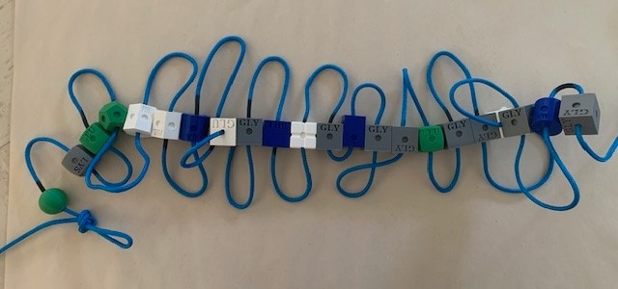

Image 2.
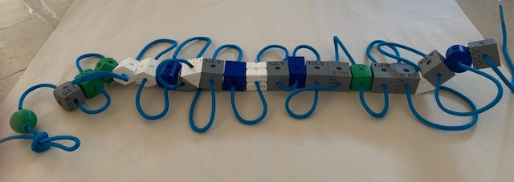
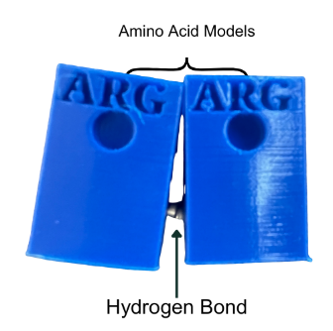

Phase 3 – Strength of Cohesion
Great news!!! You have successfully constructed a protein that forms sheets. This particular protein has adhesive and cohesive properties.

Adhesion is the protein’s ability to stick to other surfaces. Cohesion is the protein’s ability to stick to itself. Cohesion matters in glue because it determines how well the glue holds itself together. High cohesion helps glue resist stretching, pulling, or bending over time.

We will determine the protein’s ability to maintain its structure and overall strength by measuring the cohesive properties of the amino acids. Your next step is to determine the strength of the bonds that give the protein its cohesive properties. The cohesiveness of the protein is due to the number of hydrogen bonds. We are using magnets to symbolize the bonding.

Setting up the Vernier force probe:
- Insert the force probe plug into the LabQuest.
- Turn the LabQuest on.
- Once the LabQuest is on, you may need to change the mode of data collection to “time.”
Set the length of time to 15 seconds. (This will ensure that once you hit “play,” your LabQuest will collect changes in the number of newtons applied to the probe for 15 seconds. This is plenty of time to gradually pull on the protein model.) (See Images 3-7 on how to alter the durations of data collection,)

Image 3. Image 4.
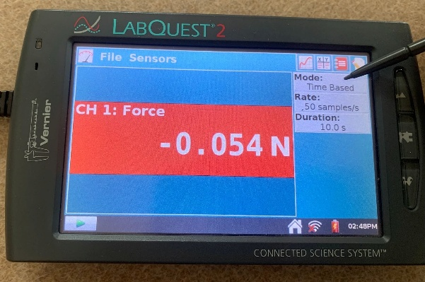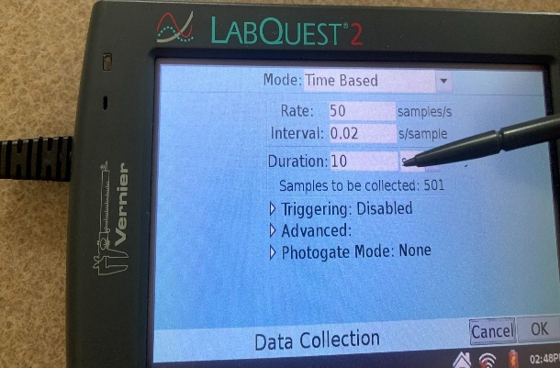
Image 5. Image 6.
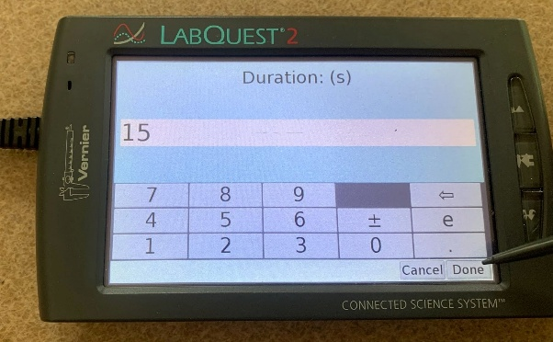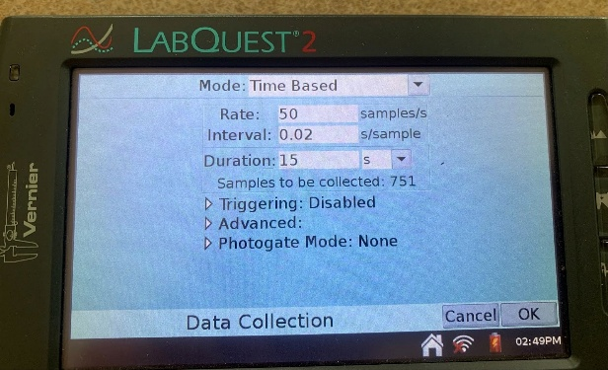

Image 7.
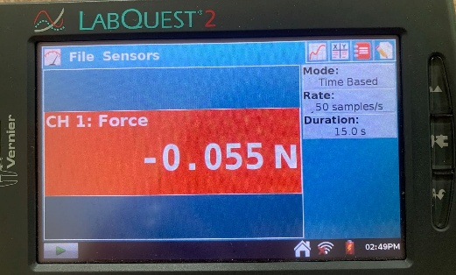

- Your LabQuest is ready to start collecting data. Now, to test the cohesiveness of the protein, form a loop at one end of the cord as depicted in Images 8 and 9. Then, hook the Vernier force probe to one of the loops you formed on the protein model. A lab partner will hold the other looped end of the protein sheet.

Image 8. Image 9.
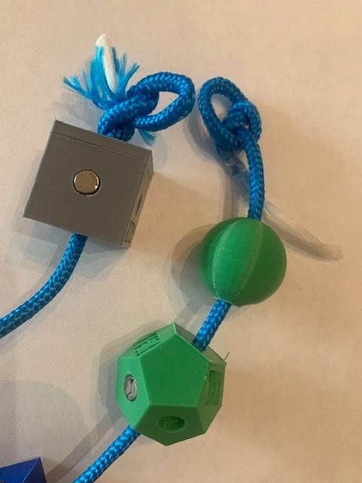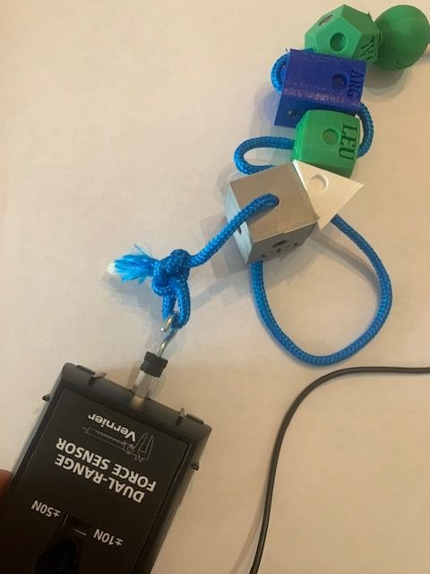

- Press “play” on the LabQuest and then, using the force probe, begin to pull on the protein model until it is apart. Each time a bond breaks between the amino acids, the force probe will collect the change in newtons.

- Record the number of newtons you are able to apply before the protein loses all structural integrity. This process should be completed in 10-15 seconds. Your LabQuest will automatically stop collecting data in 15 seconds.

Your LabQuest will display data similar to that of Image 10. Each peak represents the number of newtons needed to break a specific bond.

Image 10.
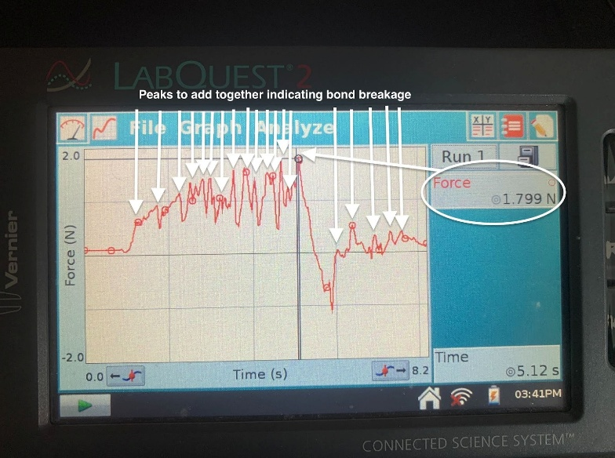

- Using the stylist, select at least 15 of the highest peaks and record the number of newtons.

Peak 1 + Peak 2 + Peak 3 + Peak 4 + Peak 5 + Peak 6 + Peak 7 + Peak 8 + Peak 9 + Peak 10 + Peak 11 + Peak 12 + Peak 13 + Peak 14 + Peak 15
=_________Total Newtons
Add up each of the peaks and enter that number in the data table below.

- Repeat the process three times and record the data in the table below

Original silk amyloid cohesive strength
Trial | Force in Newtons
1 | Answers will vary
2 | Answers will vary
3 | Answers will vary
Average | Answers will vary

Analysis Questions
- Compare your average cohesion to two other lab groups. Provide two explanations as to why the numbers are different. Answers will vary.

- What statistical test could you do to determine whether the average cohesive properties were significantly different between two different protein models? A t-test could be used to determine whether the mean level of cohesion from one group is significantly different than another group, but more samples must be taken in order to accurately investigate the difference between the two models.

- How does the molecular structure of the protein contribute to its cohesive properties? The cohesive properties of a protein are determined by its molecular structure, specifically the arrangement of amino acids and any functional groups present. For example, proteins with extended and flexible structures tend to exhibit higher adhesive properties due to increased surface contact with other molecules.

- What role do intermolecular forces play in the cohesive behavior of proteins? Intermolecular forces such as van der Waals forces, hydrogen bonding, and electrostatic interactions play a significant role in the cohesive and adhesive behavior of proteins. These forces facilitate the attraction between the protein molecules and the surface to which are adhering, influencing the strength and durability of the cohesion.

- How are the forces of attraction between the magnets used in your model similar to and different from those of hydrogen bonds? Both magnets and hydrogen bonds involve attractive forces; they differ in their strength and dependency on specific molecular structures. Magnetic attraction is due to the spin of electrons. Hydrogen bonding arises from electrostatic interactions between partial charges on different molecules. Hydrogen bonding is usually much weaker than a magnetic force.

- Provide three limitations of the silk-amyloid model you constructed.

Answers will vary but may include:
- The magnets may not accurately represent the bonding patterns of the proteins in the silk-amyloid protein.
- The 3D shape of the model may not accurately demonstrate the beta sheets or helices that are possible in real proteins.
- Factors such as temperature, humidity, and pH alter proteins, and this model does not take that into account.
- Proteins have 4 levels of folding; this model only demonstrates two levels of protein conformation.

- Compare the protein that you constructed to the originally designed silk-amyloid protein. Explain how the two molecules differ. Include in your explanation how the bacteria used to produce the new proteins would be different from each other.
Answers will vary but may include: The 3D shape of the protein is different. This is due to the new sequence of amino acids. As a result of the new sequence in amino acids, the resulting DNA and mRNA that would code for the new protein would also be different.

Phase 4 – Synthetic Biology Meeting the Challenge
The silk amyloid does exhibit some properties of cohesion. However, vascular surgeons would like to use a fast-drying, fluid-resistant glue to aid in the repair of blood vessels. The stronger the glue, the more likely the blood vessel repair will be successful.

Your task as a synthetic biologist is to develop a new protein using the amino acids provided that is more cohesive than the current amyloid.

Your kit contains a green paracord and excess amino acids for you to accomplish this task.
    - Discuss with your research team which amino acids to use, and the sequence that they should be placed on the cord. Make sure that your new synthesized protein follows the rules below.

Protein-Building Rules
Just like in the real world, you must work under certain constraints.
- You only have two chances to design a more cohesive protein.
- You cannot increase the number of amino acids in the protein to more than 22. (Long strands of genetic code are more difficult to be successfully inserted and be translated into proteins by bacteria).
- The combination of some amino acids together cause proteins to form helices. In this scenario, assume placing a glutamine and a valine near each other will result in a spiral instead of a sheet.
- Repetitive sequences of some amino acids mimic the genetic code of a virus. Cells have evolved a defense mechanism (RNAi) to stop the translation of viral mRNA. In this model, having multiple glycine amino acids in a row would result in no translation. Avoid placing three glycines or serines in a row.

Last, just because your protein is more cohesive doesn’t necessarily mean that it will be stable. Protein conformation has four layers of folding. Our model is really only investing the first two levels of protein conformation. In reality, there is a chance the protein you design could be unstable and break apart at room temperature.

- Make your new protein model.

- Once you have constructed your new protein model, test the cohesiveness by repeating the steps used in Phase 3. Place your results in the table below.

Novel Protein cohesive strength
Trial | Force in Newtons
1 | Answers will vary
2 | Answers will vary
3 | Answers will vary
Average | Answers will vary

- Once you are happy with your newly designed novel protein, provide the new order of amino acids and the associated strand of mRNA. Also include the correct order of nucleotides in DNA so that they can then be inserted into a bacteria and start producing your new glue.

(Answers will vary)
Amino Acid
Sequence
mRNA
Strand
DNA
Strand

Amino Acid
Sequence
mRNA
Strand
DNA
Strand

Amino Acid
Sequence
mRNA
Strand
DNA
Strand

Analysis Questions

- Was your newly designed synthetic protein more cohesive than the original silk amyloid?
Yes or no. Students may describe whether it was similar/different.

- Explain why your novel protein had different cohesive properties.
Answers will vary, but may include the number of H bonds / magnets were different. The order of amino acids and their shapes were different, which resulted in a change in how much force was needed to break a bond.

- Besides surgical glue, list three other uses for a new cohesive.
Answers will vary, but may include craft glues, boat repair, aquarium production, first aid kits, hardware repair glue.

- What are some factors that may limit the use of your new protein glue?
Answers will vary, but may include inability to adhere when wet, may not be able to be inserted into a bacteria, causes allergic reactions in patients.

- Using your notes, text or internet resources, describe the process of transcription. Be sure to include the main enzymes required for the process to occur.
In prokaryotes, transcription has three main steps: initiation, elongation, and termination. In eukaryotes, the mRNA is processed.

During initiation, RNA polymerase binds to the promoter region on the template strand of DNA.

During elongation RNA polymerase synthesizes RNA by adding complementary ribonucleotides (A,U,C,G) to the growing RNA chain.

The termination phase is different for prokaryotes and eukaryotes. In prokaryotes, a protein may bind to the forming RNA and cause polymerase to detach. In eukaryotes, a poly A tail is added.
Processing of mRNA in eukaryotes involves the removal of introns and the splicing together of exons. Spliceosome enzymes allow the connecting of the multiple exons.

- Using your notes, text or internet resources, list and describe the process of translation. Be sure to include the main enzymes required for the process to occur.
Translation also has three steps: initiation, elongation, and termination.

During initiation, a small and large ribosomal subunit attach to the molecule of mRNA. The ribosome attaches at the AUG (start codon) and codes for methionine.

During elongation, tRNA molecules bring amino acids to the mRNA-ribosomal complex. Each tRNA carries a specific amino acid. The anticodon of the tRNA pairs with the codon of the mRNA, ensuring the correct sequence of amino acids is achieved. The ribosome catalyzes the formation of the peptide bonds between the amino acids.

Termination occurs when the ribosome complex reaches the stop codon. The stop codon does not code for an amino acid, and when the ribosome reaches a stop codon, the large and small subunit break off of the mRNA and stop polypeptide formation.

- Using your notes, text or internet resources, describe how RNAi may impede the process of protein production.
RNAi is a mechanism by which small RNA molecules (single stranded or double stranded) inhibit gene expression by degrading or blocking the translation of specific mRNA molecules. RNAi can impact protein production by inhibiting the start of translation, destabilizing or even degrading mRNA.

- How can the field of synthetic biology help us understand the process of evolution?
Answer will vary but may include:
Synthetic biology provides opportunities for studying evolution at the molecular and organismal levels. Synthetic biology allows scientists to engineer and manipulate genetic material in a controlled environment. By observing how these synthetic constructs evolve over generations, researchers can gain insights into fundamental evolutionary processes such as mutation rates, natural selection, and genetic drift.

Synthetic biologists can simulate evolutionary scenarios that may not be observable in natural settings. This allows scientists to test hypotheses about evolutionary outcomes and mechanisms over short periods of time in a controlled environment.

Synthetically designed codes for a specific trait enable scientists to explore the effects of specific genetic variations on an organism's fitness and behavior. This can contribute to our understanding of how genetic diversity arises and persists in natural populations.

Overall, synthetic biology provides a powerful toolkit for studying evolution at both the molecular and organismal levels, offering new perspectives and applications in various scientific and industrial fields.

Citations
- Anthony, W.E., Carr, R.R., DeLorenzo, D.M. et al. Development of Rhodococcus opacus as a chassis for lignin valorization and bioproduction of high-value compounds. Biotechnol Biofuels 12, 192 (2019). https://doi.org/10.1186/s13068-019-1535-3

- Eugene Kim, Juya Jeon, Yaguang Zhu, Ethan D. Hoppe, Young-Shin Jun, Guy M. Genin, and Fuzhong Zhang (2021). A Biosynthetic Hybrid Spidroin-Amyloid-Mussel Foot Protein for Underwater Adhesion on Diverse Surfaces. ACS Applied Materials & Interfaces 2021 13 (41), 48457-48468 DOI: 10.1021/acsami.1c14182

- Le Feuvre, Rosalind A. and Nigel S. Scrutton. (2018). A living foundry for Synthetic Biological Materials: A synthetic biology roadmap to new advanced materials. Synthetic and Systems Biotechnology 3:105 - 112.

- Li, Jingyao, Yaguang Zhu, Han Yu, Bin Dai, Young-Shin Jun, and Fuzhong Zhang* (2021). Microbially Synthesized Polymeric Amyloid Fiber Promotes β‐Nanocrystal Formation and Displays Gigapascal Tensile Strength, ACS Nano 15, 11843−11853.

- Qian, Zhi-Gang, Fang Pan and Xiao-Xia Xia. (2020) Synthetic biology for protein-based materials, Biotechnology, 65:197–204.

Appendix: Codon Wheel
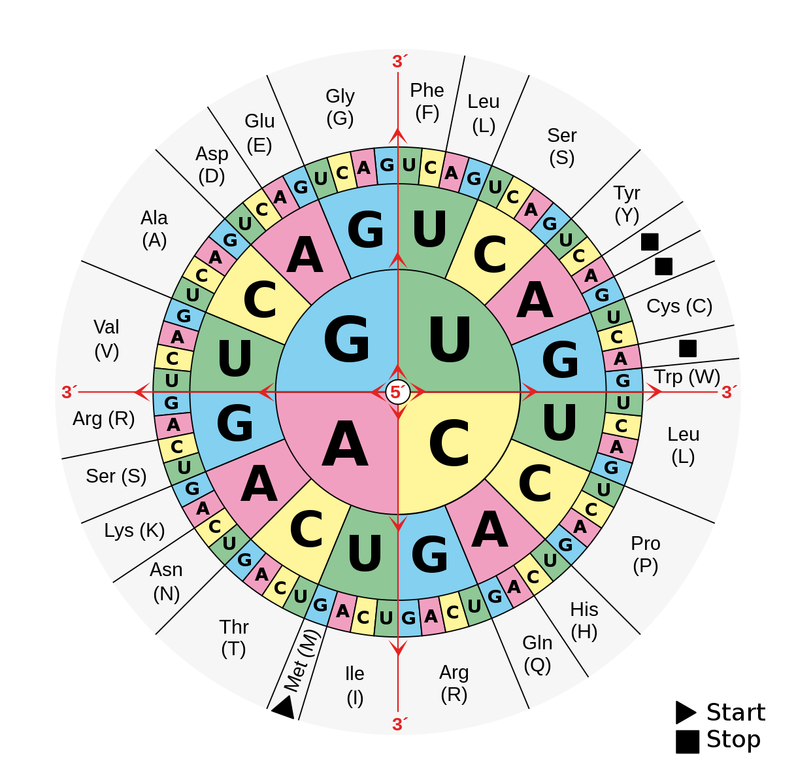
By Mouagip - Codons aminoacids table.png, Public Domain, https://commons.wikimedia.org/w/index.php?curid=5986132

Amino Acid Abbreviations, Names, and Symbols
Ala – Alanine (A) | Glu – Glutamate (E) | Leu – Leucine (L) | Ser – Serine (S)
Arg – Arginine (R) | Gln – Glutamine (Q) | Lys - Lysine (K) | Thr - Threonine (T)
Asn – Asparagine (N) | Gly – Glycine (G) | Met – Methionine (M) | Trp – Tryptophan (W)
Asp – Aspartate (D) | His – Histidine (H) | Phe – Phenylalanine (F) | Tyr – Tyrosine (Y)
Cys – Cysteine (C) | Ile – Isoleucine (I) | Pro – Proline (P) | Val - Valine (V)

