New Genes, New Proteins: Pre-Lab Worksheet
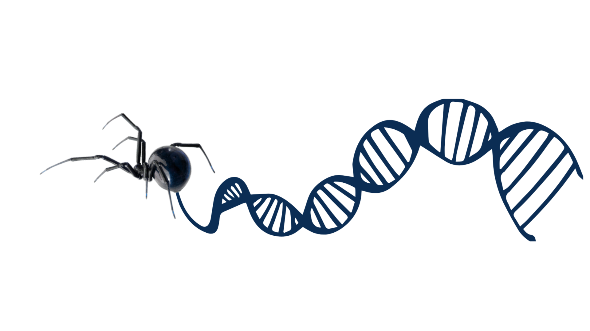
Instructions: After reading the procedures for our investigation, please complete the following pre-lab questions.

- In your own words, please state the main objective of Phase 1 of the investigation.

- In your own words, please state the objectives of Phases 2 and 3.

- Do you expect all of the lab groups’ proteins built in Phase 1 to look similar?

- What are the objectives of Phase 4?

- Do you expect all the lab groups will have proteins from Phase 4 with the same confirmation?

- After reading the procedures, what three aspects of the lab are you most concerned with?

