Case Study: The Impossible Burger Is Possible

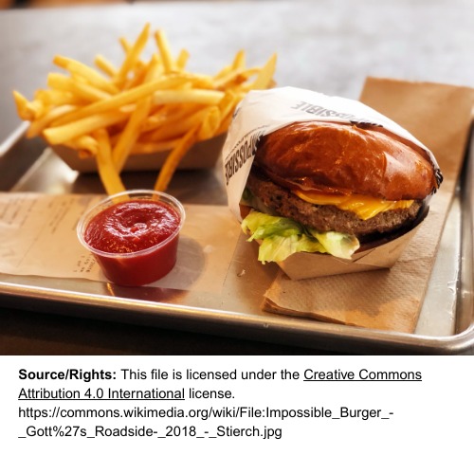
The story you are about to read is real. The names have not been changed to protect the innocent.

It is a glorious Midwestern day. There is a gentle breeze blowing, the sun is shining, and the humidity is actually low. It is a perfect day to hold the annual cross-country team barbecue. Some of the team is playing spikeball, while others are in a heated cornhole tournament. Haley is doing her best at karaoke, and the rest are demolishing the chips, veggies, and other snacks that Coach M had already set out.

The music stops, and Coach M yells out, “How many dogs, brats, and burgers?”

Of course, everyone is too involved in playing to hear and respond. That’s when Coach S, with his booming voice, echoes across the park. “No order, no eating! Who wants a brat, burger, or a dog?”

The orders immediately come crashing in. Coach S is LOUD! Everyone orders what they want, and Coach M starts cranking out the food. Everyone, that is, except Emma. Coach S casually walks over to Emma and asks, “Hey, aren’t you gonna order something?”

“Thanks, Coach, but I am a vegetarian. I will just have chips and some veggies. I am used to making do at barbecues,” replied Emma.

The coaches sound gruff, but they always have our backs. “Don’t worry, Emma, we’ve got you,” Coach M says. “Have you ever had an Impossible Burger?”

“Really funny, Coach. I am a vegetarian. Burgers are impossible,” Emma quips.

“No, really, check this out. It’s called an Impossible Burger. We got them just for you. I am definitely a carnivore, but Coach fixed me one the other day, and I thought I was having a regular burger.”

“What is it made of?” Emma asked.

“Uh, I don’t know. I’d say some plant stuff and some red goo to make it look real. I don’t really know, but I think Coach has the box over there, or we can look it up on your phone,” answered Coach M.

Emma whipped out her phone, did a quick Google search, and then yelled over to Coach M, “Hey, Coach, thanks for thinking of me. I’ll have two Impossible Burgers!”

“You got it, boss! Two IBs coming up,” fired back Coach M.

Emma grabbed her burgers and sat down next to her best bud, Haley. As usual, Haley was in her own little world and didn’t hear any of the chatter about Emma’s sandwich. She was just staring at Emma.

“What are you looking at? Haven’t you ever seen someone eat a burger before?” Emma joked.

Haley rattled off a string of questions: “Dude, you are a vegetarian. Are you crazy? When was the last time you ate meat? You haven’t eaten meat in years, and now you’re going to have your first piece of meat in years at the cross-country barbecue? Coach M is a good cook and all, but a hamburger? How about a steak or something fancy? No offense to Coach M, but if you get sick and can’t run tomorrow, that will really suck. Are you sure about this?”

Emma smiled, took a big bite, and, with a mouthful, mumbled, “Yep, I am, and this is good!”

“Care for a taste?” she asked Haley.

“I had a hot dog, but since you’re trying a burger, I’ll take a taste with you,” Haley replied, then took a chunk of Emma’s other burger.

“Wow, this is good! Don’t tell my dad, but Coach may make a better burger than he does.”

“Hey, save some of that for me. I said a taste!” Emma laughed.

“Oops, sorry. Now that you’re a carnivore, are we going out for chicken fajitas next week?” Haley asked.

“Carnivore? Heck no. I’m still an herbivore. You just tasted an Impossible Burger.”

“A what? That was a veggie burger?” Haley asked, confused.

“Nope, that was an Impossible Burger. According to Coach S, it’s made of plant stuff and red goo, but I checked it out, and though he’s off on the details, it is made from plants,” she explained.

“And since your dad is the goofy science teacher, I’m going to suggest we talk about the Impossible Burger in his sustainability class,” Emma said.

“Oh great. Now I have to hear him get all excited about science stuff at home, school, and cross-country,” Haley grumbled.
True to form, Emma told Haley’s dad all about the Impossible Burger.

Watch these short videos explaining how the Impossible Burger came to be.
- Heme - The Magic Ingredient in the Impossible™ Burger (2:24 minutes)
- The Science Behind the Impossible Burger (3:50 minutes)

Analysis Questions
Instructions: Use the information in the above article and in the videos to explain what makes the Impossible Burger possible.

- Provide three different types of scientists who helped to develop the Impossible Burger.

- What molecule gives the impossible burger its flavor?

- What is the original source of the flavor molecule scientists determined would be best for developing the Impossible Burger?

- What process is used to produce the quantity of the flavor molecule needed to produce the Impossible Burger?

- What are two of the plant-based protein sources of protein found in the Impossible Burger?

- What did the food scientists add to the Impossible Burger to get it to sizzle when it was cooked?

- How were scientists able to produce the flavor molecule using fermentation?

