How to Make Your Own Amino Acid Models
With a 3D Printer

Materials Needed
- 3D printer
- colored 3D printer filament red, orange, yellow, green, blue, pink, gray, black, white
  - or white filament and paint that is red, orange, yellow, green, blue, pink, gray, and black
- slicing software (e.g., Cura)
- super glue
- 6 mm x 2 mm neodymium magnets (link)
- 3 mm x 2 mm neodymium magnets (link)
- marker
- 15 ft of blue paracord (marked) with a diameter of 5/32 inches (link)
- 15 ft of green paracord (unmarked) with a diameter of 5/32 inches
- optional (4 mm aglets for the ends of the blue and green cords)
- color printer

Step-by-Step Instructions

1. Download the .stl Files
- You can download the STL files for the amino acid models from Tinkercad or Google Drive + Methionine (white).
- We recommend downloading the "Methionine" (the white sphere) separately because it needs to have supports and a raft/brim for plate adhesion. Alternatively, you can print the entire set with raft/brim plate adhesion and do a little more cleanup later.
- The table below provides coding for the amino acids needed for one group’s kit.

Download the .stl Files
Amino Acid Model | Filament Color | Tinkercad Link | Google Drive .stl
lysine and glycine | red | lysine and glycine (red) | https://drive.google.com/file/d/1WqeB4SlU4a_1v_JSEoTqZjeKXtvF2nfa/view?usp=drive_link
leucine | orange | leucine (orange) | https://drive.google.com/file/d/1tTB_XC2Bxf5qPRg7RgBY7kaA5MbD4gdu/view?usp=drive_link
valine | yellow | valine (yellow) | https://drive.google.com/file/d/1C2zEaWEoGrYAt1HkEnqlIOE6xM9joxxK/view?usp=drive_link
phenylalanine and serine | green | phenylalanine and serine (green) | https://drive.google.com/file/d/1pJKk1yoTEGG3b3y-lKlIEW34eGoYk_1b/view?usp=drive_link
alanine and arginine | blue | alanine and arginine (blue) | https://drive.google.com/file/d/1DBRK0GAM4UZwpNNKJlPiv24Xxyry0hHb/view?usp=drive_link
glutamic acid | pink | glutamic acid (pink) | https://drive.google.com/file/d/1C5Bd9saXl9C1TOI8EdXOHsjaWXtTjL1Q/view?usp=drive_link
glutamine | gray | glutamine (gray) | https://drive.google.com/file/d/1eSCeGtmHh5Z4X30-vaXz14WoOEcJ48Uj/view?usp=drive_link
threonine | black | threonine (black) | https://drive.google.com/file/d/1Zf-D2QkRBEEX-BIEf9UAdR8Cy7aGzksi/view?usp=drive_link
methionine | white (note: print with raft and supports) | methionine (white) | https://drive.google.com/file/d/14KDskPCvNVLhzkD6go6ooaRGWlsMwIXS/view?usp=drive_link

2. Use Slicing Software
- Before printing, you will need to use slicing software. We used Cura.
- For everything but the Methionine, use standard quality settings with a 20% infill.
  - You can use a brim/raft plate adhesion, if necessary.
- For Methionine, use the same settings plus supports at a 45-degree support overhang angle and a brim/raft plate adhesion. You can also slice the entire STL with these settings to save printing time, but this will require more cleanup.

3. Convert STL to G-code and Print
- Once you have converted your STL files to G-code, you are ready to print.
  - You may either print all parts in white filament and paint them afterward or use the filament colors listed below.
- You will need to run this print four times to have a complete classroom set (enough for 4 groups). You will have a few extras of some amino acid models.

4. Attach the Magnets
- Super glue the magnets on using the sizing specifications in the table below:

Magnet Specifications
Amino Acid Model | Shape and Color | Number and Size of Magnets | Number of 3D Prints Needed for Kit
methionine | white sphere | none | 3
lysine | blue rounded cube 1 | 2 x 6 mm x 2 mm | 3
leucine | orange rounded cube 2 | 2 x 6 mm x 2 mm | 4
valine | yellow multifaceted polygon | 2 x 6 mm x 2 mm | 3
phenylalanine | green hexagon | 2 x 6 mm x 2 mm | 4
alanine | blue cylinder | 2 x 6 mm x 2 mm | 4
glutamic acid | pink triangle 1 | 2 x 6 mm x 2 mm | 3
glutamine | white triangle 2 | 2 x 6 mm x 2 mm | 4
glycine | yellow cube 1 | 2 x 6 mm x 2 mm | 10
threonine | black cube 2 | 2 x 3 mm x 2 mm (small) | 3
serine | green indented (lined) cube | 2 x 6 mm x 2 mm | 3
arginine | blue rectangular prism | 2 x 3 mm x 2 mm (small) and 2 x 6 mm x 2 mm (large) | 4

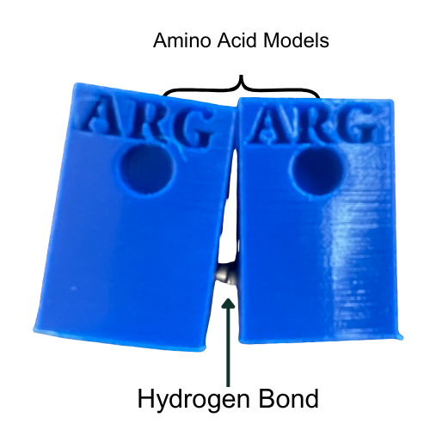
- The prints are set up to accommodate 6 mm x 2 mm neodymium magnets and 3 mm x 2 mm magnets for specific amino acids that do not have holes for the 3 mm x 2 mm magnets.
- Order approximately 100 6 mm x 2 mm neodymium magnets and approximately 20 3 mm x 2 mm magnets.
- Ensure the models fit together by testing the poles of the magnets. Label the north pole of the magnet with a marker and distribute north- and south-pole facing magnets evenly on individual models.

5. Paracord for the Modeling
- Order the following items for completing your modeling kit: RELIABILT 0.1563-in x 38-ft Braided Polypropylene Rope (BLUE)
- Each kit gets approximately 15 ft of blue paracord and 15 ft of green paracord.
- Mark the blue paracord with a marker to indicate the approximate location of the amino acids. (Electrical tape may be used as an alternative, but it might limit the ease of sliding the amino acids onto the wire).
- The placement of these marks will impact the final protein shape.
- We suggest constructing one model first and then marking your cords accordingly. This way, the proteins in your class will have a similar conformation.
- The cords we use were constructed in the following manner.
  - Tie a loop at one end of the cord then measure from the loop and mark the cord at the following locations: 5 in., 6.5 in., 14.5 in., 22 in., 31.5 in., 38 in., 43 in., 50 in., 56.5 in. 61.5 in., 71 in., 77in., 83.5 in., 91.5 in., 96.75 in., 104.5 in., 111.5, 118.5 in. 128 in., 133.5 in., 138 in., 143 in.

6. Print the Amino Acid Placemats on a Color Printer
- To help students keep track of the modeling components, print this amino acid placemat using a color printer: Amino Acid Placemat.

Now you have a complete set of 3D printed amino acid models ready for classroom use! Enjoy teaching and exploring with these interactive models.

