Case Study: Finding Inspiration in Nature

Have you ever wondered where inventors look for ideas? How do people dream up, design, generate, develop, and produce the wide variety of products that we see today? It may surprise you that many of our inventions and engineering marvels were actually inspired by nature. Inspiration by nature is often referred to as biomimicry.

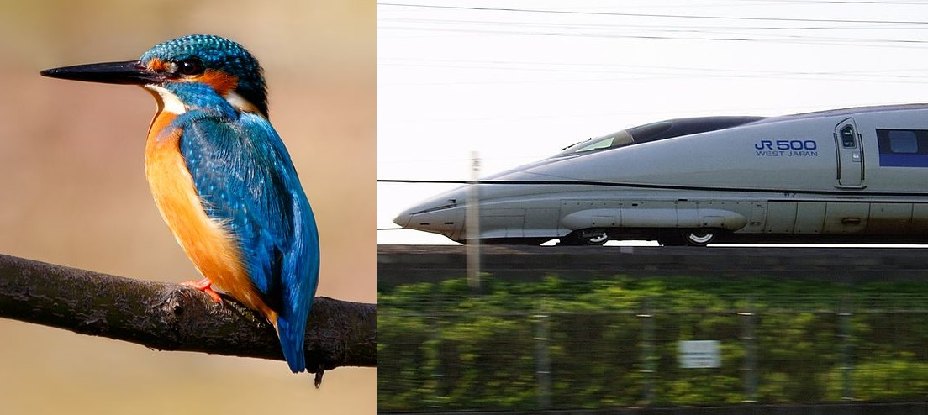
Whether it was Galileo's early designs for flight, the lattice work of bridges, or the designs of flippers, they are all inspired by nature. The designs of many bridges are based on the lattice work of a butterfly wing. The fins that you might use when snorkeling are based on the structures of a duck’s foot, or the Velcro that you might use to attach something to your backpack has its origins in the burrs that get caught in your dog’s fur. Even some computer processing and decision-making coding has its roots in how ants make decisions as a colony.

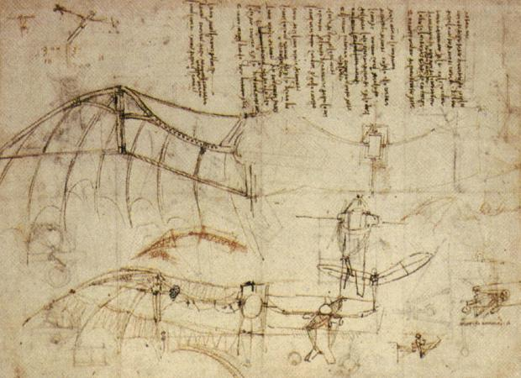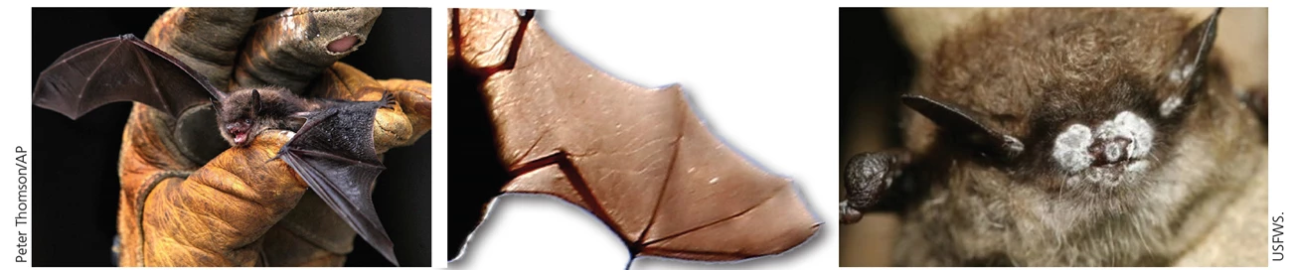

Nature has provided the framework for improvements in large-scale projects such as bridges, wind turbine design, and bullet trains, but nature has also inspired scientists to develop solutions at much smaller scales.

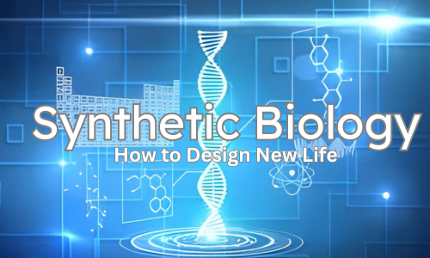
Today, synthetic biologists are investigating how things as small as a few nanometers can be used to address a variety of issues facing society. Synthetic biology is taking biomimicry to an entirely new level. Instead of going super big, synthetic biologists are working at the genetic level. Synthetic biologists are engineering novel sequences of genetic code so that bacteria can produce insulin to treat diabetes, change cells so that the symptoms of muscular dystrophy are reduced, and even develop new types of spider silk and glues that can be used in prenatal surgery.

Synthetic biologists at the University of California, Berkeley and Washington University are using unlikely organisms to develop new products: mussels and spiders! They are mimicking the genetic code of both mussels and spiders to produce stronger fibers and more adhesive glues.
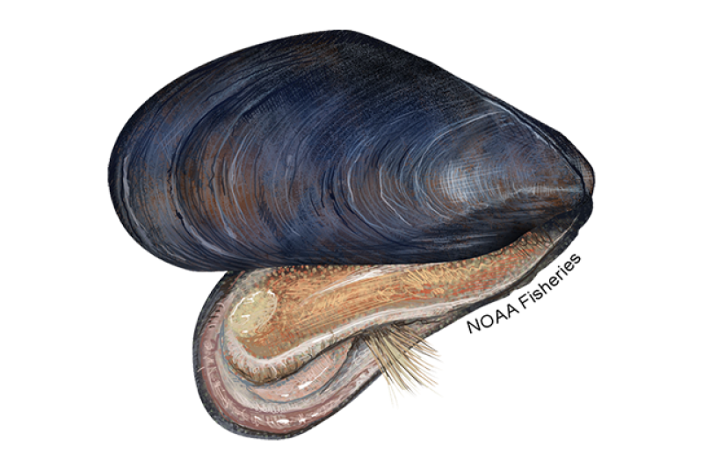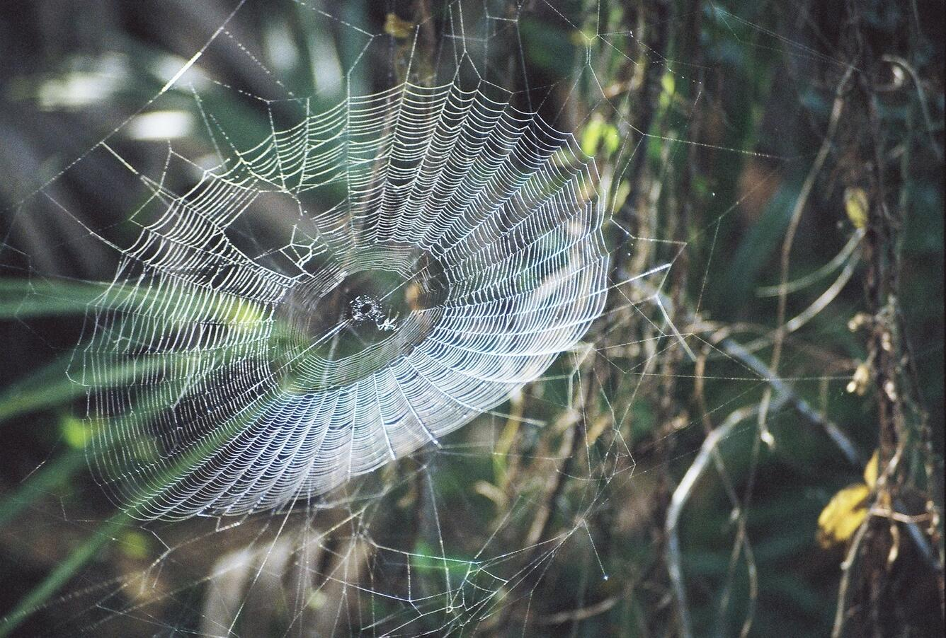
(Mussel protein fibers) (Sewal 2018)

These synthetic biologists rely on the central dogma of molecular biology to engineer novel metabolic pathways to produce materials. Remember, DNA is a sequence of nucleotides. The sequence of nucleotides (A,T, C, and G) then codes for traits, i.e., the breakdown of sugar or the production of ethanol. Understanding how gene expression is controlled is also key in understanding when certain traits are expressed. Once the genetic code controlling a particular metabolic pathway is known, synthetic biologists are then able to manipulate the code so that microorganisms like bacteria can utilize novel metabolic pathways or even produce new materials. Synthetic biologists can view the DNA sequence of a microorganism as a sort of computer code. Thus, a bacteria may be programmed to produce a specific compound. Change the code, and the bacteria will produce a different material.

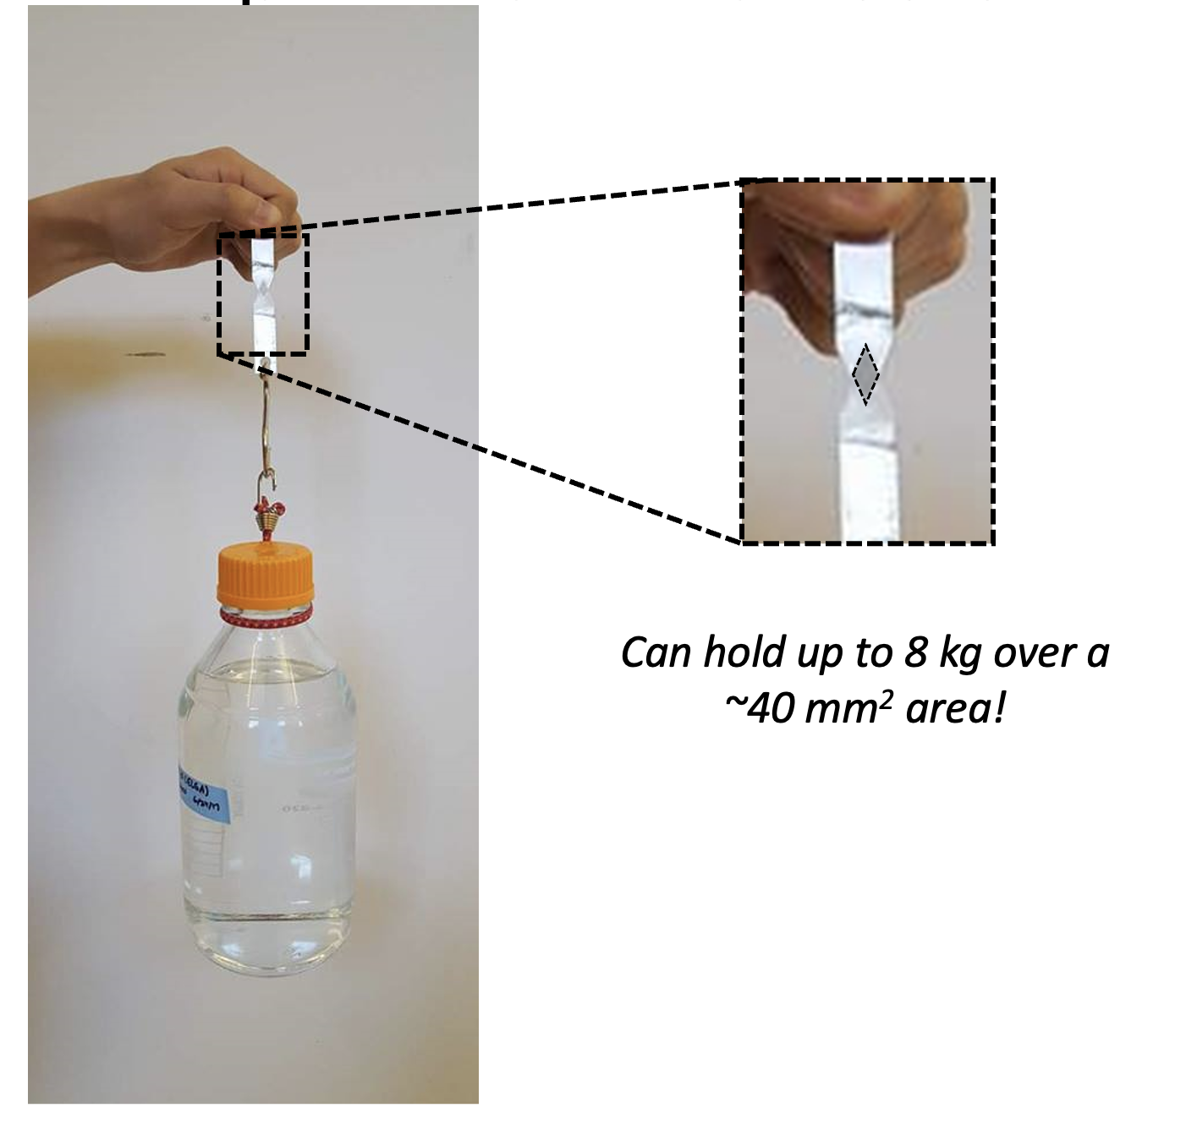
The research team at Washington University McKelvey School of Engineering is working to develop a protein-based glue that combines the strength of spider silk and the ability to be adhesive in aquatic environments seen in natural mussel proteins. Their work relies on decoding the genetic sequences of spider silk production and mussel protein production and then generating a new sequence that is a combination of both. After synthesizing the new genetic code, they can insert that code into a bacterium that will then produce the new adhesive protein. (Jeon et al personal communication)

Synthetic biologists, chemical engineers, and genetic engineers are striving to develop sustainable products that are saving lives. After completing this introduction to synthetic biology, you will model the proteins derived from spider silk and mussel proteins and then try to develop a new and stronger adhesive.

Analysis Questions
Instructions: Use the information above to answer the following questions.

- After watching these clips “mussels” (2:28 minutes) and “spiders” (4:18 minutes), what products might you generate as a synthetic biologist?

- What is the central dogma of molecular biology?

- Why is a deep understanding of the central dogma of molecular biology necessary for a synthetic biologist?

- In your own words, explain biomimicry and discuss how synthetic biology is taking biomimicry to an entirely new level.

- How could using such technologies developed through synthetic biology impact society and the environment?

Citations
- https://www.sciencefocus.com/future-technology/biomimetic-design-10-examples-of-nature-inspiring-technology
- https://www.dawn.com/news/1297127
- https://www.microphotonics.com/biomimicry-burr-invention-velcro/#:~:text=Velcro%20was%20invented%20by%20George,burr%20to%20adhere%20exceedingly%20well
- https://drive.google.com/file/d/14uBM6JweX1fq82gclr8jG4om0Md9oqSe/view?usp=sharing
- https://www.youtube.com/watch?v=_JjlVgSOyJw
- https://www.genome.gov/about-genomics/policy-issues/Synthetic-Biology
- https://biomimicry.org/what-is-biomimicry
- https://insideecology.com/2018/06/21/a-closer-look-at-spider-webs

