Case Study: Finding Inspiration in Nature
Teacher Guide / Answer Key

Teacher Resources
This case study is designed for use in a variety of science courses, including Anatomy and Physiology, AP Biology, AP Environmental Science, Environmental Science, Environmental Sustainability, Geoscience, and Human Body Systems.
In this study, students will explore how synthetic biologists are inspired by nature to develop new materials that help solve a wide range of global challenges. The case highlights advances in insulin production, disease treatments, and fuel production, with a particular focus on how synthetic biology draws inspiration from aquatic mussels and spiders to engineer proteins for real-world applications.
This short reading and video activity should be completed prior to starting the activity. Together, the reading and modeling activity can be used to reinforce or review student understanding of the central dogma of molecular biology. The objective of this introduction is to provide an overview of synthetic biology and to challenge students to consider how they might design a better adhesive.
 | NGSS Standards
HS-LS1-5: | Illustrating how human interventions can alter metabolic processes in organisms to meet specific needs, such as renewable fuel production.
HS-LS1-7: | Illustrating that cellular respiration is a chemical process whereby the bonds of food molecules and oxygen molecules are broken and the bonds in new compounds are formed resulting in a net transfer of energy.
HS-LS2-4 . | Using mathematical representations to support claims for the cycling of matter and flow of energy among organisms in an ecosystem.
HS-LS4-6: | Demonstrating how human ingenuity can guide the evolution of biological systems for beneficial purposes, offering a unique perspective on human influence on biological diversity.
HS-ESS3-2: | Evaluating competing design solutions for developing, managing, and utilizing energy and mineral resources based on cost-benefit ratios.
HS-ESS3-4: | Evaluating or refining a technological solution that reduces impacts of human activities on natural systems.
HS-ETS1-3: | Evaluating a solution to a complex real-world problem based on prioritized criteria and trade-offs that account for a range of constraints, including cost, safety, reliability, and aesthetics as well as possible social, cultural, and environmental impacts.

Case Study: Synthetic Biology and Cutting-Edge Biomimicry

Have you ever wondered where inventors look for ideas? How do people dream up, design, generate, develop, and produce the wide variety of products that we see today? It may surprise you that many of our inventions and engineering marvels were actually inspired by nature. Inspiration by nature is often referred to as biomimicry.

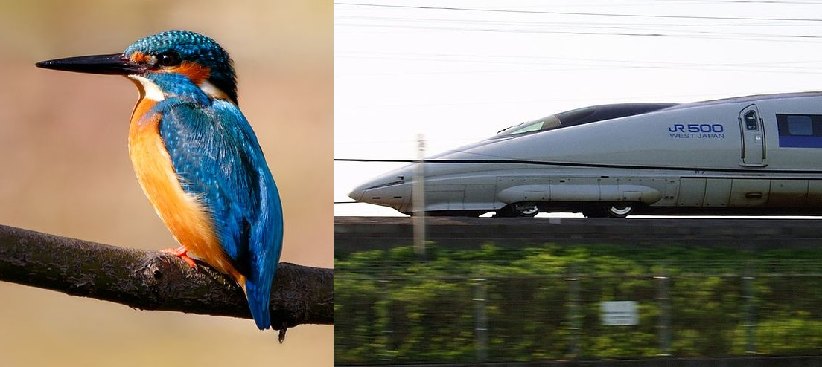
Whether it was Galileo's early designs for flight, the lattice work of bridges, or the designs of flippers, they are all inspired by nature. The designs of many bridges are based on the lattice work of a butterfly wing. The fins that you might use when snorkeling are based on the structures of a duck’s foot, or the Velcro that you might use to attach something to your backpack has its origins in the burrs that get caught in your dog’s fur. Even some computer processing and decision-making coding has its roots in how ants make decisions as a colony.

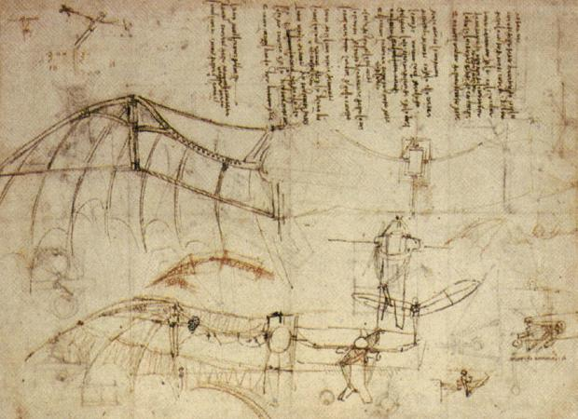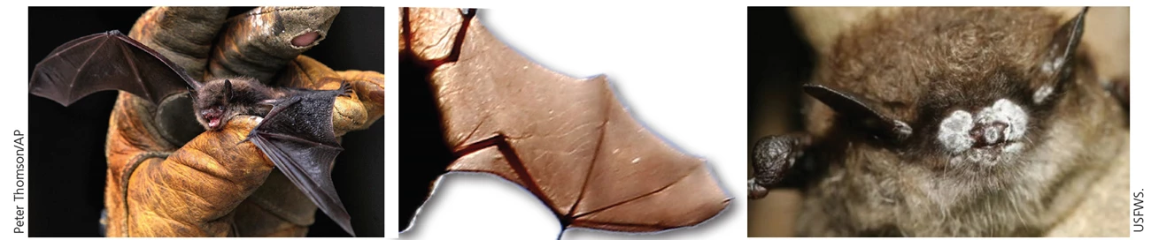

Nature has provided the framework for improvements in large-scale projects such as bridges, wind turbine design, and bullet trains, but nature has also inspired scientists to develop solutions at much smaller scales.

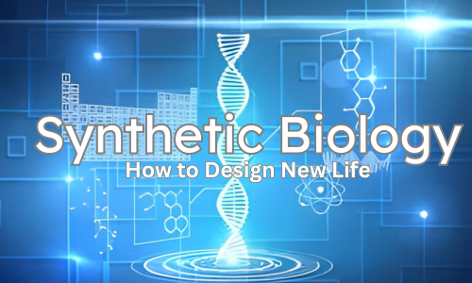
Today, synthetic biologists are investigating how things as small as a few nanometers can be used to address a variety of issues facing society. Synthetic biology is taking biomimicry to an entirely new level. Instead of going super big, synthetic biologists are working at the genetic level. Synthetic biologists are engineering novel sequences of genetic code so that bacteria can produce insulin to treat diabetes, change cells so that the symptoms of muscular dystrophy are reduced, and even develop new types of spider silk and glues that can be used in prenatal surgery.

Synthetic biologists at the University of California, Berkeley and Washington University are using unlikely organisms to develop new products: mussels and spiders! They are mimicking the genetic code of both mussels and spiders to produce stronger fibers and more adhesive glues.
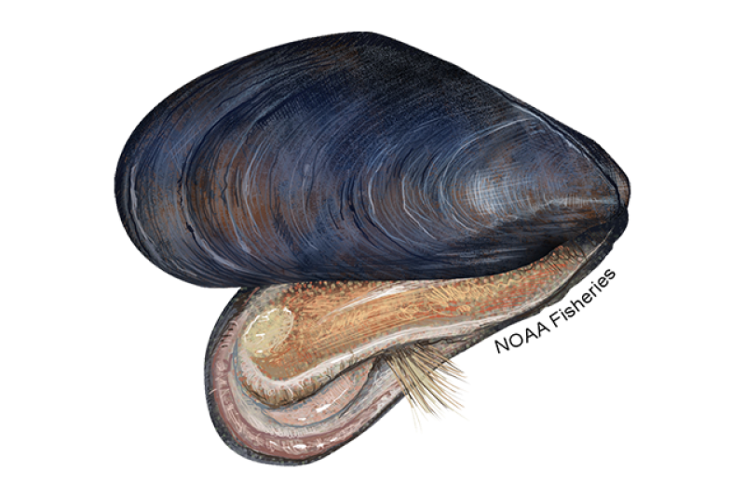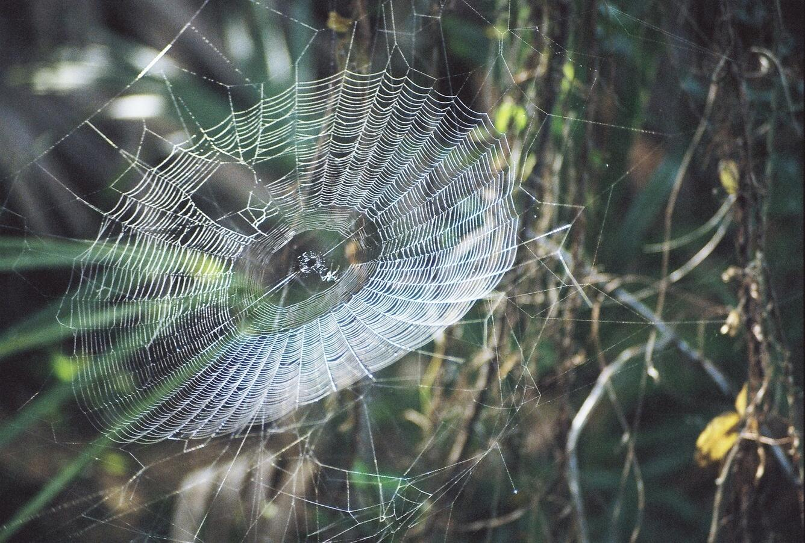
(Mussel protein fibers) (Sewal 2018)

These synthetic biologists rely on the central dogma of molecular biology to engineer novel metabolic pathways to produce materials. Remember, DNA is a sequence of nucleotides. The sequence of nucleotides (A,T, C, and G) then codes for traits, i.e., the breakdown of sugar or the production of ethanol. Understanding how gene expression is controlled is also key in understanding when certain traits are expressed. Once the genetic code controlling a particular metabolic pathway is known, synthetic biologists are then able to manipulate the code so that microorganisms like bacteria can utilize novel metabolic pathways or even produce new materials. Synthetic biologists can view the DNA sequence of a microorganism as a sort of computer code. Thus, a bacteria may be programmed to produce a specific compound. Change the code, and the bacteria will produce a different material.

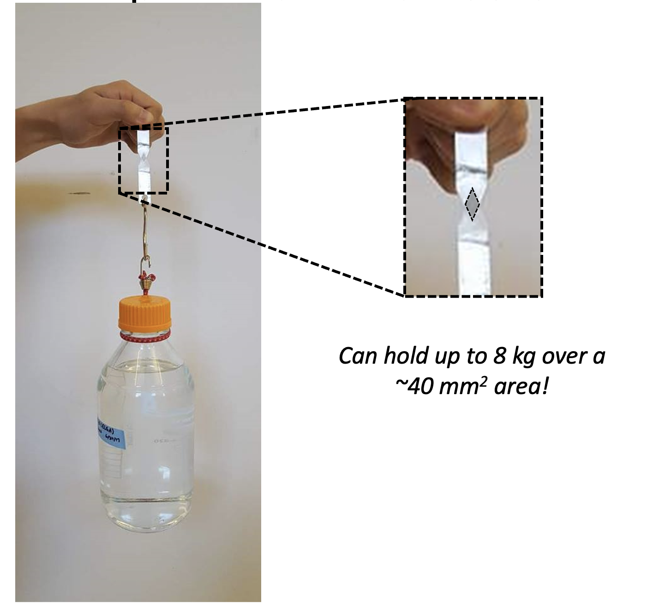
The research team at Washington University McKelvey School of Engineering is working to develop a protein-based glue that combines the strength of spider silk and the ability to be adhesive in aquatic environments seen in natural mussel proteins. Their work relies on decoding the genetic sequences of spider silk production and mussel protein production and then generating a new sequence that is a combination of both. After synthesizing the new genetic code, they can insert that code into a bacterium that will then produce the new adhesive protein. (Jeon et al personal communication)

Synthetic biologists, chemical engineers, and genetic engineers are striving to develop sustainable products that are saving lives. After completing this introduction to synthetic biology, you will model the proteins derived from spider silk and mussel proteins and then try to develop a new and stronger adhesive.

Analysis Questions
Instructions: Use the information above to answer the following questions.

- After watching these clips “mussels” (2:28 minutes) and “spiders” (4:18 minutes), what products might you generate as a synthetic biologist?
Answers may include but are not limited to the following: new fibers, glues or adhesives, bioplastics, insulin, biofuels, vaccines, vitamins.

- What is the central dogma of molecular biology?
The central dogma of molecular biology is a fundamental concept that explains how genetic information is transferred within a cell to produce proteins. First, transcription occurs. Transcription is when a segment of DNA is copied into messenger RNA (mRNA) by the enzyme RNA polymerase. This mRNA strand carries the genetic instructions from the nucleus to the ribosome, where translation occurs. In translation, the ribosome reads the sequence of the mRNA and assembles a chain of amino acids in the correct order to form a protein, based on the genetic code.

- Why is a deep understanding of the central dogma of molecular biology necessary for a synthetic biologist?
The central dogma of molecular biology is essential for a synthetic biologist because it provides the foundation for how genetic information is stored and expressed. The central dogma—DNA → RNA → Protein—explains how genes are transcribed into messenger RNA and then translated into proteins, which perform all of the functions in a cell. Synthetic biologists rely on this knowledge to design and build new genetic codes or modify existing ones to produce new materials like the spider silk/mussel glue. Understanding regulatory sequences, codon usage, RNA stability, and protein folding is crucial for successful genetic engineering. Without a solid grasp of how genetic information flows and is controlled within cells, it would be impossible to predict or engineer biological outcomes with precision.

- In your own words, explain biomimicry and discuss how synthetic biology is taking biomimicry to an entirely new level.
Biomimicry is studying and imitating nature’s designs, processes, or systems to solve human problems. Biomimicry involves looking at how organisms have evolved to survive and function efficiently and then applying those principles to address problems facing society.

Synthetic biology is transforming biomimicry by making it possible not just to imitate biological systems, but also to recreate or even enhance them at the molecular level. Instead of merely copying nature’s designs, synthetic biologists can build biological parts, pathways, or entire organisms that function like—or better than—those found in nature. For instance, synthetic biologists can engineer bacteria to produce spider silk, a material stronger than steel and lighter than carbon fiber. Synthetic biology expands the potential of biomimicry by giving scientists the tools to design life-inspired solutions from the inside out, offering more precision, adaptability, and innovation.

- How could using such technologies developed through synthetic biology impact society and the environment?
Synthetic biology has the potential to greatly impact both society and the environment. There are definite ethical considerations and risks associated with the use of synthetic biology, and great care must be taken to ensure technologies are safe and accessible to all. The benefits of using synthetic biology are vast. Synthetic biologists can engineer organisms to produce medicines, biofuels, biodegradable plastics, or lab-grown foods. It can make society more sustainable by reducing our reliance on fossil fuels, lowering pollution, and making essential products more affordable and accessible. It can also help produce new vaccines and improve crop yields. Synthetically engineered microbes can help clean up pollution, degrade plastic waste, or capture carbon dioxide to fight climate change. However, there are risks that must be addressed. There may be the potential for unintended ecological consequences, ethical issues related to genetic modification, and the misuse of synthetic organisms.

Citations
- https://www.sciencefocus.com/future-technology/biomimetic-design-10-examples-of-nature-inspiring-technology
- https://www.dawn.com/news/1297127
- https://www.microphotonics.com/biomimicry-burr-invention-velcro/#:~:text=Velcro%20was%20invented%20by%20George,burr%20to%20adhere%20exceedingly%20well
- https://drive.google.com/file/d/14uBM6JweX1fq82gclr8jG4om0Md9oqSe/view?usp=sharing
- https://www.youtube.com/watch?v=_JjlVgSOyJw
- https://www.genome.gov/about-genomics/policy-issues/Synthetic-Biology
- https://biomimicry.org/what-is-biomimicry
- https://insideecology.com/2018/06/21/a-closer-look-at-spider-webs

