Case Study: The Evolution of Fermentation - From Alcohol to Bioplastics

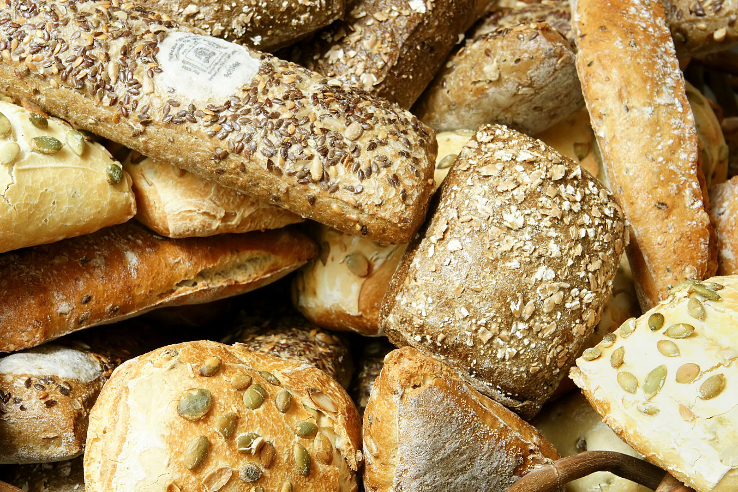
Ancient Mesopotamians and Egyptians are thought to be the first civilizations to make bread. The Egyptians began adding yeast to flour around 3,000 BCE. Yeast is a single-celled fungus, and today there are approximately 1,500 different species of yeast. The yeast in the flour began breaking down the sugars and released CO₂, thus causing the bread to rise. The Egyptians also used yeast to develop wine and beer, which resulted in the production of alcohol. The yeast used in both baking and brewing is usually Saccharomyces cerevisiae. Currently, fermentation is used to make a variety of breads, and ethanol. Ethanol can then be consumed by humans or used as a fuel additive. Using ethanol as a biofuel is one key to reducing fossil fuel use and a potential environmentally sustainable solution to fuel insecurity. Scientists have shown that yeast can be used for so much more than just making great bread, a bottle of beer, or even reducing the cost of filling up your car with gas.
Image 1. Modern day breads

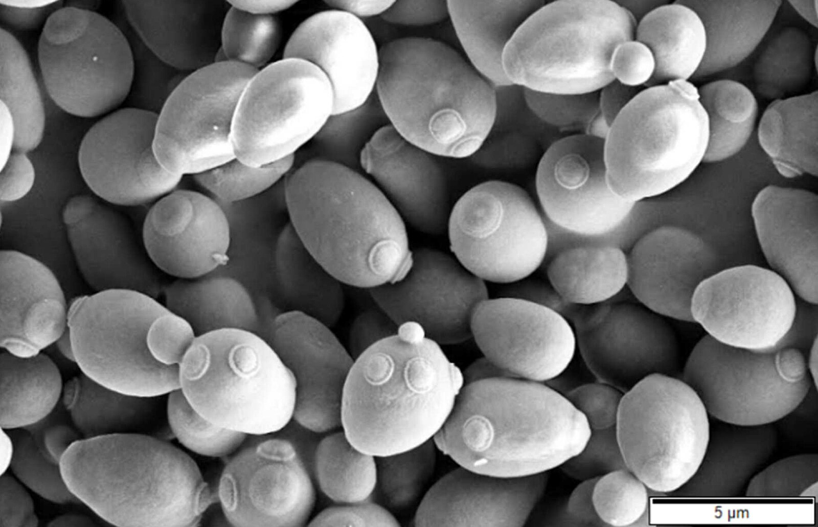
Biochemists, geneticists, food scientists, genetic engineers, and evolutionary biologists long wondered why the fermentation pathway arose. How were yeast cells able to survive in the presence of ethanol, and when did the metabolic pathway first appear in organisms? Answering such questions was the first step in helping scientists unlock the mysteries of this biochemical pathway. In fact, through understanding this complicated biochemical process, and the central dogma of molecular biology, synthetic biologists have even been able to reprogram yeast cells to produce novel proteins and new products like bioplastics, and then use that knowledge to help society.

Image 2. Brewer’s yeast (Saccharomyces cerevisiae)

Evolutionary History of Fermentation
More than 500 million years ago, various species of yeast evolved the ability to break down sugars using a metabolic pathway we call fermentation (Dashko et al. 2014). During fermentation, sugars are broken down, yielding the by-products ATP (cellular energy), CO₂ , and ethanol. Fermentation in yeast is a two-step process. First glucose is broken down via glycolysis into a molecule called pyruvate. The second step occurs when a molecule called NAD removes some hydrogens from pyruvate to form acetaldehyde, which is then broken down into ethanol and CO₂. Fermentation produces small amounts of ATP (cellular energy), but for yeast it is enough for them to survive. This process occurs when there is little oxygen or when sugar concentrations are very low (Image 3.). The ethanol that is produced is toxic to all cells, and at a certain concentration, even to the yeast that can produce the ethanol. So how and why would cells produce a chemical that is toxic to themselves? The answer is niche exploitation and a means to out-compete other microbes for the carbon bound in sugars.

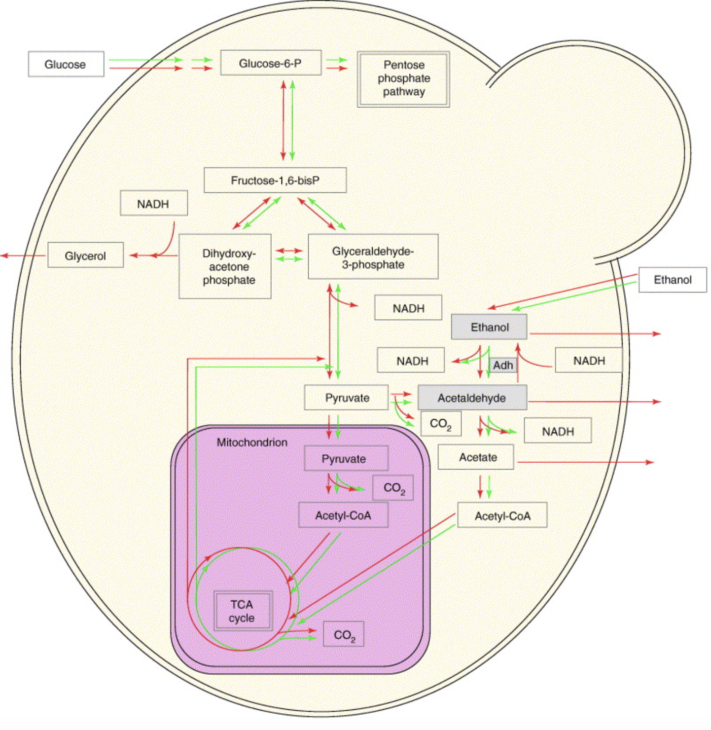
Image 3. Metabolism in Yeast (from Piskur et al.2006)

Three species of yeast can produce alcohol in both aerobic and anaerobic conditions (Piskur et al. 2006). These yeast species can consume monosaccharides, convert it to ATP to be used for growth and maintenance, and produce ethanol. There are even some yeast species that are able to use the ethanol as a carbon source when the ethanol concentration is not too high. This ability to survive in the presence of, and even on, ethanol gave these organisms a selective advantage. It is hypothesized (Dashko et al. 2014) that yeast gain a selective advantage by rapidly utilizing available sugars, decreasing oxygen levels as a result of rapid respiration, and then the release of ethanol further limits bacterial growth. Modern plants with fruits first appear in the fossil record at 125 mya (Sun et al. 2011). The increase in the number of yeast species that can produce ethanol increased at about the same time. Utilization of the new resource (fruit) is a classic example of adaptation and niche exploitation. Yeast species that were better able to survive in environments with low oxygen levels and higher alcohol levels were thus able to outcompete bacteria and other fungi for resources. Natural selection was the driving mechanism for fermentation in yeast with two selection pressures, tolerance to ethanol and a form of anaerobic respiration.
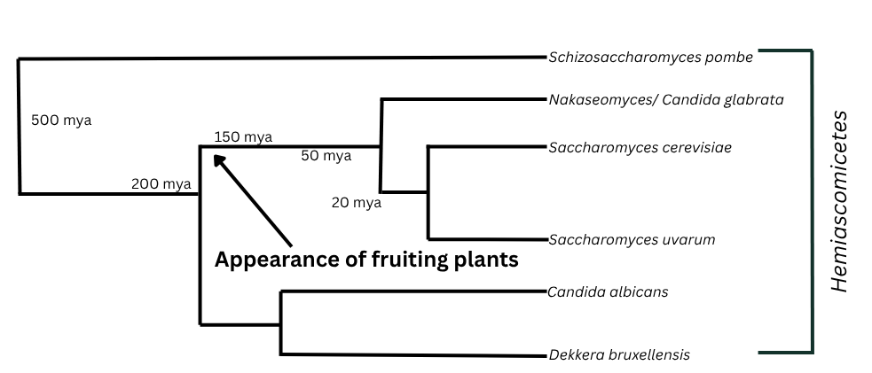
Image 4. Phylogenetic relationship of various yeast species. Only Saccharomyces, Dekkera, and Schizosaccharomyces can produce ethanol in both aerobic and anaerobic environments (adapted from Dashko et al. 2014).

How ethanol production evolved is much more complicated. There are a variety of metabolic pathways that must occur for alcohol fermentation to take place. Research suggests that a specific gene, URA1, allows yeast to survive in anaerobic conditions. Also, scientists surmise that in one type of yeast (Crabtree positive yeast) the gene to go through the process of fermentation is always switched on, and in another type of yeast (Crabtree negative yeast) the genes related to fermentation are only turned on when oxygen levels are low. Multiple genes involved with controlling ribosomes and mitochondria, both of which play a role in cellular metabolism, have been impacted over evolutionary time. What appears to be the “how” fermentation evolved is alteration in the switches that control expression of a trait. Some of the genes have repressors, and some have promoters, thus controlling the expression of various genes related to aerobic and anaerobic respiration when glucose and oxygen levels are at specific points.

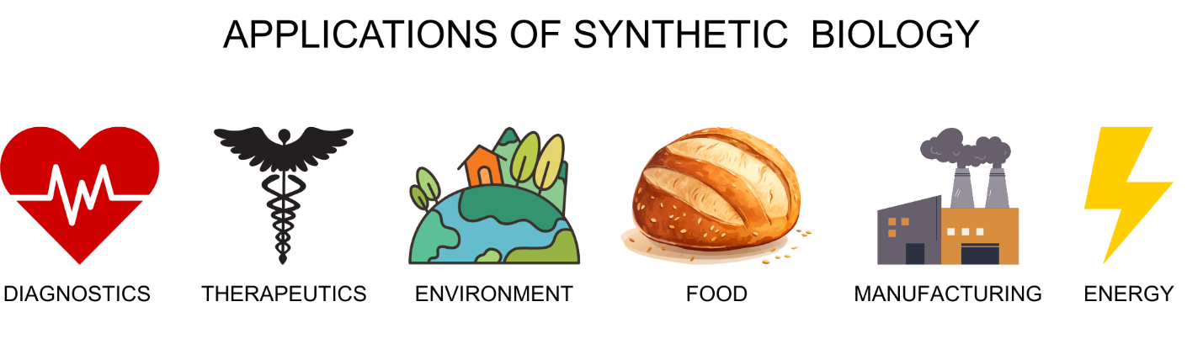
By beginning to understand how fermentation evolved, scientists become better able to harness the process and adapt this natural metabolic pathway so that it can be used to tackle a variety of problems. Synthetic biologists are spearheading scientific investigations to use natural processes as a framework or foundation to build new metabolic pathways so that existing products can be produced through more efficient processes, and novel products can be designed to tackle issues facing society.

Synthetic Biology - Maximizing Fermentation
Synthetic biologists rely on the central dogma of molecular biology to engineer novel metabolic pathways to produce materials. Remember, DNA is a sequence of nucleotides. The sequence of nucleotides (A,T, C, and G) then codes for particular traits, i.e., the breakdown of sugar or the production of ethanol. Understanding how gene expression is controlled is also key in understanding when certain traits are expressed. Once the genetic code controlling a particular metabolic pathway is known, synthetic biologists are then able to manipulate the code so that a microorganism like a bacterium can utilize novel metabolic pathways or even produce new materials. Synthetic biologists can view the DNA sequence of a microorganism as a sort of computer code. Thus, a bacterium may be programmed to produce a specific compound. Change the code and the bacterium will produce a different material. Change inserts new codes, and the microscopic machine can metabolize new molecules. Synthetic biologists are employing such approaches to harness the metabolic pathway of fermentation to not only produce ethanol, but to enable yeast to metabolize a variety of materials and produce other compounds besides just ethanol.


Bioethanol and Fuel Security
It is no surprise to any driver in the United States that gasoline prices are high. The high prices at the pump are a result of many contributing factors. Geopolitical instability, cost of oil production, logistical issues with refining crude oil, and fluctuations in demand all impact the price at the pump. What if there was a way to not only reduce the amount of price fluctuation in gas prices but also create a viable, sustainable means to lower production cost and thus our cost at the pump?

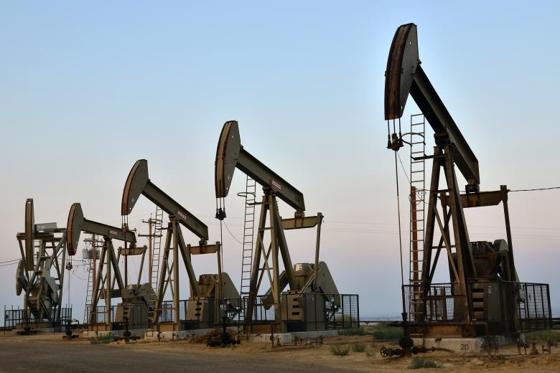
Would it surprise you that the solution to fuel security is not tied to discovering new oil reserves or altering methods of oil refinement? Investment into fuel security does not necessarily have to be directed into oil production, but rather into agriculture, engineering, and genetics. Through advances in these areas, alternative fuels such as bioethanol can replace the use of most of the conventional gasoline that we buy at our local gas station.

Traditionally, oil is extracted from the ground using offshore oil rigs or drills. The crude oil is then shipped to an oil refinery. During the refining process, oil is separated into a variety of products such as diesel fuel, jet fuel, lubricating oils, plastics, polyesters, polystyrene, nylon, and of course gasoline. Though the process of refining can generate a variety of products, it is also a major source of air pollutants, including toxic metals, particulates, and gases such as nitrogen oxides, sulfur oxides, methane, carbon monoxide, benzenes, toluenes, and others.

There are also environmental, logistical, and human health-related concerns with the shipping of crude oil and some of the refined products. Reducing the amount of oil shipped is the simplest and most direct method to reduce the frequency and impact of oil spills on the ecosystem and on human health.

Bioethanol is a sustainable solution to fuel needs. Bioethanol is an organic fuel derived from plant material. Historically, ethanol has been generated via the process of fermentation. Grains such as corn or sugar from sugar cane are the energy source for yeast fermentation. The ethanol is then isolated and distributed for use. However, advances in production by synthetic biologists and chemical engineers have allowed for the use of a wide assortment of plant materials.

Humans, like most other organisms, utilize glucose, other simple sugars, and a few complex carbohydrates as our energy source. But instead of thinking about sugar as an energy source, let’s think about it as a carbon source. All living things need carbon, and the food that we eat enables us to gain the carbon we need to go about our daily lives. Yeast and other organisms also use sugar as a carbon source. Only a few organisms, like the microbes in the guts of termites, can use the complex carbohydrate cellulose as a carbon source.

Image 3 shows that most yeasts are only able to use glucose, and three species can use glucose and low concentrations of ethanol. Work done by chemical engineers and synthetic biologists is increasing the types of carbon sources available to yeast.

The sugars in plants that we eat are also the sugars in plants that are accessible for fermentation. Take corn, for example. The kernel of the corn is what is mostly used for livestock and fermentation practices. For most organisms, a majority of the remainder of the corn plant is an inaccessible cellulose. On average, nearly 50% of a plant is cellulose. This cellulose can be found in the stems and leaves of the plant. In addition to cellulose, related polymers include hemicellulose, lignin, and lignocellulose. Cellulose provides the rigidity plants need. Without cellulose, trees would not be able to support themselves. From an evolutionary perspective, cellulose is the perfect building material for plants. Few organisms can break down cellulose, and thus trees and other plants are able to support their photosynthetic structures. Chemical engineers and synthetic biologists are developing metabolic pathways that allow genetically modified organisms to break down cellulose and thus increase the amount of bioethanol produced from plant material.

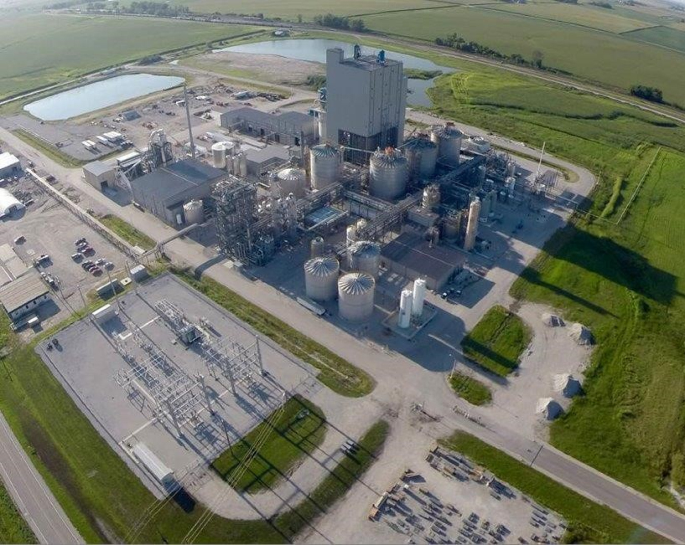

By maximizing the use of plant-based polymers, fuel production can approach a carbon-neutral impact and minimize the dangers associated with transporting crude oil long distances. Further, fermentation and production of ethanol produces much fewer pollutants than the steps required to process crude oil.

A Two-Pronged Approach - Bioplastics
Synthetic biologists are also reprogramming micromachines to generate novel products. One such product is bioplastic. A team of researchers headquartered at Washington University is developing new technologies to reduce our reliance on traditional plastics.
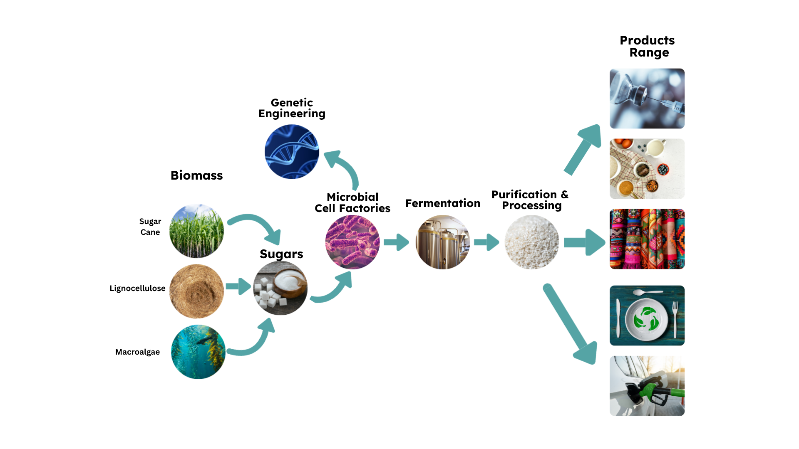

One member of the SMARC consortium is Dr. Fuzhong Zhang. His team is pioneering the development of new pathways to produce a wide variety of materials. One such material is a new fiber based on the proteins associated with spider silk. His team has manipulated the genetic code of bacteria so that E. coli can secrete a fiber that is similar to spider silk. Using synthetic biology, Dr. Zhang’s lab has developed new metabolic pathways based on pathways in alcoholic fermentation (see Image 5).
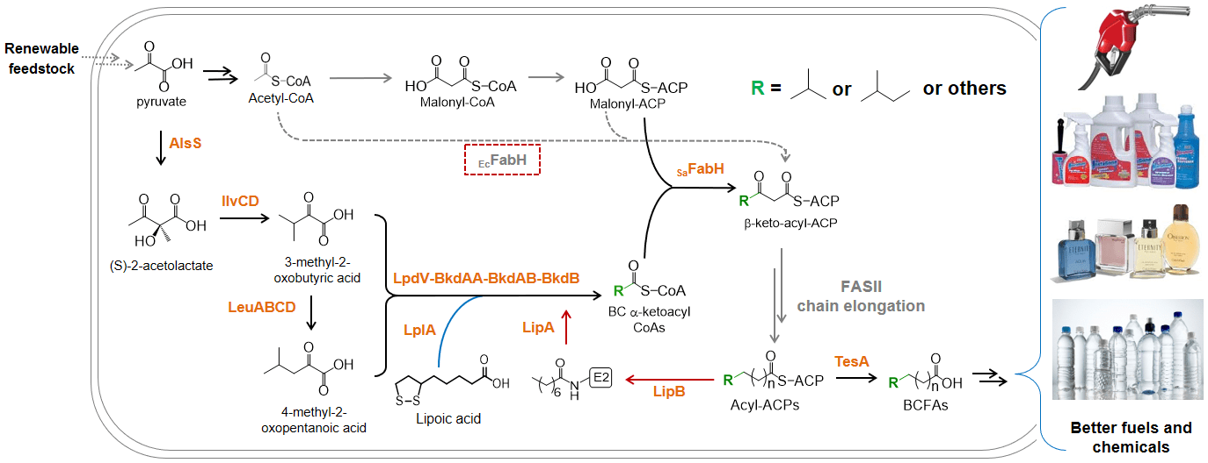
Image 5. Metabolic pathway converting pyruvate to various polymers. Pyruvate is involved in the second step of alcohol fermentation (Zhang 2024)

Not only are new fibers being produced, but researchers have also inserted novel genetic code based on the genetic code of yeast into bacteria that has allowed them to produce bioplastics instead of ethanol (Jeon et al. 2023).

Conclusion
Detritivores play a crucial role in ecosystem processes. Yeast and other microscopic decomposers have evolved and adapted to a wide range of ecological conditions. Yeast were able to exploit new habitats as fruiting plants emerged in the landscape. Populations expanded as the sugary fruits provided an ideal habitat for yeast and bacteria. Over evolutionary time, yeast evolved ethanol production and the ability to survive in low oxygen environments to outcompete other organisms.

Today, synthetic biologists are adapting the metabolic process of fermentation. Using gene-editing techniques, scientists are reprogramming the genetic code of bacteria and yeast to not only utilize novel carbon sources but also produce new materials that can better the human condition. Synthetic biology is relying on the concepts of transcription and translation, that DNA codes for RNA, and the RNA in turn codes ribosomal production of proteins to generate cellular machinery that can produce compostable plastics, use CO₂ as a food source, or break down previously indigestible hydrocarbons. Thus, understanding evolutionary processes, gene expression, and gene-editing techniques will allow humans to adapt and solve ecological and environmental challenges now and into the future.

Analysis Questions
- What are the steps of fermentation, and why is it advantageous for cells?

- How would you describe a niche?

- What is a repressor?

- What is a promoter gene?

- What is bioethanol?

- What biochemical process can be used to generate bioethanol?

- What types of polymers are synthetic biologists programming bacteria to utilize as a food source?

- How can synthetic biology help create fuel security?

- What are bioplastics, and what makes them a viable alternative to conventional plastics?

- How are synthetic biology and chemical engineering using a two-pronged approach to solve design challenges in the 21st century?

Citations
- https://www.sciencedirect.com/topics/agricultural-and-biological-sciences/lignocellulose
- https://www.sciencedirect.com/topics/materials-science/bioethanol#:~:text=Bioethanol%20is%20an%20organic%20biofuel,Computer%20Aided%20Chemical%20Engineering%2C%202019
- https://www.sciencedirect.com/topics/chemistry/fermentation
- https://www.eia.gov/energyexplained/oil-and-petroleum-products/refining-crude-oil-the-refining-process.php
- https://www.genome.gov/about-genomics/policy-issues/Synthetic-Biology
- https://www.sciencedirect.com/topics/biochemistry-genetics-and-molecular-biology/cellulose
- https://www.sciencedirect.com/topics/chemistry/hemicellulose#:~:text=Hemicellulose%20is%20a%20heteropolymer%20with,dramatically%20for%20different%20feedstock%20sources
- https://www.ili-lignin.com/what-is-lignin.html
- https://en.wikipedia.org/wiki/Bread#cite_note-arzani11-9
- https://bio.libretexts.org/Bookshelves/Human_Biology/Human_Biology_(Wakim_and_Grewal)/05%3A_Cells/5.10%3A_Fermentation
- https://www.youtube.com/watch?v=XREALVgxBEI
- https://www.khanacademy.org/science/ap-biology/ecology-ap/community-ecology/a/niches-competition
- https://www.genome.gov/genetics-glossary/Repressor#:~:text=Definition&text=A%20repressor%2C%20as%20related%20to,of%20messenger%20RNA%20(mRNA)
- https://www.genome.gov/genetics-glossary/Promoter#:~:text=A%20promoter%2C%20as%20related%20to,molecule%20(such%20as%20mRNA)
- https://www.acs.org/careers/chemical-sciences/areas/chemical-engineering.html
- https://www.sciencedirect.com/topics/engineering/bioplastics
- https://www.sciencedirect.com/science/article/abs/pii/B9780444521491000069#:~:text=However%2C%20yeasts%20are%20not%20just,competitors%2C%20parasites%2C%20or%20pathogens
- https://www.nature.com/scitable/topicpage/translation-dna-to-mrna-to-protein-393
- https://www.genome.gov/genetics-glossary/Central-Dogma#:~:text=Definition,or%20RNA%20directly%20to%20protein
- https://www.youtube.com/watch?v=_JjlVgSOyJw
- Bai W., Anthony W.E., Hartline C.J., Wang S., Wang B., Ning J., Hsu F., Dantas G.*, Zhang F.*, Engineering Diverse Fatty Acid Compositions of Phospholipids in Escherichia coli. Metab. Eng., 74, 11-23, doi: 10.1016/j.ymben.2022.08.011.(2022)
- Liang L, Liu R, Freed EF, Eckert CA. Synthetic Biology and Metabolic Engineering Employing Escherichia coli for C2-C6 Bioalcohol Production. Front Bioeng Biotechnol. 2020 Jul 3;8:710. doi: 10.3389/fbioe.2020.00710. PMID: 32719784; PMCID: PMC7347752.
- Dashko S, Zhou N, Compagno C, Piškur J. Why, when, and how did yeast evolve alcoholic fermentation? FEMS Yeast Res. 2014 Sep;14(6):826-32. doi: 10.1111/1567-1364.12161. Epub 2014 Jun 9. PMID: 24824836; PMCID: PMC4262006.
- Piskur J, Rozpedowska E, Polakova S, Merico A. Compagno C. How did Saccharomyces cerevisiae evolve to become a good brewer? Trends Genet. 2006;22:183–186.
- Sun G, Dilcher DL, Wang H, Chen Z. A eudicot from the Early Cretaceous of China. Nature. 2011 Mar 31;471(7340):625-8. doi: 10.1038/nature09811. PMID: 21455178.
- Jeon J, Subramani SV, Lee KZ, Jiang B, Zhang F. Microbial Synthesis of High-Molecular-Weight, Highly Repetitive Protein Polymers. International Journal of Molecular Sciences. 2023; 24(7):6416. https://doi.org/10.3390/ijms24076416

