Article: Developing New Surgical Materials

You probably know someone who has needed stitches, but what you may not realize is that suturing dates back to around 300 BCE. Ancient Egyptians used a variety of materials for stitching wounds, including plant fibers, wool thread, and animal tendons.

In India, there is documentation of suturing practices as early as 500 BCE. The Ancient Greeks also used sutures and recorded detailed descriptions of wound care, including stages of healing and types of infections associated with injuries around 300 BCE.
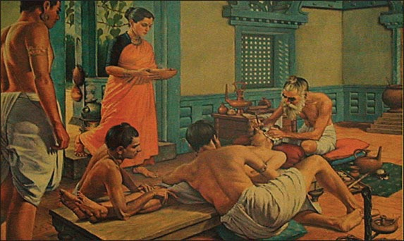
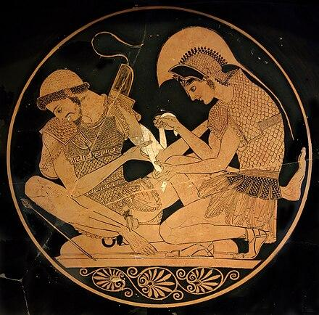

Today, physicians have a wide range of suturing materials available, most of which are synthetic fibers such as nylon and polyester.


In addition to traditional stitches, doctors now have access to surgical glues that can help close wounds. These adhesives are faster and easier to use for small cuts, but they are not suitable for closing larger or more complex wounds.

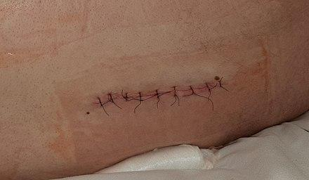

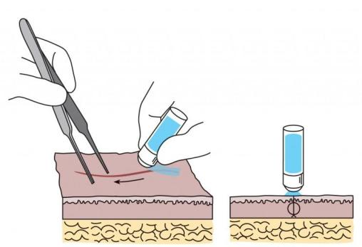
The ongoing search for safe, strong, and effective surgical adhesives that enable less invasive procedures is driving research teams across the country.

Watch the short video to explore the uses and limitations of surgical glue, and then we will learn how the SMARC research team led by Dr. Fuzhong Zhang is developing a strong adhesive inspired by spider silk proteins and the underwater adhesion strategies of mussels.

Sutures or Surgical Glues? video (9:03 minutes)

Citations
- https://babavickramabedi.medium.com/ancient-india-and-diabetes-c1cf917d83e2
- https://carrington.edu/blog/the-evolution-of-surgical-sutures-from-traditional-to-absorbable-and-beyond
- Hall Lance T. and Julian E. Bailes. 2005. Using Dermabond for Wound Closure in Lumbar and Cervical Neurosurgical Procedures. Operative Neurosurgery, 2005, vol. 56 (147-150). https://api.semanticscholar.org/CorpusID:8674659
- Muffly TM, Tizzano AP, Walters MD. The history and evolution of sutures in pelvic surgery. 2011. J R Soc Med. 2011 Mar;104(3):107-12. doi: 10.1258/jrsm.2010.100243. PMID: 21357979; PMCID: PMC3046193.
- https://medium.com/exploring-history/5-strange-facts-about-how-surgery-was-performed-in-ancient-egypt-d4382901a60
- https://www.stlouischildrens.org/node/10031
- https://en.m.wikipedia.org/wiki/Bandage#
- https://en.wikipedia.org/wiki/Surgical_suture

