Building an Electric Circuit to Convert
the Sensor Resistance into a Usable Voltage
INSTRUCTIONS

Use this instruction manual to help you build an electric circuit to convert the sensor resistance into a usable voltage. The goal is to determine the relationships between applied force and sensor voltage output. Make sure you have the following items:
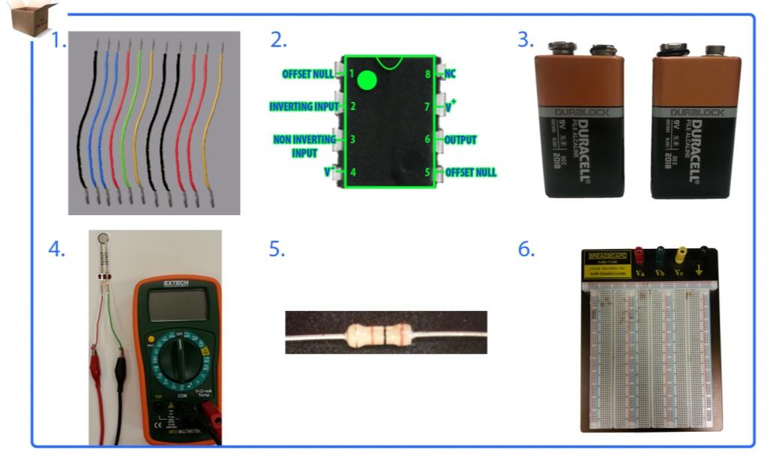
multimeter with sensor attached
11 6-inch wires (22 gauge)
breadboard
two 9V batteries
LM 741 op amp
30k Ω resistor

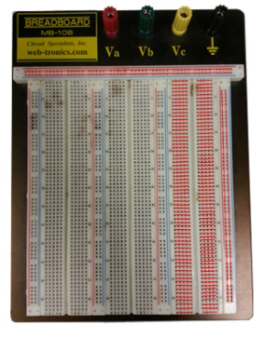
- Breadboard Basics
  - Letters on the breadboard are used to identify vertical columns.
  - Numbers on the breadboard are used to identify horizontal rows.
Figure 2C
  - The red lines in Figure 1 show how vertical columns and horizontal rows are internally connected.
  - When you connect a power source to a set of vertical columns, you can access voltage (+) and ground (-) from that set of vertically holes.

Figure 1

- Operational Amplifier (Op Amp) Basics
  - The main purpose of this integrated circuit is to amplify a weak signal.
  - It usually has two inputs (inverting input [2], non-inverting input [3]), and one output (6).
  - It has a wide range of functions: inverting amplifier, non-inverting amplifier, differential amplifier, voltage follower, summing amplifier, instrumentation amplifier.
  - In our circuit, we will use it as a non-inverting amplifier. See the Figure 2 schematic.
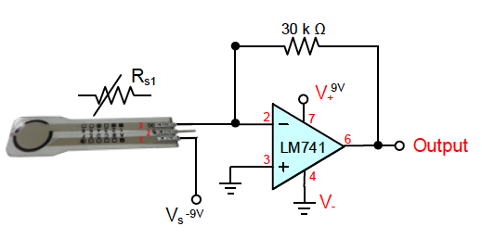

Figure 2

- Resistor Basics
  - As the name implies, a resistor is used in a circuit to create resistance to an electrical current. It limits the current passing through it.
  - Resistors have variable (Figure 3A) or fixed resistance (Figure 3B). A diagonal line through its symbol denotes that its resistance will vary.
  - The unit of a resistor is ohms (Ω).

Figure 3B
Figure 3A

- Op Amp 741 Placement
  - Locate pin 1, which is identified by a circle.
  - Place your op amp chip center in-between vertical column “e” and “f.”
  - Note: Do NOT place your chip in-between “a-e” or “f-j.”
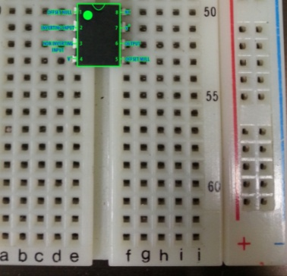
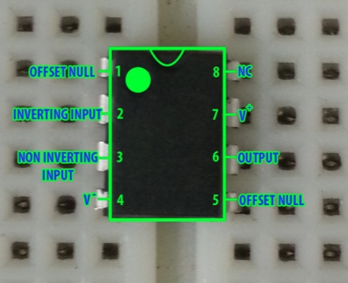

Figure 4B
Figure 4A

- Op Amp 741 – Voltage Connection (V+)
Connect a wire from pin 7 to your voltage supply (vertical “+” column). See Figures 5A and 5B.
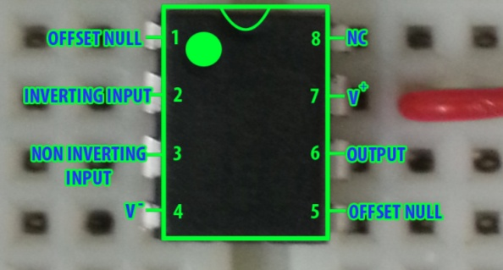
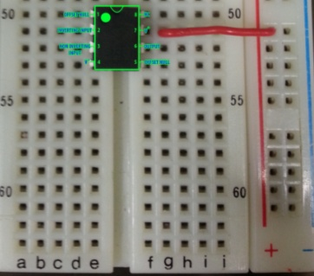

Figure 5B
Figure 5A

- Op Amp 741 – Ground Connection (V+)
Connect a wire from pin 4 to your ground supply (vertical “-“ column). See Figures 6A and 6B.
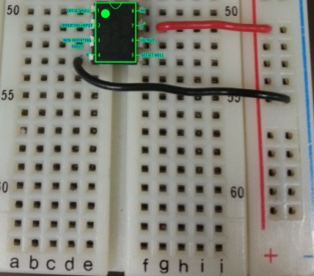
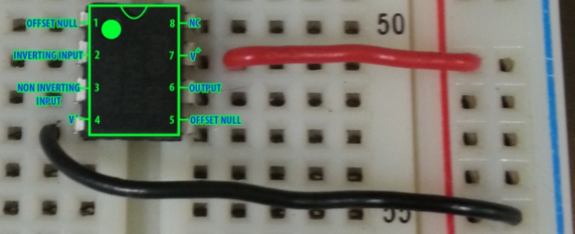

Figure 6B
Figure 6A

- Op Amp 741 – Non-Inverting Input Connection
Use 2 wires to connect from pin 3 to your ground supply (vertical “-“ column). See Figures 7A and 7B.
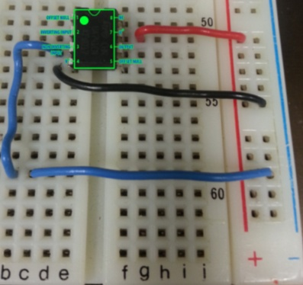
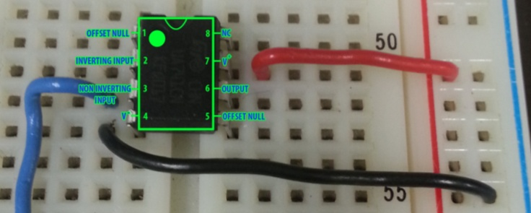

Figure 7B
Figure 7A

- Op Amp 741 – Inverting Input Connection
Connect a wire from pin 2 to any horizontal row above the op amp chip. See Figures 8A and 8B.
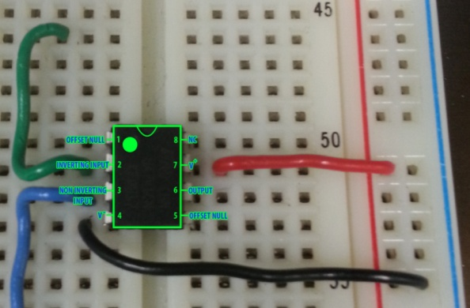
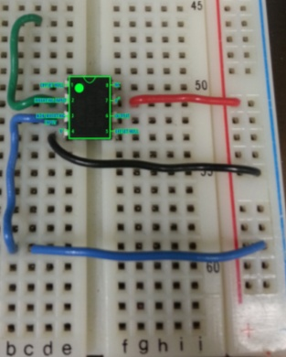

Figure 8B
Figure 8A

- Op Amp 741 – Output Connection
- Connect a wire from pin 6 to any horizontal row above the op amp chip.
- You can choose to horizontally align it to an inverting input row from the previous step.
- See Figures 9A and 9B.
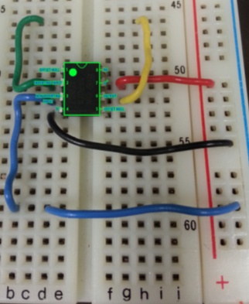
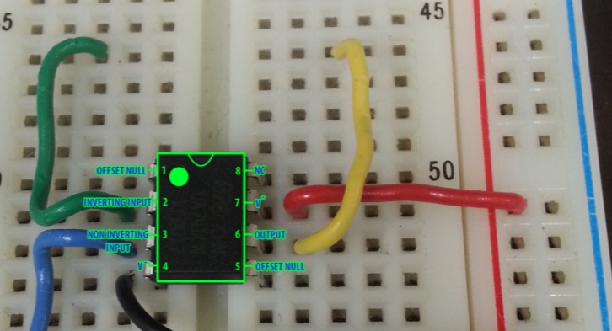

Figure 9B
Figure 9A

- Resistor Connection – 30k Ohms
Place the 30k ohms resistor in-between your inverting input and output connections.
See Figures 10A and 10B.
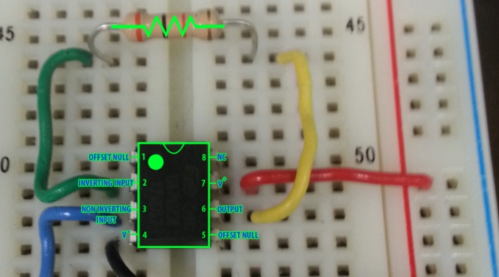
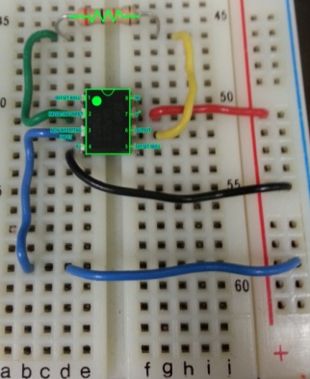

Figure 10B
Figure 10A

- Power Supply – Obtaining +9V and -9V
- Place the 9V batteries side by side, as shown in Figure 11A.
- Connect the two 9V batteries in series. To do this, connect the positive terminal of the left battery to the negative terminal of the right battery.
- Connect the multimeter to verify the output voltage on each side.
- Figure 11B shows a reading of a negative voltage.
- NOTE: REMEMBER WHICH SIDE OUTPUTS NEGATIVE and POSITIVE.
- NOTE: Connecting batteries incorrectly may cause the batteries to overheat!
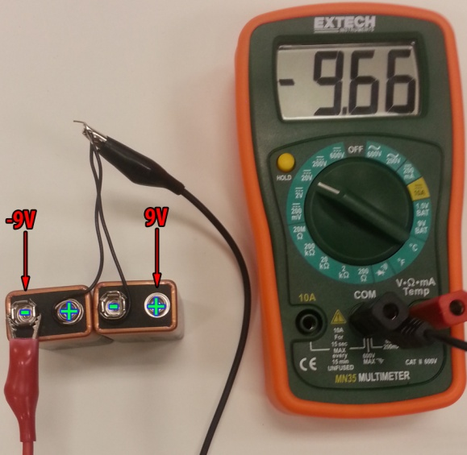
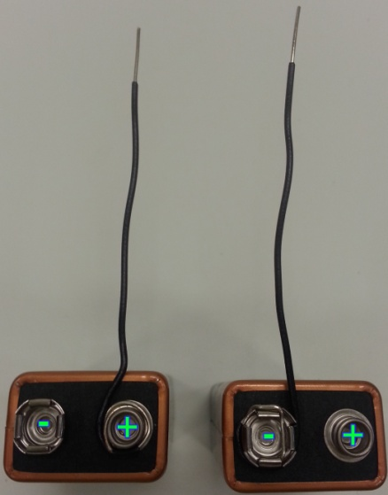

Figure 11B
Figure 11A

- Power Supply – Power Op Amp with +9V
  - Disconnect wires in the previous step.
  - Connect the positive terminal to the positive vertical column on the breadboard.
  - Connect the negative terminal to the negative vertical column on the breadboard.
  - NOTE: Connecting batteries incorrectly may cause the batteries to overheat!
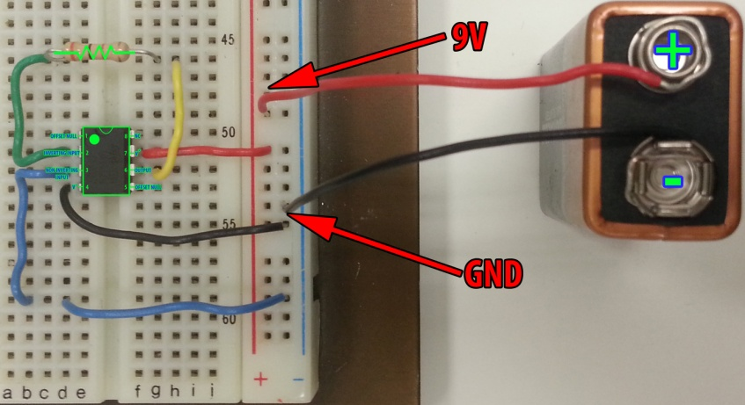
Figure 12

- Power Supply – Power Sensor with -9V
  - Connect the negative terminal to pin 1 of the FlexiForce sensor.
  - Connect a wire to pin 3 of the FlexiForce sensor
  - NOTE: PIN 2 DOES NOT GET USED!!
  - NOTE: Connecting batteries incorrectly may cause the batteries to overheat!
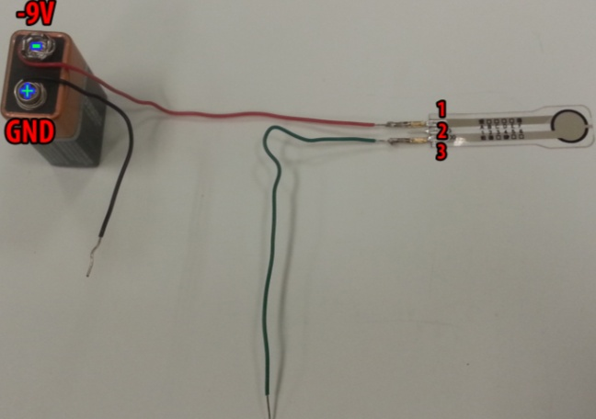

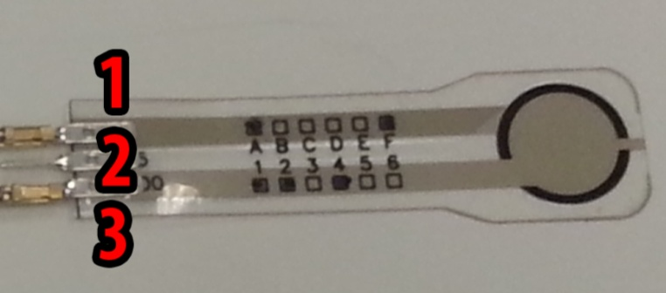

Figure 13B
Figure 13A

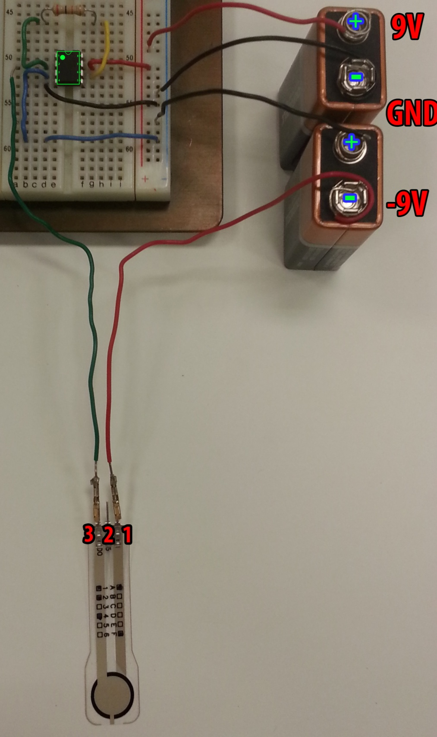
Figure 14
- Connect Sensor to Breadboard
  - Connect the positive terminal of the lower battery to the negative vertical column of the breadboard.
  - Connect pin 3 of the FlexiForce sensor to pin 2 of the op amp.
  - NOTE: Connecting batteries incorrectly may cause the batteries to overheat!

