Roller Coaster Final Model Handout Answer Key

Objective: To build a model of your roller coaster that shows where its potential energy comes from and how its kinetic energy changes over time, and use evidence to explain it in writing.

Phase 1: Review Your Evidence

ASK & RESEARCH | What do you already know from Lesson 4? What are we building toward today?
Instructions: Think back to your Energy Skate Park trials, where you changed height, mass, and friction. Answer the following questions.
What did your data show about where your coaster had the most potential energy? Where did it have the most kinetic energy?
Example answers:
Most Potential Energy: top of each hill/loop Most Kinetic Energy: bottom of each drop

You already found the answer to last activity's mystery: Energy doesn't disappear, it changes form, and a little always leaks out as heat due to friction.
Quick check: What evidence from your Energy Skate Park trials supports this?
Example answer: My Energy Skate Park graphs showed the total energy bar staying the same height while the thermal energy bar grew a little every time the skater crossed a section of track with friction.

Today you'll go further by building a model that shows exactly where your car's potential energy comes from and how its kinetic energy changes as it moves, using your own coaster as evidence. Gather:
- Your team's original paper roller coaster.
- Your data notes or screenshots from the Energy Skate Park simulation.
- Poster paper or a whiteboard, plus markers in at least two colors.

Phase 2: Build Your Model

⭐ Your Challenge: Build a labeled model of your roller coaster that shows where potential energy comes from, how kinetic energy changes as the car moves, and where both are at their maximum and then explain it in writing using eight specific vocabulary words.

PLAN | Decide with the team how you'll divide the work: who traces the track, who labels components, who marks the energy points.

You will label at least three points on your track (for example, A, B, C). At each point, decide: Is the car at its fastest, or does it have the most stored energy?
Answers will vary depending on groups’ rollercoaster models.

CREATE | Build your labeled model, then check it against the criteria below.

Sketch or photograph the team's labeled model, and paste or attach it in the box below.
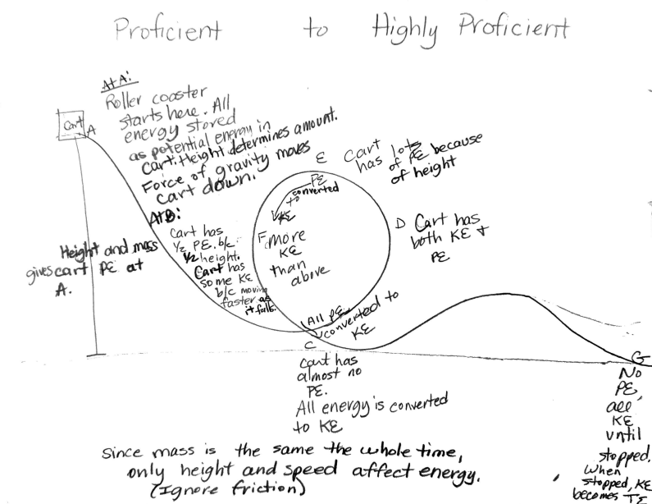
Check your model against this list: Does it label the base, track, every hill/loop/turn, the catch mechanism, and the car? Does it use directional arrows to show the car's motion? Are at least three points labeled with the correct energy type?
Grading criteria: model labels the base, track, every hill/loop/turn, the catch mechanism, and the car; uses directional arrows to show the car's motion; labels at least three points with the correct energy type.

Point | Height (High / Low) |  | Speed (Fast / Slow) | Energy Type (Max PE or Max KE)
A | High |  | Slow | Max PE
B | Medium |  | Medium | Mix of PE and KE (about half of each -- height is dropping but the car is not yet at its fastest)
C | Low |  | Fast | Max KE
D | Medium |  | Medium | Mix of PE and KE (climbing back up out of the loop)
E | High |  | Slow | Max PE
F | Medium-Low |  | Fast | Mostly KE (more KE than at E, since it is lower and faster)
G | Low |  | Fast | Max KE (until the car stops -- once stopped, its remaining KE converts to thermal energy)
IMPROVE |  | Check your point log against your model and fix any point where the energy type doesn't match its height and speed.

If a point's energy type doesn't match (for example, a low point marked as maximum potential energy), relabel it correctly before moving on to Phase 3.
Answers will vary depending on groups’ rollercoaster models.

Phase 3: Analyze & Explain
Complete this part on your own, using the team's labeled model and point log.
Look for the patterns in your own model. Complete each sentence below using evidence from your labeled points. (Example: As the car's height increases, its potential energy increases.)
As the car's height increases, its potential energy increases.
As the car's speed increases, its kinetic energy increases.
As friction acts on the car, some of its mechanical energy converts to thermal energy (heat).

Now fill in each blank using evidence from your model:
The kinetic energy in my model is greatest at the lowest point of each drop (for example, point C or point G).
The potential energy in my model is greatest at the highest points on the track (for example, points A and E).
Energy is lost to thermal energy (friction) continuously, everywhere the car touches the track -- which is why point E is lower than point A.
Even so, the total amount of energy in my system stays the same (conserved) -- it just keeps changing form.

Write your final model paragraph:
- Walk your reader through your model from start to finish, point by point.
- Explain where your car's potential energy comes from, give evidence for how its kinetic energy changes as it moves, and explain what happens to the energy that converts to heat due to friction.
- Your paragraph MUST use all eight of these words: kinetic energy, potential energy, mass, speed, height, work, gravity, force.

EXAMPLE HIGHLY PROFICIENT ANSWER: My roller coaster's car has the same mass throughout its trip, so only its height and speed determine how its energy changes. At point A, the car is at the highest point on the track, so gravity has pulled it up as far as it will go and it is moving the slowest -- this means the car has its maximum potential energy here. Getting the car up to point A in the first place took work, because a force (my hand, or the release mechanism) moved the car's mass up through a height before I let go. As the car rolls from point A toward point B, gravity pulls it downhill, so its height is dropping and its speed is increasing -- but it hasn't finished converting all of its potential energy into kinetic energy yet, so at point B the car has roughly half potential energy and half kinetic energy. By point C, the car has reached the bottom of the first drop, so it's moving at its fastest and lowest point on that section of track -- almost all its energy is now kinetic. As the car climbs into the loop toward point E, its speed decreases and its height increases again, so its kinetic energy is transforming back into potential energy; at point E, the car is back near its maximum height inside the loop, so its potential energy is high again. Coming down to the other side of the loop at point F, the car has picked up speed and lost height compared to E, so it has more kinetic energy than it did at E. At point D, on the way back up out of the loop, the car is slowing down and gaining height again, so it once again has a mix of both kinetic and potential energy. Finally, as the car rolls down the last hill toward point G, its potential energy converts into kinetic energy one final time, and it has almost no potential energy left. Notice that the second peak (E) is lower than the first peak (A) -- that's because a little bit of the car's total energy converts into thermal energy through friction with the track every time it passes over a section, so slightly less mechanical energy is available at each hill after the first. Once the car finally comes to a stop at the end of the track, its remaining kinetic energy also converts into thermal energy, since it isn't moving anymore. Even so, the total energy in the whole system -- mechanical plus thermal -- is conserved: it isn't created or destroyed, it just keeps changing form as the car travels from point A to point G.
Vocabulary check: kinetic energy (yes), potential energy (yes), mass (yes), speed (yes), height (yes), work (yes), gravity (yes), force (yes) -- all eight required terms appear and are used to explain cause-and-effect, not just listed. This answer also goes beyond Proficient by identifying points (B and D) where the car has a mix of potential and kinetic energy rather than a maximum of either, comparing relative kinetic energy between two points (E and F), and explaining what happens to the car's energy once it comes to a complete stop.

