Can Crusher Challenge Worksheet
Objective: To make a can crusher that crushes a soda can the best and identify what works best using the least amount of energy.
Part One: “Would You Rather”
Would you rather… (I hope you never do, but assuming you did) accidentally bump into your garage driving a Tesla Model X or a Ford F-150? Assume your goal is to do the least amount of damage possible. Use your best scientific reasoning to make your choice. Here are some stats about each vehicle.
TESLA MODEL X  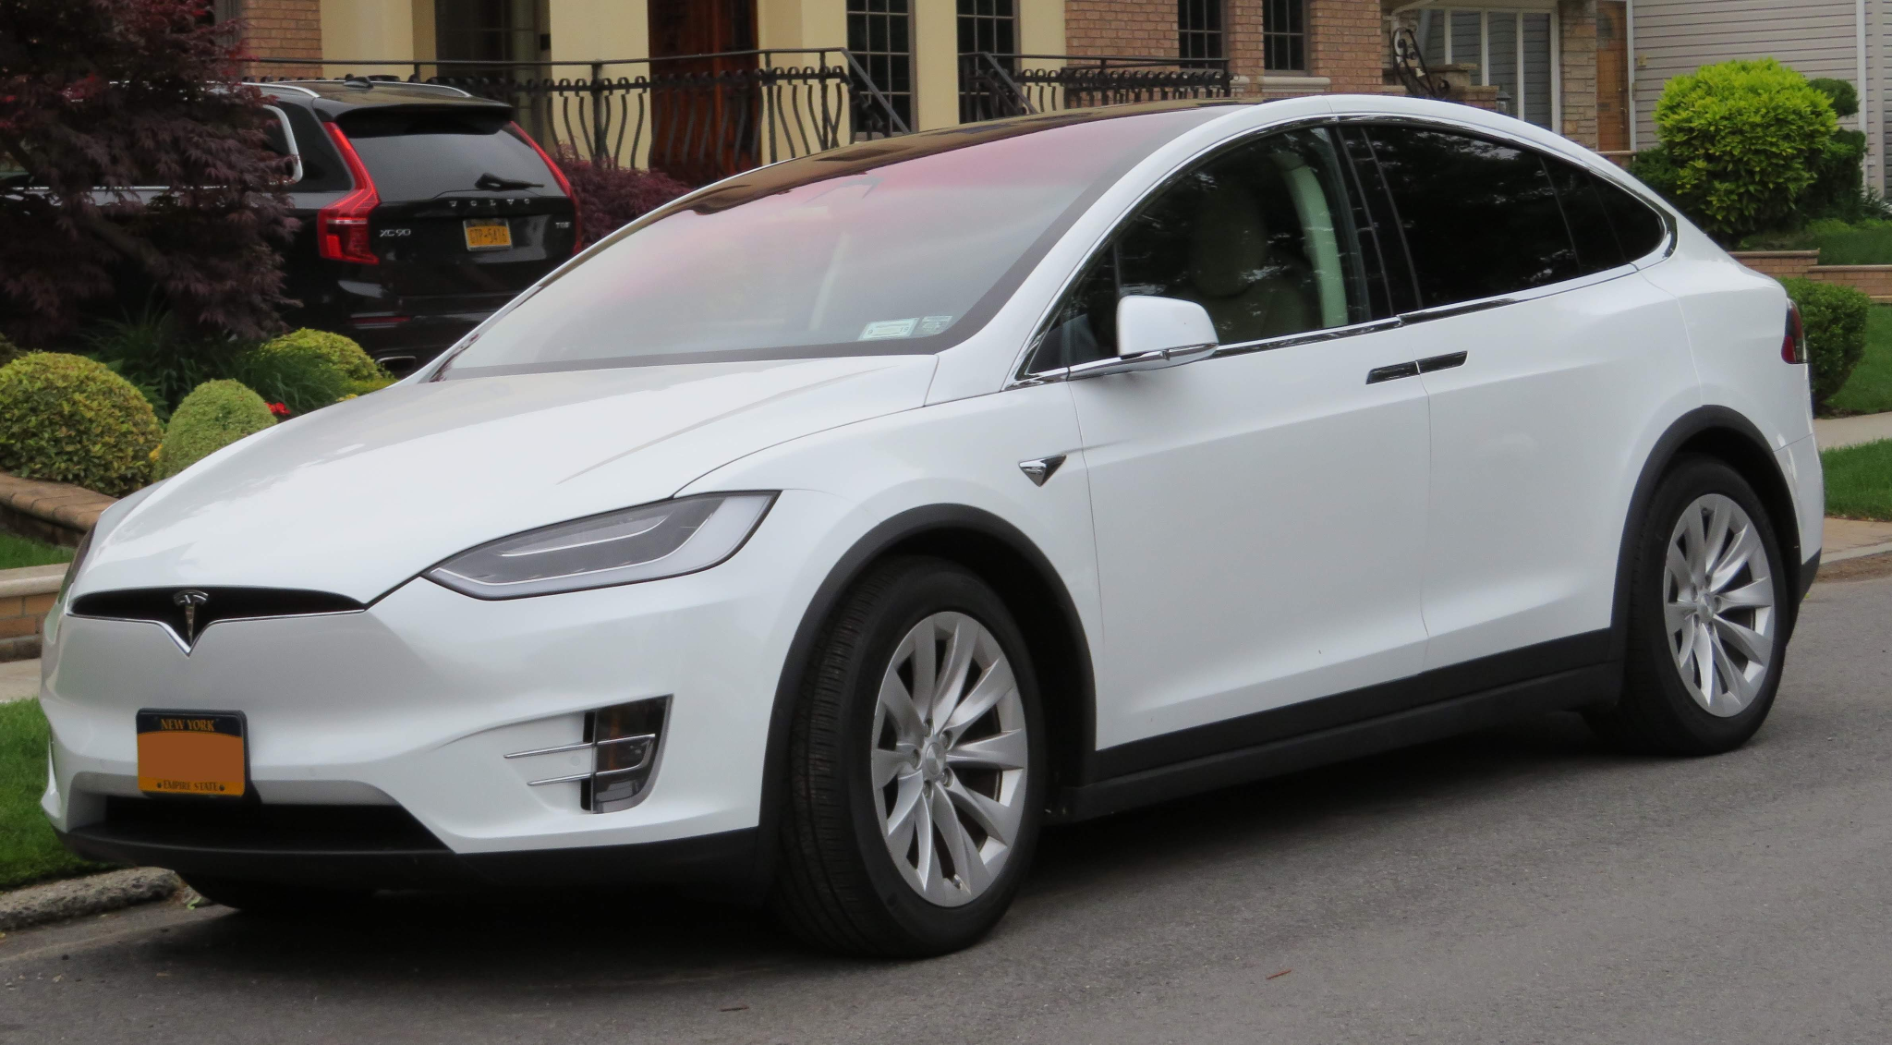  Fig. 1  ACCELERATION: 0 to 60 in 3.8 seconds  WEIGHT: 5,185 lbs  MAX SPEED: 155 miles per hour | FORD F-150  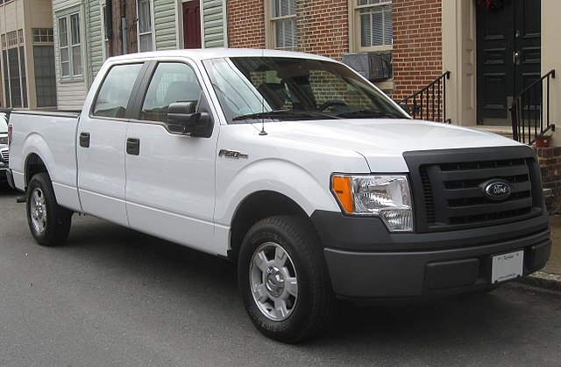  Fig. 2  ACCELERATION: 0 to 60 in 6.8 seconds  WEIGHT: 4,021 lbs  MAX SPEED: 96 miles per hour
Pick a vehicle and explain your thinking.
Document some of the explanations from other students.
Watch the first minute or so of the car crusher video.
What do you observe?
What questions do you have that would help you understand how it works?
Part 2: Design Challenge
Your challenge: Today you are going to try to make a crushing machine that requires no gas or electricity. Your goal is to make a can crusher that fully crushes a soda can using the least amount of energy. Your team can use up to 6 cans to test, so plan your tests wisely. You must collect evidence from each test.
Materials: 8 ft x 4 in irrigation PVC pipe with holes, drain pipe cap, large nail that goes through the pipe, tough water bottles, water, at least 6 empty soda cans
Each group will: Cover a can with a drain cap. Place the can on the floor and cover it with the drain pipe standing upright. Put a nail through the holes to hold the water bottle into position. Pull the nail when you are ready to crush the can.
What questions do you have before you begin?
Make a model of what you think will work best. (Remember you want to fully crush the can using the least amount of energy.) Why do you think this will work?
Build your crusher. Draw/photograph your setup.
Take careful notes of what works and what does not work and document this in the chart below.

Trial | Describe the setup. Be specific. (Note your mass, setup—full, half, or empty water bottle—and your drop height/hole position.) | Picture of the crushed can. Can also include height of can (use a ruler) if you want to be more precise.
1
2
3
4
5
6
Describe the setup that crushed the can using the least amount of energy.
Redesign your crusher. Draw/photograph your redesigned setup.
Summary: Make a model of the can crusher system that worked best for your team. Make sure to:
- Identify how you set up your crusher (be specific about your mass and height variables).
- Label where the system has the most potential energy (PE) before the bottle is dropped.
- Use arrows to show where it transforms into kinetic energy (KE) during the drop.
- Explain why this particular setup worked best (crushed with the least amount of energy).
The system: Can crusher

Reflection: Where does the energy come from that makes the can crusher work?

