What Are Polymers?
Polymers are long chains of repeating molecules.
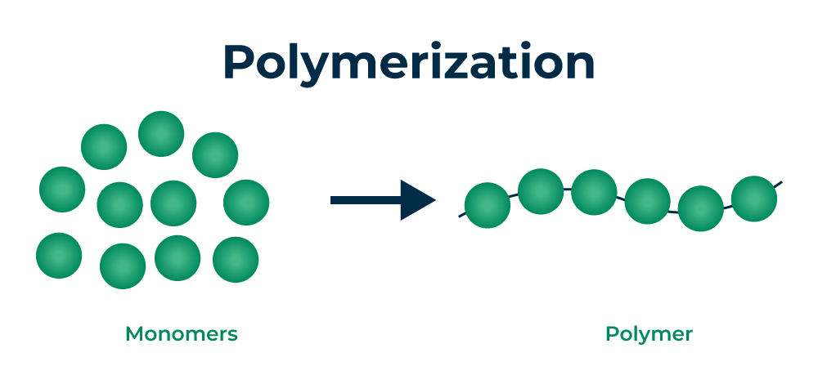
Google. (n.d.). Polymers [Image search]. Retrieved June 16, 2025, from https://www.google.com/imghp.
Like beads on a necklace - the beads are the repeating parts.
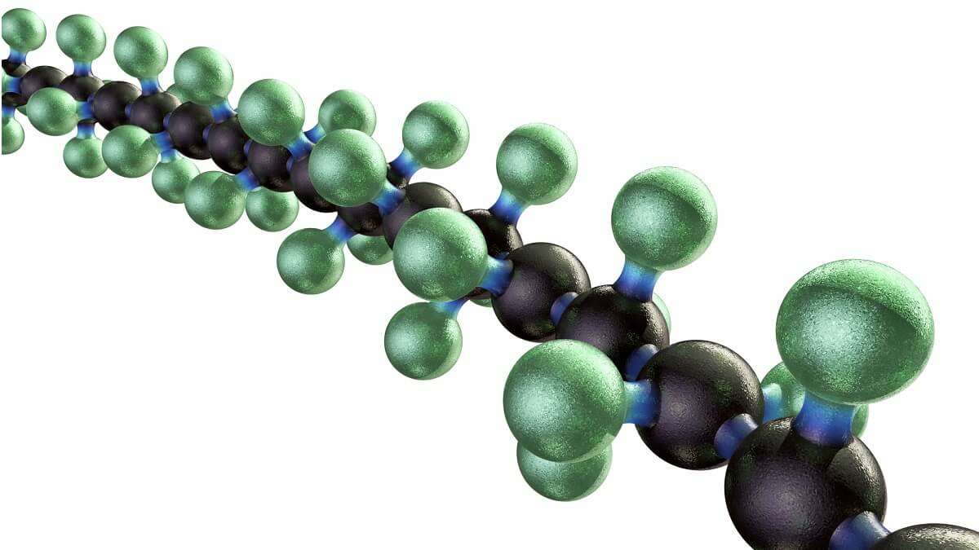
Perkins, S. (2017, October 13). Explainer: What are polymers? Cosmos. Retrieved June 16, 2025, from https://cosmosmagazine.com/science/explainer-what-is-a-polymer.
They can be natural like DNA or man-made like plastic.
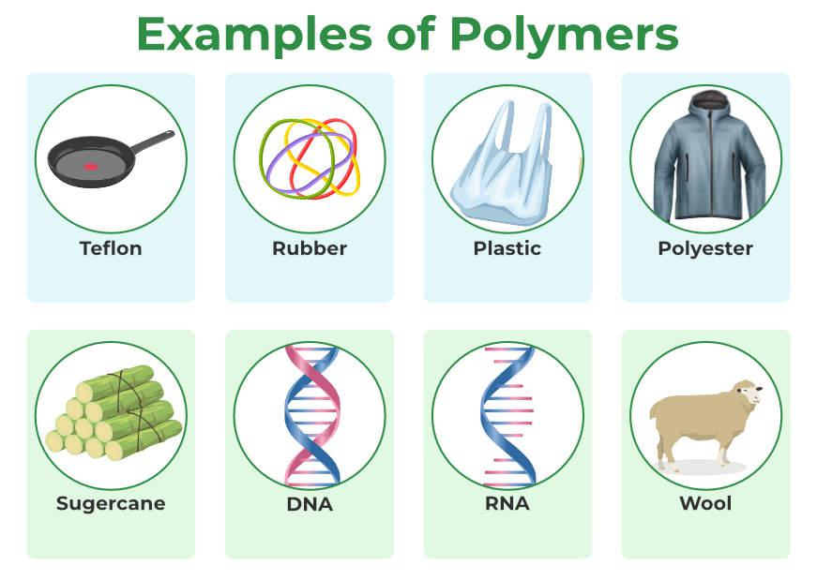
GeeksforGeeks. (2023, July 4). Examples of polymers [Image]. Retrieved [today's date], from https://www.geeksforgeeks.org/polymers.
The polymer chains can be permanently linked together through bonds called cross-linking, or the polymer chains can be entangled/tangled together.
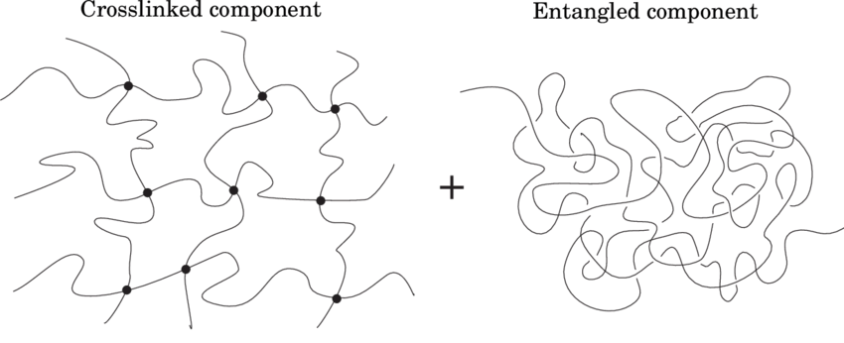
Davidson, J. (2014). The free energy of a crosslinked, entangled network is determined by Rubinstein and Panyukov by assuming a decomposition into crosslinked and entangled components [Figure 22]. In Multiscale modeling and simulation of crosslinked polymers. ResearchGate. Retrieved June 16, 2025, from https://www.researchgate.net/figure/The-free-energy-of-a-crosslinked-entangled-network-is-determined-by-Rubinstein-and_fig12_295404630.

Hydrogels
Polymers that like to hold water.
They soak up or absorb LOTS of water.
They can feel like jelly or slime.
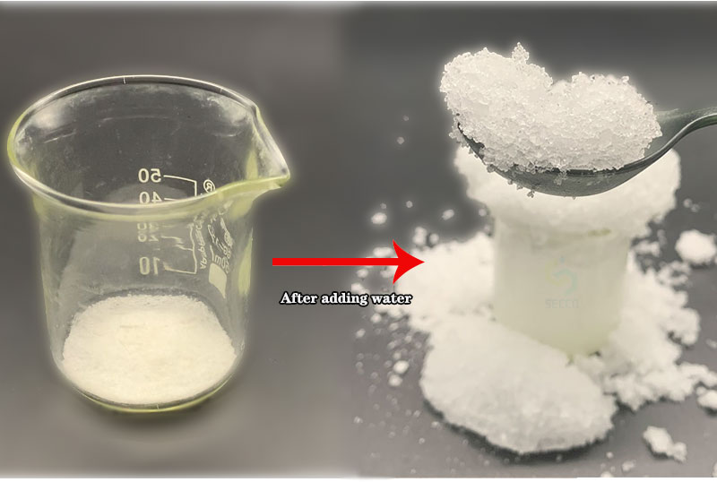
Henan SECCO Environmental Protection Technology Co., Ltd. (2021). Industrial grade sodium polyacrylate [Image]. Retrieved June 16, 2025, from https://www.hnsecco.com/Industrial-grade-sodium-polyacrylate.html.
They are used in:
- Diapers (Sodium Polyacrylate)
- Gel Bandages (Alginate)
- Gelatin
- Contact Lenses
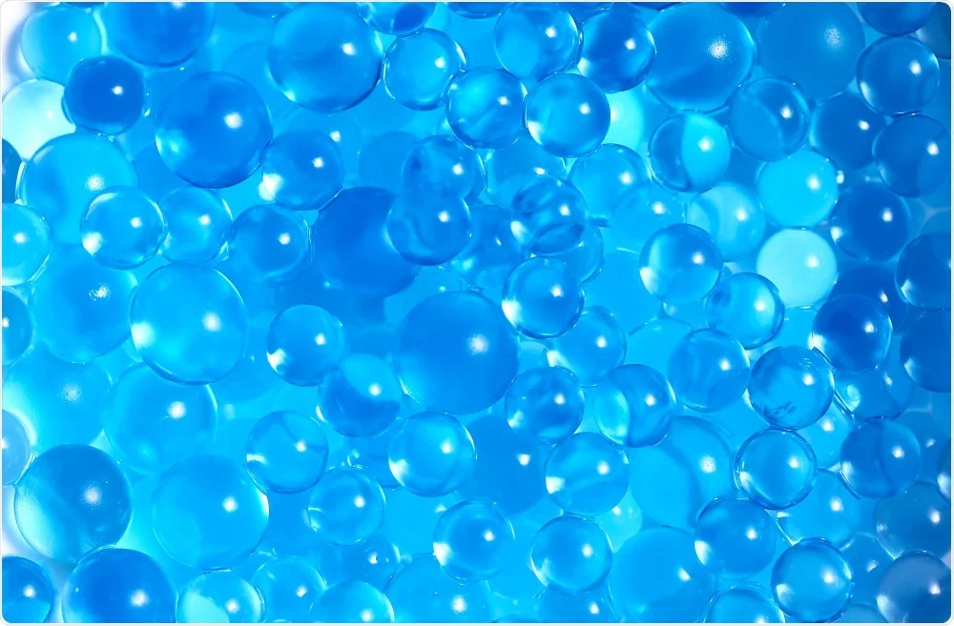
AZoLifeSciences. (2020, February 8). The use of natural hydrogels in food and agriculture practices. Retrieved June 16, 2025, from https://www.azolifesciences.com/news/20200208/The-use-of-natural-hydrogels-in-food-and-agriculture-practices.aspx.

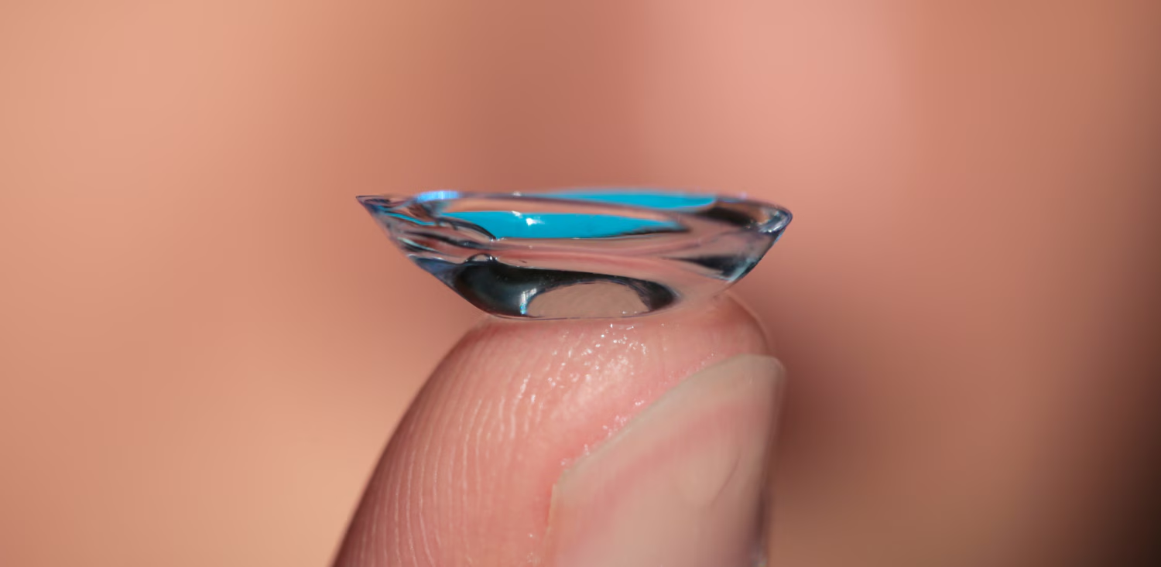
ContactsDirect. (n.d.). Silicone hydrogel contact lenses [Image]. Retrieved June 16, 2025, from https://www.contactsdirect.com/silicone-hydrogel-contact-lenses#.

Elastomers
SUPER STRETCHY polymers.
They can handle EXTREME HEAT and COLD.
They are bendy and flexible.
They do not crack easily.

They are used in:
- Tires (Rubber)
- Baby Pacifiers
- Medical Tubes
- Space Suits
- Silicone
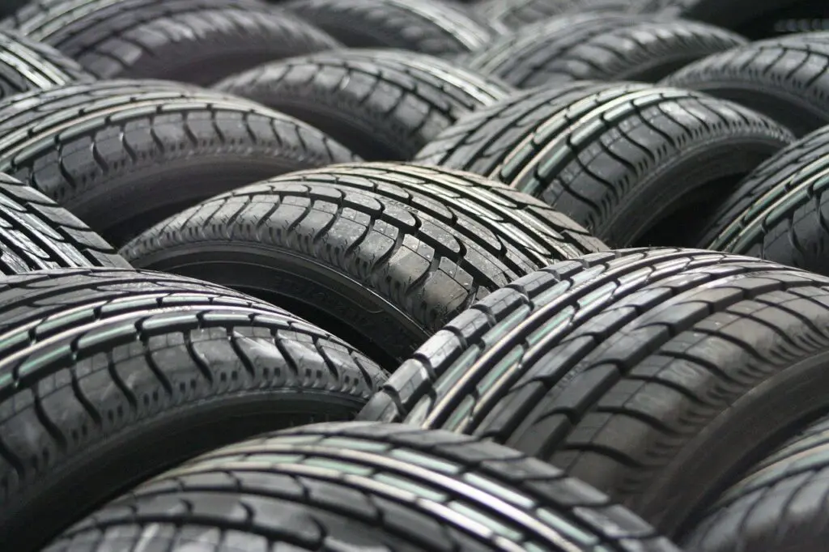
Wikipedia. (2015, April). Elastomer: Structure of polymer chains [Image]. Retrieved June 16, 2025, from https://en.wikipedia.org/wiki/Elastomer.
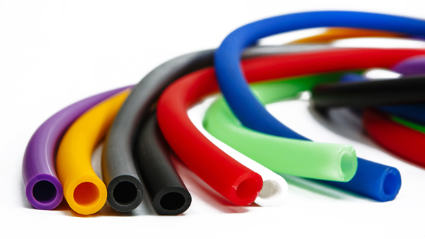
Timco Rubber. (2024, February 14). Silicone vs. plastic: Material comparison. Retrieved June 16, 2025, from https://www.timcorubber.com/blog/archive/silicone-vs-plastic-material-comparison.

Allen, B. (2019, January 22). Why use thermoplastic elastomer (TPE) over rubber (LSR) when manufacturing injection molds for pet toys & consumer goods. Tech-Tank. Retrieved June 16, 2025, from https://tech-tank.com/why-use-thermoplastic-elastomertpe-over-rubberlsr-when-manufacturing-injection-molds-for-pet-toys-consumer-goods.

Conductive Polymers
Polymers that carry ELECTRICITY.
They are thin and bendy.
Used in touchscreens and solar panels.
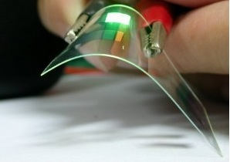
Geoset. (n.d.). Discovery and development of conductive polymers. Retrieved June 16, 2025, from https://www.geoset.info/presentation/discovery-and-development-of-conductive-polymers.
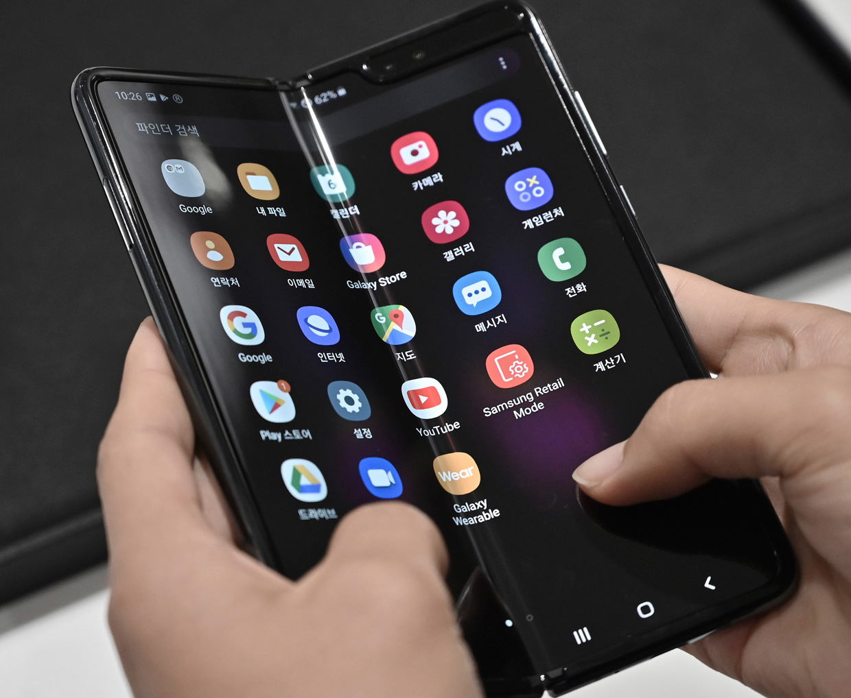
Zhou, H., & Lee, T.-W. (2020, October 22). From foldable phones to stretchy screens. IEEE Spectrum. Retrieved June 16, 2025, from https://spectrum.ieee.org/from-foldable-phones-to-stretchy-screens.
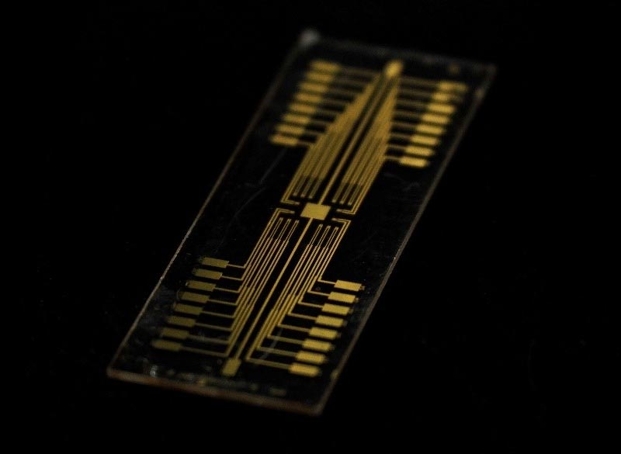
SciTechDaily. (2020, June 24). Ion conducting polymer crucial to improving neuromorphic devices. Retrieved June 16, 2025, from https://scitechdaily.com/ion-conducting-polymer-crucial-to-improving-neuromorphic-devices.

Coating Polymers
Paint that can be used for:
1 - Decoration
2 - Protection (waterproofing, corrosion, scratches)
3 - Special properties (non-stick or increase friction)
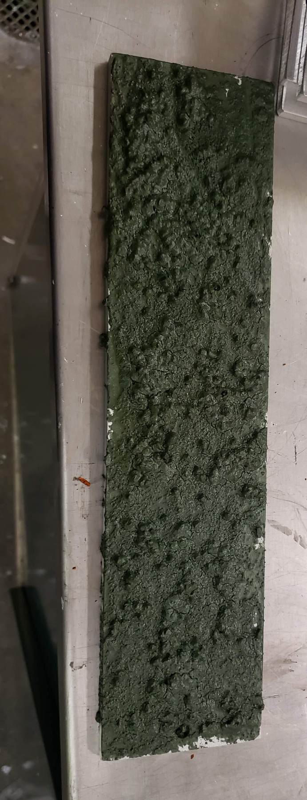
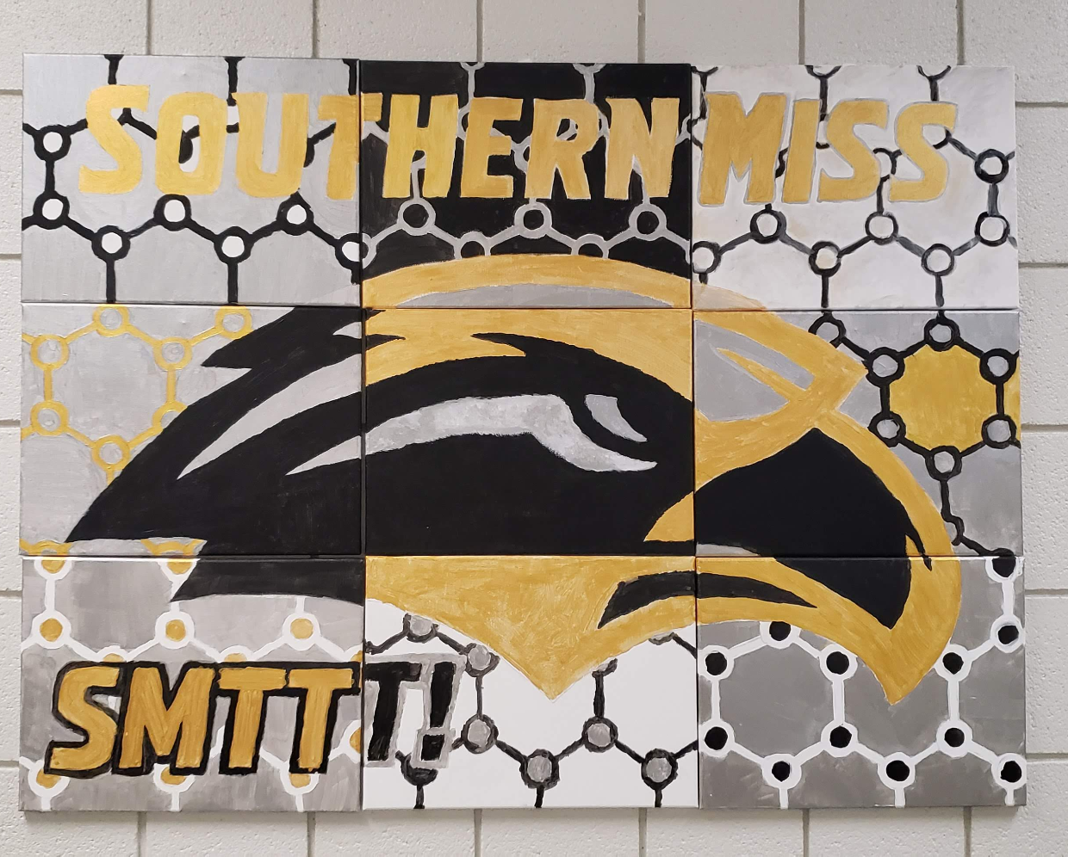
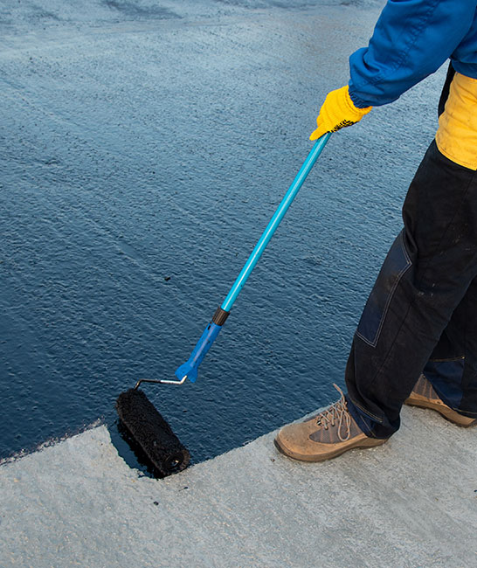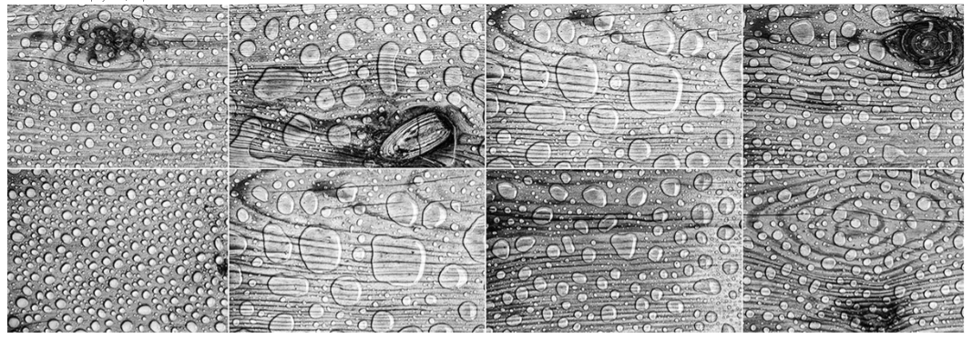
Gellner Industrial. (n.d.). Polymer coatings. Retrieved June 16, 2025, from https://www.gellnerindustrial.com/products/polymer-coatings.

Adhesives
STICKY
Form STRONG BONDS between various materials like wood, metal, plastic, glass, and ceramic.
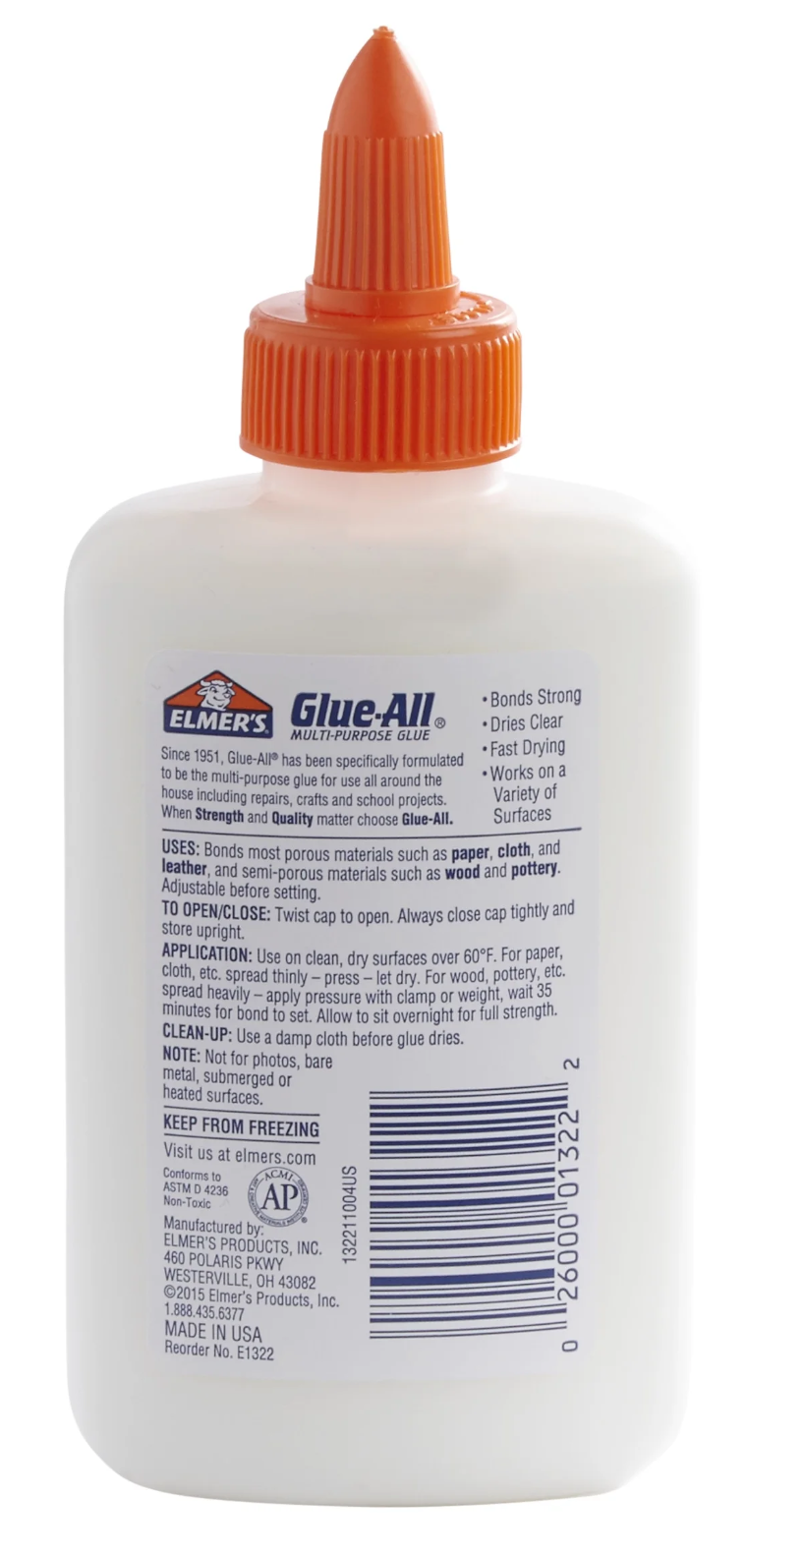
Ubuy Nepal. (n.d.). Elmer’s Glue-All, 4 oz – Multi-purpose adhesive. Retrieved June 16, 2025, from https://www.nepal.ubuy.com/en/product/4RYOR6Y-elmer-s-glue-all-multi-purpose-glue-4-oz.
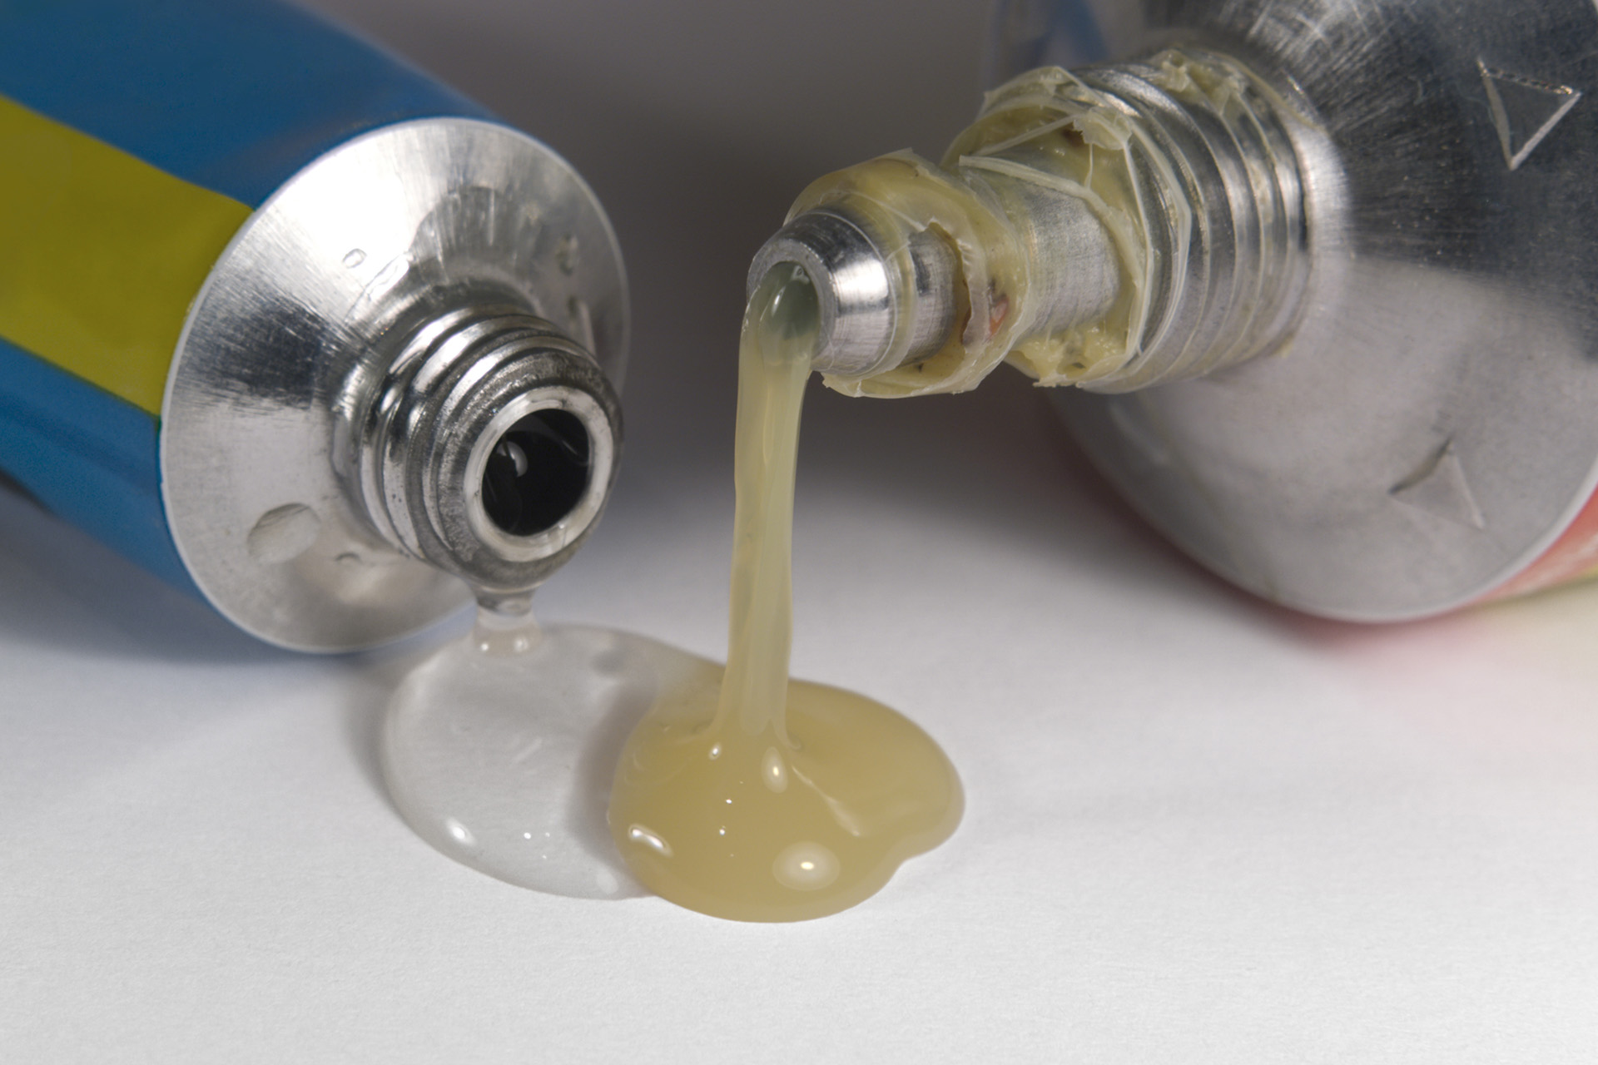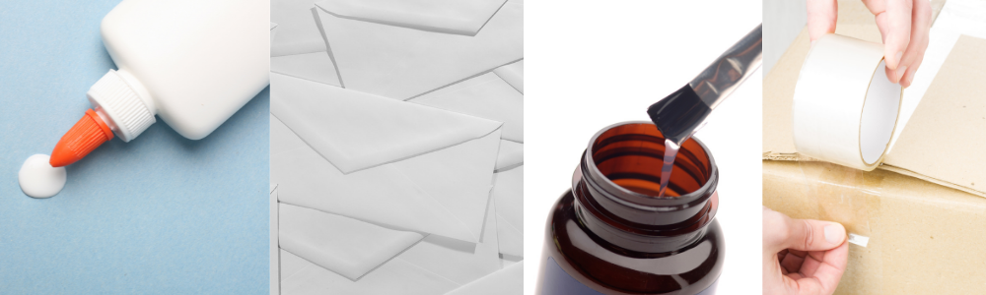
EcoEnclose. (n.d.). Eco-friendly adhesives in the world of sustainable packaging. Retrieved June 16, 2025, from https://www.ecoenclose.com/blog/ecofriendly-adhesives-in-the-world-of-sustainable-packaging.

Polyelectrolytes
Polymers that can dissolve in water AND can carry or hold tiny ions.
Used to clean water or drug delivery in the body.
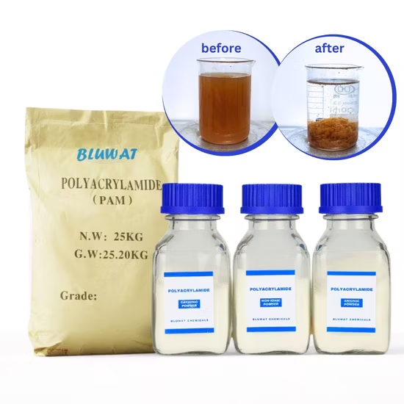
Bluwat Chemicals. (n.d.). Anionic polyelectrolyte polymer for water treatment flocculation. Retrieved June 16, 2025, from https://bluwat01.en.made-in-china.com/product/noOQhiXUbmVj/China-Anionic-Polyelectrolyte-Polymer-for-Water-Treatment-Flocculation.html.

Drug Delivery Example: The medicine is in green and the polymer in red.
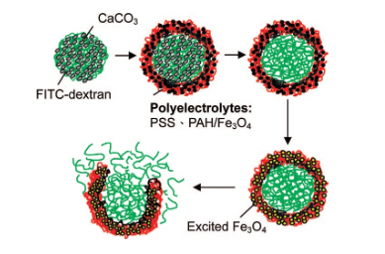
Encyclopedia.pub. (n.d.). History. Retrieved June 16, 2025, from https://encyclopedia.pub/entry/history/show/2530.

Polymer Fibers
LONG and STRONG Polymers.
They are shaped like long threads or string.
They can be stretchy and woven into fabrics.
Used in clothes (silk, wool, polyester and Spandex/Lycra),
ropes and nets (Nylon).
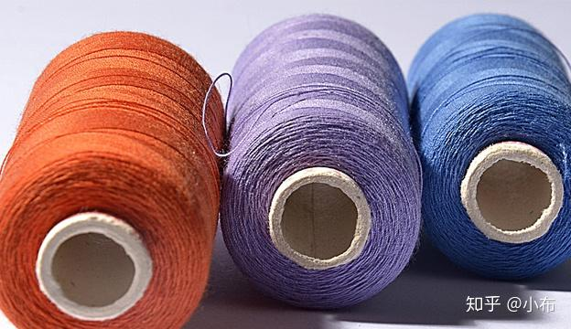
Fiber Machine. (n.d.). Difference between polyester filament and staple fiber. Retrieved June 16, 2025, from https://fiber-machine.com/en/difference-between-polyester-filament-and-staple-fiber.
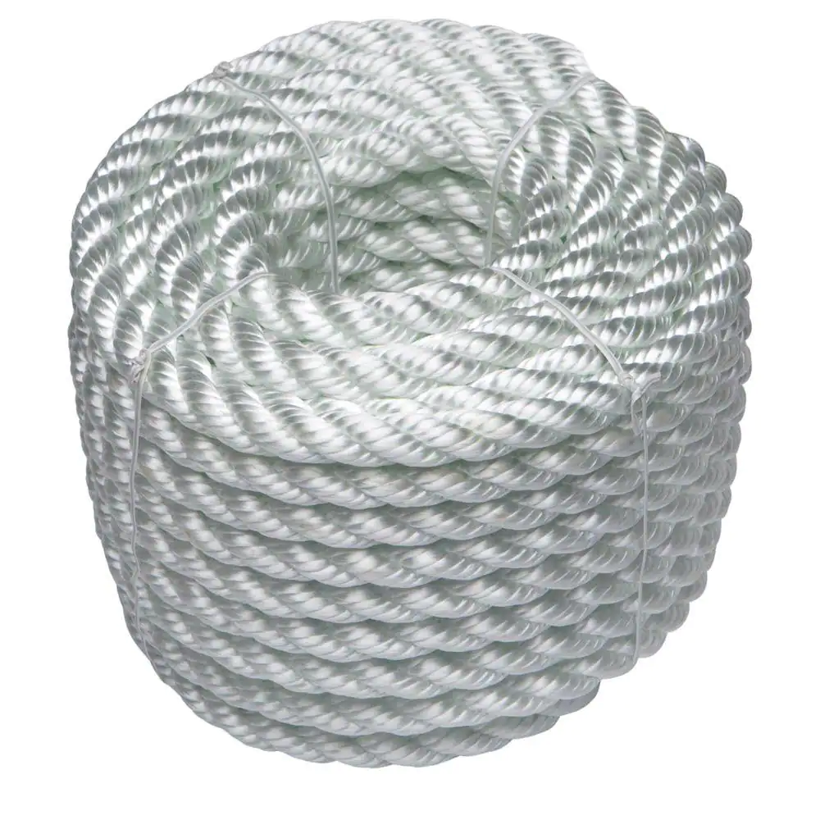
The Home Depot. (n.d.). Everbilt 1/2 in. x 50 ft. White Twisted Nylon Rope. Retrieved June 16, 2025, from https://www.homedepot.com/p/Everbilt-1-2-in-x-50-ft-White-Twisted-Nylon-Rope-73272/206094359.
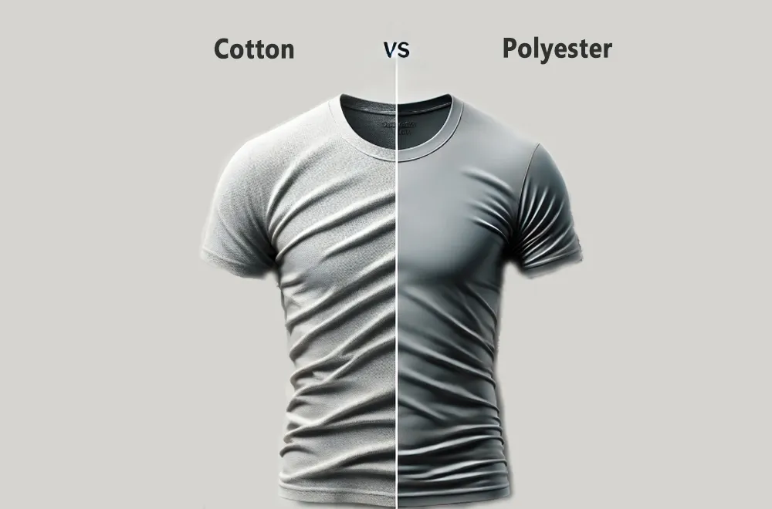
NW Custom Apparel. (2025). Cotton vs polyester: Finding the best fabric for your business [Image]. Retrieved June 17, 2025, from https://nwcustomapparel.net/wp-content/uploads/2025/01/cotton-vs-polyester-shirts.webp.
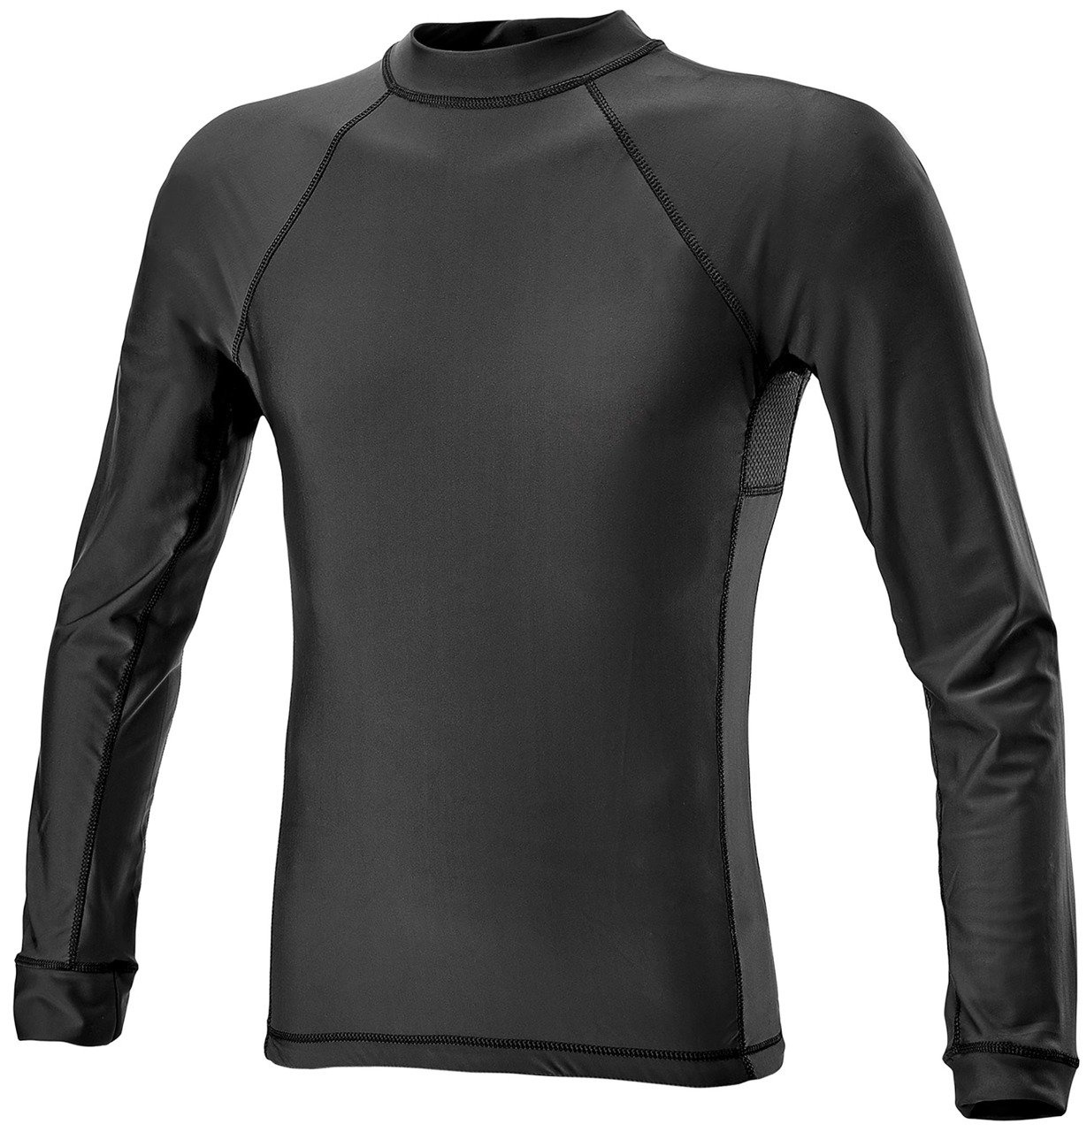
MilitarySurplus.eu. (n.d.). Long sleeve Lycra shirt – DEFCON 5® – Black [Image]. Retrieved June 17, 2025, from https://www.militarysurplus.eu/product-eng-24186-LONG-SLEEVE-LYCRA-SHIRT-DEFCON-5-R-BLACK.html.
Composites
A mix of 2 or more materials. One is usually a polymer such as epoxy. They combine the best parts of each material such as STRONG and LIGHTWEIGHT!
Composites are in airplanes, car parts, and skateboards.
Example: Formica
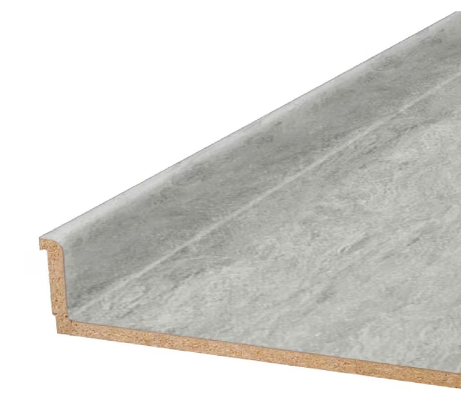
Lowe’s Home Improvement. (n.d.). VT Dimensions 96 in × 25 in White Bardiglio, matte laminate countertop with integrated backsplash [Image]. Retrieved June 17, 2025, from https://www.lowes.com/pd/VT-Dimensions-96-in-x-25-in-x-0-75-in-White-Bardiglio-9306-58-Straight-Laminate-Countertop-with-Integrated-Backsplash/5013790395.
Example Below: Carbon/Epoxy Fiber
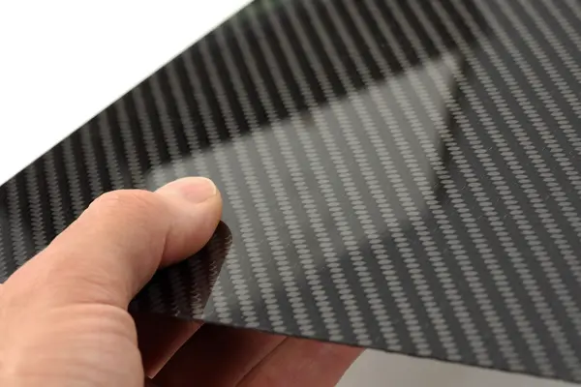
Google. (n.d.). Carbon/epoxy fiber [Image search result]. Retrieved June 17, 2025, from https://images.google.com.
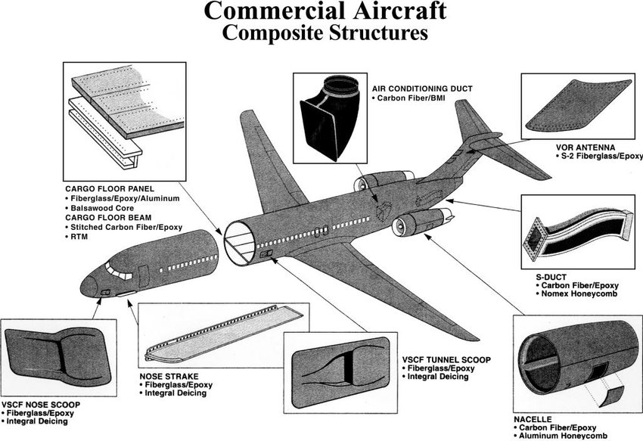
Mohammed, A. G. (2014). Commercial aircraft composite structure (Courtesy of Composites Horizon Inc.) [Figure 6]. In Experimental and numerical approach to study the mechanical behavior of the filament wound composite leaf spring. ResearchGate. Retrieved June 17, 2025, from https://www.researchgate.net/figure/Commercial-aircraft-composite-structure-Courtesy-of-Composites-Horizon-Inc_fig6_337330958.
Plastic Polymers
Moldable, Solid Polymers: They can be hard, soft, clear, colorful, thin and/or thick. They are easy to shape. They are cheap and durable. They can be recycled. They float.

Polyethylene Terephthalate, PET,  ♳1  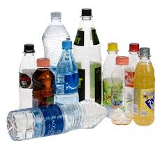  RUNI A/S. (n.d.). Empty PET‑bottles before compacting [Image]. Retrieved June 17, 2025, from https://www.compactor-runi.com/compacting/plastic-containers/pet-bottles.  Low-Density Polyethylene, LDPE  ♳4  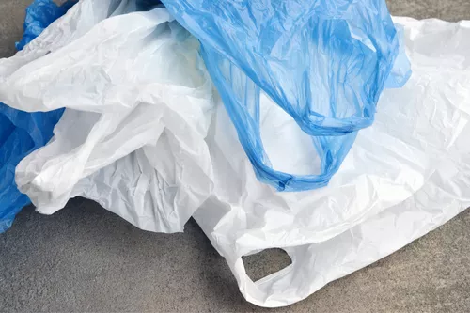  CDDL Recycling. (2025, May 13). LDPE waste collection [Image]. Retrieved June 17, 2025, from https://cddlrecycling.co.uk/the-truth-about-ldpe-plastic-recycling.  Polystyrene, PS,  ♳6  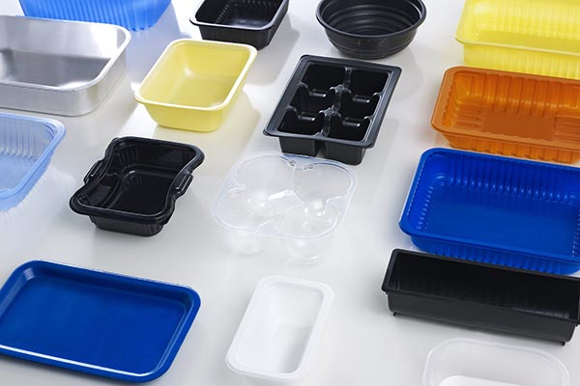  DESU Technology (Shanghai) Co., Ltd. (2023, January 1). Polystyrene PS plastic sheet. DESU Technology. https://desuplastic.com/polystyrene-ps-plastic-sheet. | High-Density Polyethylene, HDPE, ♳2  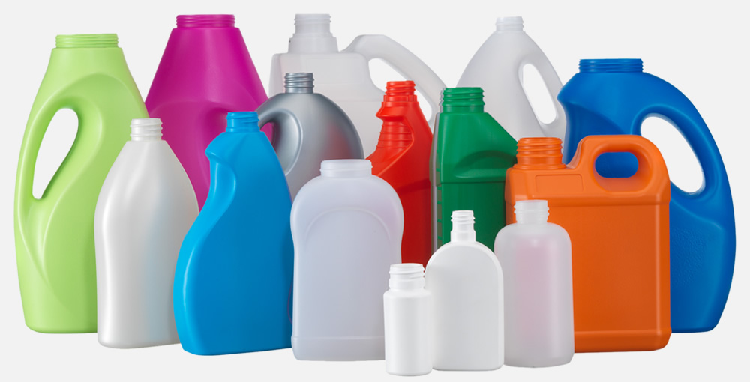  FillPlas. (n.d.). Blow molding for making plastic bottles and plastic bottles. Retrieved April 20, 2025, from https://fillplas.com/blow-molding-making-plastic-bottles-plastic-bottles.  Polypropylene, PP,  ♳5  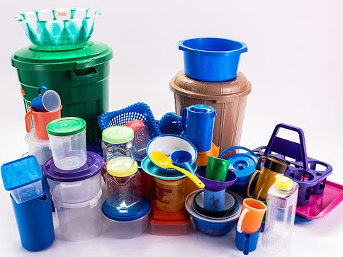  EuP Egypt. (n.d.). PP plastic: Everything you need to know about polypropylene. Retrieved June 17, 2025, from https://eupegypt.com/blog/pp-plastic.  Polyvinyl Chloride, PVC, ♳3  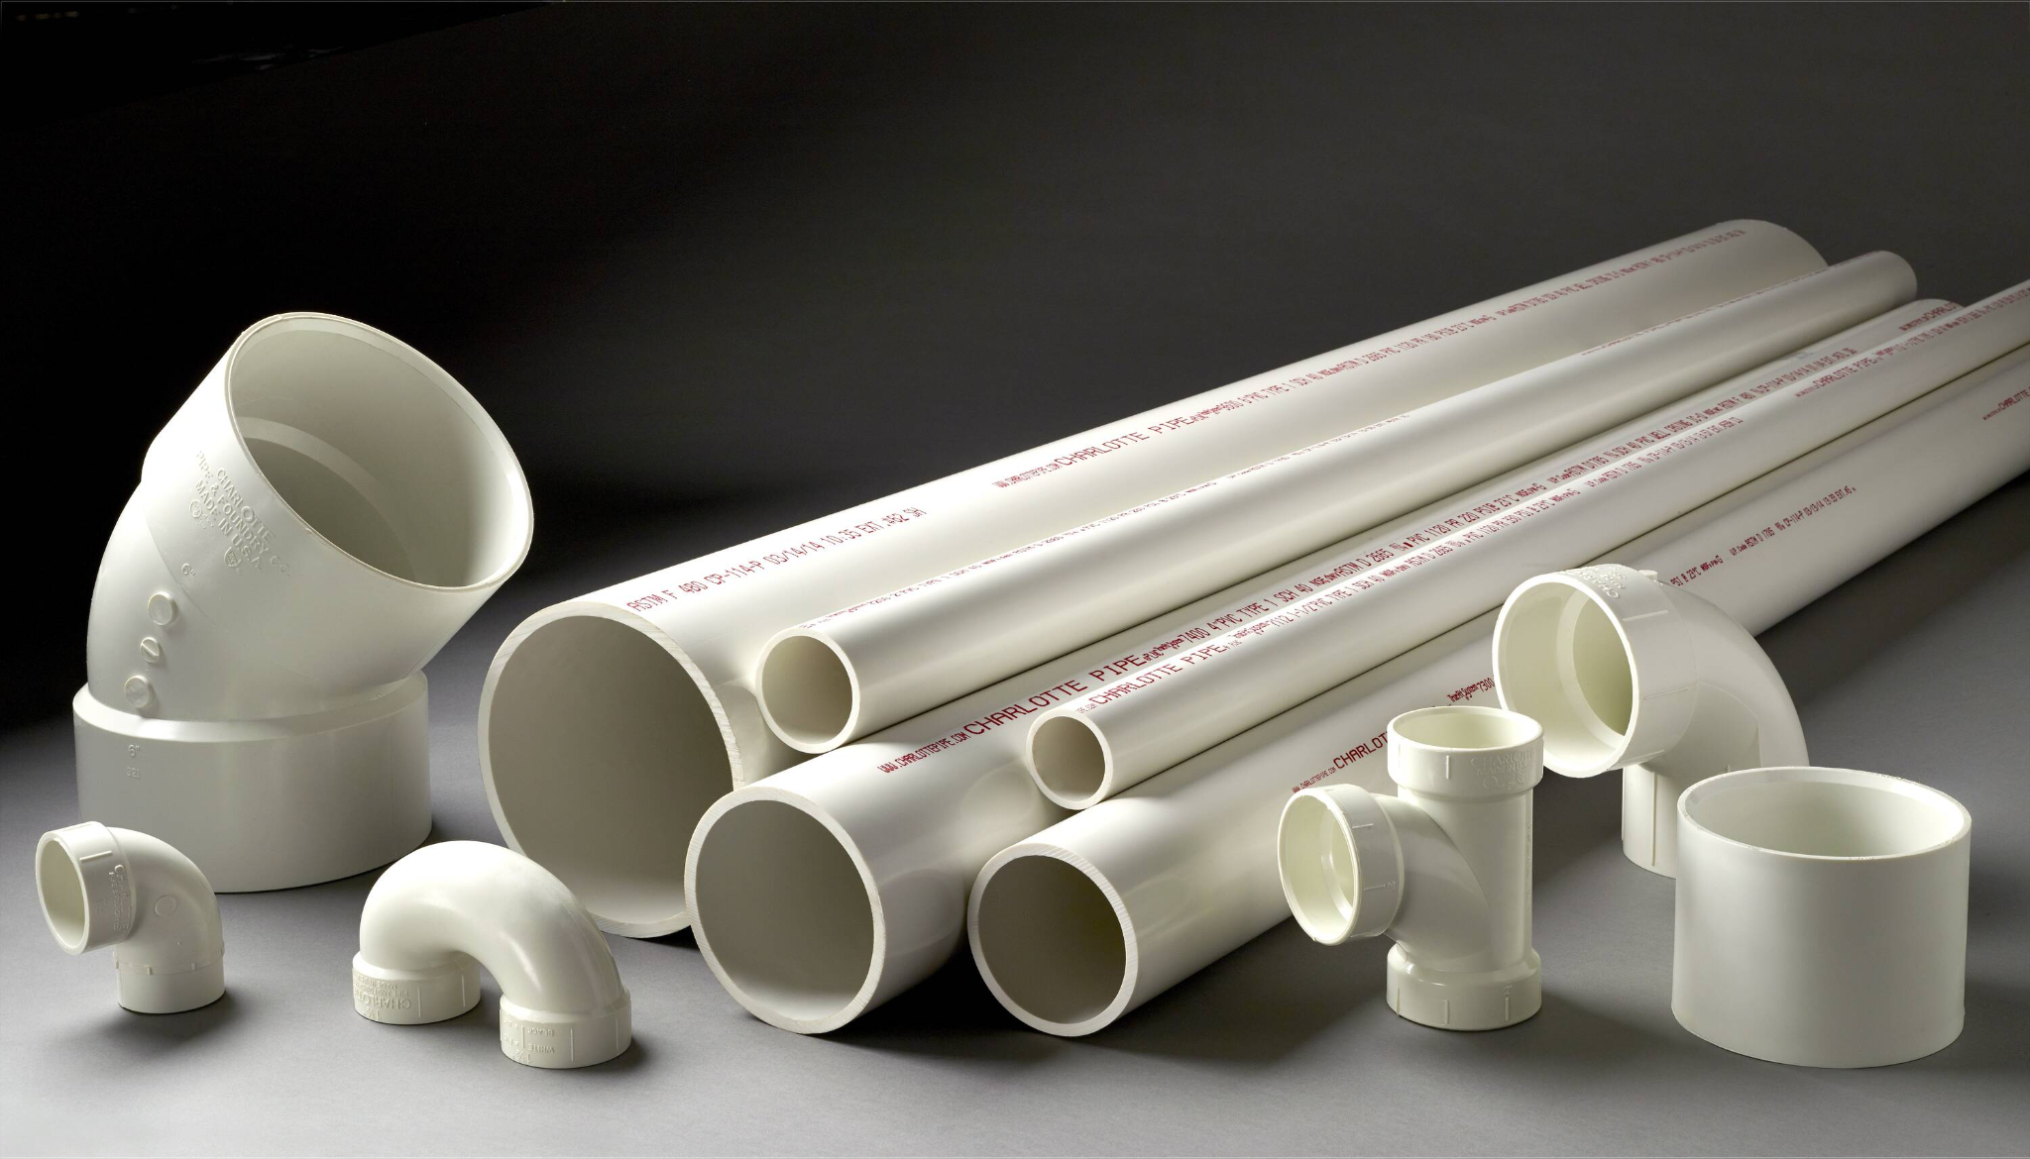  Lowe’s. (n.d.). Charlotte Pipe 1-1/2-in x 10-ft 330 Sch 40 Solidcore PVC DWV Pipe. Retrieved June 17, 2025, from https://www.lowes.com/pd/Charlotte-Pipe-1-1-2-in-x-10-ft-330-Sch-40-Solidcore-PVC-DWV-Pipe/3133037.

