Robot Design/Prototype Handout Teacher Example

Biome Name: Benthic Zone: Deep Ocean

Directions:
- Fill in your assigned Biome Name above.
- Use 5 different polymers in your robot design.
- You can use the same polymer more than once, in different parts of your robot.
- On your Robot Design/Prototype Handout, draw and label your robot.
Make sure to include:
- The polymer name
- Where each polymer is used on the robot
- Why you chose that polymer. What is it good at? (What is its special property?)
- How the polymer will help your robot work in your biome. What characteristics of the biome (like heat, cold, water, sand, etc.) makes that polymer a good choice?

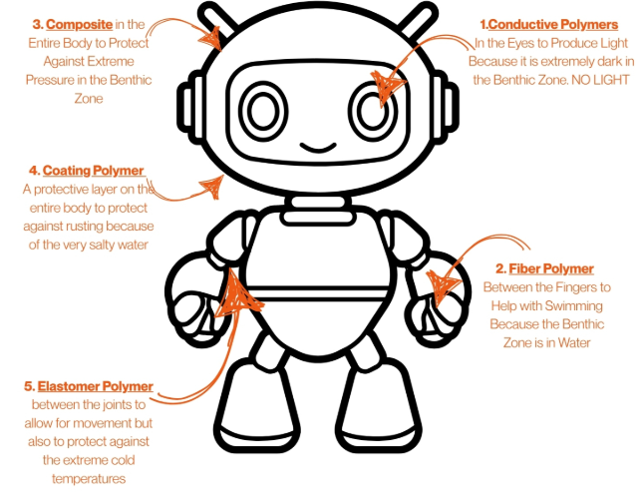
Canva. (2023). Colorful robot illustration [Image]. Canva. https://www.canva.com

