Student Examples

Sample preparation and analysis for round 1:

Brown melanin | Yellow melanin | Feathers | Scales | Hair | Cuticle/  exoskeleton | Structural coloration
Added 10 grams of protein powder after Procedure Step #7 | Added 5 drops of yellow food coloring after Step #10 | Added 52 feathers of different sizes and colors to the sample after Step #15. Feathers were stuck into sample at an angle. | Added 30 nails of close to the same size after Step #15 | Added 2- 53cm long thin plastic strands after Step #15 | Added a 2nd surface layer of a 30 ml cured solution that was created with 15 g of corn starch, 60 ml of water, 5 ml of vinegar, 10 ml of glycerin | Added 1 g of green glitter after Step #10

Sample preparation and analysis for rounds 2 and 3:

Brown Melanin | Yellow Melanin | Feathers | Scales | Hair | Cuticle/  Exoskeleton | Structural Coloration
Sample 2  Added 5 grams of protein powder after Step #7 | Sample 2  Added 3 drops of yellow food coloring after Step #10 | Sample 2  Added 36 blue feathers that were close to the same size to the sample after Step #15. Feathers were stuck into sample at an angle. | Sample 2  Added 50 nails that were different sizes after Step #15 in an overlapping pattern | Sample 2  Added 80- 1.3 cm long thin plastic strands after Step #15 in a unified/spaced out pattern. | Sample 2  Added a 2nd surface layer of a 30mL cured solution that was created with 15g of corn starch, 60mL of water, 5mL of vinegar, 5mL of glycerin | Sample 2  Added 1 gram of green glitter after Procedure step #15
Sample 3  Added 8 grams of protein powder after Step #7 | Sample 3  Added 8 drops of yellow food coloring after Step #10 | Sample 3  Added 18 green feathers that were close to the same size to the sample after Step #15. Feathers were stuck into sample at an angle. | Sample 3 Added 19 nails that were bigger (then previously used) but were different sizes side by side after step #15 | Sample 3  Added 35-5 cm long thin plastic strands after Step #15 in a unified/spaced out pattern. | Sample 3  Added a 2nd surface layer of a 30mL cured solution that was created with 10g of corn starch, 60mL of water, 5mL of vinegar, 10mL of glycerin | Sample 3  Added 2 gram of green glitter after step #15

Structural coloration found in butterflies and certain beetles - using glitter

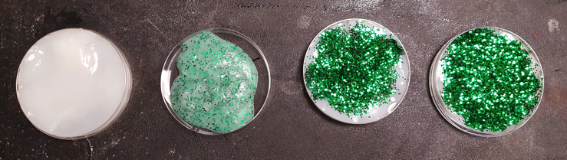
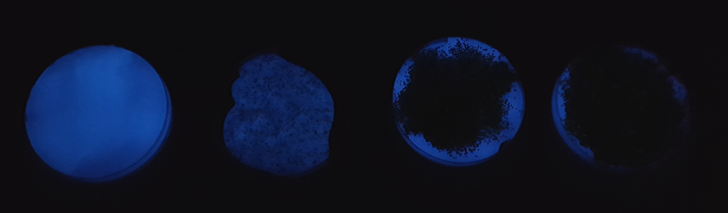

Melanin pigment - using protein powder

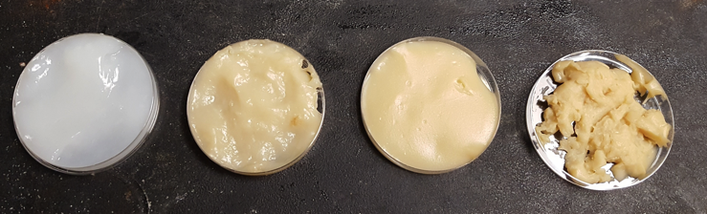
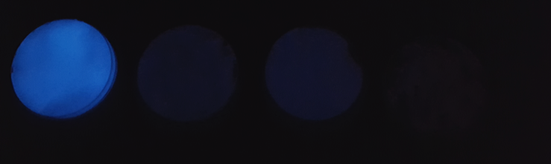

Pigment - using yellow food coloring
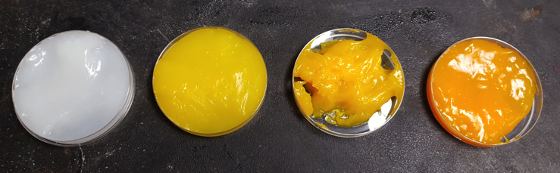
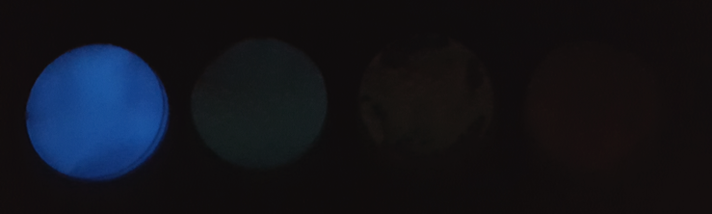

Scales - found in reptiles and fish using acrylic nails
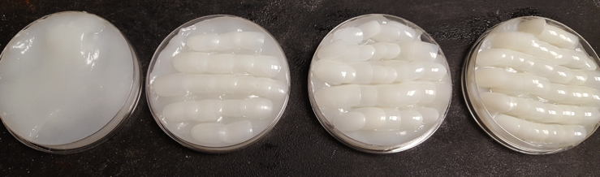
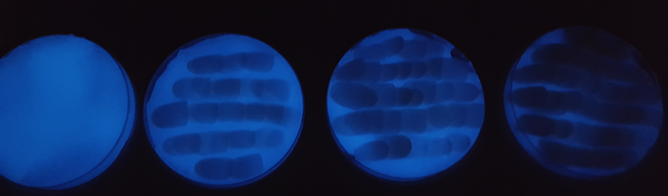

Exoskeleton - cuticle using the bio-plastic matrix
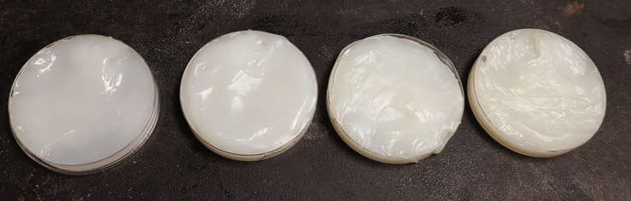
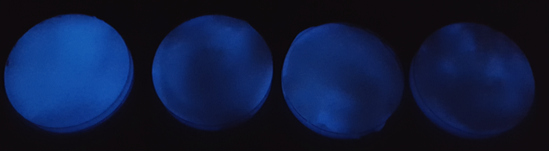

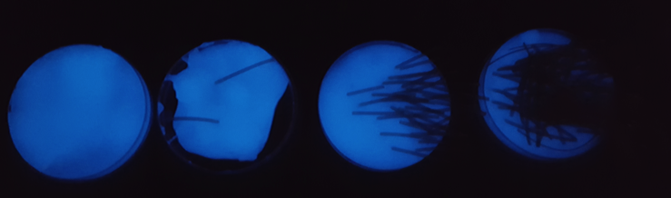
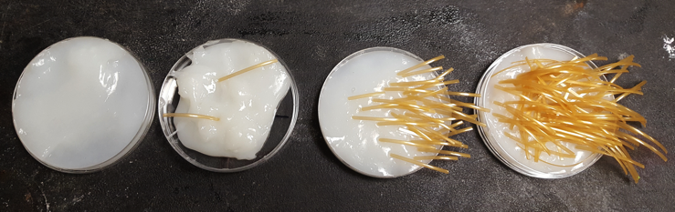
Hair found mammals - using plastic thread
Feathers

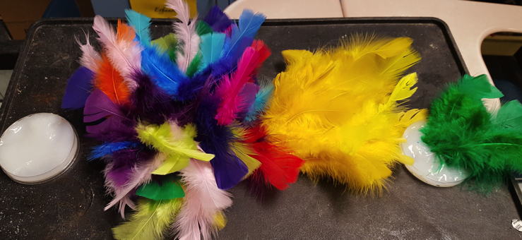

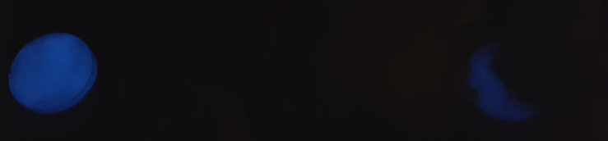

All Samples
