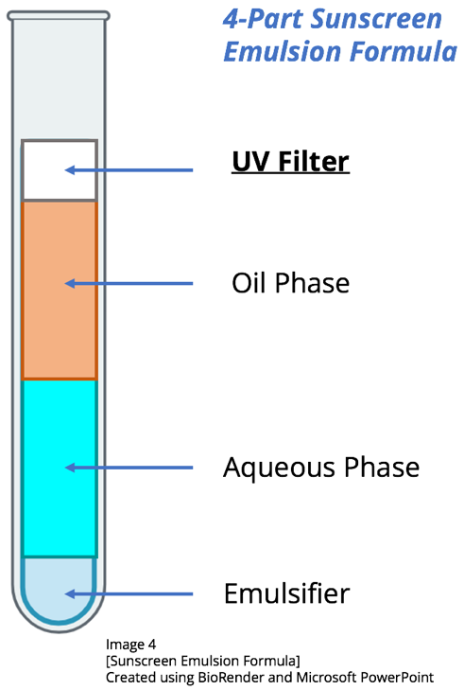
Sunscreen Emulsion Research:
UV Filters

UV filters are inorganic metal compounds evenly dispersed (spread out) in a sunscreen liquid. They do not dissolve in either the oil or liquid phase of the emulsion and therefore work by getting spread across your skin in an even pattern. They are often too small to see with the naked eye but come in crystal form.

They are typically a white powder, which is why some sunscreens leave a “white cast” or film on the skin. They work by actively reflecting away or absorbing the UV light emitted by the sun. Typically, UV rays that harm the skin have a wavelength between 280-400 nm (Liu 2019).

Option 1: Titanium Dioxide (TiO₂)
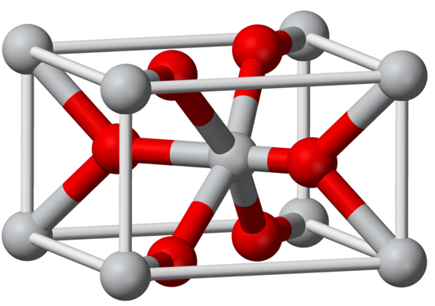
- Called a “mineral” filter because it can be found in nature; not synthetically made
- UVA radiation protection against waves in size 320-340 nm (Meftahi 2024)
- UVB radiation protection against waves in size 290-320 nm (Meftahi 2024)
- Leaves less of a white cast, but still has a chalky residue
- Lighter feel on skin
- Best for sensitive skin
Benjah 2008
- Will not get absorbed into skin

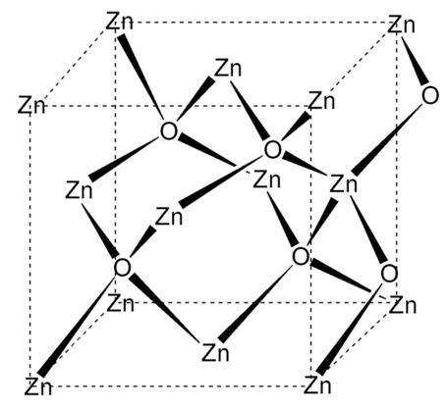
Option 2: Zinc Oxide (ZnO)
- Called a “mineral” filter because it can be found in nature; not synthetically made
- UVA radiation protection against waves in size 320-400 nm (Roudi 2021)
- UVB radiation protection against waves in size 280-320 nm (Roudi 2021)
- Will leave a white cast on skin
- Feels heavy or chalky on skin
- Will not get absorbed into skin
American Chemical Society

UV Filter Source Citations:

- Ademski, L. (2025, July 8). Sunscreen emulsion formula [Diagram]. Created using BioRender and Microsoft PowerPoint.
- American Chemical Society. (n.d.). Zinc oxide. ACS Publications. https://www.acs.org/molecule-of-the-week/archive/z/zinc-oxide.html
- Benjah-bmm27. (2008, July 3). Rutile-unit-cell-3D-balls [3D model illustration]. Wikimedia Commons. https://commons.wikimedia.org/wiki/File:Rutile-unit-cell-3D-balls.png
- Liu, Y., Zhao, C., Li, J., & Wang, J. (2019). Zinc oxide nanoparticles in modern sunscreens: Safety considerations and potential toxicity. International Journal of Nanomedicine, 14, 1163–1175. https://doi.org/10.2147/IJN.S190960
- Meftahi, G. H., Jafari, S., Barzegari, A., & Barar, J. (2024). Titanium dioxide nanoparticles in cosmetics: A comprehensive review on dermal exposure and toxicity. Cosmetics, 12(2), 77. https://doi.org/10.3390/cosmetics12020077
- Roudi, R., Norouzi, J., Khosravi, A. R., & Firooz, A. (2021). The role of titanium dioxide nanoparticles in sunscreen formulations: A review. Journal of the European Academy of Dermatology and Venereology, 35(11), e672–e680. https://doi.org/10.1111/jdv.15943

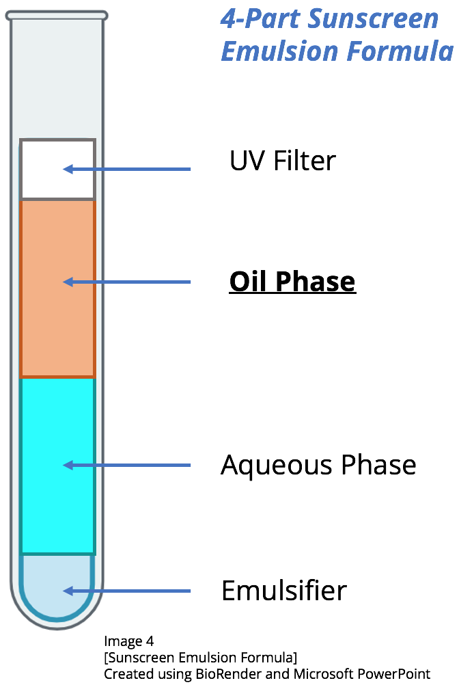
Sunscreen Emulsion Research:
Oil Phase

Skincare products are made of emulsions: immiscible mixtures of oil and water. Oils are essential components in sunscreens because they help to hydrate the skin and create a “creamy” texture, and they also play a critical role in making sure the UV filter metals spread evenly across the skin (Smijs 2011).

Without the oil phase, a sunscreen emulsion would be incredibly hard to apply to the skin. It would increase the risk of the UV filter washing away from sweat or water too quickly, which would decrease protection from the sun.

Option 1: Coconut Oil
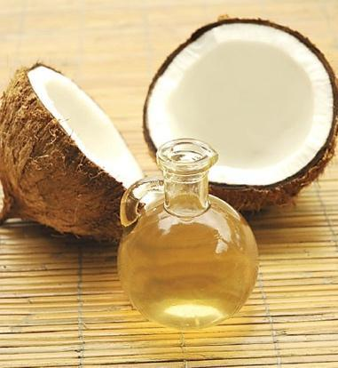
- Naturally antimicrobial – prevents skin bacteria and may prolong emulsion shelf life
- Natural skin moisturizer
- Naturally SPF 4 (Nohynek 2021)
- Many people prefer the smell
- Some people may be allergic
- Feels greasy on skin
- If not stored properly, the fats in the coconut oil will go rancid
Thamizhpparithi 2013

Option 2: Sunflower Oil
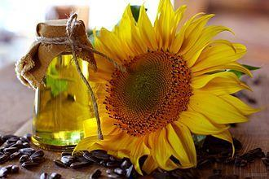
- Rich in omega-6 – good for skin health (NSA)
- Naturally SPF 4 (Nohynek 2021)
- Some people may be allergic
- Feels lighter on skin than coconut oil, but too much can still feel greasy
- Can clog pores in large quantities
- Has a longer shelf life than coconut oil
- Contains Vitamin E – good for skin (NSA)
Krzysztof 2015

Oil Phase Source Citations:

- Ademski, L. (2025, July 8). Sunscreen emulsion formula [Diagram]. Created using BioRender and Microsoft PowerPoint.
- Krzysztof Ziarnek, Kenraiz. (2015, July 2). Sunflower oil and sunflower [Photograph]. Wikimedia Commons. https://commons.wikimedia.org/wiki/File:Sunflower_oil_and_sunflower.jpg
- National Sunflower Association (NSA). (n.d.). Linoleic sunflower oil. https://www.sunflowernsa.com/oil/linoleic-sunflower-oil
- Nohynek, G. J., Dufour, E. K., & Roberts, M. S. (2021). Nanotechnology, cosmetics and the skin: Is there a health risk? Skin Pharmacology and Physiology, 34(6), 326–341. https://doi.org/10.1159/000514649
- Smijs, T. G., & Pavel, S. (2011). Titanium dioxide and zinc oxide nanoparticles in sunscreens: Focus on their safety and effectiveness. Cosmetics, 6(2), 25. https://doi.org/10.3390/cosmetics6020025
- Thamizhpparithi Maari. (2013, March 3). Coconut and oil [Photograph]. Wikimedia Commons. https://commons.wikimedia.org/wiki/File:Coconut_and_oil.jpg

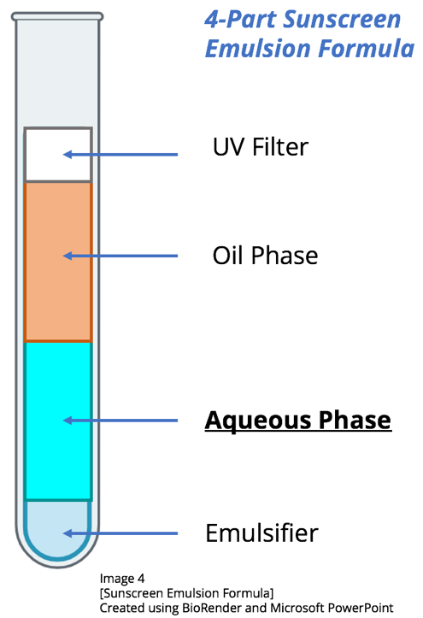
Sunscreen Emulsion Research:
Aqueous Phase

Skincare products are made of emulsions: immiscible mixtures of oil and water. Water-based solutions (known as the aqueous phase) dissolve preservatives in traditional sunscreens so they have a long shelf life. It also helps the sunscreen feel lightweight and smooth.

The aqueous phase hydrates the skin and helps disperse the oil droplets throughout the cream. The more the oil droplets get dispersed, the more the UV filter spreads. This increases the amount of skin protected from harmful UV rays. Without the aqueous phase, sunscreens would feel greasy and thick. They would be difficult to spread on the skin, and sunscreens without an aqueous phase require more preservatives (Rieger).

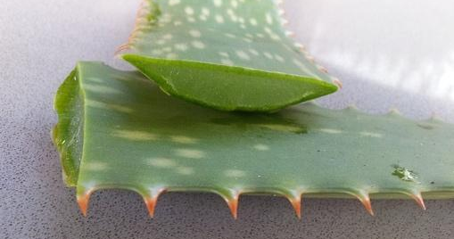
Option 1: Aloe Vera
- Contains Vitamins A, C, and E – great for skin hydration and reduces skin inflammation
- Can feel sticky in large quantities
- Some people may be allergic
- Supports skin tissue repair
Hempel 2007

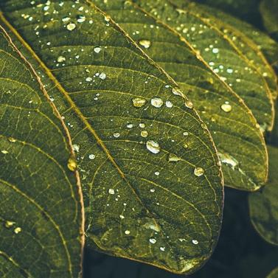
Option 2: Glycerin
- Known as one of the most hydrating materials for the skin – found in most skin moisturizers
- In dry climates, glycerin can actually pull moisture out of skin cells, making them feel drier
- Can feel sticky in large quantities
- Some people may be allergic
- Derived from palm oil, a resource linked to habitat destruction and the severe decline of orangutan populations due to unsustainable farming practices
Grangettes 2023

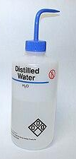
Option 3: Distilled Water
- Pure, microbe free
- Easy to use/mix
- Gentle on sensitive skin
- Not as hydrating as glycerin or aloe
Jynto 2007

Aqueous Phase Source Citations:

- Ademski, L. (2025, July 8). Sunscreen emulsion formula [Diagram]. Created using BioRender and Microsoft PowerPoint.
- Grangettes Switzerland. (2023, May 25). Glycerine végétale en cosmétique : définition, utilisation, propriétés [Blog post]. Grangettes Store. https://www.sunflowernsa.com/oil/linoleic-sunflower-oil
- Jörg Hempel. (2007, February 25). Cut Aloe Vera leaf [Photograph]. Wikimedia Commons. https://commons.wikimedia.org/wiki/File:Cut_Aloe_Vera_Leaf.jpg
- Jynto. (2007, August 18). Lab wash-bottles water EtOH [Photograph]. Wikimedia Commons. https://commons.wikimedia.org/wiki/File:Lab_wash-bottles_water_EtOH.jpg
- Rieger, M. (1997). Introduction to cosmetic emulsions and emulsification (IFSCC Monograph No. 4) [PDF]. Micelle Press on behalf of the International Federation of Societies of Cosmetic Chemists. Retrieved from https://ifscc.org/wp-content/uploads/2018/05/4-Intro-to-Cosmetic-Emulsions-and-Emulsification.pdf

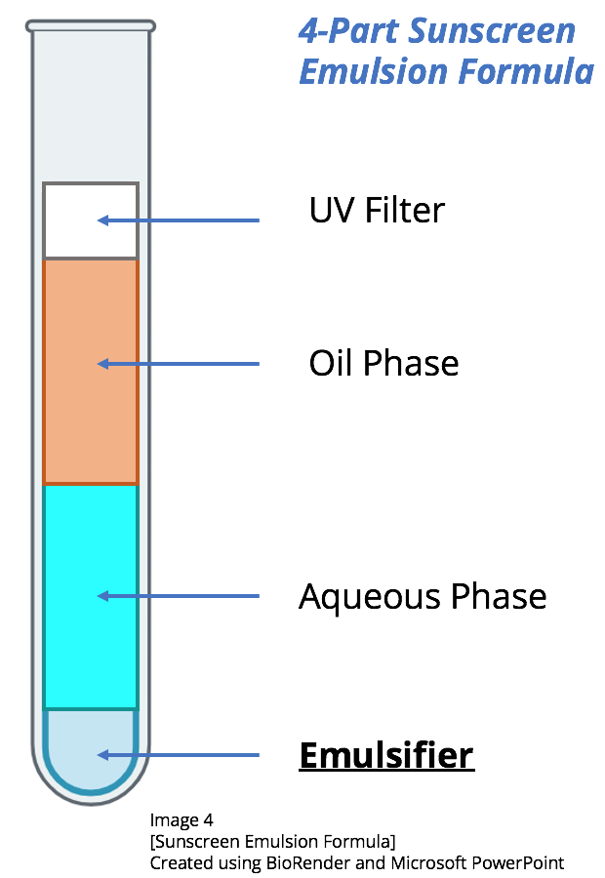
Sunscreen Emulsion Research:
Emulsifier

Skincare products are made of emulsions: immiscible mixtures of oil and water. The oil and water naturally want to separate over time. Emulsifiers are molecules that stabilize the emulsion and prevent the oil and water from separating. They have both hydrophobic (oil loving) and hydrophilic (water loving) sides, priming them to “wrap” around the oil droplets in a way that holds the droplets intact (Franco 2023).

Without an emulsifier, the oil and water phases would separate into two layers in the container: the oils on the top and the aqueous on the bottom. This would mean inconsistent SPF protection, leading to more skin DNA damage.

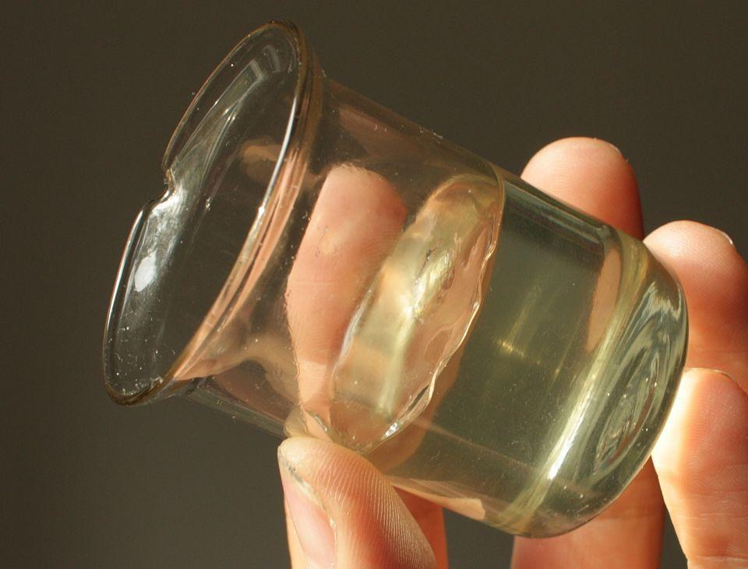
Option 1: Tween 80
- Not biodegradable in large quantities
- Synthetically made (not natural)
- Easy to use
- Particularly good at stabilizing emulsions (Franco)
- Compatible with most UV filters
- Can feel sticky

Niemitalo

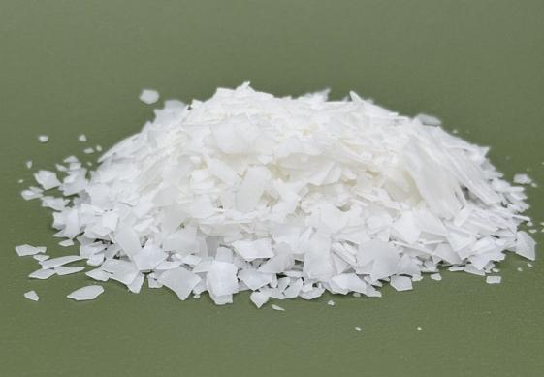

Option 2: Olivem 1000
- Natural/plant based
- Feels smooth on skin (Xi'an)
- Not as good at stabilizing oils
- Biodegradable/environmentally safe

Formulator Sample Shop

Emulsifier Source Citations:

- Ademski, L. (2025, July 8). Sunscreen emulsion formula [Diagram]. Created using BioRender and Microsoft PowerPoint.
- Formulator Sample Shop. (n.d.). Olivem® 1000 MB [Product information]. Retrieved July 8, 2025, from https://www.formulatorsampleshop.com/products/olivem-1000-mb?srsltid=AfmBOorJqi-Cq2XH9gemCWG9lPEAXHUPfjRCegDAL83WJlnCV5C_m2JD
- Franco, P., Maione, S., Ruggiero, S., & Martelli, G. (2023). Development of natural and eco-sustainable sunscreen formulations: A green and multifunctional emulsifier enhances the performance. Cosmetics, 12(3), 118. https://doi.org/10.3390/cosmetics12030118
- Niemitalo, O. (n.d.). Cubic phase gel [Image]. Wikimedia Commons. Retrieved July 8, 2025, from https://commons.wikimedia.org/wiki/File:Cubic_phase_gel.jpg
- Xi'an Lyphar Biotech Co., Ltd. (n.d.). The reason of deep moisturizing effect of Olivem 1000. Retrieved July 8, 2025, from https://www.biolyphar.com/the-reason-of-deep-moisturizing-effect-of-olivem-1000/?utm_source=chatgpt.com

