Pendulum Art Packet

Instructions: You are an intern for a neurologist. It is time to interview your first patient! Fill out the patient intake form below.

Patient Intake Form

Patient Information
- Full Name:

- Date of Birth:

- Emergency Contact Name:

Current State of Mind:
(Please check all that apply)
- Deep sleep
- Loss of bodily awareness
- Creative
- Deep meditation
- Reduced consciousness
- Awake and relaxed
- Excited
- Thinking
- Alert consciousness
- Ready to learn
- Heightened perception
- Other: ________________

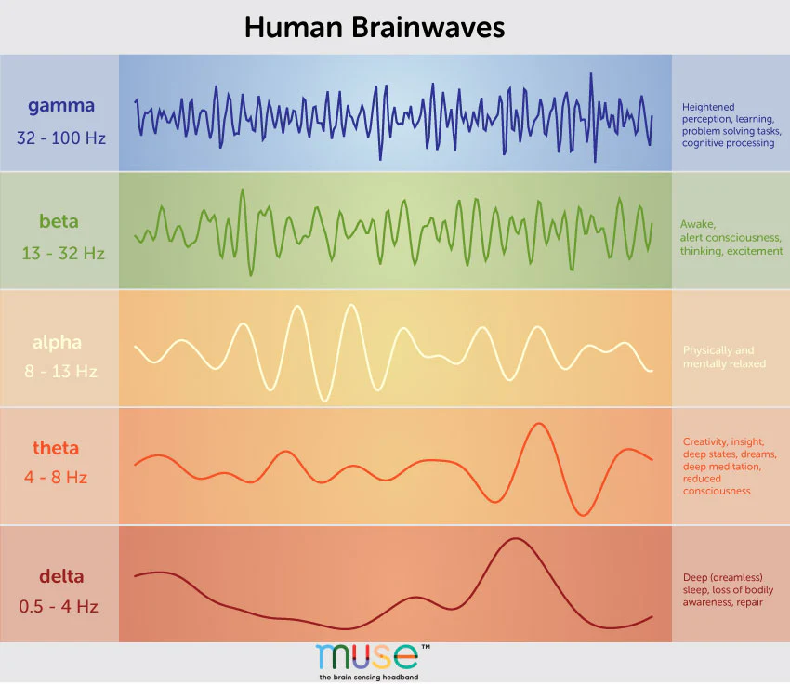
Now that you have an idea of how your patient is feeling, identify what kind of brain waves you think they are currently experiencing. Since it is your first day on the job, your boss provided this graphic to help you predict brain waves. Circle the predicted brain wave. Here is a quick video on EEGs.

Image credit: https://choosemuse.com/blogs/news/a-deep-dive-into-brainwaves-brainwave-frequencies-explained-2

Your patient needs a visual representation of what is going on in their brain. Design a pendulum to model the motion of their brainwaves.
Brain Wave Model Pendulum Design
Your pendulum will need to have a period in the range of the brain waves you are trying to model.
Type of brain wave:_______________ Target frequency:______________________
Using the relation between frequency and period, calculate the
Target period for the pendulum:_____________
Remember, the period of a simple harmonic pendulum can be modeled by:
$T=2π\sqrt{\frac{l}{g}}$ where $T$ is period, $l$ is length of the pendulum, and $g$ is acceleration due to gravity.
Design the pendulum. Think about which factor you can change to make your pendulum oscillate at the desired period. Draw a picture of your model pendulum and label the pendulum with the material you would use. Include your measurements.

Build the pendulum! Test it out. Answer the reflection questions below.
Reflect
Did you achieve your target period?

Does the patient understand what is going on in their brain now?

If you were to do it again, what would you change?

As an intern, you are trying to learn more about electroencephalography (EEG), a procedure used to measure brain activity. You know that comparing overlapping brainwave patterns can help researchers analyze EEG recordings. You decide to compare the brainwave patterns of two different patients by overlapping them. Find a patient in the room whose brainwave pattern is different from your patient's.

Planning: New Pendulum Design
Modified Pendulum  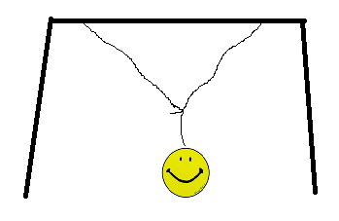  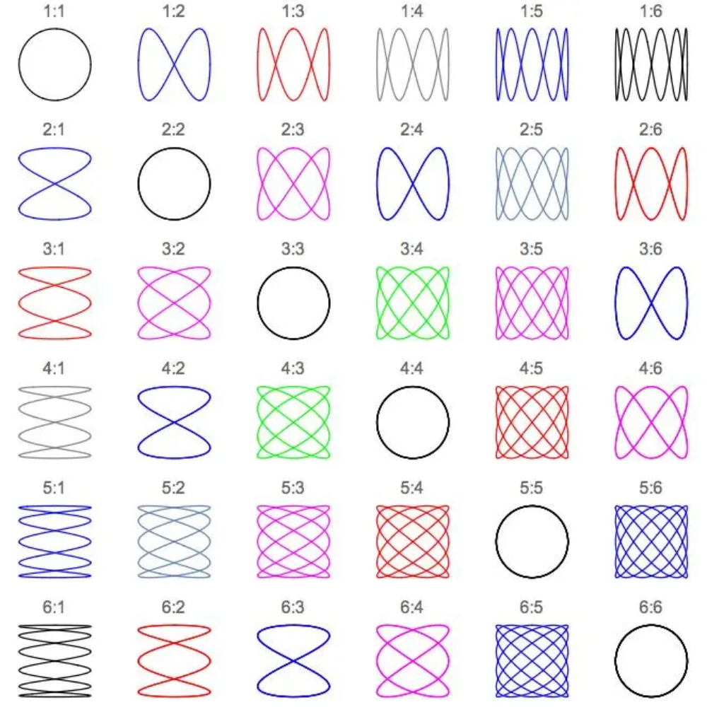  Lissajous Patterns  The numbers represent the ratio between the frequencies in the directions of oscillation. So, 1:1 means the periods in both directions are the same, and 1:2 means that the period in one direction is twice as long as the other. | How could you create a pendulum like the one in the image to the left and use it to model both oscillations?  - Target Frequency (f1):  Target Frequency (f2):  - What property of the pendulum decides the frequency?  - How could you have both of the lengths associated with the two frequencies incorporated into this design?  - Your goal is to create a painting that matches one of the Lissajous patterns.  - Round off your frequencies, if necessary, to match one of the ratios in the pattern. Calculate the periods (T) and lengths (L) for oscillations corresponding to the rounded-off frequencies.  f1: f2:  T1: T2:  L1: L2:
Improve
Were you successful in modeling your target frequencies? Does your picture look like the Lissajous pattern that you chose?

If you were to redesign your pendulum, what would you do differently?

Gallery Walk Reflection Questions

- Is there a repeating pattern visible in the designs?

- Do the designs created by the new modified pendulums represent simple harmonic motion?

- Can you break the pattern down into the x and y components? [Hint: the two frequencies]

- What does the period depend on?

- What kind of different patterns do you see around the room? List at least three similarities that you see and three differences that you see.

Reflect on the new pendulum
Similarities  1.  2.  3. | Differences  1.  2.  3.

