Design Without Building: Using Computer Simulations to Predict Material Design for Next-Generation Technologies Background Reading

How does the basic hardware of a computer work?
When you type a command into a computer, the computer takes your input and translates the information into binary data in the form of 0s and 1s. The fundamental hardware component that acts as the 1 (on) or 0 (off) switch is called a transistor. Transistors cannot store any data by themselves. Transistors send the information to the other components, such as capacitors, for storage and then send the data back as needed to perform computational tasks.

You can imagine this process like cars on a road. The parking garage is like the capacitor, where all the signals (cars) are stored. When you open the gate to the parking garage, the cars can drive out. When you shut the gate, the cars stop moving. (See Image 1.)



Image 1: Transistor lets electricity flow or stops flow.
Operating the “gate” (transistor) takes energy.

The gate is volatile, which means it changes only when you do something to it. Similarly, transistors only let information through when there is an external energy source applied. Storing the cars (signals) in the garage and opening and closing the gate takes a lot of time and energy!

What is a memristor?
Unlike transistors, memristors, short for “memory resistors,” are non-volatile resistive switches (NVRS). If the capacitor-transistor system is like a parking garage with a gate, then the memristor is more like a road with speed bumps. Speed bumps regulate the speed cars can travel without you needing to do anything. (See Image 2.)

Image 2: Memristor lets the structure of the material change to regulate the “traffic flow.”

Similarly, memristors can “remember” the signals that pass through. This material memory allows memristors to integrate data processing and storage within the same physical location, making memristor technology potentially useful for both increasing processing speed and reducing energy consumption.

How do transistors and memristors work?
Computer hardware, like all physical matter, is made of tiny atoms. The properties of both transistors and memristors are a result of their properties at the atomic scale. Transistors are made of atoms of elements called semiconductors. The atoms in semiconductors have electrons that sometimes move with electricity and sometimes do not, which makes these materials useful as switches.

Materials scientists are currently investigating how to combine atoms of materials in ways that the ability of electrons to move changes based on the design of the material. There is a lot of interest in a set of materials that are only two layers of atoms thick called two-dimensional transition metal dichalcogenides (2D TMDs). These materials make something like a peanut butter sandwich, with the metal atoms being the bread and the electrons moving through the peanut butter.

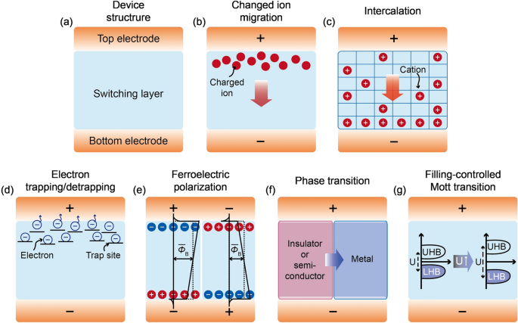
Different combinations of “bread” and “peanut butter” let the electrons flow in different ways, all of which allow the material structure to change so the memristor can “remember” what to do.
Image 3: Different proposed designs for electron movement in memristors.
Image source: https://nanoconvergencejournal.springeropen.com/articles/10.1186/s40580-023-00407-0

How are memristors designed?
Designing memristors involves looking at the atoms of the materials involved. As you know, atoms are very, very small, so it is difficult to set up and test different arrangements of atoms very efficiently. Instead of building each possible combination of atoms that could make a memristor, scientists use mathematical models.

The ability to build these mathematical models is based on a concept called Density Functional Theory (DFT). In its essence, DFT is a set of assumptions and simplifications of the behavior of electrons in atoms that is “good enough” that the equations derived from these assumptions can predict how the different atoms and their electrons will behave.
Image 4: Electrons interacting in atoms versus simplified density functional theory atom.
e-
e-
e-
e-
e-
e-
e-
e-

If you ever thought your math homework was hard, you will be amazed at how complex these equations are. Scientists need to use supercomputers to do the calculations. But, once the math is done, the DFT models do a good job of predicting what materials would be best for memristor design.

Using computer analysis of mathematical models allows scientists to identify the best materials and design for memristors. When we can build these memristors to perform reliably, we will then be able to fundamentally change how computers are built, processing information faster and with less energy. In essence, we are using today’s computers to help us design hardware for the computers of tomorrow!

