Control and Prototype Data Analysis Worksheet

Question: ________________________________________________________________________________
________________________________________________________________________________________
________________________________________________________________________________________

Control and Prototype Data
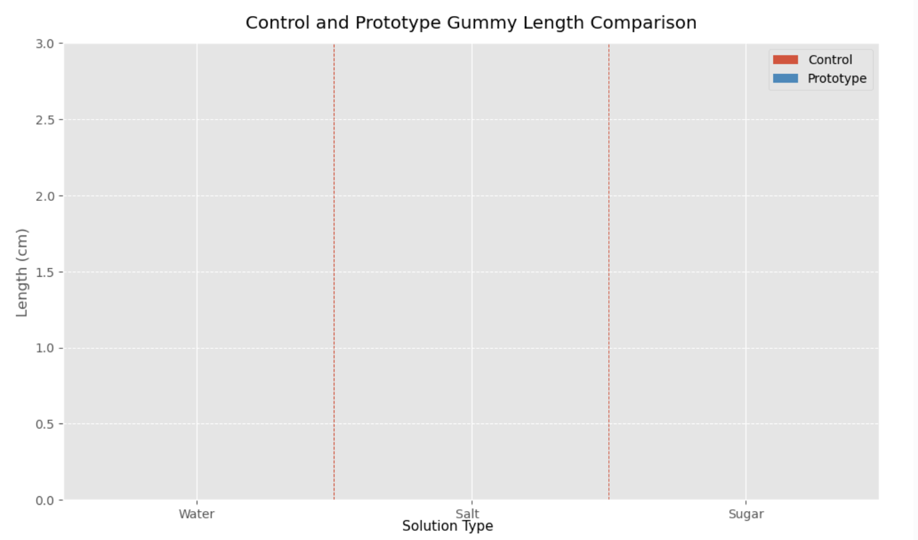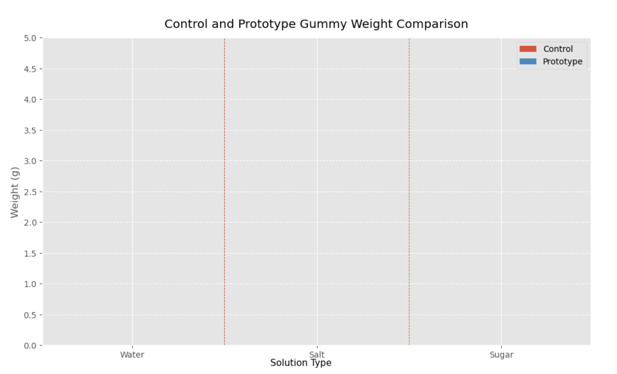

Conclusion:______________________________________________________________________________
________________________________________________________________________________________
________________________________________________________________________________________
________________________________________________________________________________________
________________________________________________________________________________________
________________________________________________________________________________________
________________________________________________________________________________________
________________________________________________________________________________________
________________________________________________________________________________________
________________________________________________________________________________________

