Engineering Design Packet

Pre-Assessment Questions

Instructions: Answer the following questions.

- What do you remember about the story The Three Little Pigs?

- What materials did each pig use to build their house?

- Which house do you think was the strongest? Why?

- What do you think engineers do?

Engineering Challenge

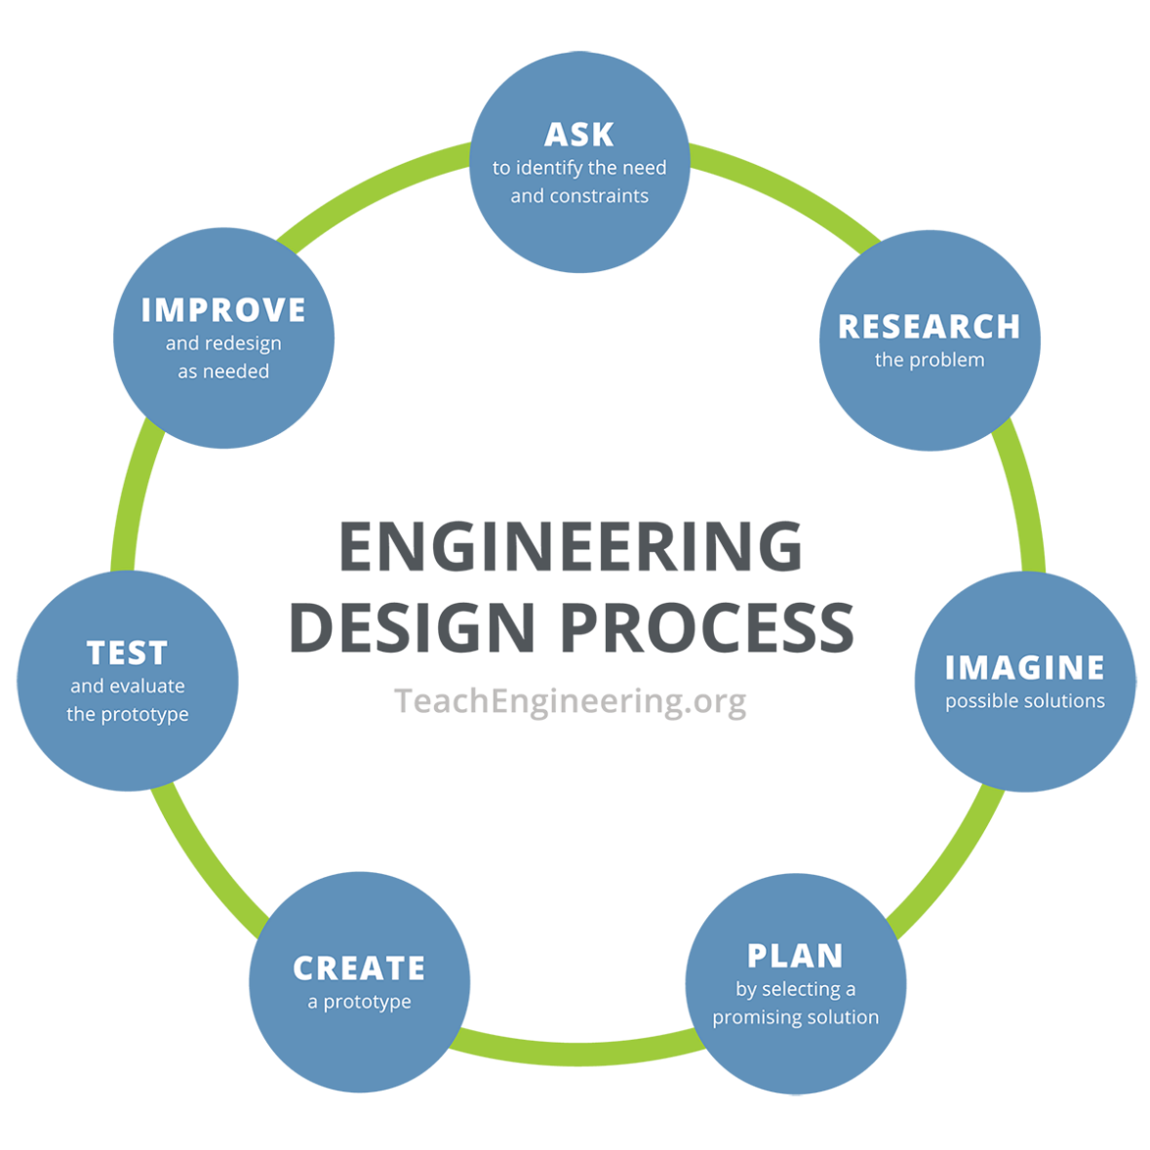
Instructions: Using the engineering design process, you and your team will act as engineers tasked with building three houses, one out of straws, one out of popsicle sticks, and one out of LEGO bricks, and then testing each to see which materials are the strongest and the weakest.

- Ask - What is the problem we are trying to solve?
____________________________________________________________________________
____________________________________________________________________________
____________________________________________________________________________
____________________________________________________________________________

- Research - What do we already know?
____________________________________________________________________________

____________________________________________________________________________
____________________________________________________________________________

____________________________________________________________________________
____________________________________________________________________________

____________________________________________________________________________

____________________________________________________________________________
- Imagine - Sketch four different ways to build a strong house with each material.

a | b
c | d
- Plan - Have each team member share their ideas. As a team, select ONE solution for each building material. Note: This can be one specific solution or a mixture of ideas. Draw your team’s solutions in the boxes below.

Design for house made of straws

Design for house made of popsicle sticks

Design for house made of LEGO bricks

- Create - Build your prototypes as shown in your group’s drawings.
- Test - Test your prototypes, record your data in the data charts below, and then answer the following questions.
Straw House
 | 10 ft | 9 ft | 8 ft | 7 ft | 6 ft | 5 ft | 4 ft | 3 ft | 2 ft | 1 ft
Air Flow
Observations

Popsicle Stick House
 | 10 ft | 9 ft | 8 ft | 7 ft | 6 ft | 5 ft | 4 ft | 3 ft | 2 ft | 1 ft
Air Flow
Observations

LEGO House
 | 10 ft | 9 ft | 8 ft | 7 ft | 6 ft | 5 ft | 4 ft | 3 ft | 2 ft | 1 ft
Air Flow
Observations

What worked in your prototypes, and why?

____________________________________________________________________________
____________________________________________________________________________
____________________________________________________________________________
____________________________________________________________________________
____________________________________________________________________________

What did not work in your prototypes, and why?

____________________________________________________________________________
____________________________________________________________________________
____________________________________________________________________________
____________________________________________________________________________
____________________________________________________________________________
- Improve - Based on your testing and results, draw how would you improve your designs.

- (optional) Iterate – Make changes and retest your updated prototypes.

Straw House
 | 10 ft | 9 ft | 8 ft | 7 ft | 6 ft | 5 ft | 4 ft | 3 ft | 2 ft | 1 ft
Air Flow
Observations

Popsicle Stick House
 | 10 ft | 9 ft | 8 ft | 7 ft | 6 ft | 5 ft | 4 ft | 3 ft | 2 ft | 1 ft
Air Flow
Observations

LEGO House
 | 10 ft | 9 ft | 8 ft | 7 ft | 6 ft | 5 ft | 4 ft | 3 ft | 2 ft | 1 ft
Air Flow
Observations

Did your changes improve your prototypes? How?

____________________________________________________________________________
____________________________________________________________________________
____________________________________________________________________________
____________________________________________________________________________
What worked in your updated prototypes, and why?

____________________________________________________________________________
____________________________________________________________________________
____________________________________________________________________________
____________________________________________________________________________

What did not work in your updated prototypes, and why?

____________________________________________________________________________
____________________________________________________________________________
____________________________________________________________________________
____________________________________________________________________________

What would you do to further improve your prototypes, and why?

____________________________________________________________________________
____________________________________________________________________________
____________________________________________________________________________
____________________________________________________________________________

Reflection Questions

What did you learn about building strong structures?

____________________________________________________________________________
____________________________________________________________________________
____________________________________________________________________________
____________________________________________________________________________
____________________________________________________________________________
____________________________________________________________________________

What would you do differently next time?

____________________________________________________________________________
____________________________________________________________________________
____________________________________________________________________________
____________________________________________________________________________
____________________________________________________________________________
____________________________________________________________________________

How did your group work together to solve problems?

____________________________________________________________________________
____________________________________________________________________________
____________________________________________________________________________
____________________________________________________________________________
____________________________________________________________________________
____________________________________________________________________________

