Project Packet

Imagine

Imagine you are a “Sport Engineer.” How do you visualize your new sport?

- Do you want to create an outdoor game or an indoor game?

- Is it a team game or an individual competition?

- What equipment do you use to play? (Example: racquet, hockey sticks, no hand, feet, head, etc.)

- How big is the field? Is it football field size, half a football field, tennis court, or table tennis sized? Compare it with a sport you know about.

- Is it at the ground level, or are there elevated elements like in ping pong or basketball, for example?

Plan
Role: ___________________________________________
Constraints
- You will have one lab table area to set up your game.
- Play should involve at least one contact between ball and base.
- The game should be set up ON the table.
- You cannot use any material other than what is provided.
- You should be able to conclude one round of your game in 10 minutes. Each round should allow both teams to score.
- Be respectful to other tables and the players.
- You will be critiqued by your peers based on the game plan.

Rules of the Game
- How do you win?

- How do you score points?

- How do you move the ball?

- What are you not allowed to do?

- What is the name of your game?

- Set up diagram:

- What kind of bounce would be best for your game? Circle the best option for each category.

Height: | Very high | High | Low | Very low | No bounce
Air Time: | Very long | Long | Short | Very short | None
Number of Bounces: | As many as possible | A lot | Not a lot | Very few | None

- What base and ball combinations do you think would best accomplish this kind of bounce? Justify your choice based on energy transfer. Come up with at least three combinations that you want to test.

Test

Go to a bounce station. There should be a meter stick or a tape measure on the wall. Choose one group member to drop the balls and one to record using a slow-motion camera.

Set up your first base on the ground at the bottom of the meter stick or tape measure. One by one, test your chosen combinations by dropping the ball onto the base and recording the bounce.

Record your findings in the table below.

Initial Findings

Drop height: ________

Make sure you drop every ball from the same height!

Base and ball you are testing  (e.g., ping pong on whiteboard) | Bounce height | Time between first bounce and second bounce | Number of bounces

- Based on these results, which combination would be the best for your game?

Research and Analysis

You are going to create a detailed analysis of your chosen base and ball combination to justify your choice. To do this, you will need to gather data from the slow-motion video of the bounce and use quadratic regression to model the bounce.

Let’s start by collecting data. Use the slow-motion video to fill in the following table.

Base: ______________ Ball:______________
Bounce # | 1 | 2 | 3
Start Time
Max Height
End Time

Use the table to create a list of ordered pairs for each bounce. You will have three sets of tables and will need to complete three sets of quadratic regression. (Hint: What is the height at the start and end times? Where is the ball at the start of the bounce?)
  Bounce 1
  Time (x) | Height (y)
  Bounce 2
  Time (x) | Height (y)
  Bounce 3
  Time (x) | Height (y)
Plot your points on the graph below. Make sure to label your axis and scale.
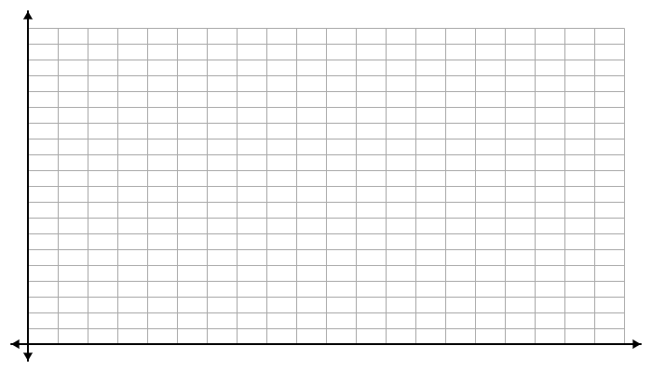

Next, you will use quadratic regression to generate three equations, one for each bounce. Equations should be in the following form:
$y=ax^{2}+bx+c$

Bounce 1: ___________________________________

Bounce 2: ___________________________________

Bounce 3: ___________________________________

Plot these equations on your graph. Answer the following questions about your graph.

- How does this graph justify your base and ball choice? How does it show that this bounce meets the ideal bounce that you came up with during the testing phase?

- Label the graph with the vertices of the quadratics and the x-intercepts.

- Label the vertex on the graph.

- Label the x-intercepts on the graph.

- What can you say about position, velocity, and acceleration of the ball
- At the vertex:

Position:

Velocity:

Acceleration:

- At the x-intercepts:

Position:

Velocity:

Acceleration:

- What energy transformations do you see between the vertex and the intercept points?

- Why are the bounce heights different?

- Does the fact that bounce heights are different violate energy conservation law? Explain your answer.

- What do the x-intercepts represent in this context?

- What is the range of your graph? What does this represent?

- What is the domain of your graph? What does this represent?

- Using the quadratic equations for position as a function of time, create velocity as a function of time. You can write it as a piecewise function.

- What can you say about the acceleration of the ball?

Play Test

From your team, one teammate is going to run the game. While running the game, they will note any thoughts regarding the game in the area below. There will be a short time after the game to debrief and add to your notes.

All others will experience/play the games after being assigned to a random team. Remember that all game play should be limited just to the tabletop. Be respectful to all of your peers.

If there is time, the teams will rotate and everyone will get to play a second game.

Note Area:
What worked?

What could be changed?

Group Reflection

- Note changes you would make to your game, and why.

- Who is the target audience for your game? How would you market it?

- What would be the environmental impact of your game? Are your materials eco-friendly? Can you think of any changes to make this sport eco-friendly?


- Which steps in the engineering design process did you participate in during this project? Which part did you enjoy the most?

