Pre/Post-Quiz Answer Key

Damaged Item | Solution
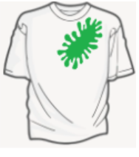  Stained | The shirt can be dyed and used again.
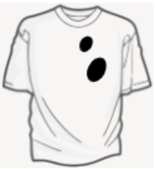  Ripped | The shirt can be sewed or patched up so you can’t see the  holes anymore.

 | 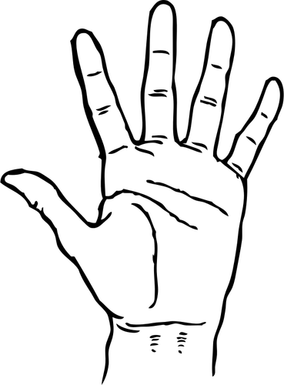 |  | 
white  green | sticky  grainy | stinky  rotten | sour  bitter
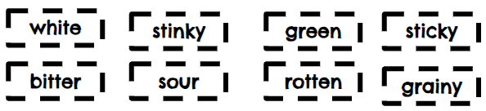

white | stinky | green | sticky
bitter | sour | rotten | grainy

