Rock Candy Recipe

Materials and Equipment List
- cooking pot (non-Teflon)  - measuring cup  - metal spoon or fork  - 1 wood skewer or popsicle stick  - 1 half-pint Mason jar  - candy thermometer | - 1 clothespin or cloth peg wide enough  to cover the top of the container or glass  - 1 ½ cups of granulated sugar  - ½ cup of bottled water  - 1 drop of food coloring
Safety and Precautionary Measures
- Be careful around the stove, flame, and heat source.  - Be careful when mixing the liquid in the pot.  - Wear thermal gloves.  - Avoid touching the pot or any surface exposed to heat.  - Wear eye protection (goggles or safety glasses).  - Wear an apron, suitable clothing, or an old t-shirt (in case the solution is spilled or splashed on the person). | - Wash your hands before starting the experiment.  - Disinfect the work area.  - Clean all the containers or glasses that you will use before mixing your ingredients.  - Wash your hands after completing the experiment.
Instructions
- Put the granulated sugar on a plate.  - Take the wooden stick and dip half of it in water.  - Roll the wet stick in the sugar. This step is very important because the stick will create the seed to form the crystals once it is covered with the granulated sugar.  - Leave the wooden stick resting on the plate until it dries, at least two hours. | 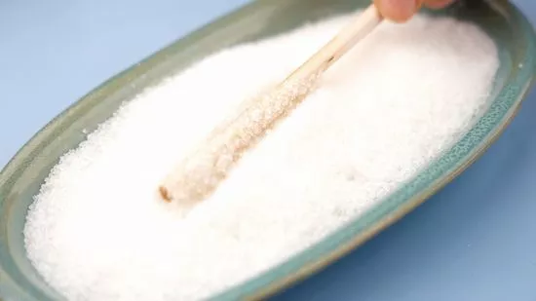
- Place the candy thermometer on the wall of the pot to check the temperature of your solution.  - Add ½ cup of water to a saucepan and bring to a boil. | 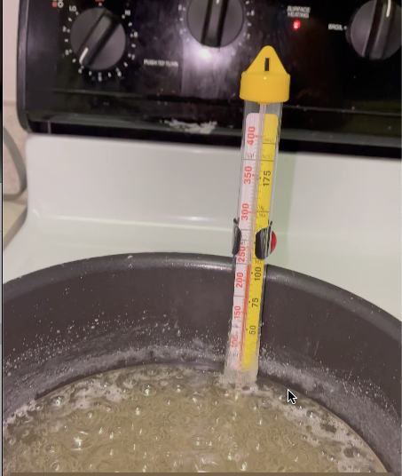
- Add the 1 ½ cups of sugar little by little. Mix everything at a medium-high temperature.  - Keep stirring the solution slowly for several minutes. Keep observing and mixing frequently to avoid crystallizing the top of the solution. It will take around 10 minutes to reach a clear liquid mixture.  - When the solution begins to boil, stir it until all of the sugar is completely mixed into the solution. | 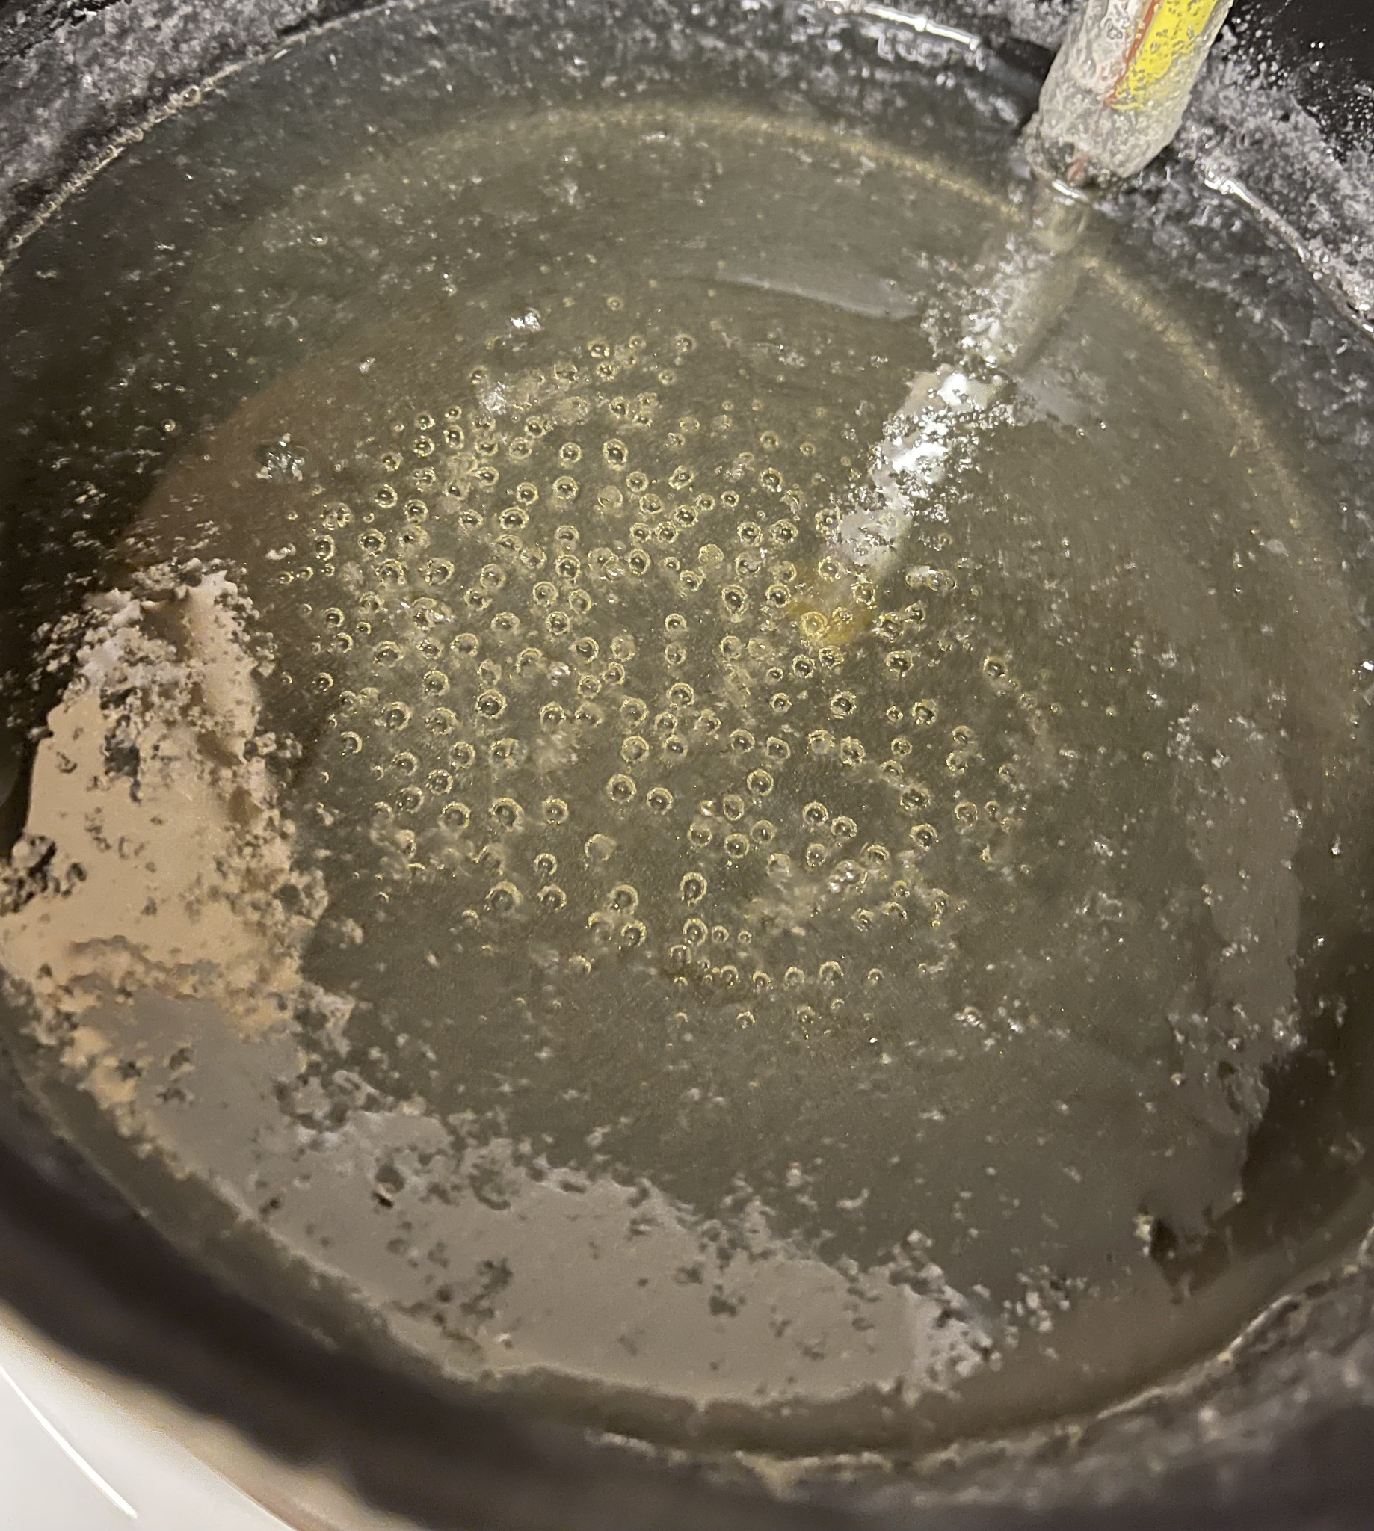
- Turn off the heat and add a drop of food coloring.  - Remove the pot from the heat and allow the solution to cool for 20 minutes.  - Take the pot with the solution and pour it into the half-liter jar. | 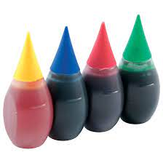
- Place the stick with the sugar seed in the middle of the glass. It is very important to leave the stick 1 ½ inches from the bottom of the jar. | 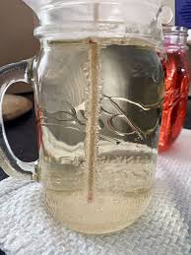
- Place a large clip in the middle of the container to keep the stick hanging in place. | 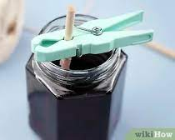
- Leave your solution there and check it every hour. Make sure the wooden stick does not touch the bottom or the walls of the jar. | 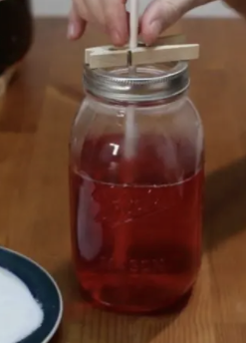
- Wait at least 3- 7 days. When the crystals have finished growing, use a spoon and crack the top shell of the solution. | 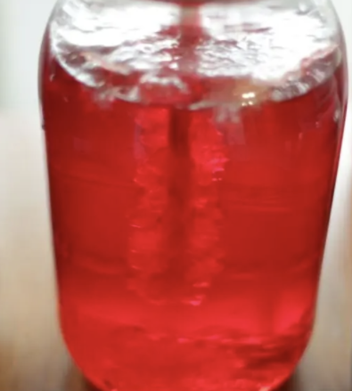
- Gently remove your skewer with the crystals from your solution and hang it in a new container, using a clip to hold it in place to drip and dry. | 