Plastic Brick Kit Components

Type | Size | TOTAL
Brick | 1x1 | 100
Brick | 1x2 | 100
Brick | 1x3 | 40
Brick | 1x4 | 40
Brick | 2x2 | 24
Plate | 2x2 | 60
Plate | 2x6 | 20
Plate | 2x8 | 30
Plate | 2x10 | 15
Plate | 4x6 | 20
Plate | 4x10 | 2
Slope  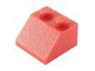 | 1x2 | 50
 | 1x2 (open) | 50
 | 2x2 | 40
Tire  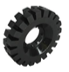 | Large | 4
 | Medium Soft | 28
 | Solid - Hard | 28
 | Small | 28
Axle  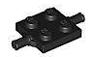  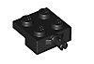 | Big | 4
 | Small One Side | 68
 | Small Two Sided | 14
2Rim  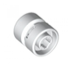 | Large | 4
 | Medium | 28
 | Small | 28
Steering Wheel  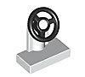 | One Size | 20
Wind Shield  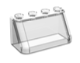 | 2x4 | 20
 | 3x6 | 3
Driver | One Size | 2

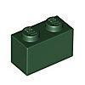

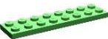

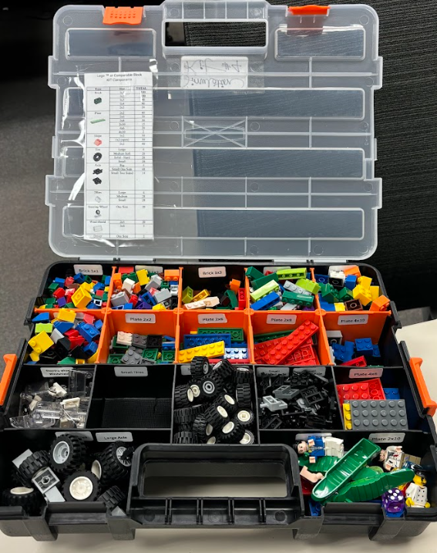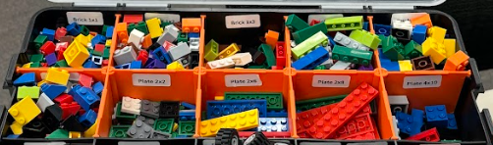
“Plastic Brick Kit - Labeled”

