Soap Motor Phenomenon Worksheet

- Have one member of your group obtain the following supplies:
  - 1 tray or wide container
  - 1 cotton swab
  - 1 pair of scissors (to cut out the boat, if not already cut out)
  - 1 boat or small leaf
  - 1 container (e.g., beaker or graduated cylinder or measuring cup) to hold water
  - 2-4 drops of liquid soap
  - colored water (enough to cover the bottom of the tray or wide container)
- Put enough water in the tray to cover the bottom.
- Place the boat on the surface of the water.
- Record your initial observations in the table below.
- Put a drop of soap onto the end of your cotton swab.
- Touch the surface of the water behind the boat.
- Discuss your observation as a group.
- Record your observations in the space below.

Boat on water observations | Boat moving observations
Use words and/or drawings… | Use words and/or drawings…
- Write at least three things you are wondering (questions) based on your observations of the boat before and after the soap in the space below.

Three questions about the boat before and after the soap

Pause Here

Notes about surface tension, lung surfactants, and breathing
While we watch the “Surface Tension of Water Explained” (3:36 minutes) video together, take notes below. Use words and drawings in your notes.

While we watch the “Surfactants Mechanism of Action” (3:42 minutes) video together, take notes below. Use words and drawings in your notes.

While we watch the “Surfactant and Surface Tension in Respiration | Breathing Mechanics | Respiratory Physiology - Byte Size Med” (4:21 minutes) video together, take notes on the items listed below. Use words and drawings in your notes.

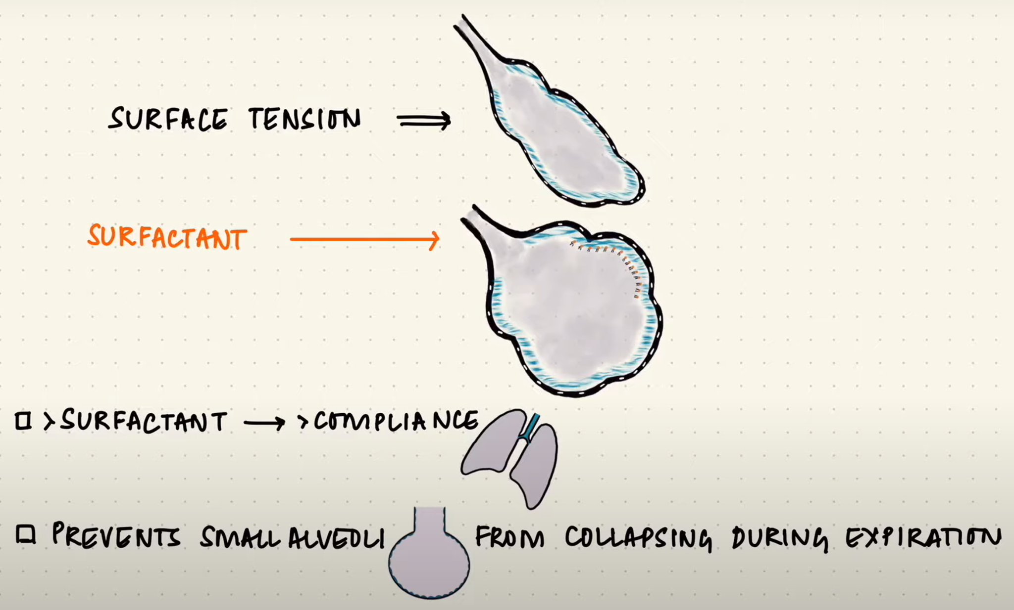

Surfactant and surface tension in breathing: Lung alveolar fluid is primarily composed of water. The greater the surface tension of the alveoli fluid, the more likely it is for an alveolus to collapse. This would make it difficult to breathe. Lung surfactants in the alveolar fluid reduce the surface tension and prevent the lung from collapsing during the breathing cycle.

What would happen in your lungs if you inhaled something that interfered with your lung surfactant? (Include the term “surface tension” in your response.)

