Engineering Design Challenge Packet

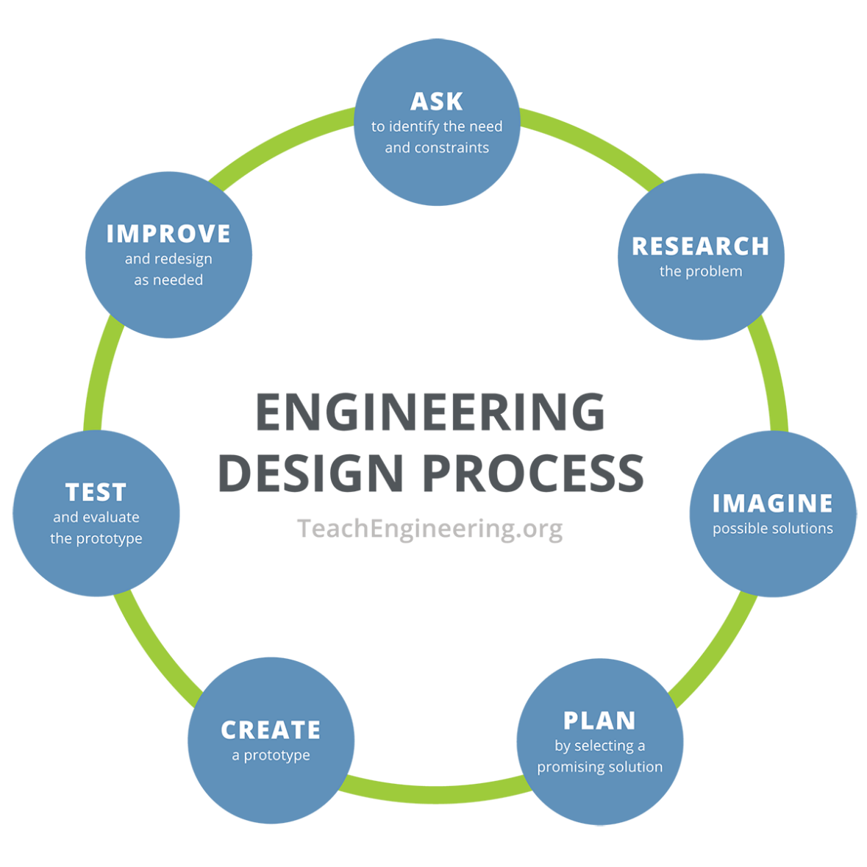
Instructions: Using the engineering design process, you and your team will act as materials engineers to create a designer slime that satisfies your targeted slime properties.

- Ask – Identify the need/problem and the criteria and constraints of your problem.
____________________________________________________________________________
____________________________________________________________________________
____________________________________________________________________________
____________________________________________________________________________

- Research – What do we know about the problem? What do we need to know?
____________________________________________________________________________

____________________________________________________________________________
____________________________________________________________________________

____________________________________________________________________________
____________________________________________________________________________

____________________________________________________________________________

____________________________________________________________________________
- Imagine – Individually sketch or write down four possible solutions.

a. | b.
c. | d.

- Plan – Have each team member share their ideas. As a team, select ONE solution. This can be one specific solution or a mixture of ideas. Draw or write your team’s solution in the box below. Make sure to identify which materials and how much of each material you will be using.

- Create – Make your designer slime according to your group’s plan.

- Test – Test your designer slime and then answer the following questions.

What worked in your design, and why?

____________________________________________________________________________
____________________________________________________________________________
____________________________________________________________________________
____________________________________________________________________________
____________________________________________________________________________

What did not work in your design, and why?

____________________________________________________________________________
____________________________________________________________________________
____________________________________________________________________________
____________________________________________________________________________
____________________________________________________________________________

- Improve – Based on your testing, how would you improve your design? Why?

____________________________________________________________________________
____________________________________________________________________________
____________________________________________________________________________
____________________________________________________________________________
____________________________________________________________________________
____________________________________________________________________________

- (Optional) Iterate – Make changes and retest your updated prototype.
Did your changes improve your prototype? How?
____________________________________________________________________________
____________________________________________________________________________
____________________________________________________________________________
____________________________________________________________________________
____________________________________________________________________________

What worked in your updated design, and why?

____________________________________________________________________________
____________________________________________________________________________
____________________________________________________________________________
____________________________________________________________________________
____________________________________________________________________________
What did not work in your updated design, and why?

____________________________________________________________________________
____________________________________________________________________________
____________________________________________________________________________
____________________________________________________________________________
____________________________________________________________________________

