Understanding a Phenomenon - Part 2 Worksheet Answer Key

Based on our shared ideas as a class, we need to answer the following questions to understand why there was a difference in drop shape of pure water versus soapy water:
- What force(s) hold water particles together? (previously answered)
- How do soap particles affect the forces between water particles?

To help us answer the question “How do soap particles affect the forces between water particles?” We need to learn some new things. Take notes in the space below:

Notes about “How do soap particles affect the forces between water particles?”
While we watch the Surfactants Mechanism of Action - Nonstop Neuron video together, take notes on the items listed below. Use words and drawings in your notes.
Remember, molecules and atoms are also known as particles
Soapy water: a mixture of soap particles and water particles
Soap particles: Soap is a type of surfactant. Each particle has a charged head which interacts with water, and a neutral tail that doesn’t interact with water.

Head Tail

Models and explanation of how soap lowers the surface tension of water:
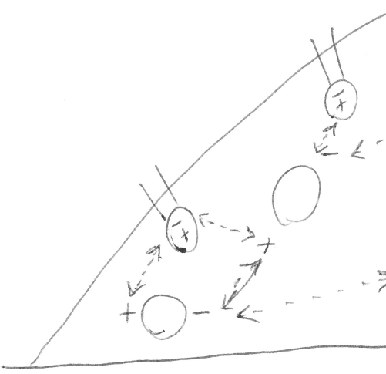
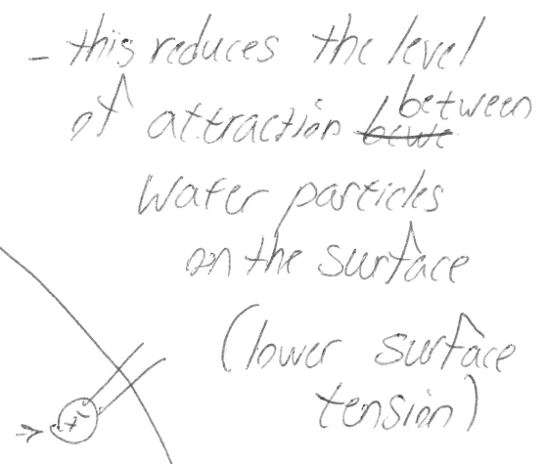
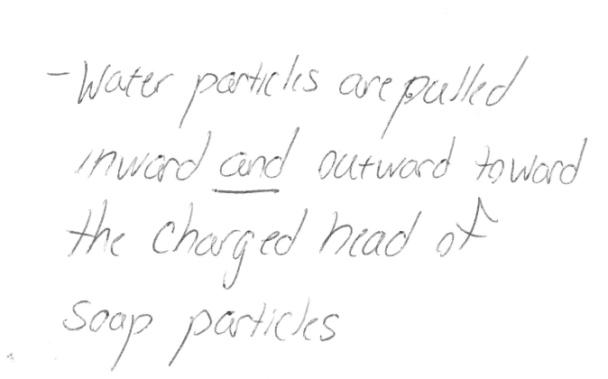

Turn this sheet over
Now that we have learned about the interactions between surfactants and water to help us answer the question of how soap particles affect the forces between water particles, revise your initial “Drop of soapy water model.”

In the space below, complete the model to show what forces are involved on the drop as a whole and in between each particle that would cause the specific shape of the drop. Remember, this is your revised model—make sure to incorporate what you've learned from your “Notes about 'What force(s) hold water particles together?'” and your “Notes about 'How do soap particles affect the forces between water particles?'”

Refer to the “KEY Revised drop of soapy water model” file
Revised drop of soapy water model
Use drawings to share your ideas. Label each part of your drawing.

Blue circles = water particles
= soap particles

Briefly describe what revisions you’ve made to your model:

Answers will vary.

