Relating a Phenomenon to Our Everyday Lives - Part 1 Worksheet Answer Key

We’ve had the opportunity to make sense of why water and soap behave the ways that they do by learning about the forces involved. Now, let’s take a look at how these same concepts are involved when we breathe.

Notes about lung surfactant, surface tension, and breathing
While we watch the Surfactant and Surface Tension in Respiration | Breathing Mechanics | Respiratory Physiology - Byte Size Med video together, take notes on the items listed below. Use words and drawings in your notes.
Surfactant and surface tension in breathing: Lung alveolar fluid is mainly made of water. The greater the surface tension of the alveoli fluid is, the more likely it is for an alveoli to collapse, and that would make it very difficult to breathe. Lung surfactant in the alveolar fluid reduces the surface tension and prevents the lung from collapsing during the breathing cycle.
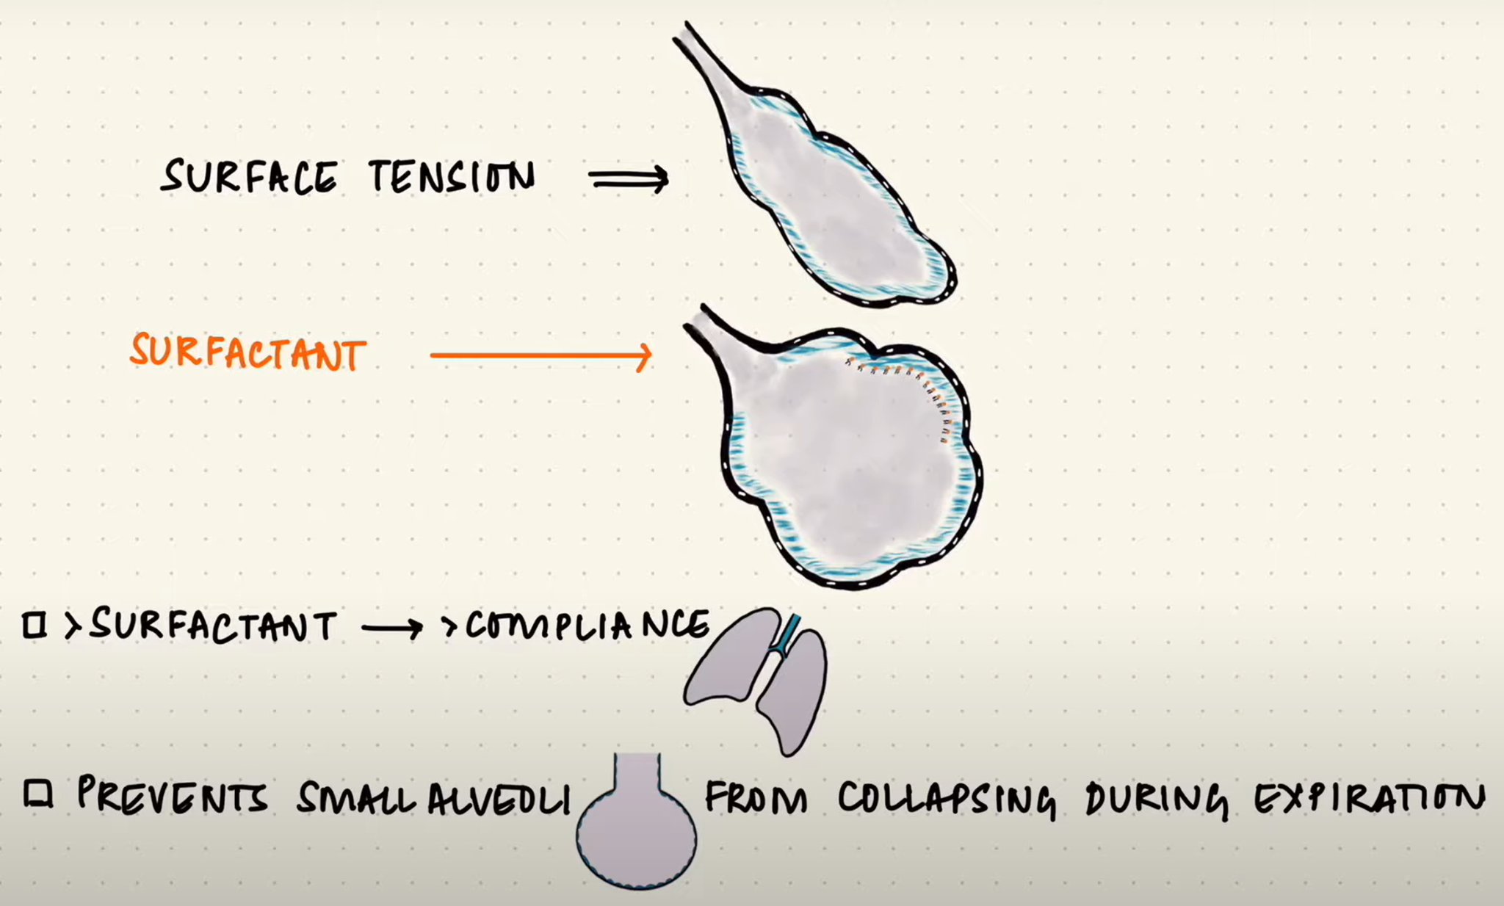
What would happen in your lungs if you inhaled something that interfered with your lung surfactant? (Include the term “surface tension” in your response.)

If lung surfactants aren’t able to do their job in the lung (interference), then the surface tension of the alveolar fluid would increase, and this would cause alveoli to collapse, making it difficult to breathe.

Turn this sheet over

Because surfactants and surface tension play an important role in breathing, let’s take a look at a related issue—vaping.

Share your current perceptions in the space below:

Pre-activity smoking perceptions survey
The purpose of this survey is only to reflect on your perceived risk of smoking and what you believe the scientific community understands concerning the effects of smoking on the human body. (Don’t worry about changing your answers on this survey in the future.)
On a scale of 1 to 10, how harmful is smoking cigarettes on the smoker’s body? (1 = no harm, 10 = significant reduction in life expectancy for an everyday smoker)

On a scale of 1 to 10, how common is smoking cigarettes among teens? (1 = no one does it, 10 = a majority of teens smoke frequently)

On a scale of 1 to 10, how well does the scientific community understand the effects of smoking cigarettes on the human body? (1 = no understanding, 10 = completely understands with no doubts)

On a scale of 1 to 10, how harmful is smoking vapes on the smoker’s body? (1 = no harm, 10 = significant reduction in life expectancy for an everyday smoker)

On a scale of 1 to 10, how common is smoking vapes among teens? (1 = no one does it, 10 = a majority of teens smoke frequently)

On a scale of 1 to 10, how well does the scientific community understand the effects of smoking vapes on the human body? (1 = no understanding, 10 = completely understands with no doubts)

