Investigating the Effects of Additives on Surface Tension - Part 1 Worksheet

Remember that we’ve agreed upon the following concepts for this investigation:
- Vaping additives that change the surface tension of alveolar fluid can have negative health effects.
- Pure water will act as alveolar fluid and soap will act as a vaping additive.
- Relative surface tension can be observed by looking at the shape of a drop of a fluid.
- Concerning the shape of a drop, the contact angle of a drop can be measured.

Follow this procedure with your group:
- Have one member of your group obtain the following supplies:
  - 1 roll of Teflon (PTFE) tape
  - 1 pair of scissors
  - 1 dropper filled with a 1:2 volumetric ratio of soap to pure water
  - 1 dropper filled with a 1:100 volumetric ratio of soap to pure water
  - 1 dropper filled with a 1:800 volumetric ratio of soap to pure water
- Cut off a strip of Teflon tape about as long as your finger.
- Lay the strip of Teflon tape flat on your table.
- Put one good, bubble-free drop of 1:2 volumetric ratio of soap to pure water on the far left of your strip of Teflon tape.
- Put one, good, bubble-free drop of 1:100 volumetric ratio of soap to pure water toward the center of your strip of Teflon tape.
- Put one, good, bubble-free drop of 1:800 volumetric ratio of soap to pure water on the far right of your strip of Teflon tape.
- Set up a dark-colored background for your drops and then have the group member who can email pictures with their phone and has a good phone camera take a very close-up picture of each drop, one at a time—remember to zoom in and be at eye level with the side of your drop of assigned soapy water.
- The picture looks something like this (the shape of your drop might be different).

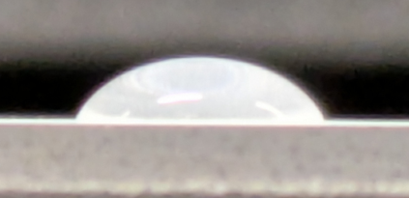

Turn this sheet over
- Email the pictures to someone in your group.
- Use the website https://protractormaster.online to upload your picture, and then use the protractor and controls to measure the contact angle.
- Record your data in the table below (notice that pure water’s contact angle has already been determined):
Volumetric ratio of soap to water | Contact angle (degrees)
1:2
1:100
1:800
Pure water | 113

- Have your teacher check your contact angles for accuracy.
- Return all of your supplies.
- Once your teacher has confirmed the accuracy of your contact angle and your group has returned your supplies, answer the questions in the space below:

Analyzing your data
Did there seem to be a relationship between your volumetric ratio of soap to water and contact angle data? Explain.

While following the procedure, you were measuring the contact angle of each drop. What does contact angle have to do with surface tension?

How does soap affect the surface tension of water?

From your perspective, does it appear to take much soap (an additive) to noticeably change the surface tension of water (a major component in alveolar fluid)? Explain using the data you collected.

