Mission Myelin: Results Sheet
Instructions: Complete this sheet with your partner.

Have these materials ready:
- pencil
- Mission Myelin: Model sheet
- Mission Myelin: Damage sheet
- Mission Myelin: Repair sheet

GRAPH
- Graph the average time for each version of your Myelin tube.

Mission Myelin
Time (seconds)
Foam-Only
Average
Repaired Myelin
Average
Damaged Myelin
Average
Myelin
Average





Tubes
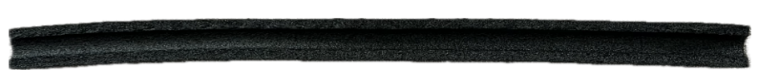

ANALYSIS, ASSESSMENT and REFLECTION

- How do the four averages compare?

- Label the neuron below using the words: axon, axon terminals, cell body, dendrites, myelin
NEURON – Nerve Cell

_______________________
_______________________
_______________________
_______________________
_______________________
- What do the objects used in class represent in the brain?

foam tube: ___________________________________

material that lined the tube: ____________________________________

marble: __________________________________

- What is myelin, and what does it do?

- What does demyelinate mean, and what is one issue could it cause for a person?

- The first box shows a myelinated neuron. Draw a representation of what a demyelinated neuron might look like in the second box.
myelinated neuron | demyelinated neuron

- What does remyelinate mean, and what is one way it can help a person?

- Have scientists discovered or invented ways to protect and/or repair myelin?
  - Yes, scientists have discovered and invented ways for myelin to be protected and/or repaired.
  - Yes, scientists have discovered how to protect myelin, but they haven’t shared that knowledge yet.
  - No, scientists are not even studying how to protect or repair myelin.
  - No, scientists have not discovered or invented ways for myelin to be protected and/or repaired, but they are working on it.

- What is an engineer?
  - A person who studies plants and animals to understand how they live.
  - A person who helps people save and invest their money.
  - A person who uses science and math to design, build, or improve things that solve problems and make life better.
  - A person who uses their hands and tools to build homes and businesses.

- Do you have an interest in engineering? Explain.

- List skills someone would need to have (or develop) to be a person who studies myelin:

- Describe one challenge you experienced while working on Mission Myelin.

- What would you change or do differently if you repeated Mission Myelin?

