
The Magical Mountains
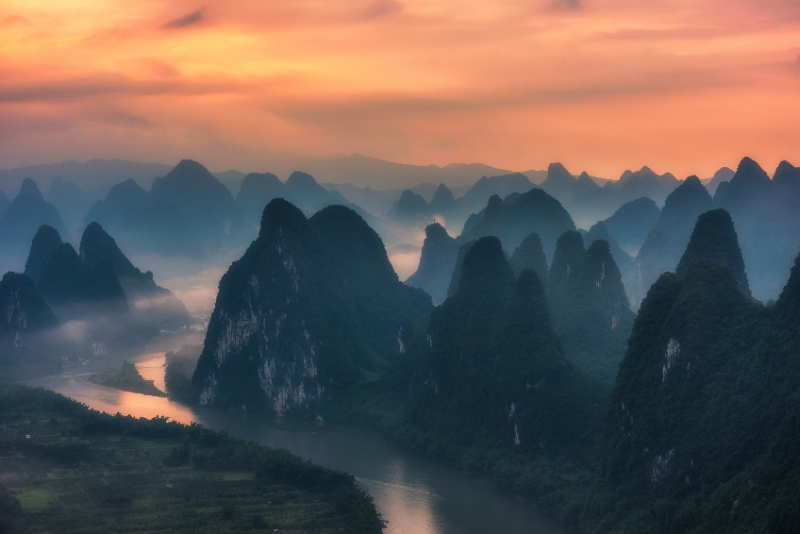

The magical mountains are some of the tallest mountains in the world. There is a lot of snow at the top of the mountains during the winter and many rivers and waterfalls that flow down the mountains. Because the mountains are so high, there are almost no trees. Instead, the mountain has lots of bushes, flowers, and grass. Many insects live in these bushes and flowers. The mountains are very rocky, which means there are lots of places for predators like bears and foxes to make their homes in caves. In the summer, it is very dry and cold. In the winter the temperatures are freezing, and it snows every day.


The Jinxed Jungle
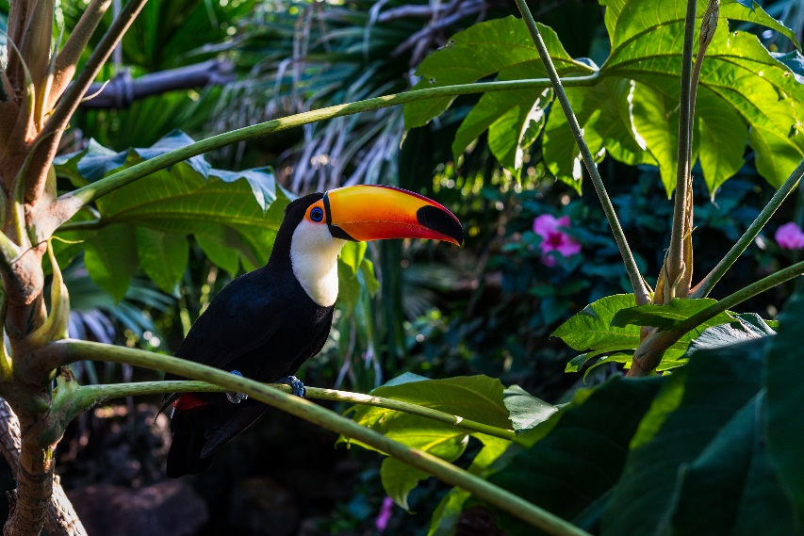

The jinxed jungle is a hot and humid place. There are not any hills or mountains, but there are many tall trees everywhere and deep green plants all along the jungle floor. The plants are so thick on the forest floor that it is almost dark. While there are many plant species here, many of them can be dangerous to eat if they do not have the right adaptations. Some of the plants in this jungle are even carnivorous! Many creatures call this jungle their home, both predators and prey. Some animals hunt at night and others during the day.

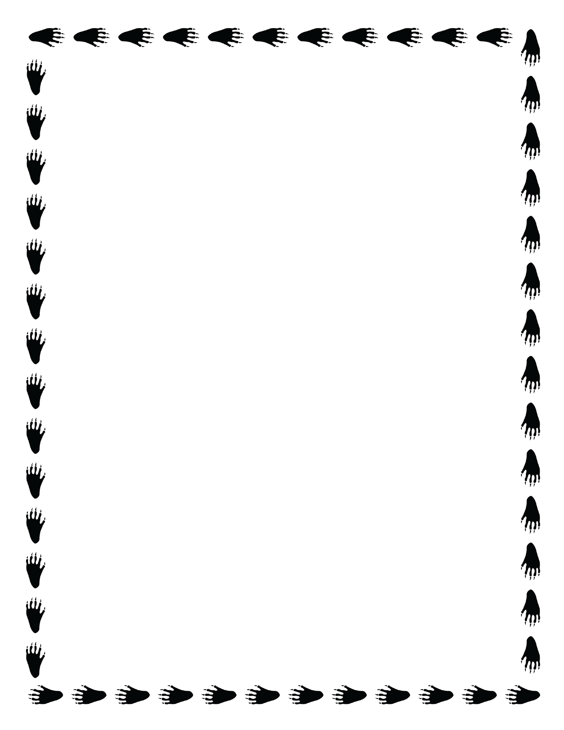
The Dangerous Desert
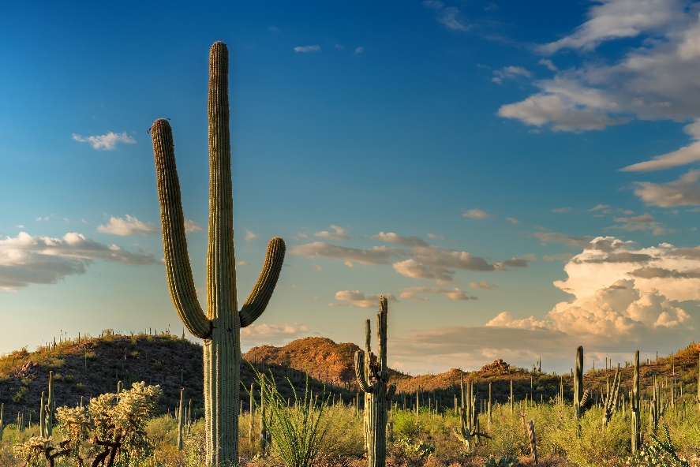
The dangerous desert is dangerously hot and can reach temperatures of 120 degrees during the day, yet it cools off at night. It rarely rains in this desert and there are few sources of water anywhere to be found, except in hidden places, usually underground. Giant cactuses in the desert have very deep roots that make it down to these underground springs and receive nutrients that way. The only shade that can be found is in the shadow of the mountains that lie at the end of the valley. Near there are also lots of tall rocks in piles that make occasional caves. Many small, scaly lizards and reptiles live in this area.


The Shady Savannah
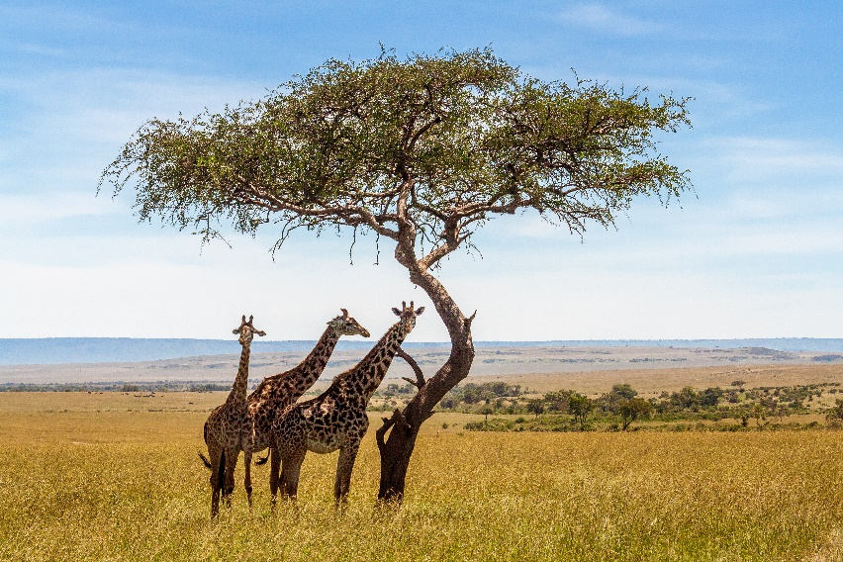
The shady savannah is a hot, dry area with very different weather depending on the year. During most of the year, it is hot and dry and only rains occasionally, but for three months of the year, the savannah experiences a monsoon season where it rains the majority of the day. This is also the time when the grass grows the most. The savannah is mostly grass with occasional trees and bushes. There are plenty of streams and ponds. The ponds are normally a gathering place for animals to drink but can also be a good place for predators like crocodiles to catch easy prey. The savannah is full of large mammals, both predators, and prey. Animals must have many tricks to survive in this competitive environment.

The Abandoned Arctic
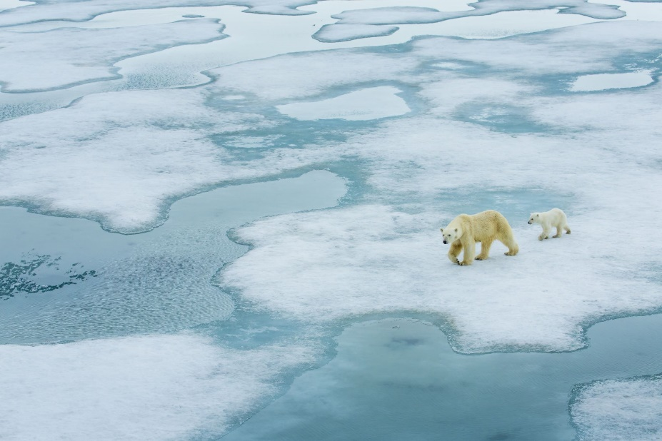

The abandoned arctic is dark for half of the year and light for the other. No plants can grow in this environment where it is nearly below freezing for most of the year except for the summer months. The area is mostly flat with some large grey rocks that are usually covered by snow. There is a thick layer of ice over water sources most of the year, but in the water are plenty of fresh fish. Packs of wild wolves roam the plains and burrowing, shrews live beneath the snow and live off small insects and worms. Giant polar bears also make the arctic their home, but they sleep during the coldest months of the year.


The Outstanding Ocean
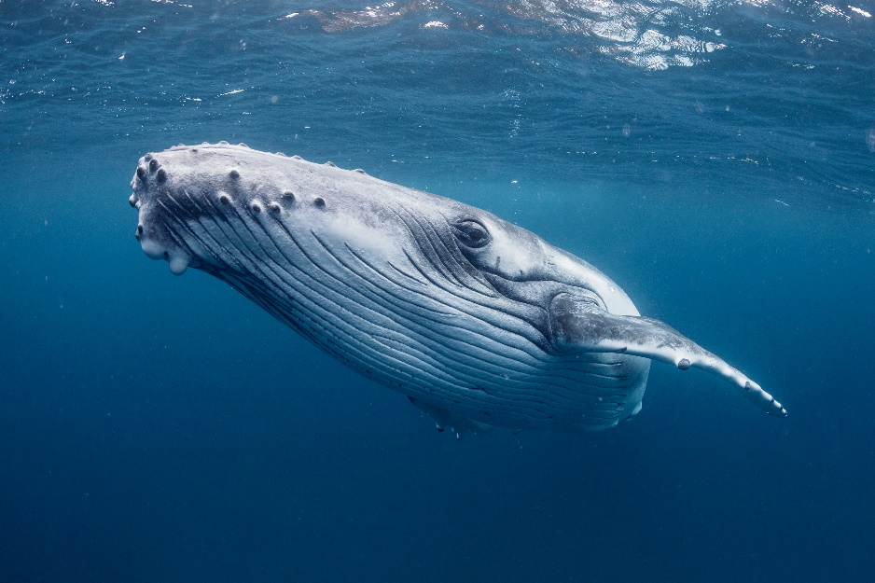
The outstanding ocean is a mild, sub-tropical sea with a giant coral reef. The reef is full of small, colorful fish. Many of these fish are good at using camouflage to blend in with the colorful reef and are tiny enough to hide under the rocks to protect themselves. These small fish eat the coral or tiny plankton in the water. Right next to the reef is a deep ocean trench. The trench contains many large ocean animals such as sharks, whales, and deep-dwelling ocean creatures. These animals will often eat smaller fish from the edges of the reef or large schools of traveling fish. The ocean remains about the same temperature all year, but for three months out of the year, the reef is taken over by crabs that nest in the reef and feast on the fish.

