Slime SOP Worksheet
- For ease, pour some glue, slime activator, and water into 3 separate plastic containers.
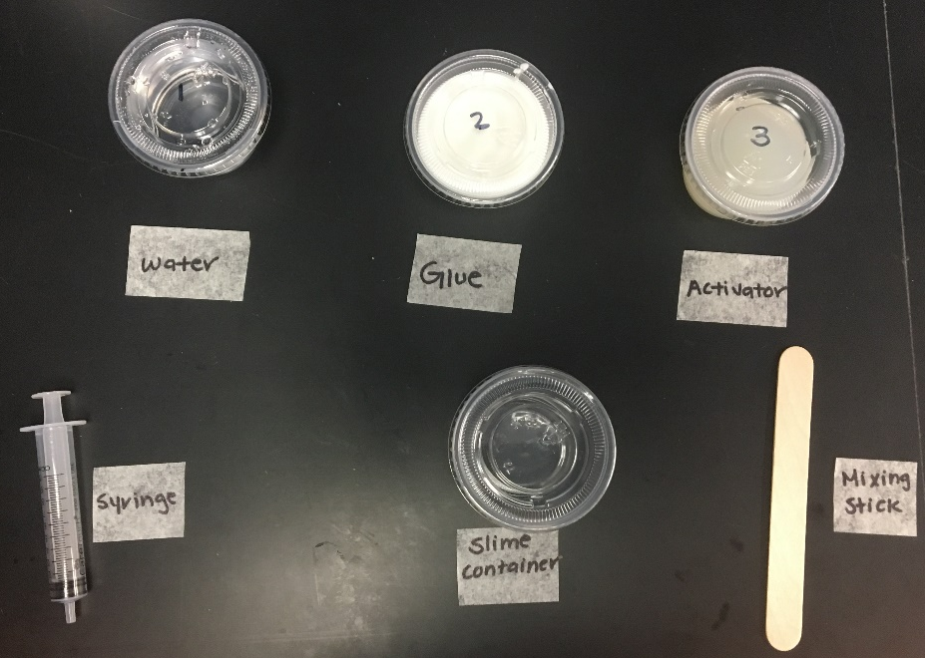
This image shows the needed supplies for this project
- Grab a syringe. Put the tip of the syringe into the water container and pull the handle on the back of the syringe all the way up until the black seal reaches the 10 ml mark. This enables the syringe to suck up the water.
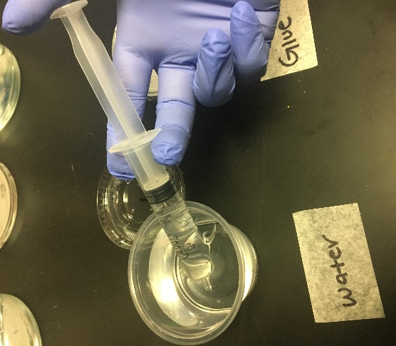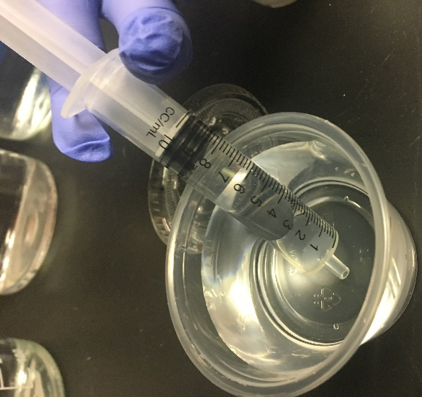
When the black seal reaches the last tick mark (10 mL mark) stop pulling on the plunger.
Pull the syringe’s plunger up to draw up the water

- Dispense the water into a separate, empty plastic container. This is to be the slime container.
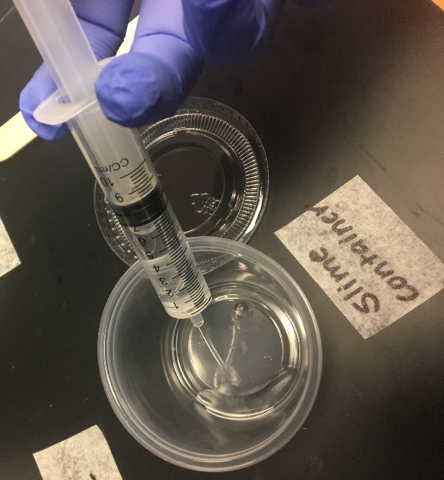
Push down on the plunger to release the water into the slime container
- Using the same syringe, put the tip of the syringe in the glue container and pull the handle on the back of the syringe to draw the glue up. Dispense into the slime container. Repeat this step 3 more times.
- Note: because glue is so sticky, it’s going to get all over the tip of the syringe. Keep extra paper towels handy to clean off the tip of the syringe before using it again to avoid “cross contamination.”
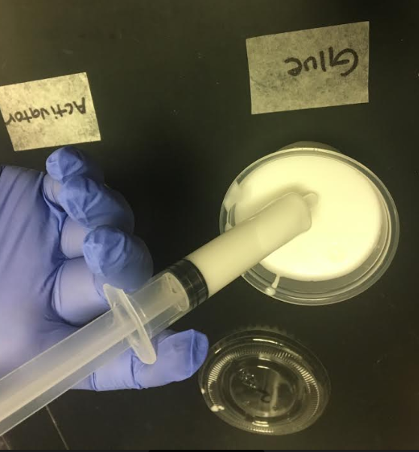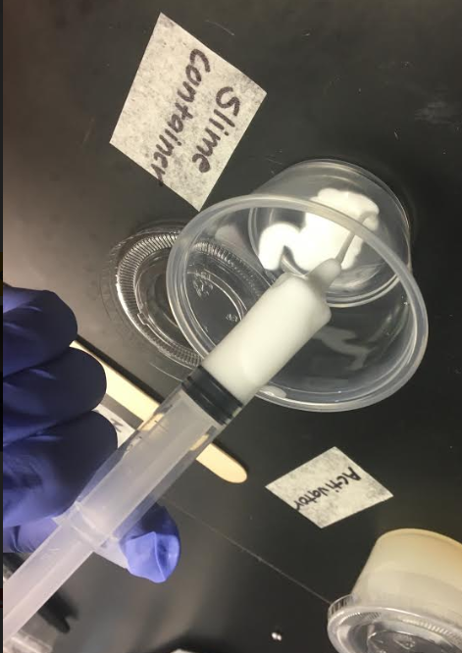
Use a paper towel to clean off the excess glue on the outside of the syringe tip.
- Use the same syringe to draw from the activator container and dispense into the slime container.
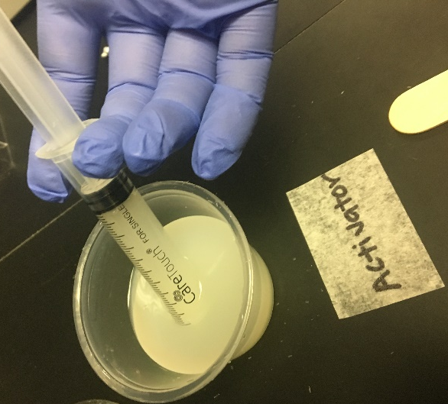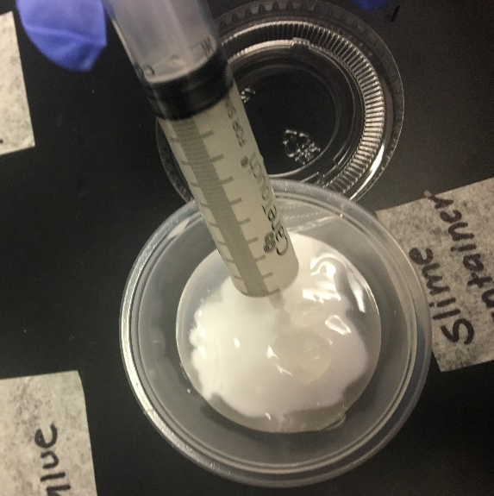
- At this point, your slime contianer should look like the image below:
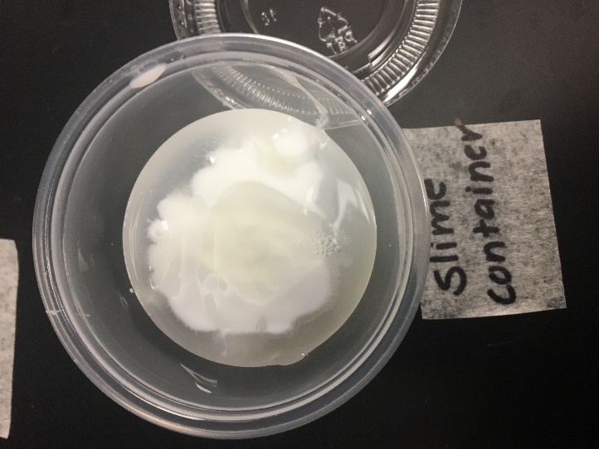
The slime doesn’t form until the ingredients are mixed together. At this point, all the ingredients are still separate from each other and you should be able to tell each ingredient apart in the slime container.
- Using the wooden stick, mix the contents of the slime container thoroughly until the slime forms. When the liquid is completely gone and all that’s left in the container is sticky slime, you can stop mixing. It typically takes about 30 seconds of mixing for the slime to completely form.

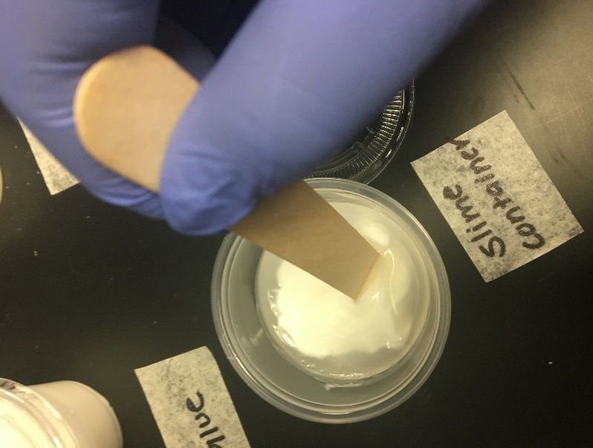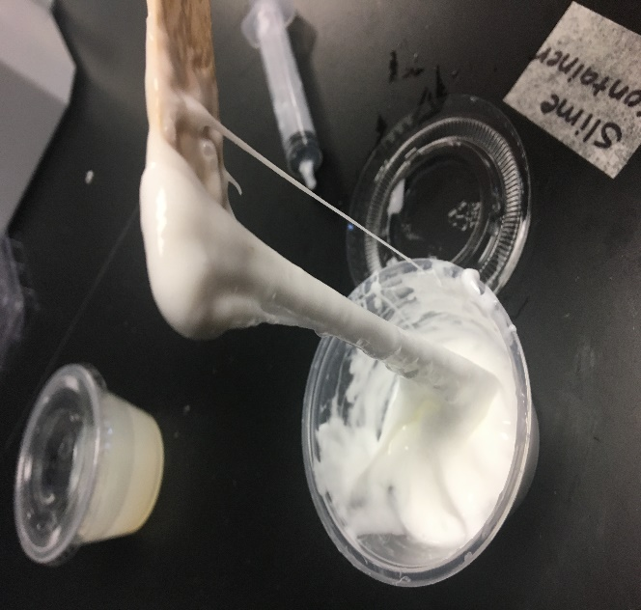
When your slime looks like this, you can stop mixing.
Mix until no liquid remains in the slime container

- When the slime is fully formed, touch it and feel the slime. Make observations using your sense of touch about the slime.
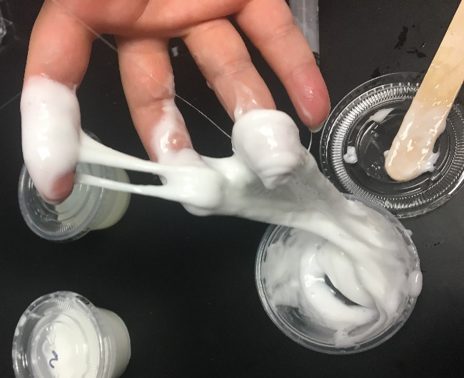
Keep in mind that the slime is going to be a little sticky when you touch it. Keep a paper towel handy to wipe your hands when you’re done playing with the slime. Once your experiment is over, be sure to wash your hands with soap and water.

