Resource Binder

Boats
Know: | Want to Know: | Learned:
Research Record

#1: | #2: |  | #3:
Other findings: |  | Want to share:

General Boat Research Links

Why do ships Float by SciShow Kids:
https://www.youtube.com/watch?v=CvWrkxzCiaY

How do ships Float by Science Out Loud MIT+K12 Videos
https://www.youtube.com/watch?v=pnIlE1xD-yM

Buoyancy: What makes something float or sink? By Kids Want to Know
https://www.youtube.com/watch?v=nMlXU97E-uQ

Boat Movement Research Links

Technobrain 2015 Boat Race
https://www.youtube.com/watch?v=cgdCmDt5gVs&spfreload=
10

Homemade sailboat:

Rubber bank powered boat:

Rubber bank powered boat:
https://www.youtube.com/watch?v=KnngK-jGfYo https://www.youtube.com/watch?v=Wy1RUskWxqk https://www.youtube.com/watch?v=USB-dHeWMiY

Balloon boat:

How to make water boat without a motor:
https://www.youtube.com/watch?v=tz-t_DXk6-c https://www.youtube.com/watch?v=RcrJvlreS84&t=3s

How will your boat move? | How will your boat move? | How will your boat move?
How will your boat move? | How will your boat move? | How will your boat move?
How will your boat move? | How will your boat move? | How will your boat move?

Sinking or Floating?

Properties Recording Sheet
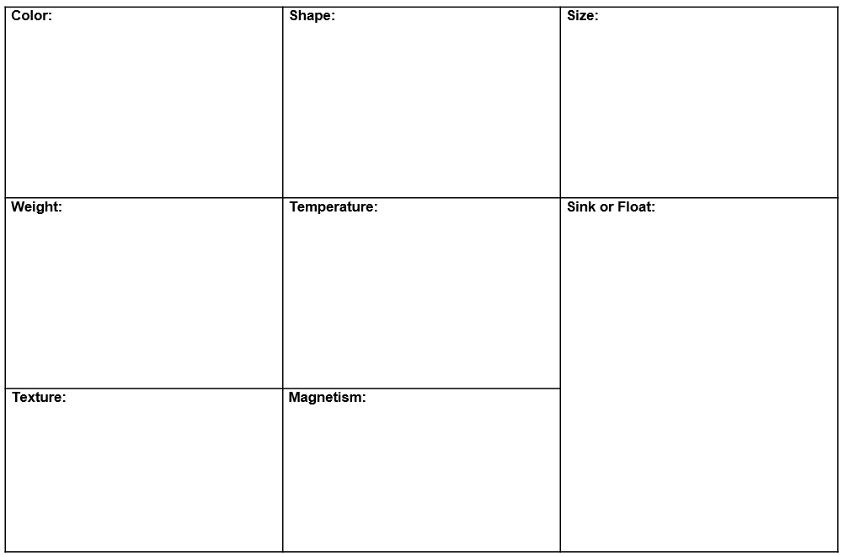
Clay Investigation
Property:

Procedure:

Observations:

Conclusion:

Materials for boat: | Materials for Boat: | Materials for boat:
Materials for boat: | Materials for boat: | Materials for boat:
Materials for boat: | Materials for boat: | Materials for boat:

Question Cards for The Most Magnificent Thing
Before: Look at the cover. What can you observe? | Before: What do you predict the most magnificent thing will be? | During: What steps has the girl taken so far as an engineer? | During: How does the girl react when she doesn’t succeed the first time?
During: Look closely at the illustrations. How has the girl’s expression changed? Why do you think the illustrator choose to show that? | During: Can you think of a  time you failed the first time? | During: Examine the verbs the author is choosing. What do they tell us about how the girl feels? | During: How did the girl discover how to make the most magnificent thing? Have you ever learned from your own mistakes?
During: Look at the speech bubbles in the illustrations. What do the other people think of her “failed” inventions? | After: What is the theme, or moral message, of this story? How can we apply that to our boat designs? | After: What other stories have we read that have a similar moral message?

Cost of Materials
Item | Price |  | Item | Bulk Price
wood plank (balsa) | $50.00 |  | 10 corks | $10.00
Styrofoam block | $50.00 |  | 4 water bottles | $30.00
cube of modeling clay | $50.00 |  | 10 rubber bands | $5.00
cork | $2.00 |  | 10 popsicle sticks | $5.00
water bottle | $10.00
rubber band | $1.00
popsicle stick | $1.00
wood stick (balsa) | $5.00
fabric (1 meter) | $5.00
fan rental | $10.00
balloon | $10.00
plastic cup | $1.00
twine (30 cm) | $10.00
plastic wrap | $10.00
aluminum foil | $10.00
duct tape | $10.00
clear tape | $5.00

Budget Approval Form

Item | Price

Total Price:
Engineer signature:
Engineer signature:
Principal Investigator (teacher) signature:

Rubric
 | 5 | 4 | 3 | 2
Description of properties | The student can describe the boat’s size, shape, color, weight, texture, and sink or float, with measurements when appropriate. | The student can describe 5 of the properties accurately and with measurements when appropriate. | The student can describe 3 of the properties accurately and with appropriate measurements. | The student can describe 2 of the properties with or without the appropriate measurements.
Boat design | The student chose materials that were in budget and made a boat that floated and could reach their destination or they had a plan to fix their design. | The student chose materials that were in budget and made a boat that floated. Their boat did not reach their destination and they did not have a plan to fix their design. | The student only met 1 of the requirements. | The students did not meet the requirements.
Teamwork | The student listened to their partner’s ideas and contributed their own ideas. They made decisions together. | The student wanted to use their own ideas and had difficulty accepting their partner’s ideas. | The student wanted to use their own ideas and did not accept their partner’s ideas. | The student did not work with their partner.
Sharing findings | The student prepared a presentation that included the materials they used and why, what went well, and what they would do next time. | The student prepared a presentation that only answers two of the three questions. | The student prepared a presentation that only answers one of the three questions. | The student did prepare for their presentation.
Self- Assessment | The student completed their self- assessment. |  |  | The student did not  complete the self- assessment

Self-Assessment

