Task Cards

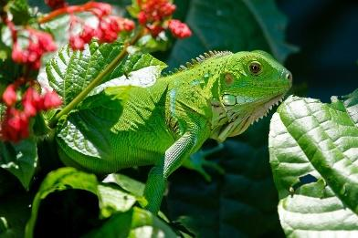  I am a green iguana. I live in a rainforest. I hurt my hand and can no longer hunt. Can you help me fix my hand and build a space for me to live while it heals? | 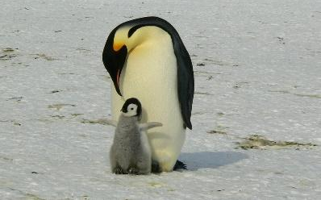  I am an emperor penguin. I live in Antarctica. I hurt my flipper and can no longer swim. Can you help me fix my flipper and build a space for me to live while it heals?
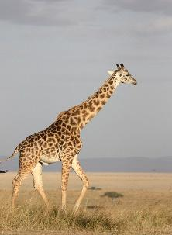  I am a giraffe. I live in the savannas of Africa. I hurt my neck and can no longer reach the food that I need. Can you help me fix my neck and build a space for me to live while it heals? | 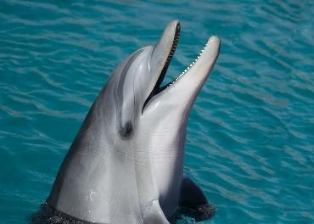  I am a dolphin. I live in the ocean. I hurt my tail and I cannot swim. Can you help me fix my tail and build a space for me to live while it heals?
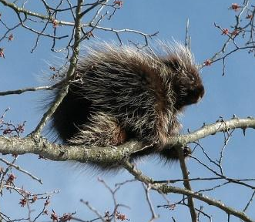  I am a porcupine. I live in a temperate forest. I lost my quills and cannot protect myself against predators. Can you help me fix my quills and build a space for me to live while they heal? | 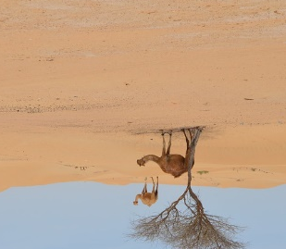  I am a camel. I live in the desert. I hurt my feet and I am getting stuck in the sand. Can you help me fix my feet and build a space for me to live while they heal?

Task Cards

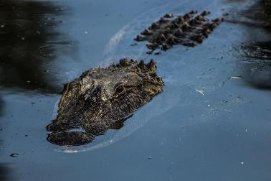  I am an alligator. I live in wetlands. I lost my teeth and cannot hunt food. Can you help me fix my teeth and build a space for me to live while I heal? | 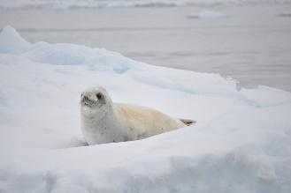  I am a seal. I live in cold areas of the ocean. I need more blubber to help me stay warm. Can you fix my blubber and build a space for me to live while it heals?
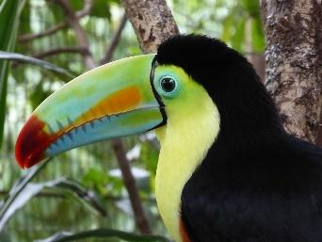  I am a toucan. I live in the rainforest. My beak was hurt. Can you fix my beak and build a space for me to live while it heals? | 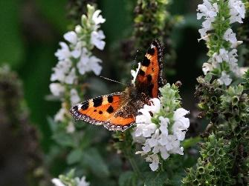  I am a butterfly. I live all over the world in fields and meadows. My wing was hurt. Can you fix my wing and build a space for me to live while it heals?

