Beyond Binary Quiz Answer Key

Instructions: Fill in the blanks with the logic gate type that is represented in the image. Your choices are AND, NOT, or OR.

- _____NOT_________ 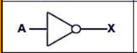

- _____AND_________ 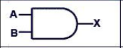

- _____OR_________ 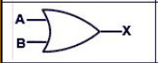

- _____OR_________ 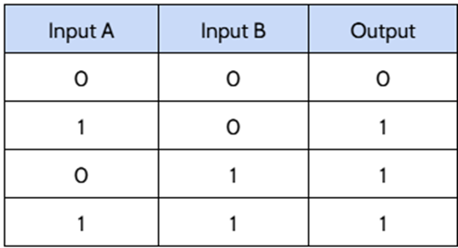

- ______AND________ 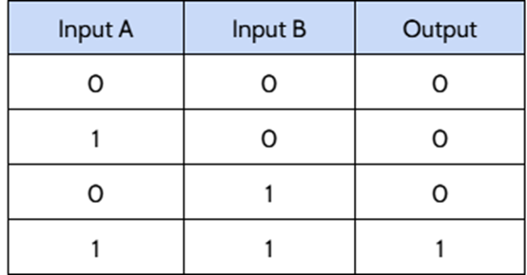

- ______NOT________ 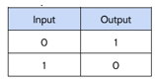

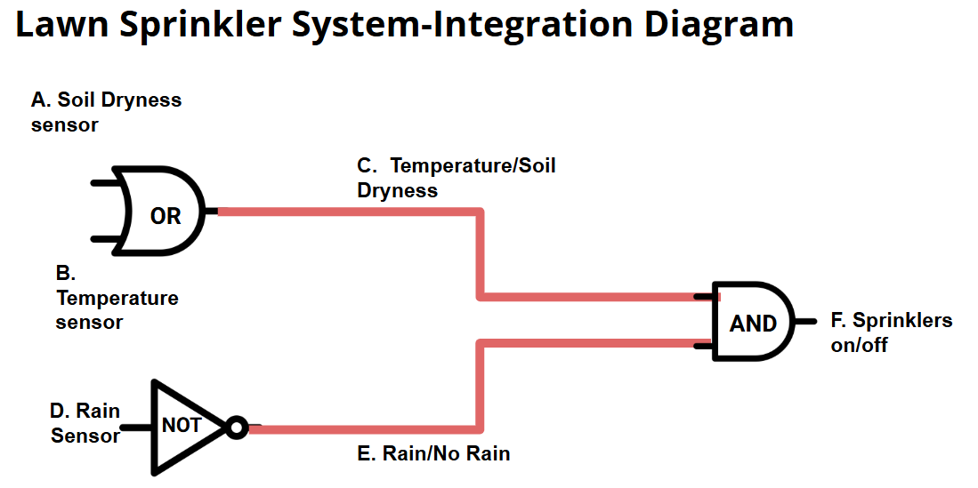
- The following is a set of logic gates that create a smart control for a sprinkler system. Create a set of truth tables for each gate using words (not 1s and 0s), and then write a statement that explains all of the conditions that must be true for the sprinkler system to automatically turn on.
OR Gate
Input A | Input B | Output C
Sensor reads below acceptable soil moisture (high input) | Sensor reads high temperature (high input) | High (on) signal sent to AND gate
Sensor reads below acceptable soil moisture (high input) | Sensor reads low temperature (low input) | High (on) signal sent to AND gate
Sensor reads soil moisture levels in acceptable range (low input) | Sensor reads high temperature (high input) | High (on) signal sent to AND gate
Sensor reads soil moisture levels in acceptable range (low input) | Sensor reads low temperature (low input) | Low (off) signal sent to AND gate

NOT Gate
Input D | Output E
Sensor detects that it is raining (high input) | Low (off) signal sent to AND gate
Sensor does not detect rain (low input)) | High (on) signal sent to AND gate

AND Gate
Input C | Input E | Output F
High signal means either high temp or dry soil | High signal means it is not raining | High (on) signal sent to turn the sprinkler system on
High signal means either high temp or dry soil | Low signal means it is raining | Low (off); sprinkler system remains off
Low signal means soil is both moist and cool | High signal means it is not raining | Low (off); sprinkler system remains off
Low signal means soil is both moist and cool | Low signal means it is raining | Low (off); sprinkler system remains off

- Choose one of the two scenarios below. Sketch the logic gate integrated circuit described by the scenario. Then create truth tables using words, not 1s and 0s, to describe how each gate functions and integrates with the others to complete the task.

Elevator Control:  An elevator moves up when either the up button is pressed inside the elevator or the up button is pressed outside the elevator, but not when the emergency stop button has been pressed. | Secure Building Access:  A user can gain access when both the correct username and password are entered or a valid biometric scan occurs, but not if the building is on lockdown.

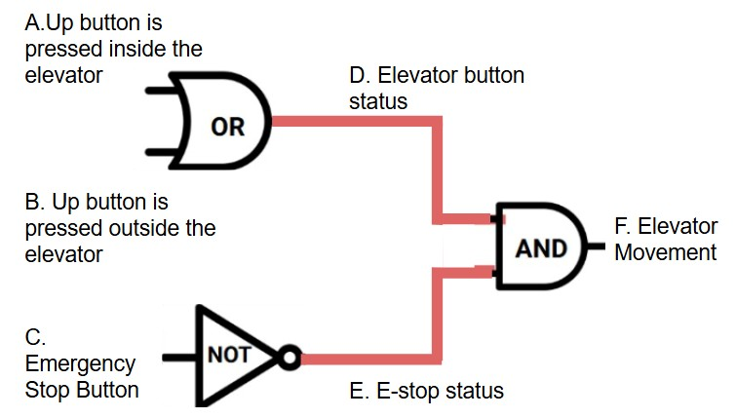
OR Gate
Input A | Input B | Output D
Sensor reads pushed button inside elevator (high input) | Sensor reads pushed button outside elevator (high input) | High (on) signal sent to AND gate
Sensor reads pushed button inside elevator (high input) | Sensor does not read pushed button outside elevator (low input) | High (on) signal sent to AND gate
Sensor does not read pushed button inside elevator (low input) | Sensor reads pushed button outside elevator (high input) | High (on) signal sent to AND gate
Sensor does not read pushed button inside elevator (low input) | Sensor does not read pushed button outside elevator (low input) | Low (off) signal sent to AND gate

NOT gate
Input C | Output E
Sensor detects that the emergency stop button has been pushed (high input) | Low (off) signal sent to AND gate
Sensor detects that the emergency stop button has not been pushed (low input) | High (on) signal sent to AND gate

AND Gate
Input D | Input E | Output F
High (on) signal sent from elevator button push | Low (off) signal sent representing emergency stop is pushed | Low (off); elevator will not move
High (on) signal sent from elevator button push | High (on) signal sent representing emergency stop is not pushed | High (on); elevator set to move
Low (off) signal sent from elevator button | Low (off) signal sent representing emergency stop pushed | Low (off); elevator will not move
Low (off) signal sent from elevator button | High (on) signal sent representing emergency stop is not pushed | Low (off); elevator will not move
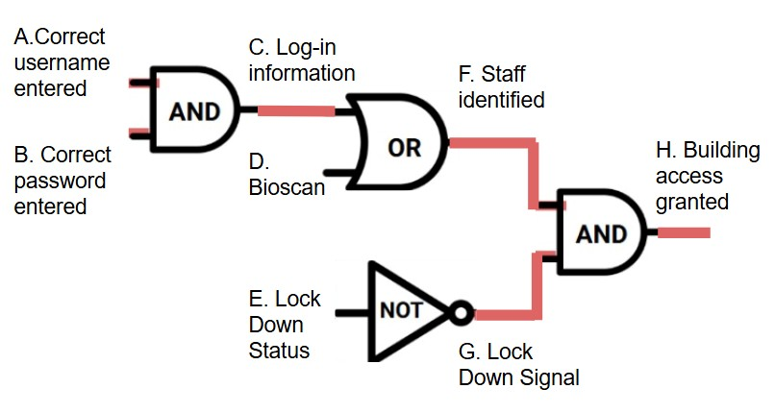
AND Gate
Input A | Input B | Output C
High (on) signal sent representing correct username | Low (off) signal sent representing incorrect password | Low (off); Log-in information not confirmed
High (on) signal sent representing correct username | High (on) signal sent representing correct password | High (on); Log-in information confirmed
Low (off) signal sent representing incorrect username | Low (off) signal sent representing incorrect password | Low (off); Log-in information not confirmed
Low (off) signal sent representing incorrect username | High (on) signal sent representing correct password | Low (off); Log-in information not confirmed

OR Gate
Input C | Input D | Output F
High (on); Log-in information confirmed | Bioscan confirms identity; high (on) | High (on) signal sent to AND gate
High (on); Log-in information confirmed | Bioscan denies identity; low (off) | High (on) signal sent to AND gate
Low (off); Log-in information not confirmed | Bioscan confirms identity; high (on) | High (on) signal sent to AND gate
Low (off); Log-in information not confirmed | Bioscan denies identity; low (off) | Low (off) signal sent to AND gate

NOT gate
Input E | Output G
Building is in lockdown; high (on) | Low (off) signal sent to AND gate
Building is not in lockdown; low (off) | High (on) signal sent to AND gate

AND Gate
Input F | Input G | Output H
High (on) signal sent to AND gate from identification sensors | Low (off) signal sent to AND gate representing building is in lockdown | Low (off); Building access not granted
High (on) signal sent to AND gate from identification sensors | High (on) signal sent to AND gate representing building is not in lockdown | High (on); Building access granted
Low (off) signal sent to AND gate from identification sensors | Low (off) signal sent to AND gate representing building is in lockdown | Low (off); Building access not granted
Low (off) signal sent to AND gate from identification sensors | High (on) signal sent to AND gate representing building is not in lockdown | Low (off); Building access not granted

