Get the Materials Down the Hill! Worksheet Answer Key
- Brainstorm
Problem scenario: You are trying to move a large amount of material down a hill. You have
limited tools and resources for your use. Your task is to move the largest amount of material
in 5 minutes and determine its acceleration down the hill. Brainstorm how you can use the
given materials provided by your teacher for the task.
Notes of brainstorming ideas:
Answers will vary.
- Plan for a solution
Answers will vary.
- Sketch the planned prototype on the hill
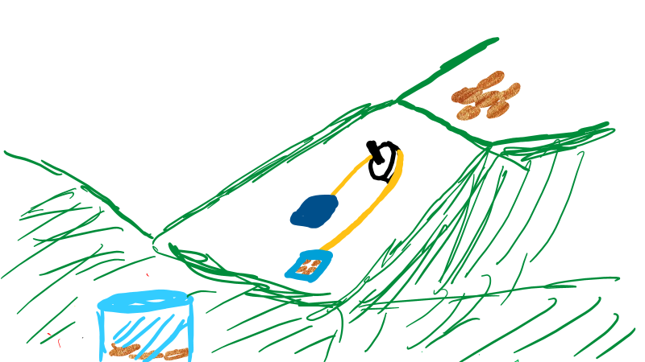
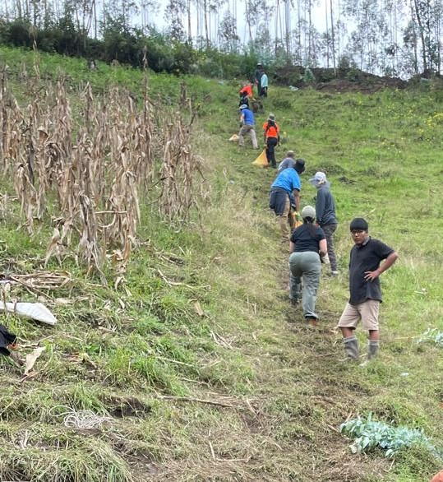
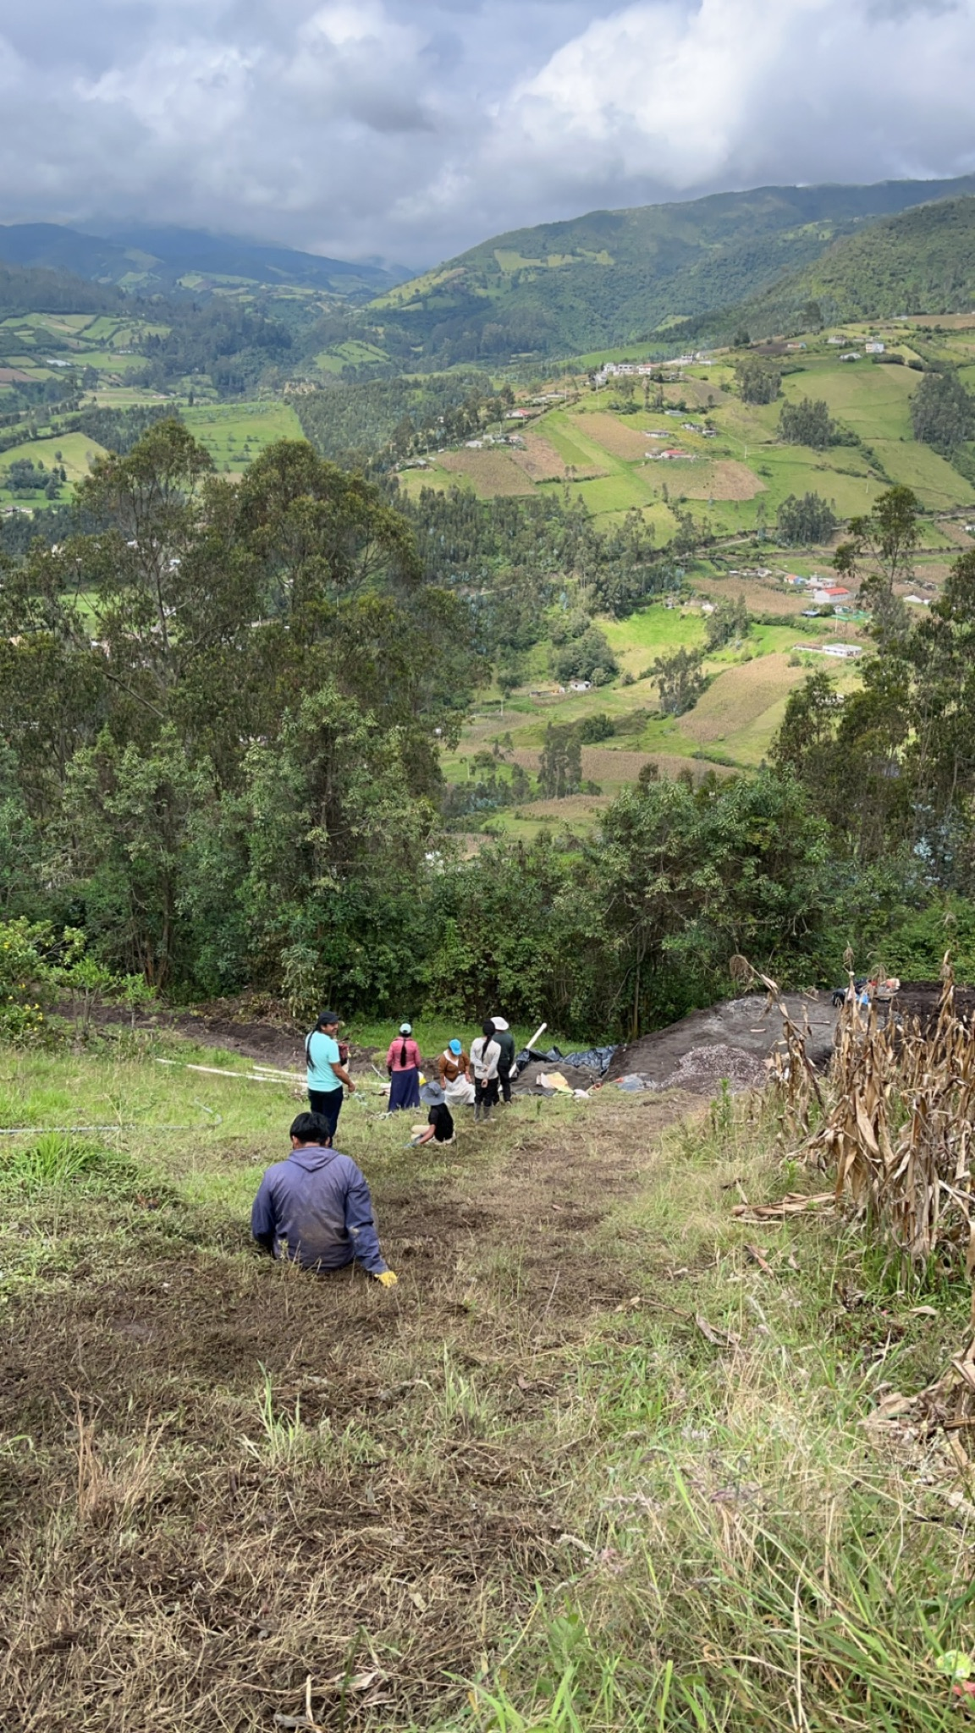
Example sketch.

- Sketch a free body diagram
2-dimensional FBD for mass going downhill
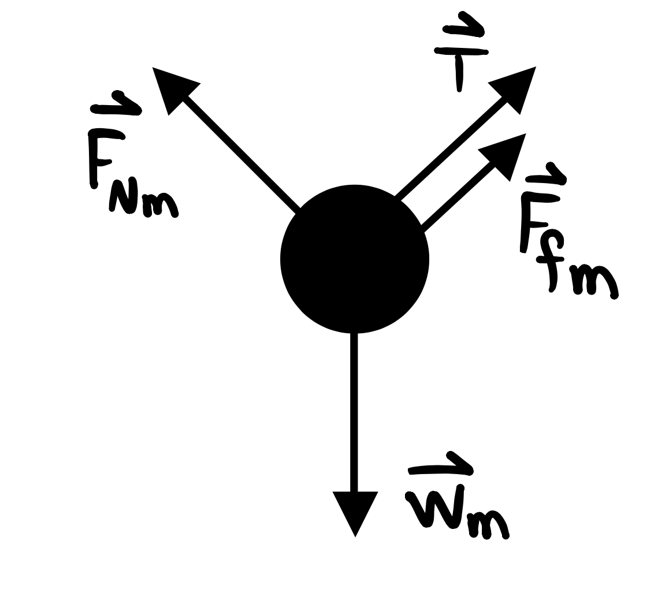
1-dimensional FBD for mass going downhill
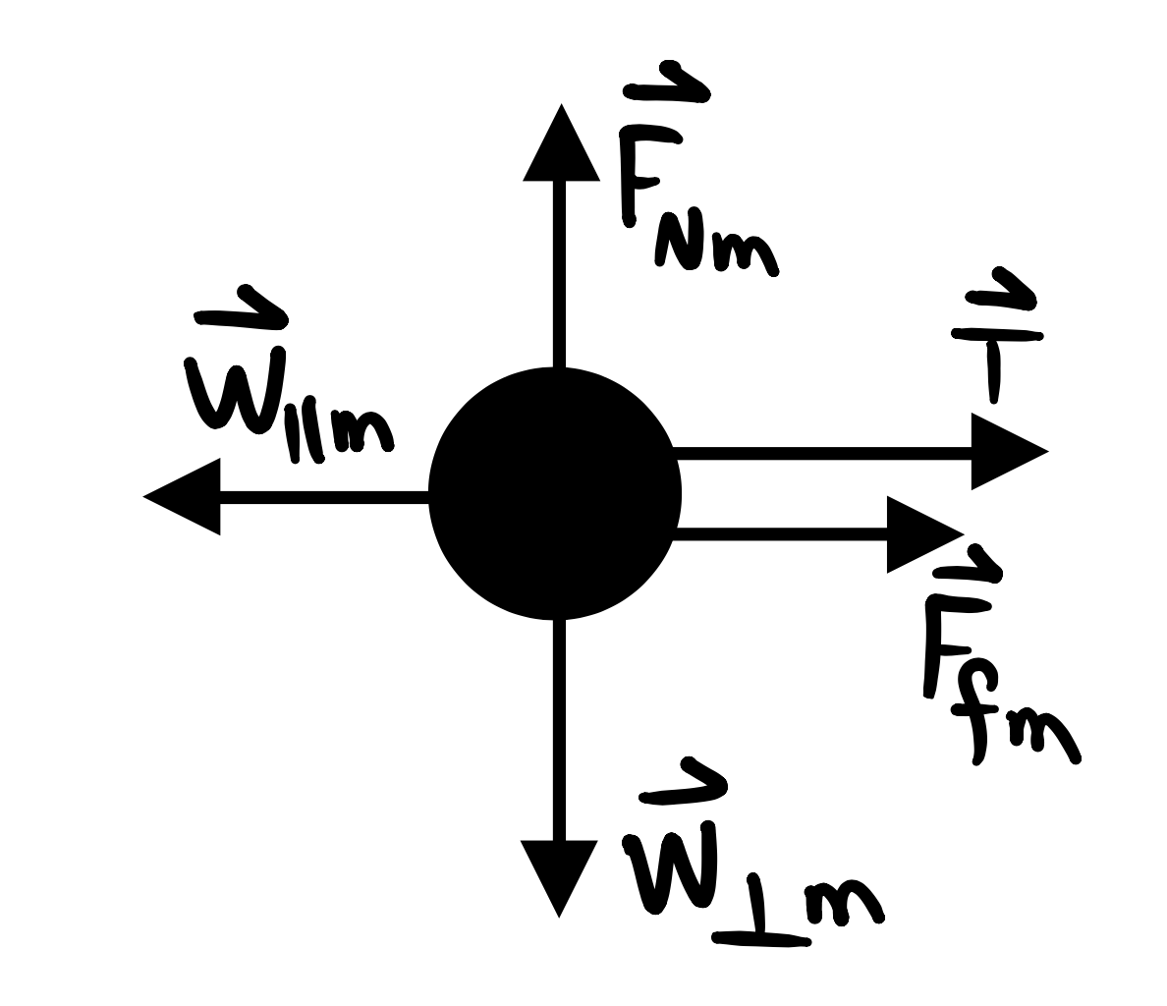

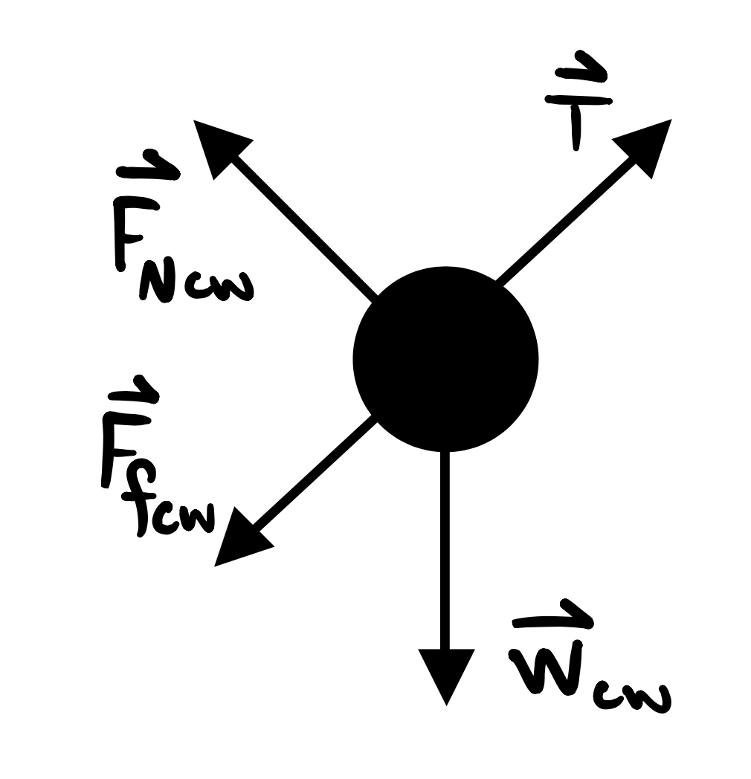
2-dimensional FBD for counterweight going uphill
1-dimensional FBD for counterweight going uphill
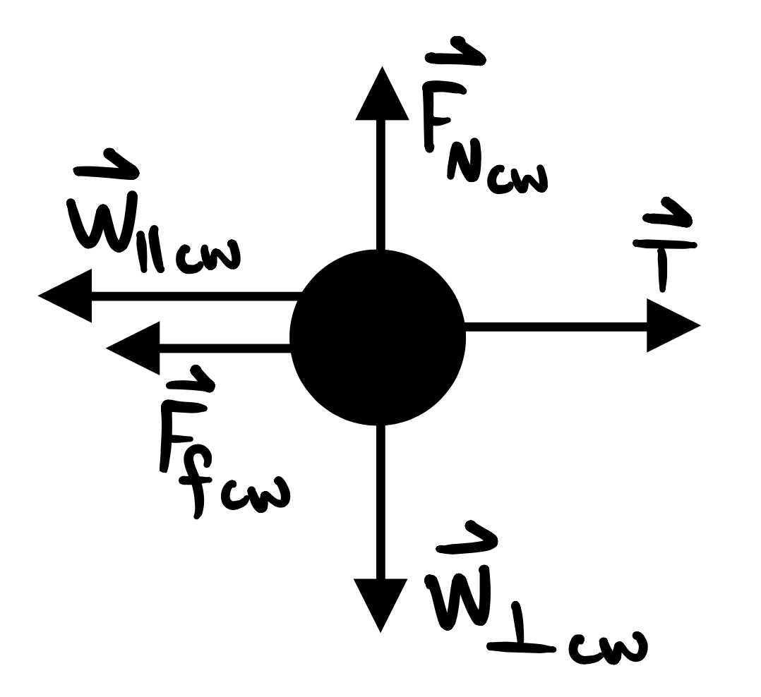

- Calculations
- Determine the angle of the hill.

Angle ___________
Height ___________
Length ___________
ANSWER: $θ=\sin^{-1}(\frac{height}{length})$
- Based on your arrangement, determine the maximum amount of time it takes to move
the maximum amount of mass.
Answers vary.
Run | Mass | Time
1
2
3
Average mass (kg)

- Determine the acceleration of the load transported by your prototype. Show all calculations that support your analysis based on Newton’s second law of motion.
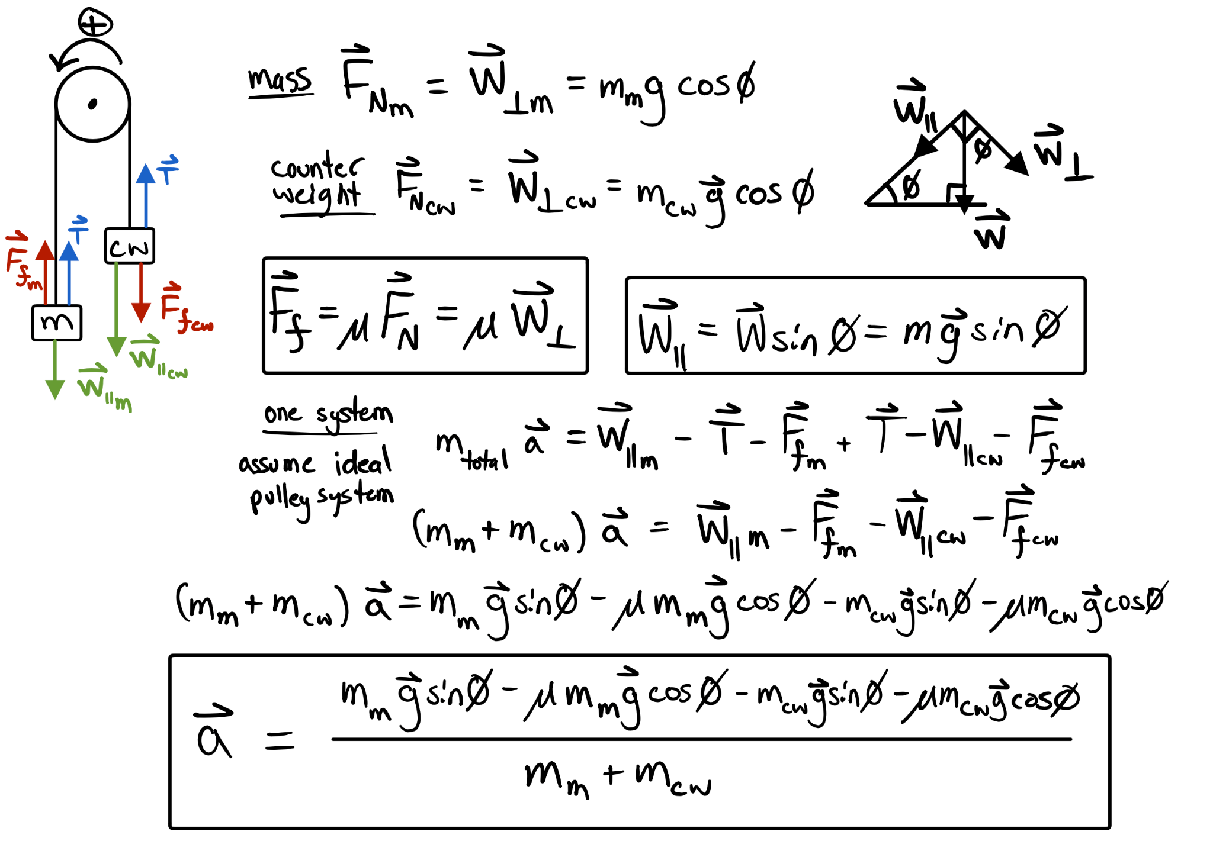
This is a possible solution to the student prototype using a pulley and rope system. For this method, the load transported down the hill is referred to as the mass (m), while the counterweight (cw) refers to an object on the opposite end of the rope. The coefficient of friction μ is determined by the material the student chooses to transport the material and counterweight.
- Based on your prototype, determine the equivalent of the mass (in kilograms) as a
load (in Newtons).
Students should use the equation referring to weight to determine the equivalent load. Weight = mass x gravity

- Report and feedback
  - Report to the group your prototype solution and data regarding the maximum mass able to transport.
Student responses will vary.

  - Annotate feedback from your peers on your solution.
Student responses will vary.
- Redesign your solution
  - Rework your solution based on the feedback provided by your peers.
Student responses will vary.

  - Sketch your redesign.
Student responses will vary.
- Based on your redesign, determine which was the maximum amount of mass in the given period. Answers will vary.
Run | Mass | Time
1
2
3
Average mass (kg)

- Reflect on your solution
Reflect on how other countries work to solve a common problem regarding transporting materials necessary for construction. How do they use their resources to solve that specific problem? What are your takeaways regarding solving their specific problem? Student responses will vary.

