NeuroMaze Guide
Guiding Questions:
- What is the ultimate goal of your robot?

- What constitutes successful maze navigation?

- What constraints must you work within?

- How do different maze-solving algorithms work?

- What sensors are available on your Cutebot?

- What are the key challenges in maze navigation?

Design Considerations:
- How does the engineering design process guide your work? Include descriptions for each step of the process.

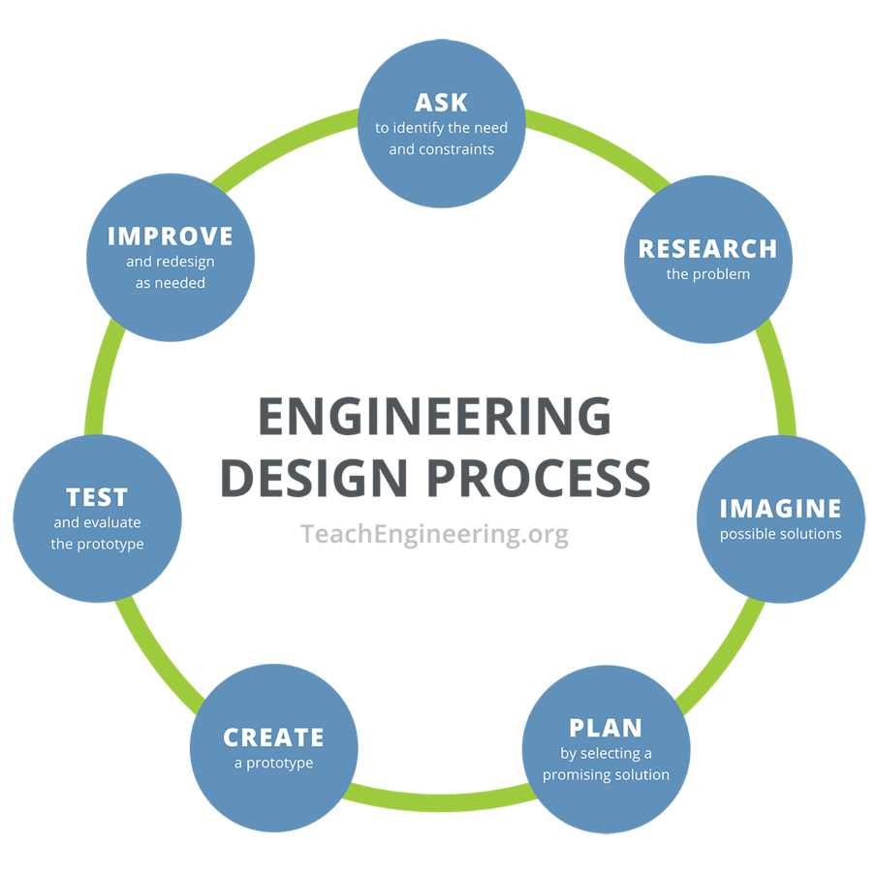

- How will the robot detect walls?

- When should it turn vs. go straight?

- How will it recognize the finish line?

- What speeds work best for different actions?

Data Table
Trial | Successful | Issues Observed | Modifications Made

Design Checklist
- Flowchart completed
- Basic movement code written
- Sensor integration completed
- Navigation logic implemented
- Testing data collected
- Optimization performed
- Documentation finished
- Reflection questions answered

