Day 1 Handout: Neuroscience

Our brains intricately process information through a series of logarithms, visual perceptions, interpretations, and responses. Neuroscientists and neuroengineers have been able to describe the many layers of neural networks that work together to create a response that can now be measured, studied, and somewhat replicated. Studying the nervous system helps us create more efficient computers and biotechnology. By understanding how the brain receives and sends information, we can build a bridge for engineers to create potential solutions to neurological problems and possibly create innovative biotechnology.

In this activity, you will learn about neurons, motor units, muscle fatigue, and biopotential signals. You will also learn about computer coding using micro:bits to record biopotential signals from muscle to determine muscle fatigue.
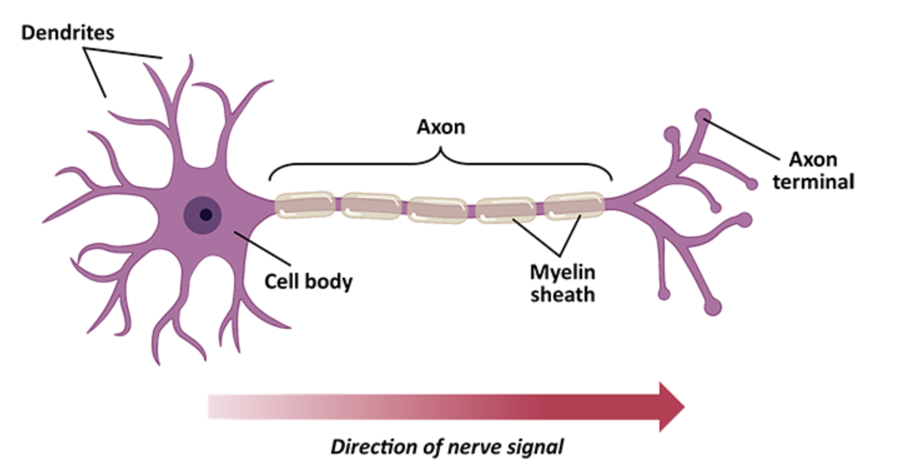
Image 1: Neuron Cell

DO NOW: The above image is a neuron. Write what you know about neurons and at least one question you have about neurons.

Part 1: Group Discussion
Instructions: Answer the following questions individually. Then you will discuss your answers within your groups. A speaker will be randomly chosen to share the ideas discussed.
Questions
- What is muscle fatigue? Recall the last time you felt fatigue after exercise, and describe what you felt.
- Why are athletes able to exercise for prolonged periods of time while non-athletes are unable?
- Think about exercise; how does your body control your muscles when you run?

Part 2: Reading Text
Instructions: Read the following short text about motor units and muscle fibers. Underline four pieces of evidence that will help revise the intro questions. Be ready to share your ideas from the text with your small groups.
Motor Units and Muscle Fibers Explained
Muscles in your body are made up of tiny fibers that contract to produce movement. A motor unit is the combination of a single nerve cell (called a motor neuron) and all the muscle fibers it controls. When your brain sends a signal to move, the motor neuron activates, and all the muscle fibers in its motor unit contract together.
There are different types of motor units: some are designed for quick, powerful movements, while others are for endurance and slow, steady actions. The strength of a muscle contraction depends on how many motor units are activated and how often they fire. This is how your body controls different levels of force, from lifting a pencil to picking up a heavy box.
Understanding motor units is important because it explains how your muscles work during everyday activities and how they adapt to exercise and fatigue.
Muscles work by contracting and relaxing in response to signals from your nervous system. When you perform everyday activities, your brain sends electrical signals through motor neurons to the muscle fibers, instructing them to contract. This is how you move your limbs, maintain posture, and perform tasks.
When you exercise, your muscles are exposed to repeated contractions, which causes small tears in the muscle fibers. The body repairs these tears, making the muscle fibers stronger and more resilient. This process, known as hypertrophy, helps muscles adapt to the demands of exercise. Over time, this adaptation leads to increased muscle strength and endurance.
Fatigue occurs when your muscles are unable to sustain the required force or power output. During prolonged or intense exercise, your muscles use up their energy reserves, and waste products such as lactic acid accumulate, which can interfere with muscle contraction. As a result, the motor units become less effective, and you experience muscle fatigue, making it harder to maintain the same level of performance.
As a group, write the best two pieces of evidence that address the intro questions.

Part 3: Diagram & Video
Instructions: Watch the video at https://www.youtube.com/watch?v=LomfcuSrdos from the beginning until you get to 4:24 minutes, and then complete the following.
- According to this segment of the video, what is muscle fatigue?

- Using the video, complete the following diagram. Use arrows and all the information that will help you explain the fatigue mechanism.
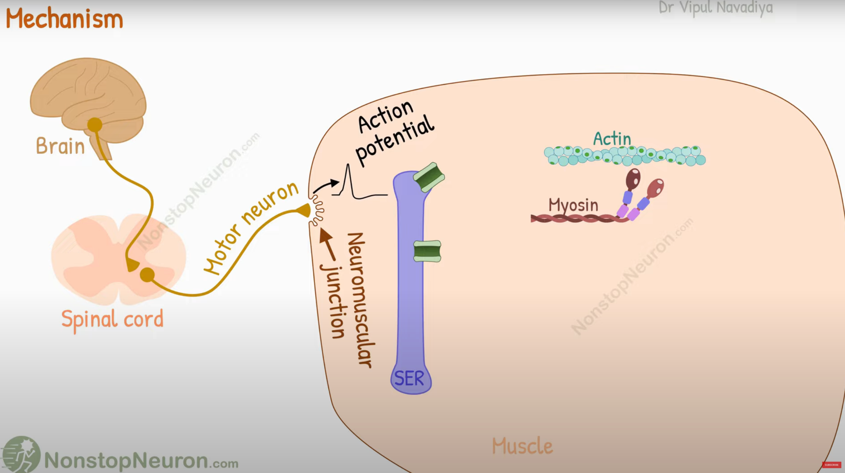
Image 2: Mechanisms behind fatigue
- Using the diagram provided in this video, explain in your own words the difference between peripheral fatigue and central fatigue. Provide examples.

Part 4: Assessment
Instructions: Using the information from class and our class discussion, write a paragraph explaining how muscle fatigue during intensive exercise can affect motor units. In your explanation, explain motor units, muscle fibers, and fatigue.

