Day 1 Handout: Neuroscience Answer Key

Our brains intricately process information through a series of logarithms, visual perceptions, interpretations and responding. Neuroscientists and neuro-engineers have been able to describe the many layers of neural networks that work together to create a response that can now be measured, studied and somewhat replicated. Studying the nervous system helps us create more efficient computers and biotechnology. By understanding how the brain receives and sends information, we can build a bridge for engineers to create potential solutions to neurological problems and possibly to create innovative biotechnology.

In this activity, you will learn about neurons, motor units, muscle fatigue, and biopotential signals. You will also learn about computer coding using micro:bits to record biopotential signals from muscle to determine muscle fatigue.
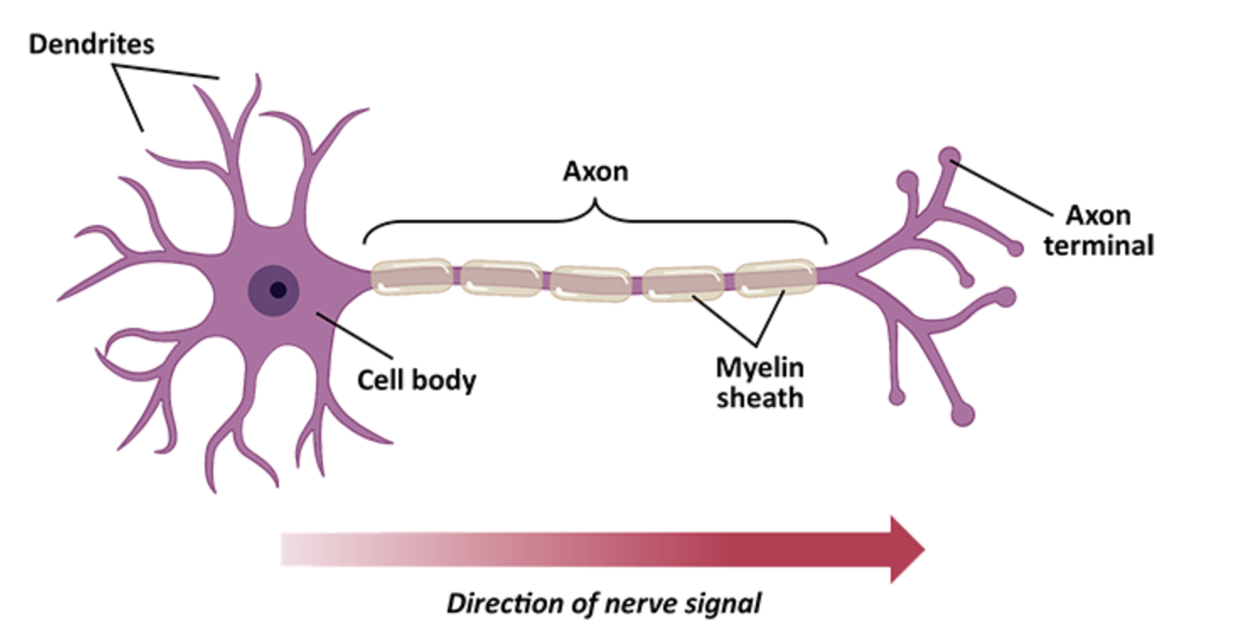
Image 1: Neuron Cell

DO NOW: The above image is a neuron. Write what you know about neurons and at least one question you have about neurons.
Possible student answers:
- Neurons are cells and they are part of the nervous system.
- Neurons help us send information from the brain to a specific part of the body and back to the brain.
- Neurons have DNA, mitochondria, and cell membranes.
- Neurons make connections within them.

Part 1: Group Discussion
Instructions: Answer the following questions individually. Then you will discuss your answers within your groups. A speaker will be randomly chosen to share the ideas discussed.
Questions
- What is muscle fatigue? Recall the last time you felt fatigue after exercise, describe what you felt.
- Why are athletes able to exercise for prolonged periods of time while non-athletes are unable?
- Think about exercise, how does your body control your muscles when you run?
These answers will vary. Listen for tiredness, pain in their muscles, inability to continue to do physical activity.

Part 2: Reading Text
Instructions: Read the following short text about motor units and muscle fibers. Underline four pieces of evidence that will help revise the intro questions. Be ready to share your ideas from the text with your small groups.
Motor Units and Muscle Fibers Explained
Muscles in your body are made up of tiny fibers that contract to produce movement. A motor unit is the combination of a single nerve cell (called a motor neuron) and all the muscle fibers it controls. When your brain sends a signal to move, the motor neuron activates, and all the muscle fibers in its motor unit contract together.
There are different types of motor units: some are designed for quick, powerful movements, while others are for endurance and slow, steady actions. The strength of a muscle contraction depends on how many motor units are activated and how often they fire. This is how your body controls different levels of force, from lifting a pencil to picking up a heavy box.
Understanding motor units is important because it explains how your muscles work during everyday activities and how they adapt to exercise and fatigue.
Muscles work by contracting and relaxing in response to signals from your nervous system. When you perform everyday activities, your brain sends electrical signals through motor neurons to the muscle fibers, instructing them to contract. This is how you move your limbs, maintain posture, and perform tasks.
When you exercise, your muscles are exposed to repeated contractions, which causes small tears in the muscle fibers. The body repairs these tears, making the muscle fibers stronger and more resilient. This process, known as hypertrophy, helps muscles adapt to the demands of exercise. Over time, this adaptation leads to increased muscle strength and endurance.
Fatigue occurs when your muscles are unable to sustain the required force or power output. During prolonged or intense exercise, your muscles use up their energy reserves, and waste products like lactic acid accumulate, which can interfere with muscle contraction. As a result, the motor units become less effective, and you experience muscle fatigue, making it harder to maintain the same level of performance.
As a group, write the best two pieces of evidence that address the intro questions.
- When you exercise, your brain sends electrical signals to your muscles that pass through motor neurons. These motor neurons’ dendrites are attached to muscle fibers. When these electrical signals pass through them, it makes the muscle fibers contract, activating the motor units needed for that specific physical activity.
- In order for a muscle to move (contract), it needs an output of energy. After many repeated movements, this energy is depleted and it accumulates lactic acid, leading to muscle fatigue. Once the muscle is fatigued, it will not be able to maintain the same performance level.
Part 3: Diagram & Video
Instructions: Watch the video at https://www.youtube.com/watch?v=LomfcuSrdos from the beginning until you get to 4:24 minutes, and then complete the following.
- According to this segment of the video, what is muscle fatigue?
It refers to the decline of muscle performance and power. It is also a protective mechanism to avoid damage. It is reversible with rest.

- Using the video, complete the following diagram. Use arrows and all the information that will help you explain the fatigue mechanism.
The next image contains all the completed pathways.

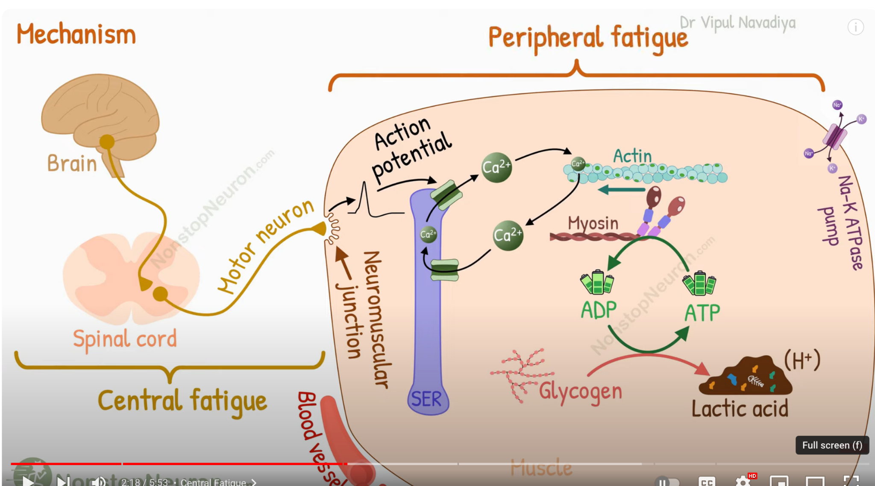
Image 2: Mechanisms behind fatigue
- Using the diagram provided in this video, explain in your own words the difference between peripheral fatigue and central fatigue. Provide examples.
Peripheral fatigue occurs within the muscles themselves, particularly in the muscle fibers and motor units. It is typically caused by factors such as the depletion of energy stores (like ATP and glycogen), accumulation of metabolic byproducts (like lactic acid), and impaired calcium ion release, which is crucial for muscle contraction. This type of fatigue leads to a reduced ability of the muscles to generate force, even though the signals from the nervous system are still strong.
Example: Imagine you are doing high-intensity weightlifting. As you perform more reps, your muscles start to feel heavy and slow to respond. This is peripheral fatigue setting in, as the muscle fibers struggle to sustain the contraction due to energy depletion and the buildup of fatigue-inducing substances.
Central fatigue, on the other hand, originates in the central nervous system (CNS), which includes the brain and spinal cord. It occurs when there is a decrease in the neural drive or the brain's ability to send effective signals to the muscles. Central fatigue can be influenced by psychological factors such as motivation, mental fatigue, and stress, as well as physiological factors like neurotransmitter imbalances. This type of fatigue can limit overall performance even when the muscles themselves are still capable of functioning.

Example: During a marathon, a runner might "hit the wall" where they feel a sudden overwhelming sense of exhaustion and a strong urge to stop, even though their muscles still have some energy left.

Part 4: Assessment
Instructions: Using the information from class and our class discussion, write a paragraph explaining how muscle fatigue during intensive exercise can affect motor units. In your explanation, explain motor units, muscle fibers, and fatigue.
During intensive exercise, muscle fatigue significantly impacts motor units, which are the functional units of movement. A motor unit consists of a motor neuron and the muscle fibers it innervates. When the brain sends a signal through the motor neuron, all of the muscle fibers within that motor unit contract simultaneously. As exercise intensity increases, more motor units are recruited to meet the demand for force. However, as fatigue sets in, the ability of these motor units to generate force diminishes. This happens because the muscle fibers within the motor units become depleted of energy and accumulate metabolic byproducts such as lactic acid, which interfere with their ability to contract effectively. Additionally, the motor neuron's ability to maintain high-frequency firing decreases, reducing the overall force output. As a result, even though the brain might still be sending strong signals, the muscles' response becomes weaker, leading to a decline in performance and increased difficulty in sustaining the exercise.

