Engineering Design Process Worksheet

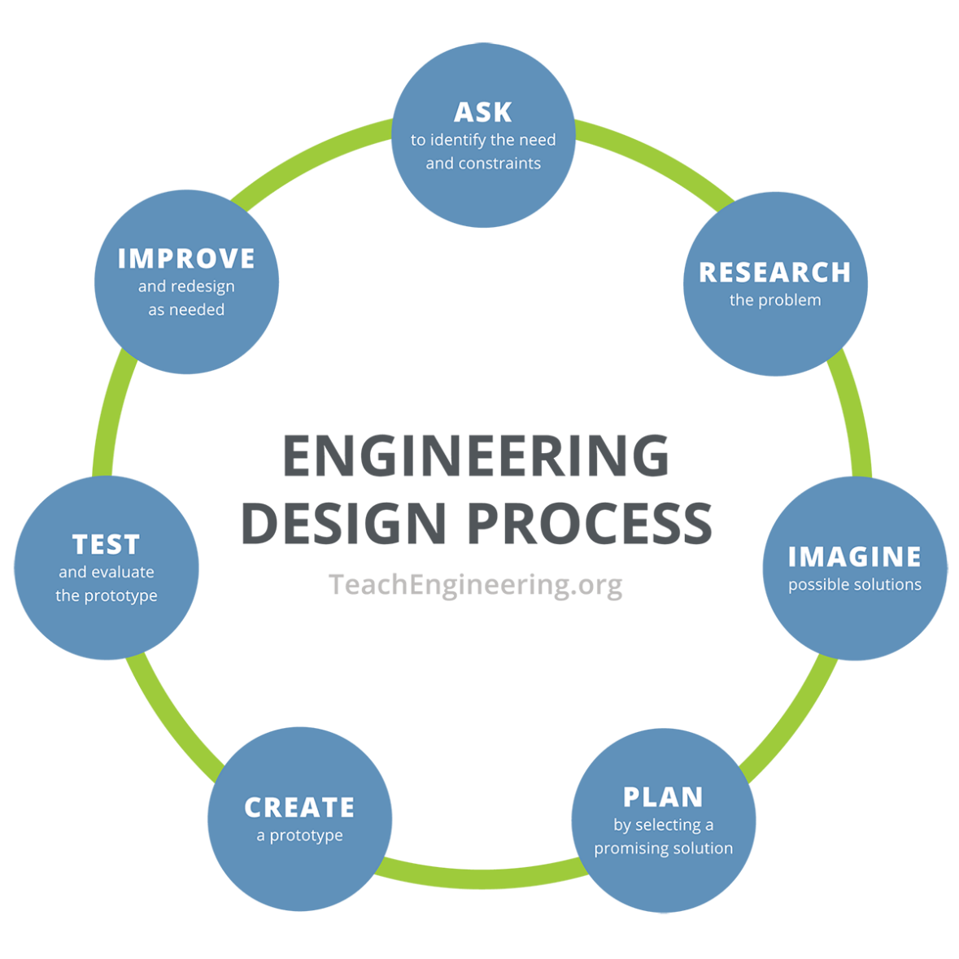
Instructions: Using the engineering design process, you and your team will solve a problem that deals with sunlight/light and/or vision.

- Ask – Identify the need and constraints of your problem.
____________________________________________________________________________
____________________________________________________________________________
____________________________________________________________________________
____________________________________________________________________________
____________________________________________________________________________
- Research – Research and learn about your problem.
____________________________________________________________________________

____________________________________________________________________________
____________________________________________________________________________

____________________________________________________________________________
____________________________________________________________________________

____________________________________________________________________________
____________________________________________________________________________

____________________________________________________________________________
- Imagine – Individually sketch out four possible solutions.

a | b
c | d
- Plan – Have each team member share their sketches. As a team, select ONE solution. This can be one specific solution or a mixture of ideas. Draw your team’s solution in the box below. Make sure to identify which materials you will be using.

- Create – Build your project exactly as shown in your group’s drawings.

- Test – Test your design and then answer the following questions.

What worked in your design, and why?

____________________________________________________________________________
____________________________________________________________________________
____________________________________________________________________________
____________________________________________________________________________
____________________________________________________________________________

What did not work in your design, and why?

____________________________________________________________________________
____________________________________________________________________________
____________________________________________________________________________
____________________________________________________________________________
____________________________________________________________________________

How would you improve your design?

____________________________________________________________________________
____________________________________________________________________________
____________________________________________________________________________
____________________________________________________________________________
____________________________________________________________________________
____________________________________________________________________________
____________________________________________________________________________

- Improve – Make changes and retest your updated prototype.
Did your changes improve your prototype? How?
____________________________________________________________________________
____________________________________________________________________________
____________________________________________________________________________
____________________________________________________________________________
____________________________________________________________________________

What worked in your updated design, and why?

____________________________________________________________________________
____________________________________________________________________________
____________________________________________________________________________
____________________________________________________________________________
____________________________________________________________________________

What did not work in your updated design, and why?

____________________________________________________________________________
____________________________________________________________________________
____________________________________________________________________________
____________________________________________________________________________

Reflection – Answer the following questions.
- What worked during this activity?
____________________________________________________________________________
____________________________________________________________________________
____________________________________________________________________________

- What did not work during this activity?
____________________________________________________________________________
____________________________________________________________________________
____________________________________________________________________________

- What would you change if you could do this activity over again?
____________________________________________________________________________
____________________________________________________________________________
____________________________________________________________________________
____________________________________________________________________________

