Product Images

Group 1 / Product 1  Octopus  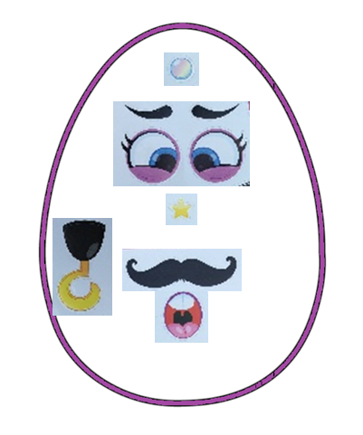 | Group 1 / Product 2  Octopus  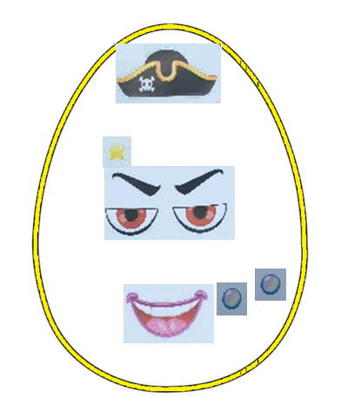
Group 1 / Product 3  Unicorn  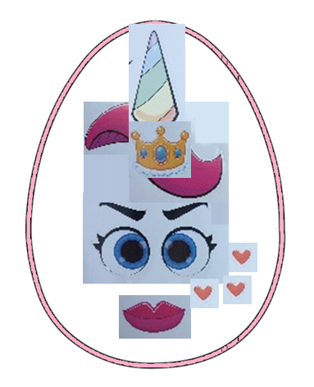 | Group 1 / Product 4  Unicorn  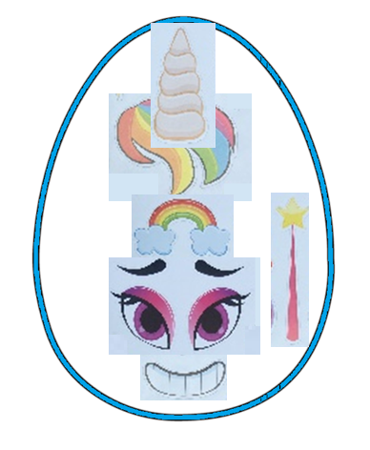

Group 2 / Product 1  Tiger  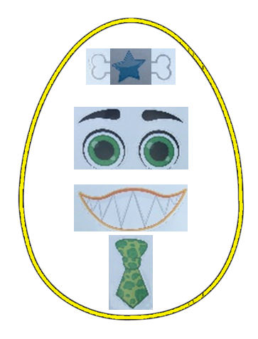 | Group 2 / Product 2  Tiger  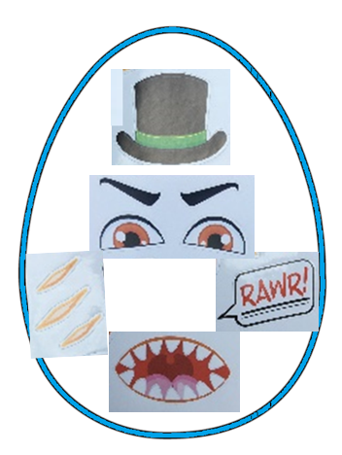
Group 2 / Product 3  Elephant  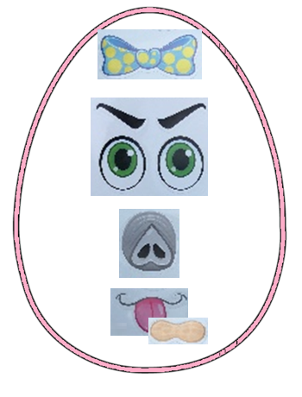 | Group 2 / Product 4  Elephant  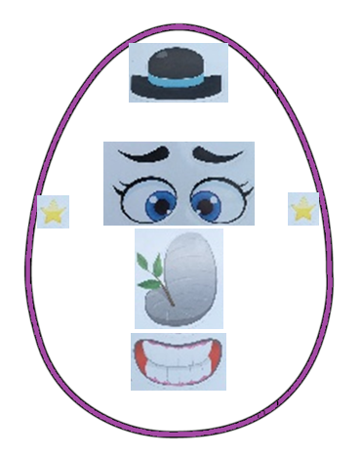

Group 3 / Product 1  Shark  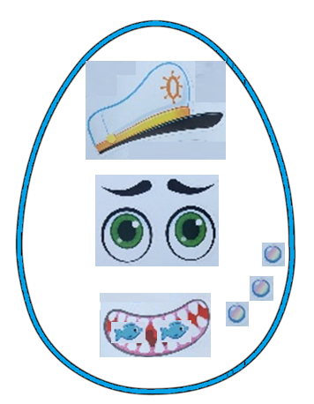 | Group 3 / Product 2  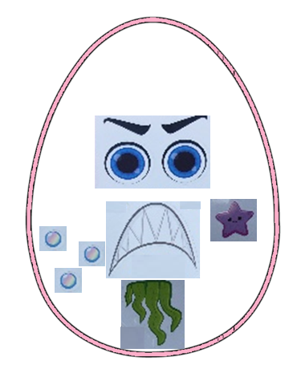  Shark
Group 3 / Product 3  Monkey  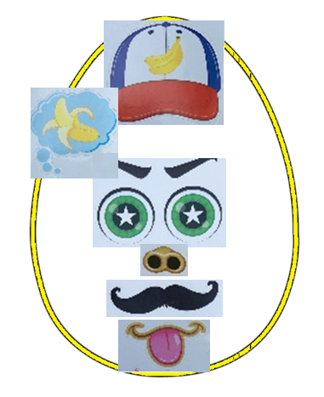 | Group 3 / Product 4  Monkey  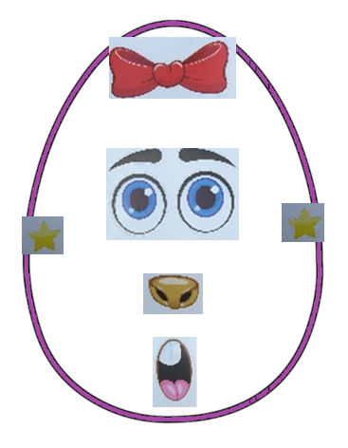

Group 4 / Product 1  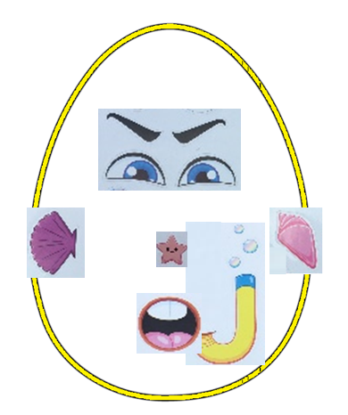  Clownfish | Group 4 / Product 2  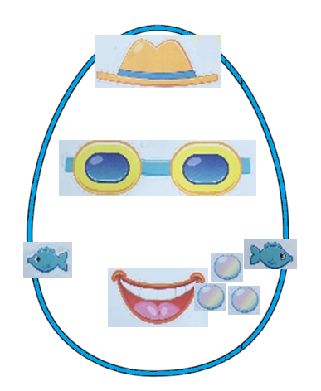  Clownfish
Group 4 / Product 3  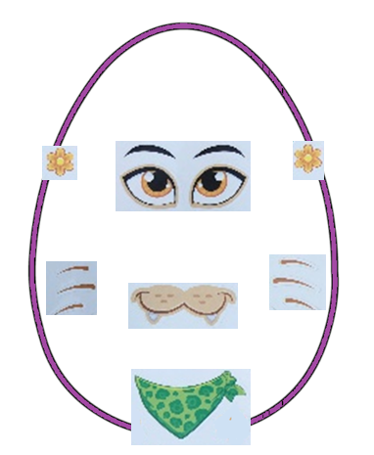  Lion | Group 4 / Product 4  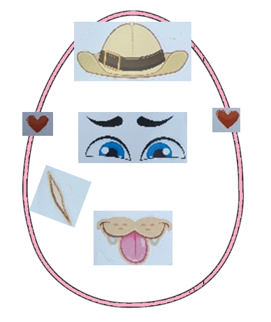  Lion

