No Bones About It Worksheet

In this lab, you use a force sensor and microscopic camera to collect data, as well as graph and analyze the data. You will make and test three decalcified chicken bone samples:
Chicken bone cross section with HOLLOW core | 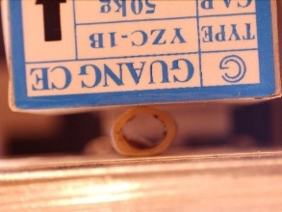
Composite of chicken bone with SOFT inner core | 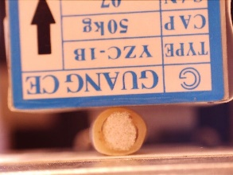
Composite of chicken bone with HARD inner core | 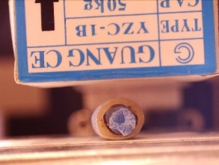

- Create your three samples and document your prediction in order of least to greatest stiffness. Draw a sketch (colored if possible) and include the dimension of each sample to the nearest mm. You are not expected to make the correct assumptions ahead of time so do not come back later and change these answers.
LEAST STIFF | MID STIFF | MOST STIFF
Description of Material(s) | Description of Material(s) | Description of Material(s)
Sketch with Dimensions | Sketch with Dimensions | Sketch with Dimensions

- Use the test fixture to collect data on one sample at a time as follows, beginning with the hollow chicken bone.

- Place the sample on the staging area oriented as shown. | 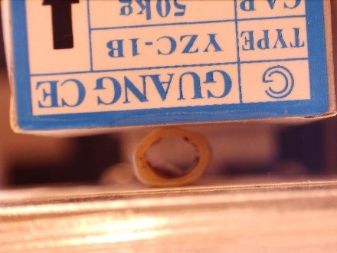
- Locate the window with the NoBonesAboutIt Program. Do not alter the code or upload code to the Arduino microcontroller board. | 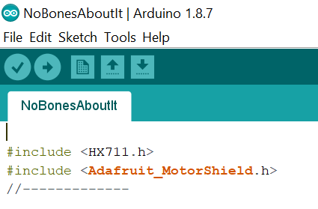
- Open the Serial Monitor Window, if it is not already open. Use the Arduino software’s Serial Monitor to send instructions to control the motor and to measure force values. | 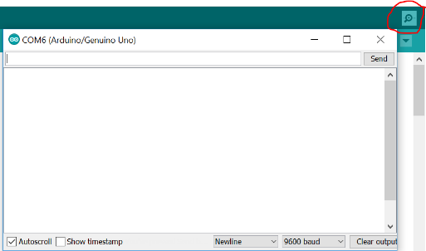
- Use repeated commands of a small motor movement step to lower the load cell until it is just above the sample but not touching the sample. Type the command d; then hit enter. When prompted, type 100; then hit enter. The load cell should be just above the sample but not yet touching it as shown in the first picture. | 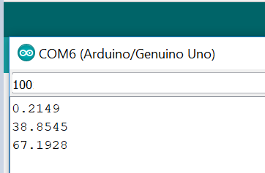
- Use the tare command to nullify any weight. Type the command t; then hit enter. | 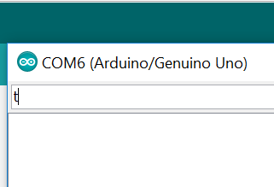
- Use the measure command m to make sure the tare command worked. You will not see force values of 0 as the load cell is extremely sensitive to the environment; but you should see values between –10 and 10. NOTE: these results are in grams. | 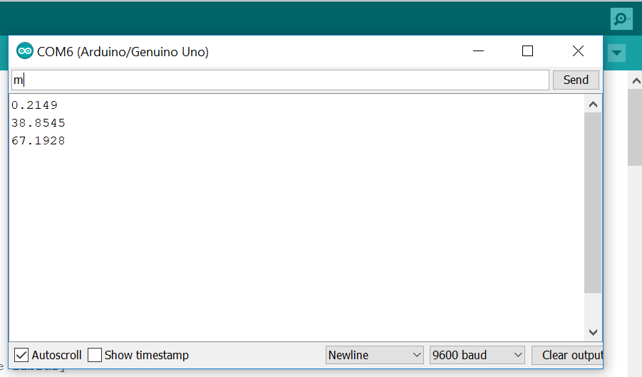
- Open the MicroCapture Plus microscopic camera software (or comparable software) if it is not already open. | 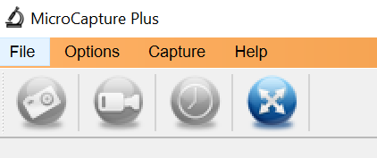
- Place the calibration slide in front of the specimen, adjust the microscopic camera’s position and focus and then capture an image as shown. Record the name of the image file in the data collection table. You do NOT record a force value for this slide. | 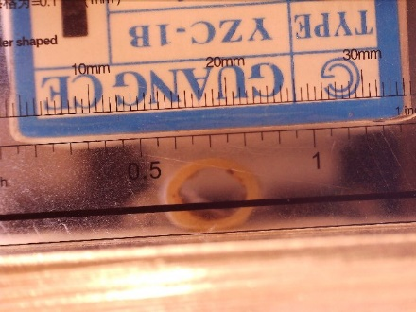
- Remove the calibration slide and capture an initial image; record the image name in the table. The force value of 0 is already entered in the table. | 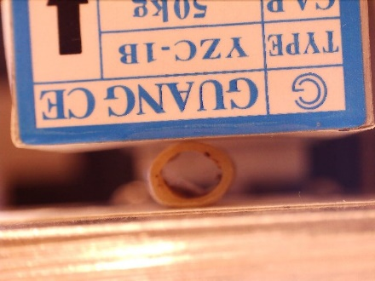
- Use the d command to lower the load cell in 100-step increments); use the m command to measure the force; record the force value (in grams); use MicroCapture Plus to capture an image; record the image name in the same row as the recorded force. | 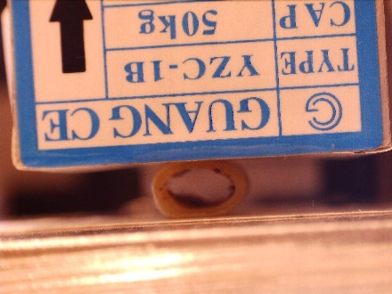  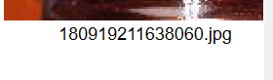
- Repeat the above step until it is visibly obvious that the sample cannot be compressed further; do not continue to apply force or you will damage the sensor. | 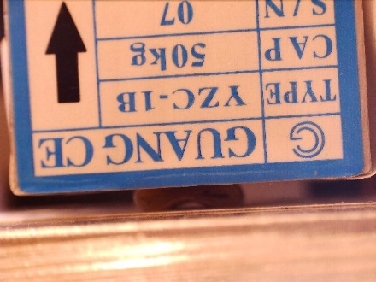
- Use a large motor movement step, such as U (with 900 steps), to raise the load cell; notice the capital letter U. Repeat as needed to remove the specimen (with 100-step increments). | 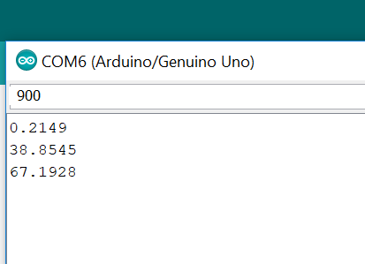

- Repeat the entire process (including taring) with the composite samples. Talk to your teacher if your chicken bone sample breaks, deforms, or becomes unusable.
- Locate all of the MicroCapture Plus image files. Organize them into three folders and share them with all of the members of your group, including your teacher.
- Move to another station so the next group can collect data.
- For each series of data:
- Use ImageJ software to open the scale picture. Use the line tool to draw a line across a known measurement shown on the calibration slide; use metric measurements. | 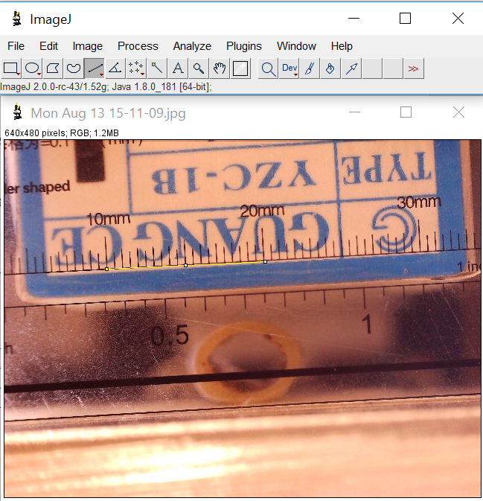
- Use Analyze->Set Scale to enter your known distance drawn with the line tool, set the unit of length to mm, and click to enable the Global checkbox. | 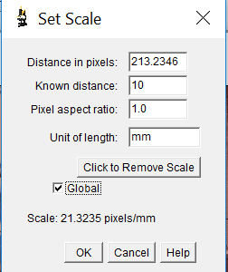
- Use File->Open Next which should display your initial picture (prior to the application of any force). Use the line tool to draw a vertical line across the diameter of the sample. Use  Analyze->Measure and record the LENGTH (which is in mm). | 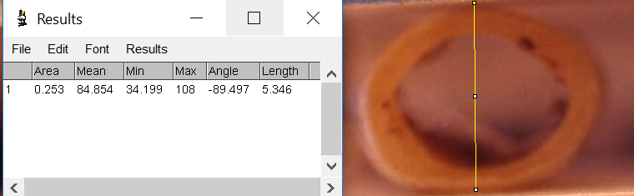
- Repeat the above step for all measurements in the set. As long as you continue to use File->Open Next, your previous line will remain in place and you just need to adjust it shorter and take a measurement.

- Share the data with all members in the group.
- Convert the force data from grams to kg in the corresponding chart column.
- Calculate ΔL (the displacement) by subtracting the ImageJ measurement in each row from the length recorded in the initial picture.
- Using Desmos, insert a table, and record ΔL (in mm) in the x₁-column and force (in kg) in the y₁-column.
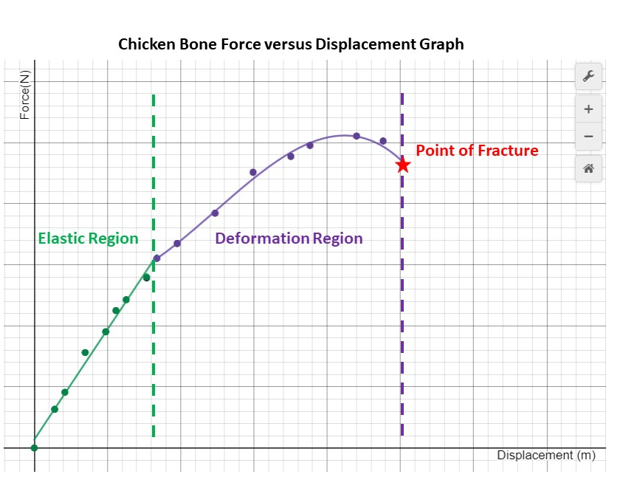
- Adjust the window so that all of the data points on the scatterplot are visible. Use the wrench tool to adjust window measurements.
- From previous knowledge, we know that a stress-strain graph can be divided into different regions. The same is true for a force-displacement graph. The three regions are: the elastic region, the deformation region, and the point of fracture as shown by the sample graph.
(Your graph will look different.)
- Using your scatterplot as a reference, circle the points on the data table that best represent the different regions. Label the corresponding sections in the table.
- Just like we practiced in class, break the data into two different tables in Desmos. The first table holds the linear data and the second the non-linear data in the ductile region. Make sure the Desmos tables have different colors.
- Insert an expression underneath the data table and run a linear regression on the first data set. Be sure to restrict the domain appropriately and to match the color of the line to the data set. Recall that the command to do this is $y_{1}\sim ax_{1}+b \{\#≤x_{1}≤\#\}$.
- Write the slope-intercept equation along with the restricted domain using interval notation:
Hollow Core Specimen | Soft Core Specimen | Hard Core Specimen

- What is the stiffness of your chicken bone sample? Tip: Include units.
Hollow Core Specimen | Soft Core Specimen | Hard Core Specimen

- Use Desmos to run a higher-order polynomial regression on the second data set representing the
ductile region. You will have to experiment with regression functions to determine if the function
is best modeled by a quadratic ($y_{2}\sim ax_{2}^{2}+bx_{2}+c$), cubic ($y_{2}\sim ax_{2}^{3}+bx_{2}^{2}+cx_{2}+d$), or quartic ($y_{2}\sim ax_{2}^{4}+bx_{2}^{3}+cx_{2}^{2}+dx_{2}+e$). Notice the R² value; however, if the value does not change much, there is no point in adding complexity using a higher-ordered function. Write the deformation region’s best-fit polynomial along with the restricted domain, using interval notation. Note: Since the domain starts with where you left off the linear restriction, one should be closed and the other open in the interval notation. (You may have to use closed notation in Desmos in order for the graph to show.)
Hollow Core Specimen | Soft Core Specimen | Hard Core Specimen

- Write a complete piece-wise defined function for the entire data set for each specimen:
Hollow Core Specimen | Soft Core Specimen | Hard Core Specimen

- Based on your results, what is the order of your samples from least to greatest in stiffness?
LEAST STIFF | MID STIFF | MOST STIFF
Description of Material(s) | Description of Material(s) | Description of Material(s)

- How did your data help you determine this order?
- How do the results compare to your initial predictions? What conclusions can you make?
- At the end of the activity, the group must share the Desmos graphs with your teacher by emailing the links; turn in this document and all data collection worksheets as well.

HOLLOW CORE CHICKEN BONE SPECIMEN
Force (g) | Force(kg) | Image Filename | Length mm | ΔL mm
Scale Image
0 (initial image) | 0 (initial image) |  |  | 0

SOFT CORE CHICKEN BONE SPECIMEN
Force (g) | Force(kg) | Image Filename | Length mm | ΔL mm
Scale Image
0 (initial image) | 0 (initial image) |  |  | 0

HARD CORE CHICKEN BONE SPECIMEN
Force (g) | Force(kg) | Image Filename | Length mm | ΔL mm
Scale Image
0 (initial image) | 0 (initial image) |  |  | 0

