Newton’s Laws Final Quiz
- For each object in the images below:
- Draw a solid arrow to show the direction of the velocity.
- Answer the question: Is a force acting upon the object?
- Answer the question: Is the object accelerating?
- If accelerating, draw a dotted arrow to indicate the direction of the acceleration (change in velocity).

Tip: Remember that “acceleration” just means a change in velocity, so if an object moves in a new direction, speeds up or slows down, these are examples of a change in velocity, or “acceleration”!

Example:

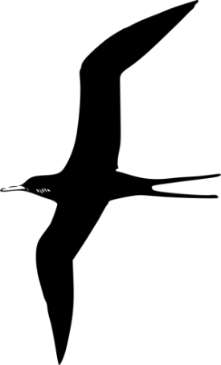
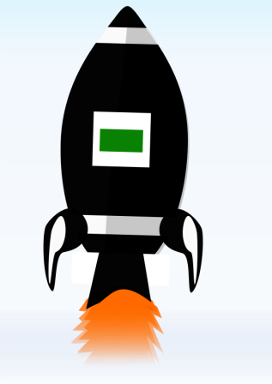

A rocket is launched. A bird soars in a straight line through the air,
Is it accelerating? _YES_ without flapping its wings.
Is it accelerating? ______

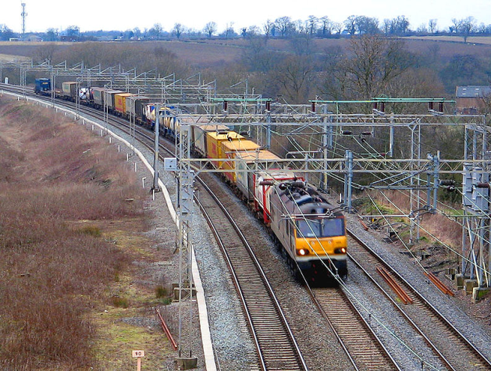

An apple falls from a tree. A train slows down as it pulls into a station.
Is it accelerating? ______ Is it accelerating? ______

- When we measure the ______________________ of an object, we measure the mass of an object by using the fact that the acceleration due to gravity is proportional to the mass.
- Volume b) Density c) Weight

- What is the equation we use to solve for force?

- In each scenario below, draw arrows to identify the action-reaction pairs. Also describe the forces. The first one has been done for you as an example.
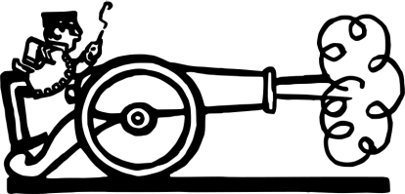
Example:
The cannon ball is thrown forward (to the right) by the explosion in the cannon, shown by the blue arrow
The cannon is thrown backwards (to the left) by the force of the cannon ball, shown by the red arrow

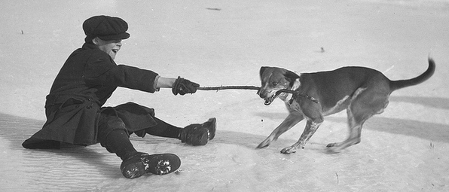

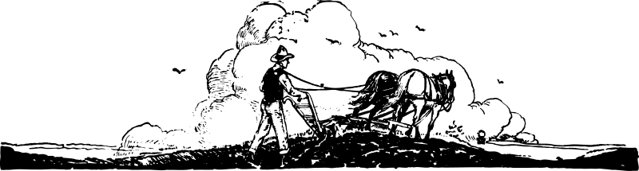

Refer to the following silly pictures, versions A and B, to answer the next few questions:

A 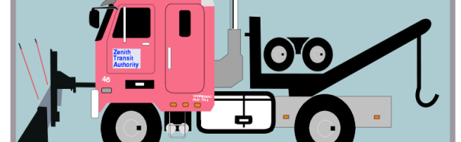 

B 

- To move the snowman, which snowplow will need to exert more force?

- Why?

- The forces are proportional to which of the following:
- the mass of the snowman
- the volume of the snowman
- the velocity of the snowman

