Revisiting Structure/Function Analysis Worksheet
Activity 1: Wind Dispersal

1. After getting feedback from another group, what ideas will you try to make improvements in your design?

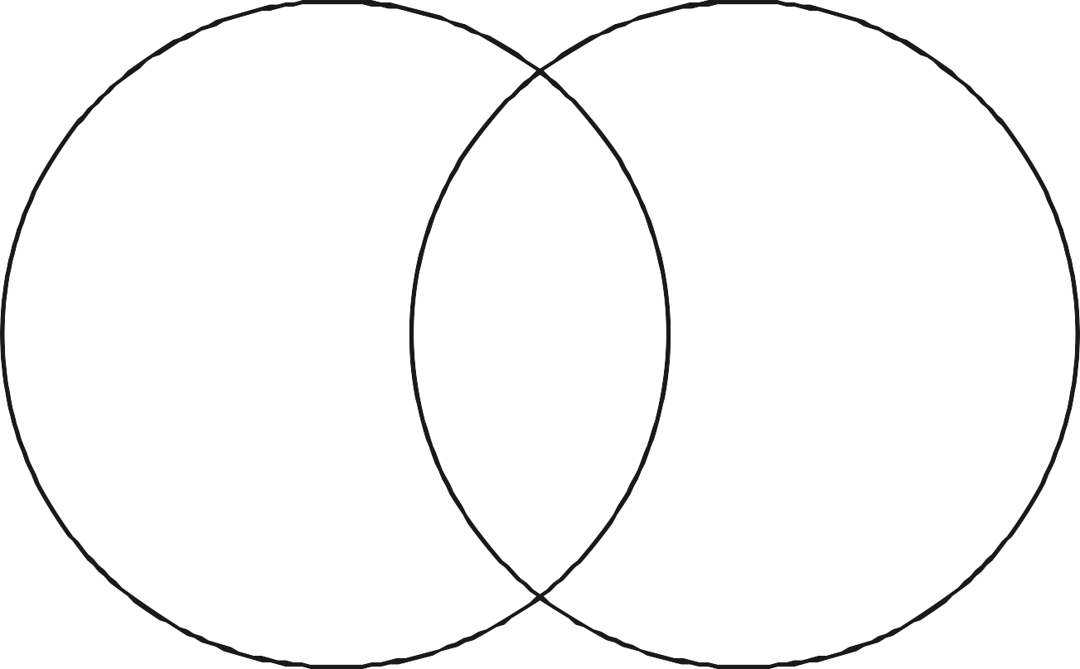
2. Biomimicry is not about making exact copies of a plant or animal. Use this Venn diagram to show the similarities and differences between your design and the bio-inspiration.

