Canvas Assignment Post
This is the assignment I created in Canvas.

Energy consumption and global warming potential are far more than buzz words. Oftentimes design decisions are arbitrary, but they could be made with reasoning that would have a positive impact on global conditions. If sustainability interests you, there are many careers as staff engineers or consultants who consider and offer advice on these decisions for a living. Check this out from our friends at Stantec.
We are going to use two Revit plug-in apps to complete an energy study and energy optimization. These plug-ins are going to convert the geometry of your building into an energy model, dependent on all the materials you selected when you designed it.
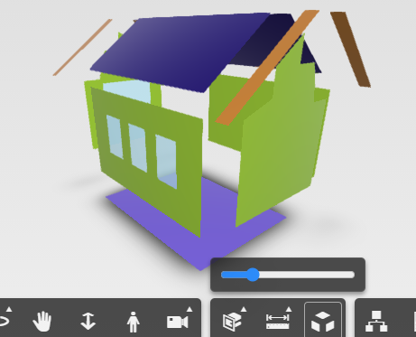

Allow me to offer some background to put the research in context. There are two types of energy that we are going to consider: operational energy and embodied energy. Operational energy is the energy that you have to pay for each month in the electric bill, as well as maintaining and repairing the structure. Embodied energy is the energy that is used in extracting the raw materials: transporting them to a factory to make them into a building materials --> Transporting the building materials to the jobsite --> Building the structure --> [skip the operational energy] --> Demolishing the structure at the end of its life --> Disposing of/Recycling these materials. This is discussed in this YouTube video (3 minutes).
.
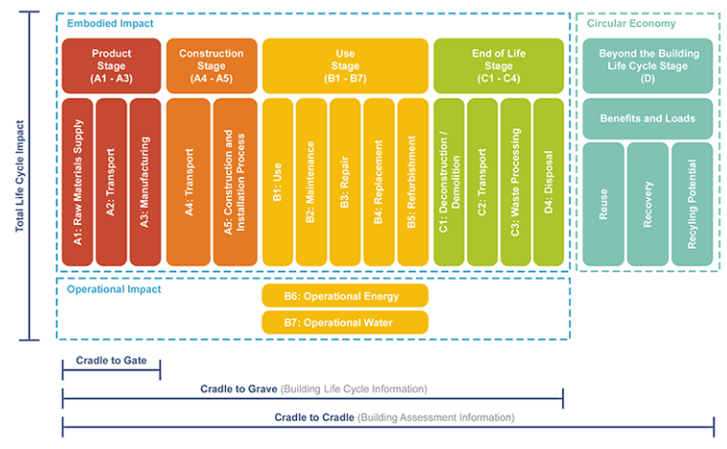
Image credit Browningday.com
Part of getting the simulation ready to study is tedious, as you have to configure each of the layers of the wall and roofing system, but I will help you get through it. I want you to complete this in two days, so if you cannot find your workshop file, or if your walls/roof are generic, and you never made all the layers of the brick and siding walls, then you may use the model included with this activity. Download it and save it with your name.
A) Embodied Energy (EE) – Use the click sheet for instructions on how to generate this report using Tally.
B) Operational Energy (OE) – Use the click sheet for instructions on how to generate this report using Energy Plus.

WHAT TO SUBMIT - You will submit two PDFs in Canvas
1) Submit the PDF version of the Embodied Energy Report you generated using Tally.
2) Submit a PDF of this SUBMISSION TEMPLATE. [NOTE: Delete/Replace anything I put in brackets.]

