Manage Definitions in Tally

Instructions: Work your way through each of the materials below, defining all of the different components. These components are organized by the CSI Divisions. When there is a default available, select it.

Right-click on the components and select EDIT DEFINITION. The following are example entries:
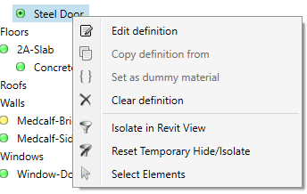

DOORS - Div 08→Door, Exterior, Steel→APPLY

Make all of these selections, then click SAVE. I also right-clicked on Cherry, Metal-Painted, and Metal-Stainless Steel and set them all to Dummy Material.
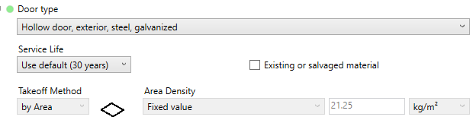
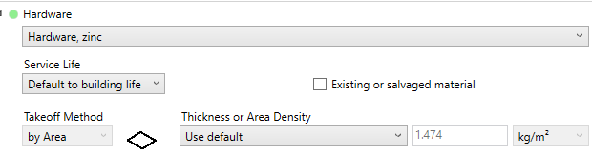
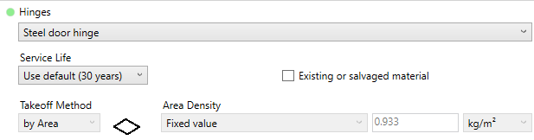

FLOORS - 03 - Concrete → Cast In place concrete, Structural concrete, 3000psi→APPLY
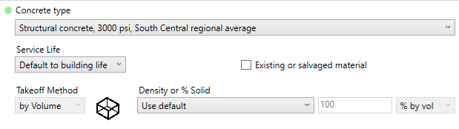
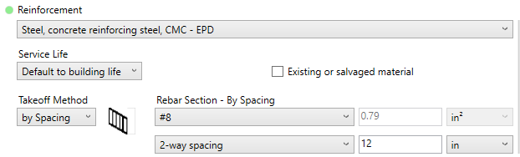

ROOFS - 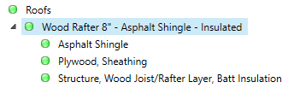
07 - Thermal and Moisture Protection→Asphalt roofing shingles→APPLY
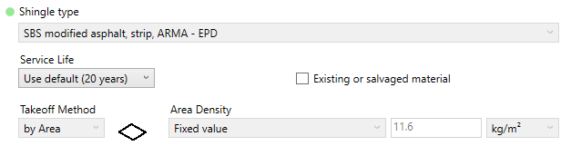
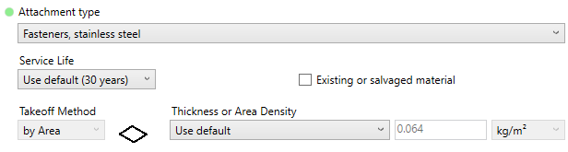

06 - Wood/Plastics/Composites→Sheet Good→Plywood-exterior grade→APPLY
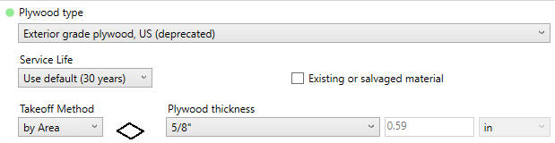
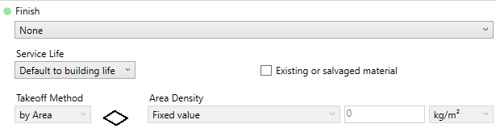

06 - Wood/Plastics/Composites→Wood framing→APPLY
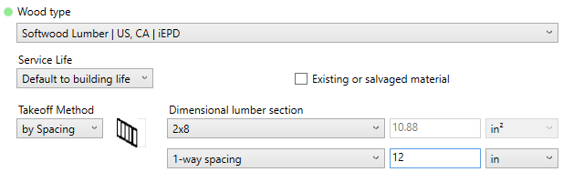

BRICK WALL - Remember that we have two different types of walls: Siding and Brick. The cool thing here is that when you configure a layer that two systems have in common, it will ask you if you want to apply the same thing to the other. Check ALL and APPLY.

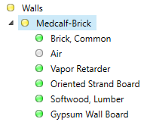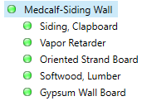

04 - Masonry→Brick→Brick→APPLY
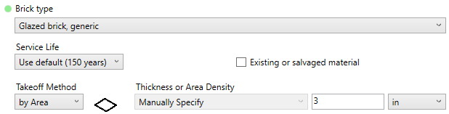
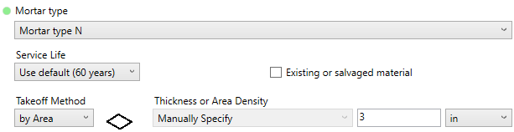

07 - Thermal and Moisture Protection→Air and Vapor Barriers→Fluid applied synth…→APPLY
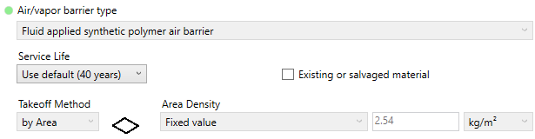

07 - Thermal and Moisture Protection→Air and Vapor barriers→Polyethelene…→APPLY
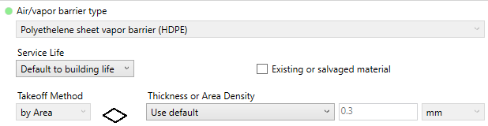

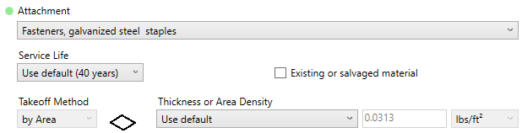

06 - Wood/Plastics/Composites→Sheet Good→Oriented Strand Board (OSB) →APPLY
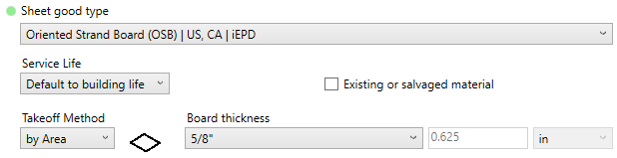

06 - Wood/Plastics/Composites→Wood→Wood framing with Insulation→APPLY
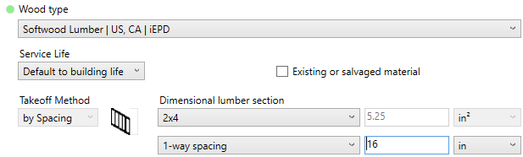
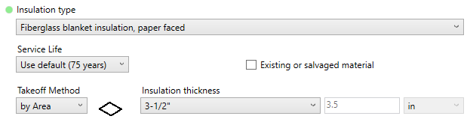

09 - Finishes→Plaster and gypsum board→Wall board, gypsum→APPLY
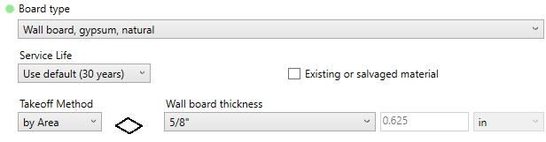

SIDING WALL - If you selected ALL as you did the brick wall, then you are only lacking the siding.

07 - Thermal and Moisture Protection→Cladding→Wood siding→APPLY
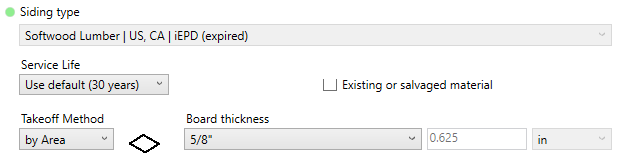
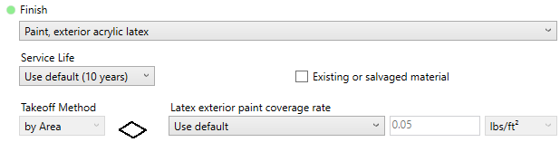
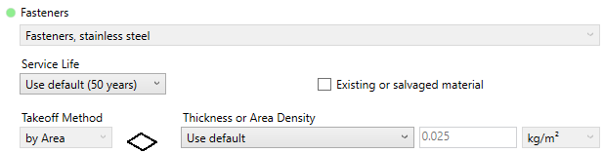

WINDOWS - We may have selected different kinds, but here is what I have…
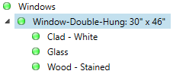
08 - Openings and Glazing→Window frame→Window frame, vinyl→APPLY
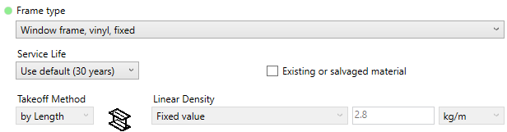
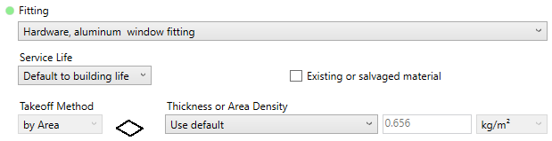

08 - Openings and Glazing→Glass→Glazing, double pane IGU→APPLY
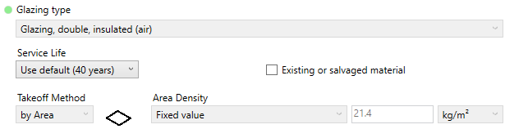
06 - Wood/Plastics/Composites→Wood→Domestic hardwood→APPLY
