Life Cycle Analysis - Operational Energy Click Sheet

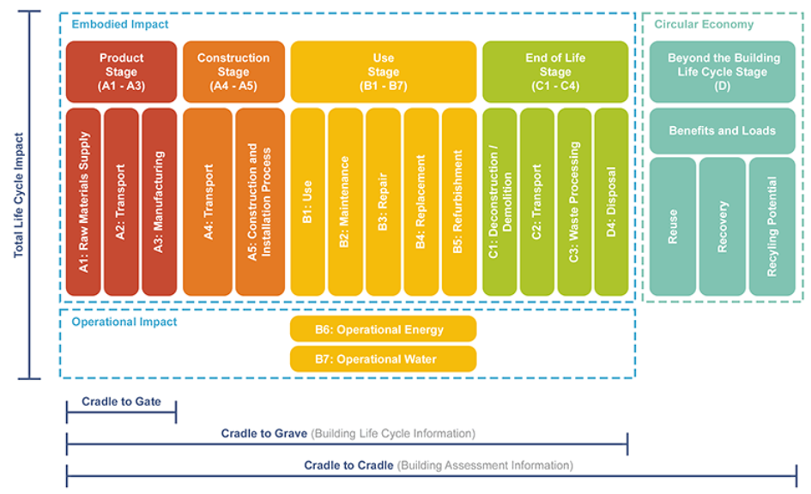
Image credit Browningday.com

Find OPERATIONAL ENERGY by Using Energy Plus Plug-In

- Open your model.
- Analyze→Create Energy Model.
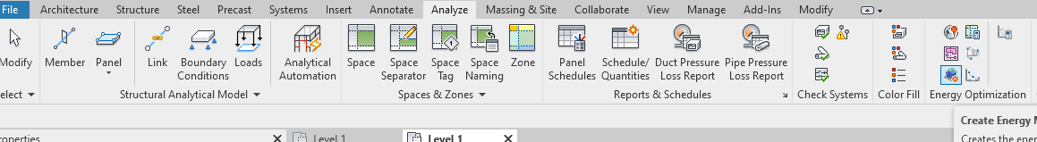
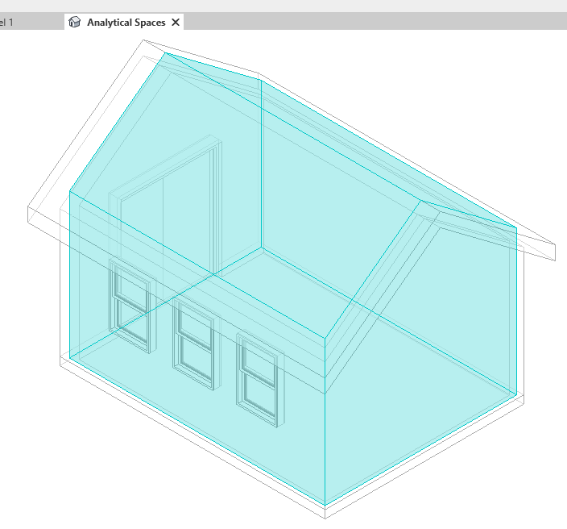
- Now create the analysis using the Energy Analytical model you just created. Analyze→Analyze
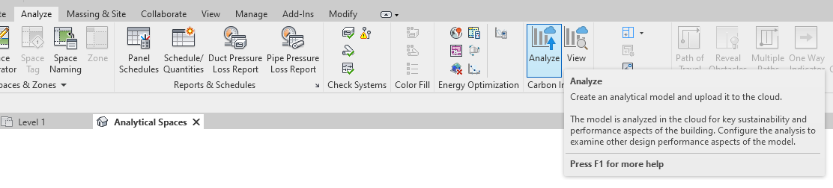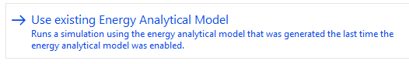
- Now View the Analysis. Revit is now going to launch a cloud application called Insight. If you have not yet logged in to Autodesk, you will be prompted to do so. From Revit, you will get a message that it is ready to view, and Autodesk will open a tab in your internet browser. At some point, it will also send you an email with a link to the report.
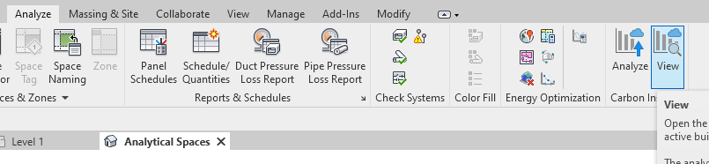

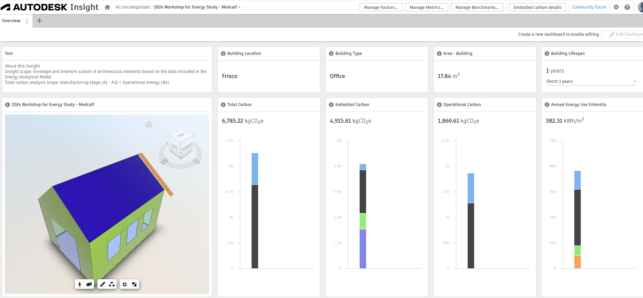
Top right box: 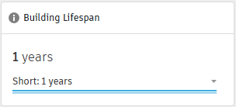Use this to toggle between 1 yr and 20 yrs.

QUESTION 1: When you select 1 YEAR LIFESPAN, what is the Total Carbon for the building? How much of this is Operational Carbon? Units are kgCO2eq.

QUESTION 2: When you select 20 YEAR LIFESPAN, what is the Total Carbon for the building? How much of this is Operational Carbon? Units are kgCO2eq.

- Now let’s try to Optimize. Revit is now going to launch a cloud application called Insight. If you have not yet logged in to Autodesk, you will be prompted to do so.

NOTE: Because Insight is a cloud application, I sometimes have trouble getting it to work properly from school. We will do our best!

First, click on Generate button to create a model in Autodesk Insight:
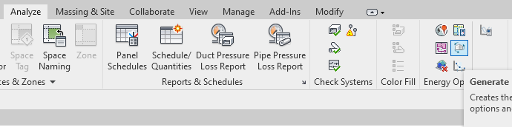
A new tab will open in your internet browser and you will see your model:
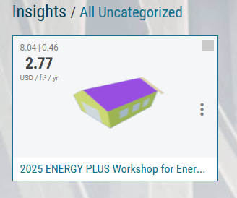
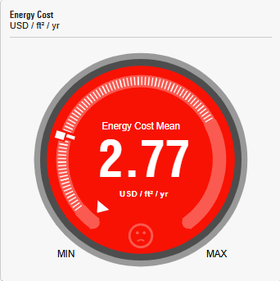
Click on this thumbnail and you will have a panel of options you can manipulate.
QUESTION 3: Before making any changes, what is your current Operational energy? The units listed are USD/ft^2/yr. How much total per year? (multiply by 192sf) How much over the 20 yr lifespan? (multiply the new number by 20) Mine would be 2.77x192x20=$10,637.

OPTIMIZE
Now investigate how to optimize. Each panel in this report has a range. The default calculation is made on a mean of all possible conditions. You can use the slidebar to zero in on a particular value or condition. I recommend going for the lowest one if it is feasible.

QUESTION 4: List all the conditions that you were able to change to help your total. For each one you applied, list the savings. Tabulate these into a spreadsheet using Google Sheets or Excel.

- Analysis Report (just for fun). This yields some interesting information regarding energy consumed during the Operational phase. This report is saved in Downloads and is viewable in Revit through the browser.
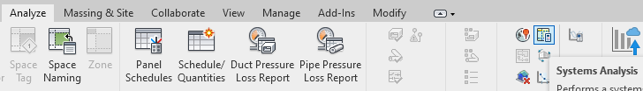
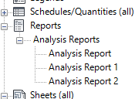Revit Browser

