Life Cycle Analysis - Embodied Energy Click Sheet
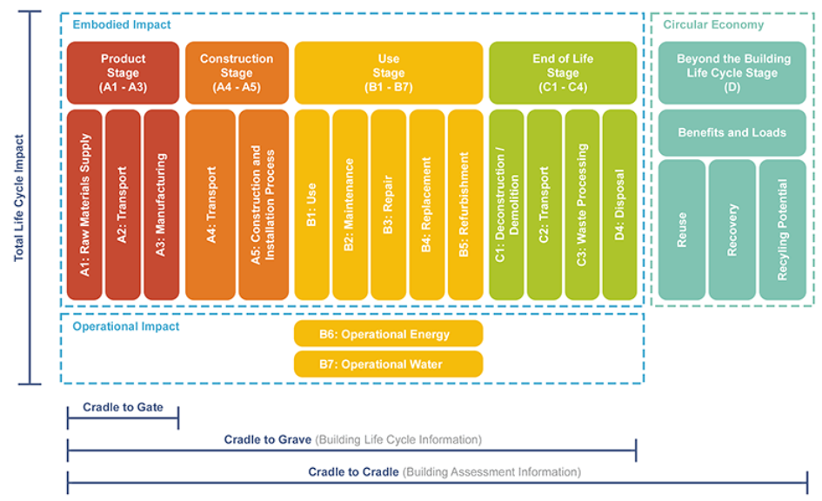
Image credit Browningday.com

You remember the life cycle phases, right? We are going to use two different plug-in apps with Revit to see how much global warming potential (GWP) your structure has. Tally will allow you to look at the EE-Embodied Energy (A1-A5 and C1-C4 and D). Energy Plus will allow you to look at the OE-Operational Energy (B1-B7).

The overall GWP is the sum of the numbers you will get from both of these exercises. GWP=EE+OE

Find EMBODIED ENERGY by using Tally Plug-In
- Open your model.
- Add-Ins→Tally.
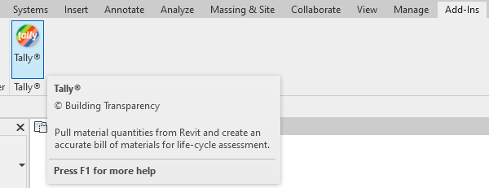

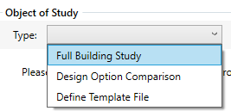
- Full Building Study.

- Click ALL for Categories and Model, then APPLY.
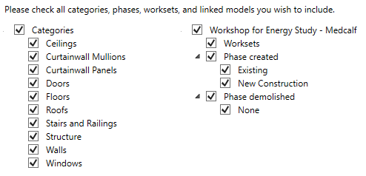

- Every Material DOT that is not green needs to be defined. Here is a sheet with definitions that you can use.
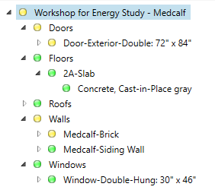

- Use the Manage Definitions for Tally sheet to complete the definitions for each component.

- Click the top button to SAVE REPORT. You will need to complete some other boxes prior to generating the report. After you do all these, click SAVE.

NOTE: The COVER field is asking if you want to include a picture on the cover page of your report. I took a screenshot of my workshop in 3D view and saved it to my Pictures folder as a PNG file. I then mapped this location and it uploaded the image.

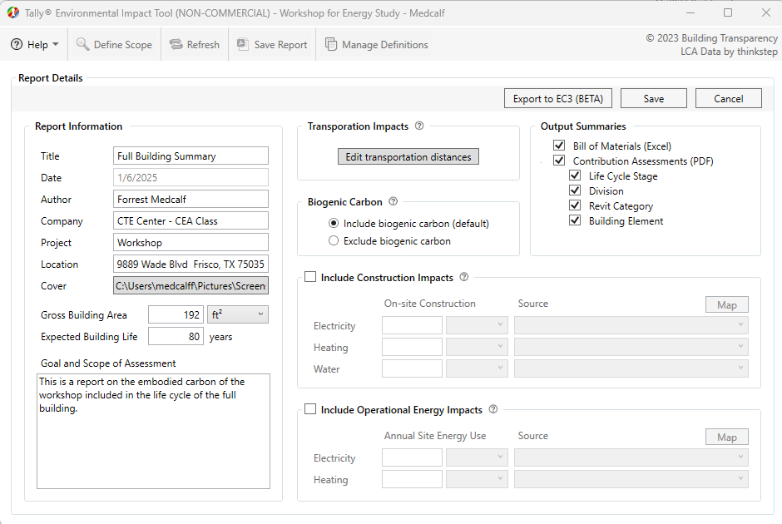
Before generating the report, you must save it. I saved mine as “Medcalf-Tally Report-Workshop.” Be sure and save it to a location that you will be able to locate.

Tally will create two files. It will create a PDF report and it will create an Excel spreadsheet with all calculations and data. MOVE BOTH OF THESE FILES TO YOUR GOOGLE DRIVE.

