Student Lab Handout

Problem: You and your class have taken a school trip on a cruise and a hurricane pushes your ship onto the shore. Within minutes you and your class discover that the you have lost power to your ship and must leave the ship to see if there are any people on the island who may be able to assist you with getting back home. After walking around on the island, you and your classmates realize that the island is uninhabited and that you need to be rescued before your fresh water supplies and food are depleted. You decide that you need to power LED lights to alert a local rescue team to come to save you.

You have a few items at your disposal to assist you in powering the LED lights such as fruit and vegetable, and wires. You will be tasked with making your own batteries from household supplies and designing an optimal circuit that you hope will eventually be used to power a LED light. In this activity, we will see if we can provide enough power for our cell phone or an LED light using our engineering skills, which will require us to know about mathematical relationships between the variables: current and voltage and power production from battery cells.

The items that you were able to obtain from the ship are listed below.
Materials:
- Different types of fruits and vegetables
- 1 penny or copper strip
- 1 galvanized zinc nail or screw
- 1 folded strip of aluminum foil
- 3 wires with alligator clips attached
- two coated electrical wires

In addition to the materials listed above, you will have access to the following items either at their group table or in a centralized location in the classroom:
- multimeter
- ruler
- LED bulbs
- calculator
- breadboard (optional)

You know from your class work that you can make a battery out of the items that you have, but you are not sure what configuration will work to light up an LED light. In fact, you do not know how well the vegetables and fruits will work as an electrolyte so, you must analyze your materials to make the best design.

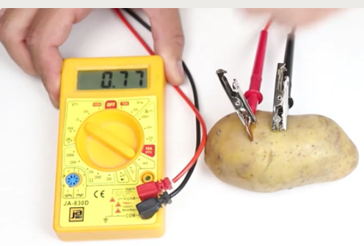
Procedure
Figure 1
- Test fruits & vegetables to identify the best electrolyte.
  - Pick at least 2 different fruits and/or vegetables.
  - Build a single battery cell using Figure 1 by inserting a copper penny and galvanized zinc screw into one piece of fruit and vegetable. Make sure the screw and penny do not touch each other.
  - You will form a simple circuit by attaching the alligator clips to the nails and pennies (electrodes) in the fruit to the terminals on the multimeter.
  - Measure the voltage and current from the multimeter and record your values in the data collection table, Table 1, in this packet.
  - If you are unable to measure the current, but can measure the voltage, it is most likely because the multimeter is unable to measure extremely low currents. In these cases, place a resistor in series with the battery and measure the voltage across the resistor. The current can then be calculated using Equation (1).
$I= \frac{V}{R}$ (1)

  - Calculate the theoretical voltage, V_{theor} using Equation (2) and the table of theoretical half-cell reactions in Figure 2.
$V_{theor}=V_{oxid}-V_{reduc}$ (2)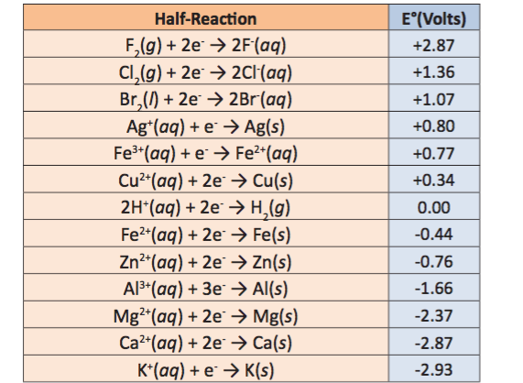
Figure 2
  - Calculate the power (in watts) from the measured values of current and voltage using the Equation (3), where V = voltage (measured) and I = current (Amps). Record in the data table below.
$P=V×I$ (3)
  - Measure the distance between the cathode and anode using a ruler. Record this value in Table 1.
  - Increase the distance between the cathode and anode 4 more times and measure the output current and voltage, and these values and calculated power in Table 1.
  - Plot the power as a function of distance, x, between anode and cathode on the graph paper. Graph your data on the graph provided (Figure 3). Be sure to include the title, labels for independent (x axis) and dependent (y axis) variables, accurate scales and intervals.
  - Based on the data in Table 1, which fruit or vegetable is the best electrolyte and which distance “x” is the optimal distance between anode and cathode?

- Test fruits & vegetables to identify the best anode.
  - Redo steps 1 – 10 using a different anode material.
  - Based on the data in Table 1, which anode and cathode pairing produce the highest power and voltage?

- Series and Parallel Configuration Testing
Once you have determined your optimal cell anode, cathode, electrolyte and distance between anode and cathode, you can begin analyzing series and parallel configurations.
  - Place two cells (optimal configuration) into the series configuration using Figure 3. Measure the combined voltage of the two cells and record the values in Table 2. 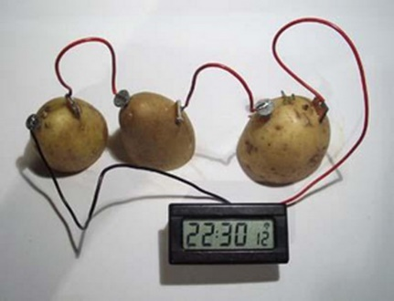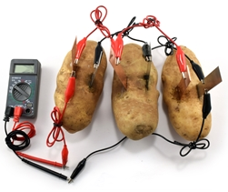
Figure 3 Figure 4
  - Place two cells into the parallel configuration as shown in Figure 4, and measure the current and voltage, and then record the values in Table 2.

- LED Test
In order to power a LED light, you must provide an adequate voltage and current. The value power supplied to the LED light depends on the type of light as shown in Figure 5. 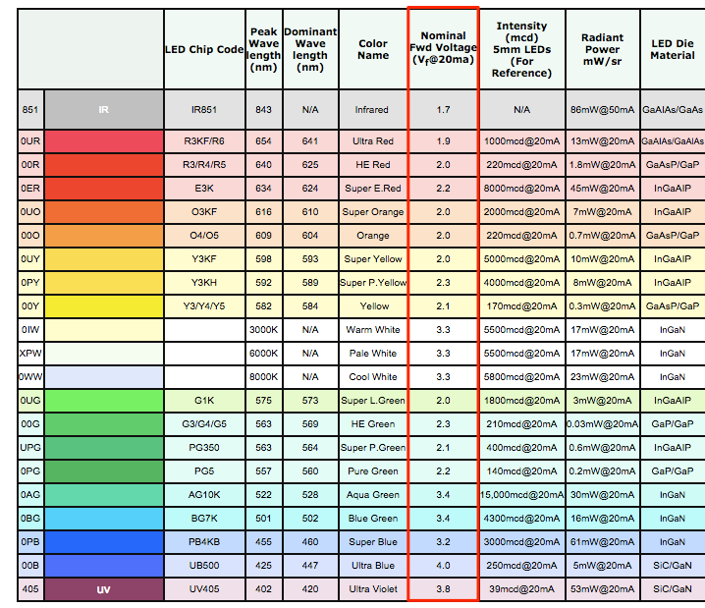
Figure 5
  - Using your results from parts A and B, create a circuit to produce the current and voltage required to power a LED bulb. Connect the circuit to the LED bulb.
  - Draw the circuit you configured to power the LED in Figure 7.

Data Collection: Use the reactions provide in the table below to calculate the theoretical voltage from your cell.

Table 1
Type of Fruit/Vegetable | Anode/Cathode | Distance between cathode and anode, x (inches) | Measured Voltage (V) | Theoretical Voltage (V) | Current (Amps) | Power (Watts)
 |  | X₁ =
 |  | X₂ =
 |  | X₃ =
 |  | X₄ =
 |  | X₁ =
 |  | X₂ =
 |  | X₃ =
 |  | X₄ =
 |  | X₁ =
 |  | X₂ =
 |  | X₃ =
 |  | X₄ =
 |  | X₁ =
 |  | X₂ =
 |  | X₃ =
 |  | X₄ =

Optimal Circuit to power LED

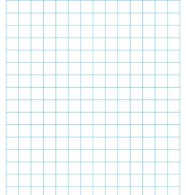

Figure 6
Figure 7

Table 2
Cell Configuration (Series or Parallel) | Anode/Cathode/Electrolyte | Voltage (V) | Current (Amps) | Power (Watts)

