Student Workbook
1.0 Lab: Introduction
An atom of silver found in silver metal has an equal number of protons and electrons. Silver metal is metallic, shiny, and makes great jewelry. Silver ions, however, are missing one electron. Silver ions typically become part of some other substance, such as silver nitrate. Silver nitrate is clear, brittle, and dissolves in water (soluble), which is why you never see silver nitrate jewelry.
Today we are going to give an electron to the silver ion in silver nitrate and see if we can make silver metal again. When an ion gains an electron it is said to be reduced. When a substance loses an electron it is said to be oxidized. Earlier research hints that both copper metal and tannin, an organic substance found in tea, may reduce silver nitrate by losing one of their electrons. So silver nitrate will be ________, copper will be ________, and tannin will be __________.
When substances are reduced and oxidized it is called a chemical reaction. Some signs of a chemical reaction are: unexpected temperature change, unexpected color change, formation of gas bubbles, or the formation of a new solid substance (precipitant). We will be looking for signs of a chemical reaction as evidence that we are making silver.
1.1 Lab: Safety
We will be using glassware, so everyone needs to wear goggles and closed-toes shoes. Never touch broken glass; instead use a broom, dustpan, and glass disposal box. Inform teacher of spills. At the end of class, rinse your hands with tap water before leaving the classroom.
1.2 Lab: Setup
Collect the following materials: 4 test tubes, 1 piece of copper wire, 2 plastic dishes (a petri dish and its lid), test tube rack, permanent marker, 4 pieces of 2.5cm² (~1 in²) plastic wrap, test tube brush, and a DI water wash bottle. DI stands for “deionized” which means very pure water. Do not use tap water for any procedure in this lab.
Mark the 4 test tubes A, B, C, and D using the permanent marker. Mark the bottom of both plastic dishes with your period number and table. If it was period 2, and you were at lab table 5, mark them with “2-5”.
1.3 Lab: Procedure
- Use the DI wash bottle to rinse out the test tubes
- Fill about two-thirds of each test tube with DI water (more than half but less than full)
- Drop the copper wire into test tube A
- Put 2 drops of silver nitrate into test tubes A, B, and D (not C)
- Put 2 drops of tannin into test tube C and D (not A or B)
- Cover all 4 test tubes with plastic wrap (sticky side down)
- Carefully shake each test tube to make sure everything is well mixed
- Place test tubes in the test tube rack and start a stopwatch
- Fill out Student Workbook, Table 1, 2.0 Worksheet: Observations. Record observations and note signs of chemical reactions. Repeat every 5 minutes.
- Answer Questions 1-12 in Student Workbook, 2.1 Worksheet: Questions.
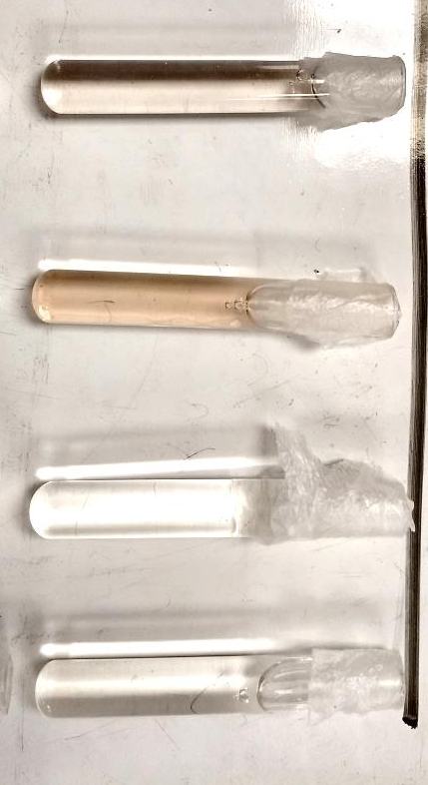
D
C
B
A

1.4 Lab: End
Set your plastic dishes where they can dry overnight. You will recognize your dishes because you marked them with your period and table. Dump the contents (including wire) of test tubes A and B into the left and right sides of the first plastic dish (see picture below). Dump the contents of test tubes C and D into the left and right sides of the second plastic dish. Clean up lab area. Clean out the 4 test tube with dish soap, test tube brush, and DI water for the next class. Make sure all the dish soap is rinsed out. Rinse your hands with tap water before leaving the classroom.
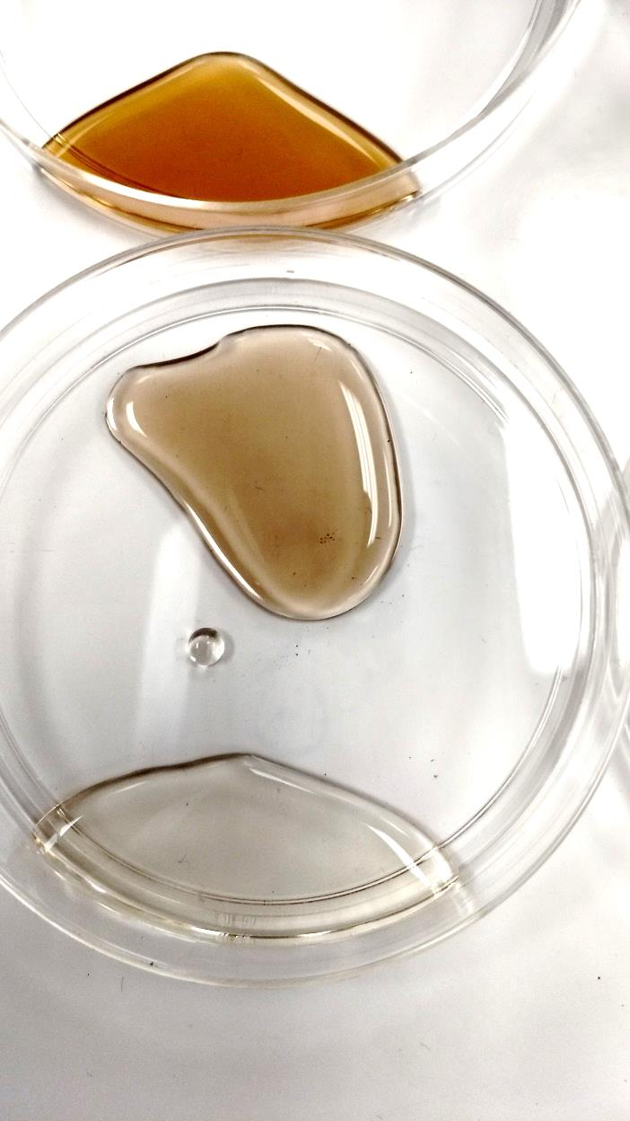
2-5

2.0 Worksheet: Observations
Table 1: Observations of copper, silver nitrate, and tannin in test tubes A, B, C, and D
 | Test tube A:  silver nitrate  copper | Test tube B:  silver nitrate |  | Test tube C:  tannin |  | Test tube D:  silver nitrate  tannin
Time | Record observations and evidence of chemical reaction
0 min
5 min
10 min
15 min
20 min
25 min

2.1 Worksheet: Questions
- Did a chemical reaction occur in test tube A?
- How do you know?

- Did a chemical reaction occur in test tube B?
- How do you know?

- Did a chemical reaction occur in test tube C?
- How do you know?

- Did a chemical reaction occur in test tube D?
- How do you know?

- Why didn’t test tubes B and C have a chemical reaction?

- In test tube A, there was only water, copper metal, and silver nitrate. So what could the black-silver substance be?

- In test tube C, there was only tannin. Did it change color or stay the same color?

- In test tube D, there was only water, tannin, and silver nitrate. So what made the solution a darker color?

3.0 Lab: Stereo microscope
Place each plastic dish under the stereo microscope. The samples should be completely dry. Focus on different areas (edges, corners, and the middle) of the sample and record what you observe in Student Workbook, Table 2, 4.0 Worksheet: Observations and answer questions 13-17.
- Tannin is brown. The best way to see tannin is to turn the bottom light on and leave the top light off. Sometimes it looks like torn brown paper. Sometimes it stains other things brown.
- Silver nitrate looks like clear sugar or melted glass. The best way to see silver nitrate is to turn both lights on. It is not shiny. It may look like wet sugar crystals pouring over the edge or it may look like pine tree branches made of glass.
- Copper(II) nitrate is a pale green. It looks like moss. The best way to see copper(II) nitrate is to turn on the top light but leave the bottom off. The grey parts are silver metal.
- Silver is silvery and shiny. The best way to see silver is to turn on the top light but leave the bottom off. In test tube A, silver may be coating the copper wire, growing like trees from the copper wire, or in silver clumps that broke off. If it sparkles it’s silver. In test tube D, silver particles may form sheets like sand forms a beach. They may form lines called dendrites that look like shiny-white pine branches or snowflakes.
- When finished with table 2 and questions 13-17, read Student Workbook sections 5.0, 5.1, 5,2, 5,3, and-5.4.
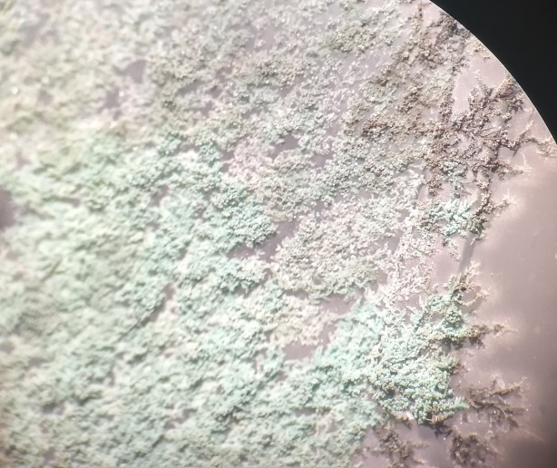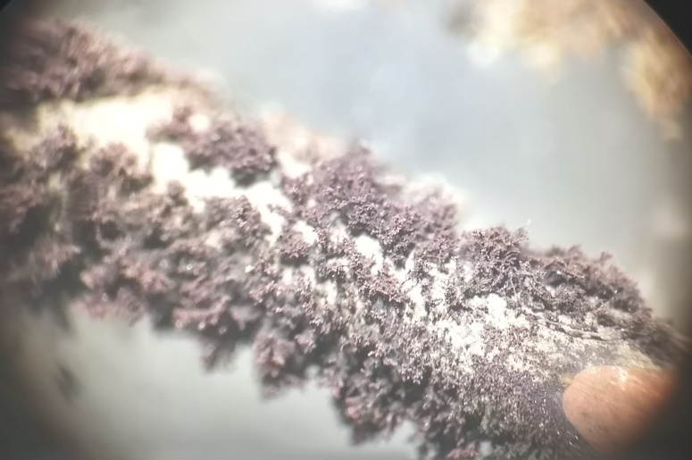
Copper(II) Nitrate
Copper Metal
Silver Metal
Silver metal
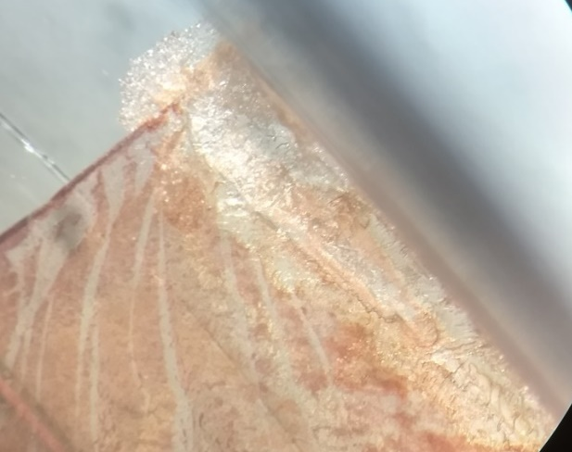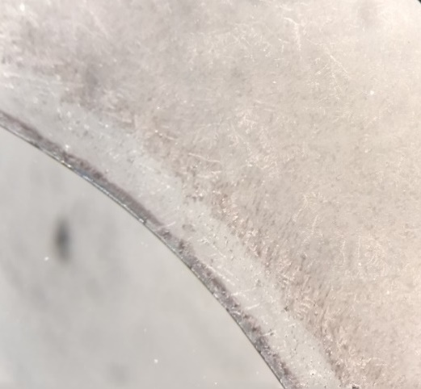
Silver Nitrate
Tannin
Silver Metal

4.0 Worksheet: Observations 2
Table 2: Stereo microscope observations
Record observations and evidence of silver, silver nitrate, tannin, copper, and copper(II) nitrate from the dried samples
Test tube A:  silver nitrate  copper | Test tube B:  silver nitrate | Test tube C:  tannin | Test tube D:  silver nitrate  tannin

- In your own words, what does silver look like in sample A?

- In your own words, what does copper(II) nitrate look like in sample A?

- In your own words, what does silver nitrate look like in sample B?

- In your own words, what does tannin look like in sample C?

- In your own words, what does silver look like in sample D?

5.0 Reading: What happened in test tube A?
In test tube A the only reactants present were copper and silver nitrate, so the only substances that can be in the test tube and the dried sample have to be from copper, silver, and nitrate. Silver was reduced and copper was oxidized. This type of reaction is called a redox reaction because silver nitrate is reduced (red) and copper is oxidized (ox). This type of reaction is also called a single replacement reaction because copper replaces silver in silver nitrate. The chemical reaction looks like:
Copper + Silver Nitrate Silver Metal + Copper(II) Nitrate
- Silver nitrate produces silver when it reacts with copper.
- Silver is visible because it forms in one place—on the copper wire.
- Another product is copper(II) nitrate, a pale green substance.
- It is hard to see, but the solution in test tube A at the end is not perfectly clear. It is pale green because it contains copper(II) nitrate.
- Silver on the copper wire appears black at first. This is just an optical effect when the amount of silver is small.
- In the dried sample, sometimes the green copper(II) nitrate coats the silver metal.
- Silver metal forms dendrites like pine trees.
5.1 Reading: What happened in test tubes B and C?
In test tube B, the only reactant is silver nitrate. There is nothing to reduce silver so no reaction happens. There is no temperature change, color change, bubbles, or precipitants. There are no signs of a chemical reaction. In test tube C, the only reactant is tannin. There is no silver to reduce so no reaction happens. Neither reactant changed color or produced silver.
- Silver nitrate did not become silver by itself.
- Silver nitrate did not turn brown by itself.
- Tannin did not become silver by itself.
- Tannin is brown but did not become a darker brown by itself.
5.2 Reading: Particle Diagram
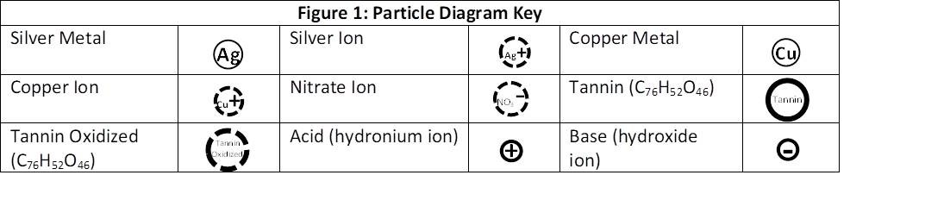

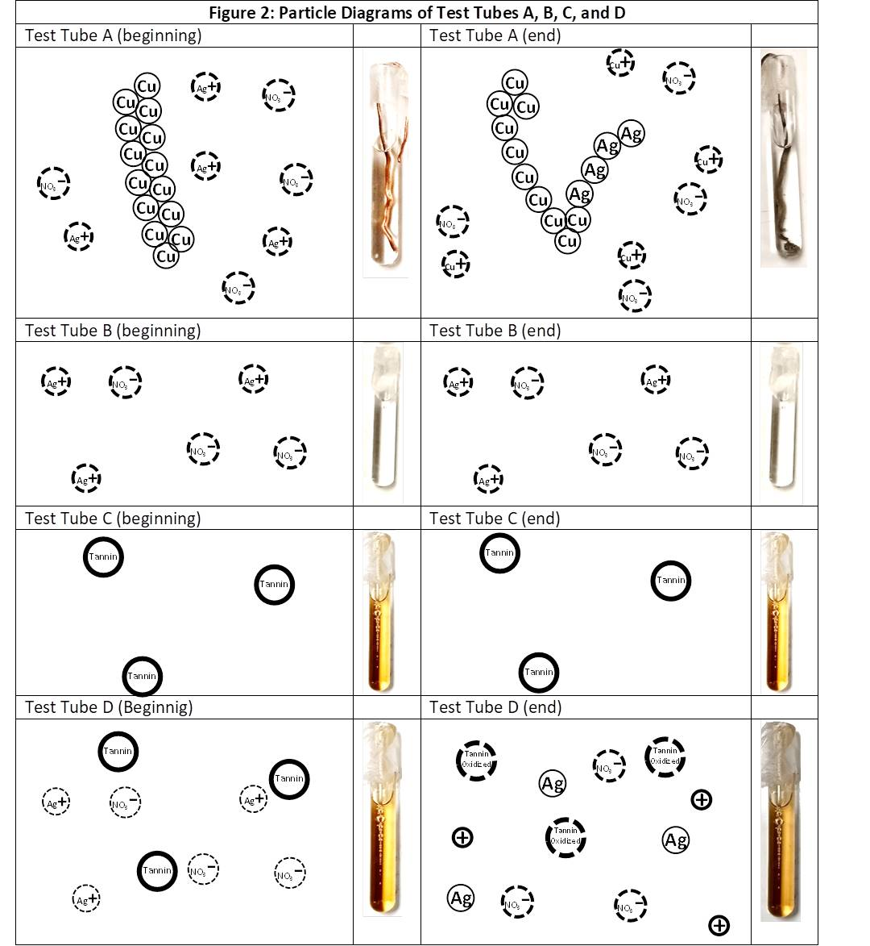
(Beginning)

5.3 Reading: What happened in test tube D?
In test tube D there are two reactants, silver nitrate and tannin. There is a color change so there is a sign of a chemical reaction. The color change did not come from the silver nitrate or the tannin by themselves, but because of the chemical reaction between them. The chemical reaction is:
Tannin + Silver nitrate Silver Metal + Oxidized Tannin + More Acidic Solution
Just like in test tube A, the reaction produces silver. The particles of silver are so tiny that you can’t see them. They are only a nanometer across (a millionth of a millimeter) so we call them nanoparticles. The amount of silver you made in test tube A and D were the same.
But why did silver look brown? This has to do with how tiny particles scatter light. When light scatters we see colors. For example clouds, which appear white, are made of water droplets. Water is not white, but we see white because the droplets of water scatter sunlight. Blue eyes and green eyes don’t have blue or green particles in them. They have tiny particles of brown melanin. Melanin scatters light reflected in eyes. If there is some melanin you see blue. If there is more melanin you see green. When nanoparticles of silver scatter light you see shades of yellow, amber, and brown.
The color seen from scattered light changes based on how many silver particles there are and by their size. More particles scatter more light so you see a darker color. Larger particles also scatter more light so you also see a darker color. Unfortunately, tannin is naturally brown so it is difficult to know the reason why a test tube looks brown. Figure 3 uses particle diagrams to describe the three reasons why a solution containing silver nanoparticles might look brown.

5.4 Reading: Color Change
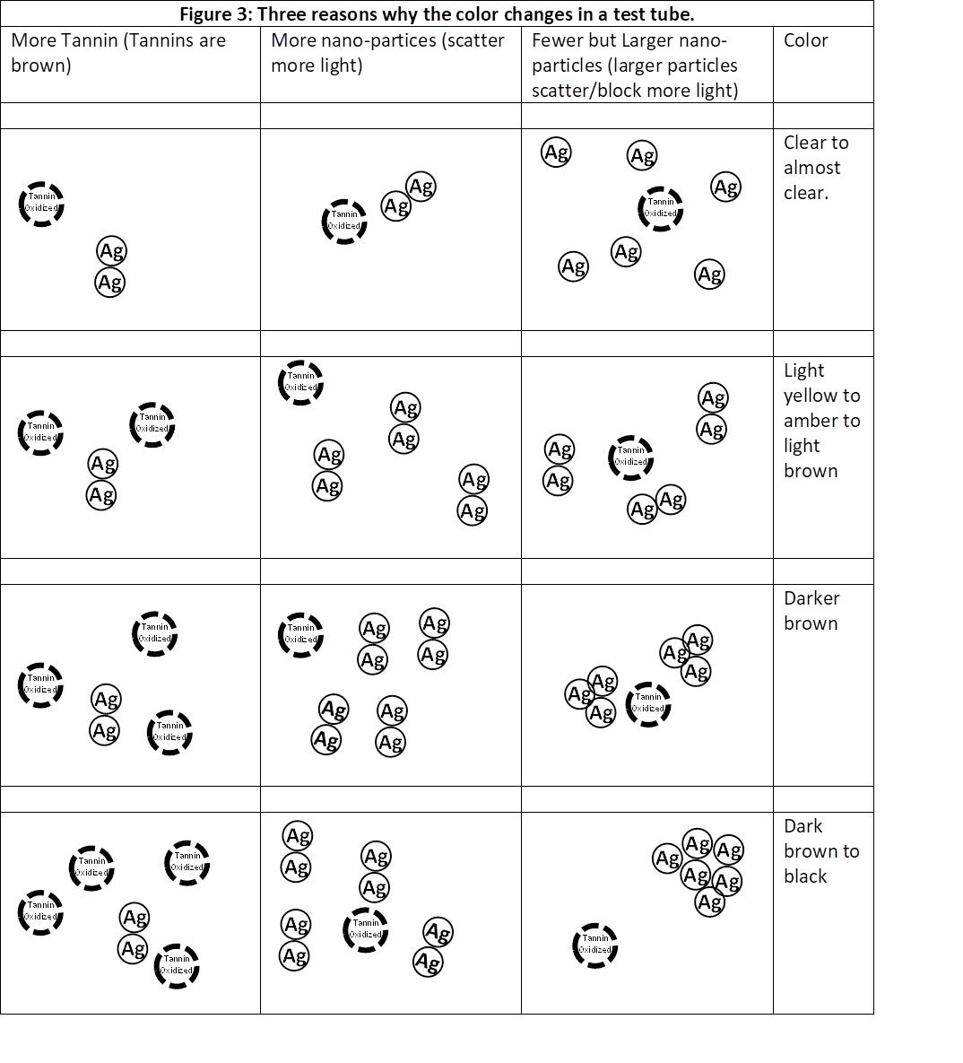
More nanoparticles (scatter more light)

6.0 Worksheet: Questions 2
As a group, use the information from the dried samples, the information from reading 5.0 to 5.4, and the observations in table 1 and table 2 to answer these questions:

- What is the evidence that no chemical reaction happened in test tube B?

- What is the evidence that no chemical reaction happened in test tube C?

- What is the evidence that the black-silver substance in test tube A was silver metal?

- In test tube D what substance made the solution a darker color?

- Look back at questions 9, 10, and 12. How did your new answers change?

7.0 Reading: Silver Nanoparticles 1
Silver nanoparticles have beneficial properties. Silver nanoparticles can treat drinking water and can be used as an antimicrobial agent. A kilogram of silver is expensive but a kilogram of silver nanoparticles is worth at least ten times more. Both are silver, but silver nanoparticles are more useful because of their small size. The ways you could make silver nanoparticles better include:
- Change the manufacturing process to make more silver nanoparticles in each test tube
- Change the manufacturing process to make silver nanoparticles faster
- Change the manufacturing process to use less silver nitrate, because silver nitrate is expensive and is consumed in the reaction.
- And the most important potential improvement: Change the manufacturing process to build even smaller-sized silver nanoparticles. Smaller silver nanoparticles are more efficient as anti-microbial agents and each silver nanoparticle uses less silver.

7.1 Reading: Silver Nanoparticles 2
There is a principle in chemistry that predicts changes in chemical reactions called Le Chatelier’s Principle. Applied to the manufacturing of silver nanoparticles, the principle states that if we can change the starting conditions, we change how fast we make silver nanoparticles. The idea is that reactions are self-correcting. For example, if a reaction makes low temperature products, then start with hot reactants instead and the reaction will be faster because the cold temperature products “self-correct” the hot reactants. Conversely, if a reaction makes acidic products, then start with acidic reactants and the reaction will be slower because the acidic products “cannot self-correct” the acidic reactants.
Changing the concentration of the reactants also changes the products. Changing the amount of tannin will change the amount of silver nanoparticles produced (the limiting reactant), the speed silver nanoparticles are produced (that is, Le Chatelier’s Principle), and the size of the silver nanoparticles (tannin blocks the growth of silver). Changing the amount of silver nitrate will also change the amount, speed, and size of silver nanoparticles produced.
Today you will act like a chemical engineer and improve an existing manufacturing process. You goal is to make a change that will make a better amount, speed, or size of silver nanoparticles. You will start with the same manufacturing process for test tube D that created silver nanoparticles on the first day and you will make an adjustment. Although your goal is to improve the manufacturing process of making silver nanoparticles, discovering something that makes the process more inefficient is also good, because you can report that doing the opposite improves the process.
Some of the changes you could try:
  - Add 1 or 2 extra drops of silver nitrate to have extra silver nitrate.
  - Add 1 or 2 extra drops of tannin to have extra tannin.
  - Add 2 extra drops of silver nitrate and 2 extra drops of tannic acid.
  - Add 1 drop less silver nitrate.
  - Add 1 drop less tannic acid.
  - Add 1 or 2 drops of acetic acid to make the solution more acidic.
  - Add 1 or 2 drops of Sodium Hydroxide to make the solution less acidic (more basic).
  - Some other change using available supplies and approved by the teacher.

8.0 Worksheet: Complete Particle Diagram
There is a particle diagram for test tube D in Student Workbook, 5.2 Reading: Particle Diagram. Table 3 changes the beginning conditions. Draw the particle diagrams at the end of the reaction. Predict what would change compared to what happened in test tube D.

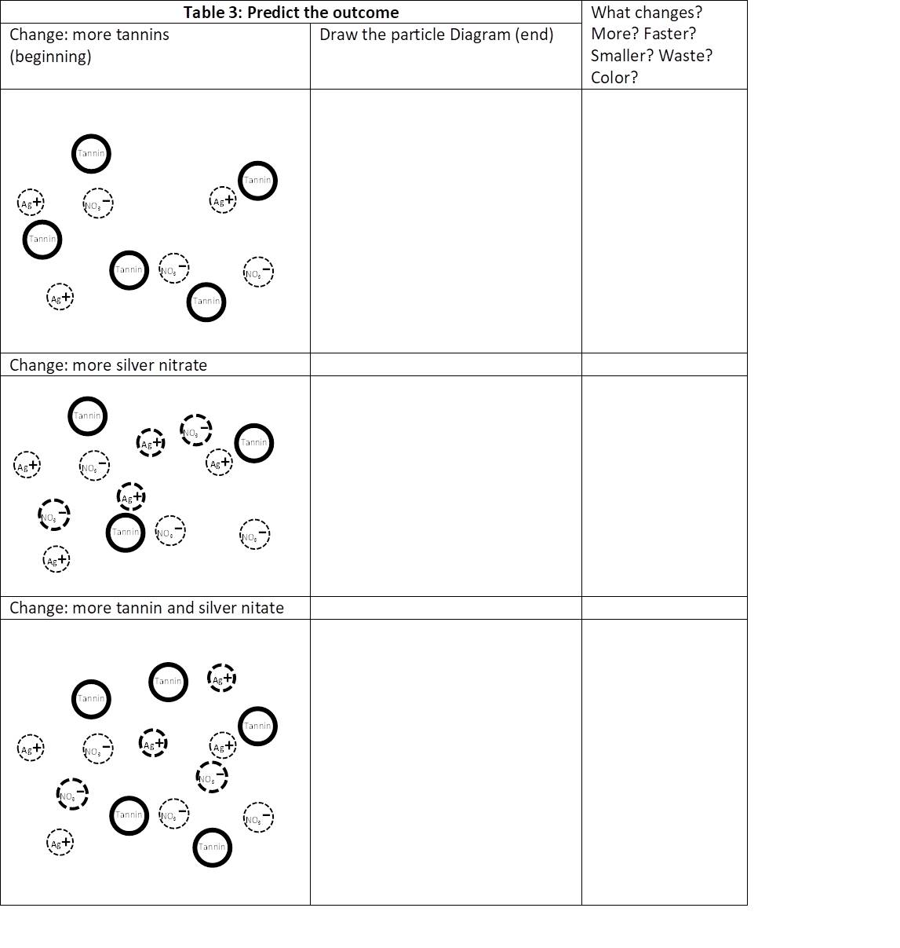

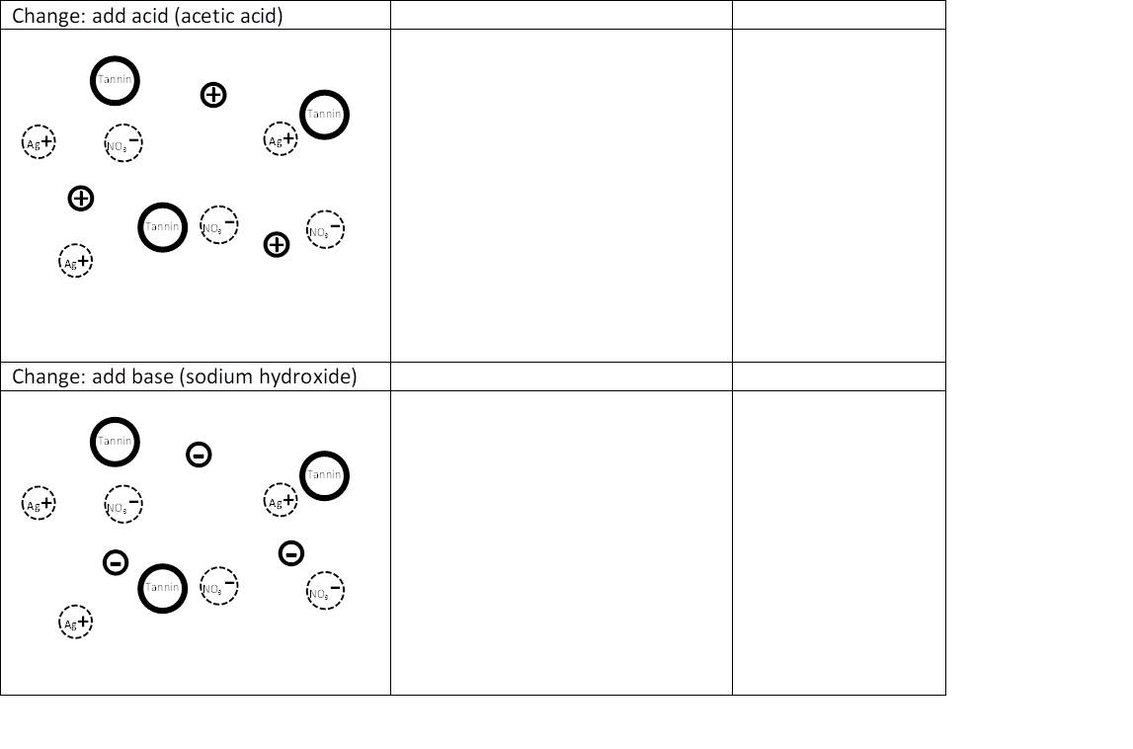

9.0 Lab: Introduction 2
Mixing silver nitrate and tannin produce silver nanoparticles, but we were not able to optimize the process in our first attempt. Today your group will be exploring a way to improve the manufacturing process of making silver nanoparticles.

9.1 Lab: Safety
We will be using glassware, so everyone needs to wear goggles and closed-toes shoes. Never touch broken glass: instead, use a broom, dustpan, and the glass disposal box.
9.2 Lab: Setup
Collect the following materials: 2 small test tubes, 1 plastic dish, and DI water wash bottle.
Mark the 2 test tubes D and E using a permanent marker. Mark the bottom of the plastic dish with your period number and table. Also, mark the bottom of the dish with the letters “D” and “E” on opposite sides.
9.3 Lab: Procedure
  - Answer questions 23 and 24 in Student Workbook, 10.0 Worksheet: Observations 3.
  - Use the DI wash bottle to rinse out the test tubes.
  - Fill each test tube two-thirds of the way with DI water.
  - Put 2 drops of silver nitrate into test tube D.
  - Put 2 drops of tannin into test tube D.
  - Add whatever your group decided to add to test tube E in whatever order you think best.
  - Cover both test tubes with plastic wrap (sticky side down).
  - Shake each test tube to make sure everything is well mixed.
  - Start a stopwatch.
  - Fill out Student Workbook, Table 4, 10.0 Worksheet: Observation 3.
9.4 Lab: End
Dump the contents of Test Tubes D and E into the left and right sides of the plastic dish, over where you marked the bottom with the letters “D” and “E”. Set your plastic dish where it can dry overnight. Clean up lab area. Clean out the 2 test tubes using soap, test tube brush, and DI water for the next class. Make sure all the dish soap is rinsed out. Rinse your hands with tap water before leaving the classroom.

10.0 Worksheet: Observation 3
- Group Choice to improve silver nanoparticle production:_________________________
- Do you think it will (circle all the answers that apply)
Produce more silver nanoparticles Produce the same amount Produce less

Produce silver nanoparticles faster Produce them same speed Produce them slower

Reduce Silver Nitrate waste Keep same waste Increase waste
And most importantly
Reduce silver nanoparticle size Produce the same size Produce larger size
Table 4: Effect of changing silver nanoparticle production
 | Test tube D  2 drops silver nitrate  2 drops tannic acid | Test tube E  ___ drops of silver nitrate  ___ drops of tannic acid  ___ drops of _______________
Time | Record Observations
0 min
5 min
10 min
15 min
20 min

10.1 Worksheet: Questions 3
Use the stereo microscope to examine dried D and E samples. You are comparing the old process with your improved process. Use the information in table 4 along with everything you learned to answer questions 25-33.
- Did you produce more/less silver?
- How do you know?

- Did you produce silver faster/slower?
- How do you know?

- Did you waste more/less silver nitrate?
- How do you know?

- Did you produce smaller/larger silver nano particles?

- How do you know?

- Acting like a chemical engineer, what is you final recommendation to improve the creation of silver nanoparticles?

- Concerning your recommendation, how will the manufacturing process be improved?

- Concerning your recommendation, are there any tradeoffs?

